Valencia SWCD Belen 1, 2, 3, 4 Sites
10-year Monitoring Report
2023
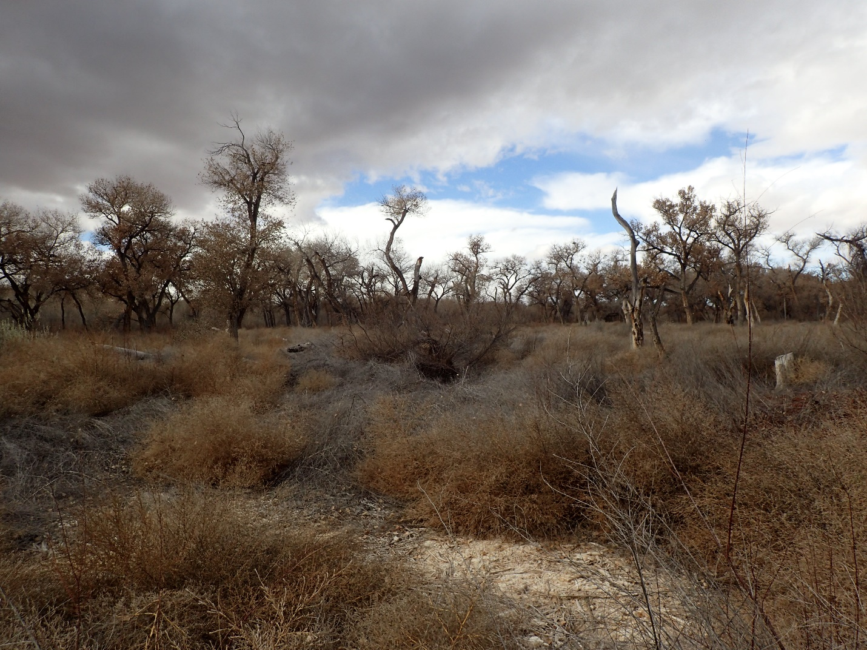Prepared by
Alex Makowicki & Clay Goetsch
With 2016 work of Kathryn R Mahan & Daniel Hernandez
And 2011/2012 work of Joe Zebrowski,
New Mexico Forest and watershed Restoration Institute
for the
Greater Rio Grande Watershed Alliance

Contents
Acronyms and Abbreviations 4
Purpose of Report 5
Ecological Context of Bosque Restoration 5
Monitoring and Field Methods 6
Original (2012) protocols 6
5 and 10-year revisits (2016 and 2022) protocols 7
Personnel Involved 8
Bosque Ecological Monitoring Program Sites 9
Belen Projects 10
Belen 1 13
Belen_1 2012 & 2023 14
Observed plant species 14
Tree Component 16
Belen 2 25
Belen_2 2012-2022 26
Observed plant species 26
Tree Component 28
Belen 3 35
Belen_3 2012-2023 36
Observed plant species 36
Tree Component 38
Belen 4 44
Belen_4 2012-2023 45
Observed plant species 45
Tree Component 47
Next steps (monitoring) 53
References 54
Appendix I – Plot Coordinates Table 55
Appendix II - Modified Hink and Ohmart categories, from NMRAM 56
Appendix III – Sample Datasheet 59
Appendix IV – Surface Fuels 63
Appendix V – Photo Pages 64

Acronyms and Abbreviations

Acronym, Abbreviation, or Term | Explanation or Definition as used by NMFWRI
FSA | Farm Service Agency, a department of the USDA
GIS | Geographic Information Systems
GRGWA | Greater Rio Grande Watershed Alliance
LIDAR | Light detecting and ranging, a remote sensing technique using light to gather elevation data
NHNM | Natural Heritage New Mexico
NMDGF | New Mexico Department of Game and Fish
NMED SWQB | New Mexico Environment Department Surface Water Quality Bureau
NMFWRI | New Mexico Forest and Watershed Restoration Institute
NMHU | New Mexico Highlands University
NMRAM | New Mexico Rapid Assessment Method, version 2.1
NRCS | Natural Resource Conservation Service
PC | Plot center
RGIS | Resource Geographic Information System
SWCD | Soil and Water Conservation District
USDA | United States Department of Agriculture
USGS | United States Geological Survey
WQCC | Water Quality Control Commission
WSS | Web Soil Survey, a soils database of the NRCS

Purpose of Report
This report covers pre-treatment and 5 and 10-year-post-treatment vegetation monitoring assessments performed on non-native phreatophyte removal projects near Belen, NM submitted by the Valencia Soil and Water Conservation District to the Greater Rio Grande Watershed Alliance in 2011. Following a discussion of the ecological context, and our monitoring methods, we present pertinent background, observations, and assessment results for each project.

Ecological Context of Bosque Restoration
Neither the challenges nor the importance of working in the bosque and other riparian areas in New Mexico today should be underestimated. According to the New Mexico Department of Game and Fish Conservation Division, wetlands and riparian areas comprise approximately 0.6 percent of all land in New Mexico (2012). Despite this small percentage, estimates of New Mexican vertebrate species depending on wetland and riparian habitat for their survival ranges from 55% (New Mexico Department of Game and Fish Conservation Services Division, 2012) to 80% (Audubon New Mexico, 2013). These areas also provide flood mitigation, filtration of sediment and pollutants, and water for a variety of purposes including groundwater recharge (Audubon New Mexico, 2013). In addition, native vegetation such as cottonwoods have cultural significance to many communities.
As much as these areas are disproportionately important to ecosystems and human communities, they are equally disproportionately impacted by disturbance. Anthropogenic impacts with major consequences for our riparian areas include dams, reservoirs, levees, channelization, acequias and ditches, jetty jacks, riprap and Gabion baskets, urbanization, removal of native phreatophytes, grazing by domestic livestock, excessive grazing pressure by native ungulate populations absent natural predation cycles, beaver removal, logging, mining, recreation, transportation, introduction and spread of invasive exotic species, groundwater extraction, altered fire and flood regimes, drought and climate change (Committee on Riparian Zone Functioning and Strategies for Management, et al., 2002). Statewide, it is estimated that as much as 90% of New Mexico’s historical riparian areas have been lost (Audubon New Mexico, 2013), and approximately 39% of our remaining perennial stream miles are impaired (New Mexico Department of Game and Fish Conservation Services Division, 2012).
New Mexico is fortunate enough to have the Middle Rio Grande Bosque, the largest remaining bosque in the Southwest (USDA USFS, 1996). However, over the past two decades, the number of fires in the bosque has been increasing. Historically, the primary disturbance regime in the bosque has been flooding, not fire, which means the system is not fire-adapted. In fact, native species like cottonwood resprout from their roots after floods and need wet soils to germinate from seed. Flooding also promotes decomposition of organic material and keeps the soil moist which reduces the likelihood of fire. Today, overbank flow is uncommon in many areas of the Rio Grande due to the heavy alteration of the channel and flow regimes (two obvious examples are the structures defining the upper and lower extent of the Middle Rio Grande: Cochiti Dam and Elephant Butte Reservoir). This has led to low fuel moisture content and high fuel loads, as well as increased human presence in the riparian area. As a result, bosque fires are more common and more severe: they kill cottonwoods and other native species, creating spaces which are filled by non-native species such as salt cedar, Russian olive, Siberian elm, and Tree-of-Heaven. We are constantly learning more about how these species can exploit and encourage a riparian fire regime, in addition to many other changes they bring to ecosystems.
Efforts geared toward the removal of these nonnative species can help to reduce fire risk, preserve native vegetation, and be part of a larger effort to restore the bosque and the watershed as a whole to a more natural and functional ecosystem. The Greater Rio Grande Watershed Alliance (GRGWA) has been working on these issues with a variety of collaborating organizations and agencies within the Rio Grande basin for several years. Since 2013, the New Mexico Forest and Watershed Restoration Institute (NMFWRI) has been working with GRGWA and the Claunch-Pinto Soil and Water Conservation District (SWCD) to begin construction of a geodatabase for all of GRGWA’s non-native phreatophyte removal projects as well as to perform the formal pre- and post-treatment monitoring, utilizing a range of field methods as well as LIDAR analysis where appropriate and available.

Monitoring and Field Methods

Original (2012) protocols
Due to the short timeframe between project selection and implementation in 2011/2012, only a narrow window was available to perform pre-treatment monitoring. That window was outside the optimum season for performing vegetation monitoring in this type of landscape. For that reason, a hasty monitoring protocol was developed. This protocol was based on placing photo point plots at locations distributed across the project area and representative of the diversity of the project area. In addition, an estimate of ground and canopy cover by percent within a 1/10-acre circular plot centered at the photo point was determined using ocular estimates. Overstory canopy was determined for a 1/10-acre circular area, also centered at the photo point. Finally, a Hink & Ohmart style vegetation structure assessment was performed. Vegetation species that were observed at each plot and in the project area was recorded. The plot size and density of observations limit the utility of this monitoring for describing overall site conditions or for generating any meaningful statistics.

Cover (%)
Tree  canopy | Seedlings/saplings  <5’/5 – 15’ |  | Shrubs |  | Gramanoid | Forbs | Litter | Bare Soil | Rock | Gravel | Water or wet  soil
Figure 1.Categories used for 2012 percent cover estimates.

A base map of the project location was constructed using project boundary data provided by New Mexico State Forestry. Planned photo points were selected by visual inspection of May 2011 true-color digital orthorectified aerial photography obtained from the United States Department of Agriculture (http://datagateway.nrcs.usda.gov/). A GIS file for the photo point plots was created using ArcGIS software. Coordinates were derived from the GIS file and loaded into a Garmin GPS 60 CSx Global Positioning System and a Trimble 2005 GeoXM Global Positioning System. The Garmin GPS was used to navigate to the general location of the planned photo point. The actual location of the photo point was determined by visual inspection of the area and selection was based on the ability to physically occupy a position at or near the planned point. The coordinates of the photo point were then collected using the more precise Trimble GeoXM GPS.

Once the plot location was determined, a 1/100 acre radius plot was established by placing pin-flags at 11’ 9” from plot center in each cardinal direction. Photos were taken from plot center in each cardinal direction and from a distance north of plot center (66’, where possible) toward plot center. Ocular estimates were made of understory canopy and ground cover within the 1/100 plot. Overstory canopy cover was estimated using a concave spherical densiometer, with measurements made in four cardinal directions, approximately mid-way between plot center and the edge of the 1/100 acre plot. This method provides an estimate of canopy cover for a 1/10 acre area centered on the plot. A Hink & Ohmart structure class determination was made using a worksheet developed by SWCA Environmental Consultants (see datasheet example in Appendix III). Finally, plant species observed within the 1/10 area around the plot were recorded, as were other comments document conditions at the plot.

Figure 2. example of plot layout. The outer circle represents the 1/10 acre plot and the blue circle is the 1/100 plot

5 and 10-year revisits (2016 and 2022) protocols
To allow comparisons between site conditions, the original site protocols were employed for the 5 and 10-year revisits as well as newer protocols for the 10-year revisit.
Plot locations as recorded in 2011 and 2016 were found using a Garmin GPS, and all plot setup and measurements were the same as in 2011 and 2016, with a few exceptions. In 2016 a ground cover category was added for plant basal/bole, which was omitted from the ground cover in 2011. Further, for both 2016 and 2022 monitoring, in addition to the original Hink and Ohmart structural classification, we recorded the structure type within a modified Hink and Ohmart classification system (see Appendix II). This second Hink and Ohmart-based system is used by the NMED as part of the modified NMRAM protocol employed for pre-treatment monitoring on GRGWA projects beginning in 2013. Additions in 2022 were the inclusion of NMFWRI's Riparian Common Stand Exam-based protocols (https://nmfwri.org/wpcontent/uploads/2020/07/GRGWA_plotprotocols_Instructions_datasheets_withcheatsheets_3.1.2020km.pdf) which added measurements of soil texture; ground and aerial cover on the entire plot as well as aerial cover by individual species, seedling and sapling tallies and individual tree measurements (Appendix X). Individual tree measurements included establishing a witness tree when available, measuring tree height, diameter at breast height (DBH), live crown base height and overall health of the tree. Fuel transects were also established. (Appendix X).

For the sake of continuity, site visits were made around the same time of year as 5 and 10 years prior, even though this was not the ideal season for plant identification in either case. It is worth noting that the winter of 2016/2017 was warmer than the winter of 2011/2012, so even though site visits were conducted around the same time of year, plant communities differed. This is especially obvious in the photographs (Appendix V).
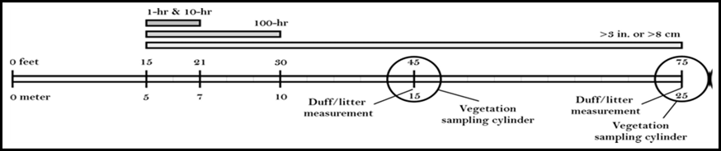

Figure 3. Example of fuels transect

Personnel Involved
2012 Monitoring Team:
- Joe Zebrowski, New Mexico Forest and Watershed Restoration Institute
- Jill Wick, New Mexico Department of Game and Fish (Sites B1 and B2)
- Dave Lightfoot, SWCA Environmental Consultants (Sites B3 and B4)
- Cody Stropki, SWCA Environmental Consultants (Sites B3 and B4)

2016 Monitoring Team:
- Kathryn R Mahan, Ecological Monitoring Specialist
- Christopher B Martinez, Monitoring Technician (NMHU Student Intern)
- Daniel Hernandez, Ecological Monitoring Technician
2023 Monitoring Team.
- Alex Makowicki, Ecological Monitoring Technician
- Clay Goetsch, Ecological Monitoring Technician
- Jordan Martinez, Ecological Monitoring Technician
Other persons contacted 2012:
- Charlie Lujan, Valencia Soil and Water Conservation District
- Madeline Miller, Valencia Soil and Water Conservation District
Other persons contacted 2016:
- Madeline Miller, Valencia Soil and Water Conservation District
Other Persons Contacted 2023:
- Yasmeen Najmi, Middle Rio Grande Nature Conservancy

Bosque Ecological Monitoring Program Sites
Two Bosque Ecological Monitoring Program (BEMP) monitoring sites were located at the northern end of project area Belen 1 and the southern portion of project area Belen 2. These sites were likely disturbed during the treatment activity. GRGWA monitoring now strives to integrate BEMP monitoring into the overall project monitoring scheme.
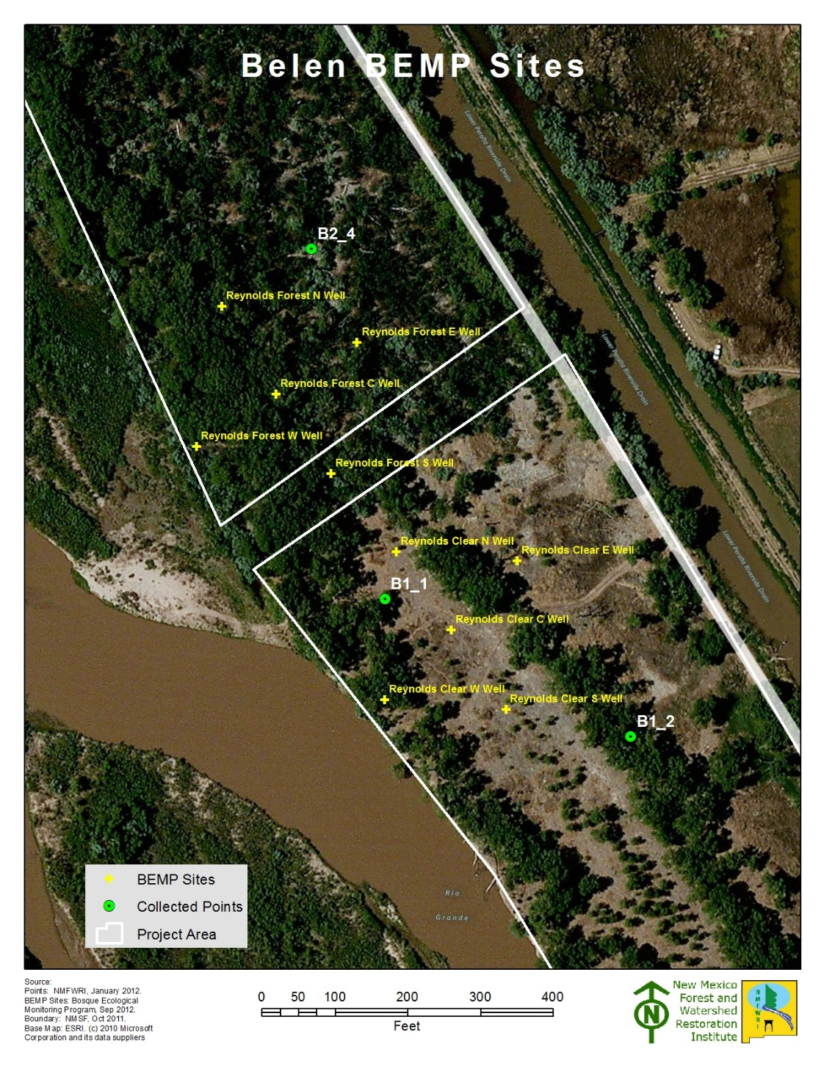
Figure 4. BEMP sites present on Belen projects.

Belen Projects
Belen projects 1, 2, 3 and 4 are located on state/Middle Rio Grande Conservancy District (MRCGD) property between the Rio Grande and the Lower Peralta Riverside Drain east of Belen in Valencia County, NM.
The nearby city of Los Lunas receives an average of 9.75 inches of precipitation annually. The average high temperature is 94 degrees in July, and the average low is 18 in December and January (U.S. Climate Data, 2017). According to the NRCS Web Soil Survey, the four project areas are comprised of <1% Riverwash (in Belen 1 and Belen 2) and the remainder Mixed alluvial land. Ecological sites within this project include R042XA055NM Salty Bottomland (USDA NRCS, 2016).
Salty Bottomland can support a range of plant communities which typically include cottonwood, salt cedar, mixed exotics (dominated by Russian olive/ Russian knapweed/ etc.), saltgrass and saltgrass-sacaton, and bottomland grassland (possibly dominated by saltgrass, giant sacaton, dropseed, muhly, burrograss, alkali sacaton, galleta, vinemesquite, and/or tobosa). Typically, the vegetation consists of a shrub/grass mixture characterized by fourwing saltbush and greasewood. Tall, mid-grass, and short grasses are present. Blue grama, foxtail, sand dropseed, spike dropseed, giant dropseed, New Mexico feathergrass and tansymustard are common. When the plant community deteriorates, there is an increase in amounts of shrubs and short grasses (USDA NRCS n.d.).
Pre-treatment monitoring was conducted at these sites on January 12, 2012 and February 7, 2012 as part of a restoration project non-native phreatophytes scheduled for 2011-2012. Post-treatment monitoring was conducted November 18, 2016, December 8, 2016, and December 16, 2016. All sites are located east of the Rio Grande and west of the Lower Peralta Riverside Drain. Sites 1, 2 and 3 are adjacent to one another; site 4 is approximately 0.4 miles north. The project was sponsored by the VSWCD. Restoration goals include enhancing wildlife and removing nonnative woody invasives. A fifth 2011 site, Belen 5, is approximately 0.5 north of Belen 4; this site was not monitored, as treatment began on the site before pre-treatment monitoring had been conducted.

Bosque Fires
In 2019 the Iron Works fire occurred in the town of Belen, burning 138-acres of the bosque and adjacent land. The fire started on private land via the dumping of hot ash and quickly spread due to spring winds. In 2022 The Big Hole fire ignited in the footprint of the Iron Works fire and burned 892-acres along the bosque. 41% of our project boundaries were burned in the Big Hole Fire and the damage is evident in Appendix V.

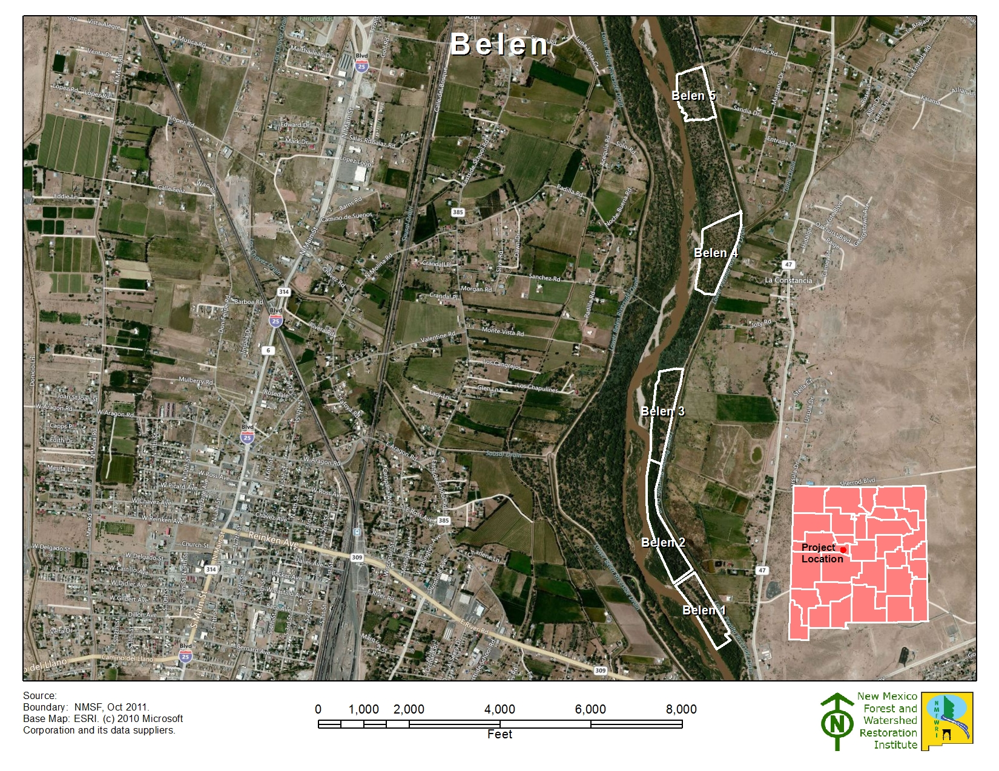
Figure 5. Belen projects in geographic context.

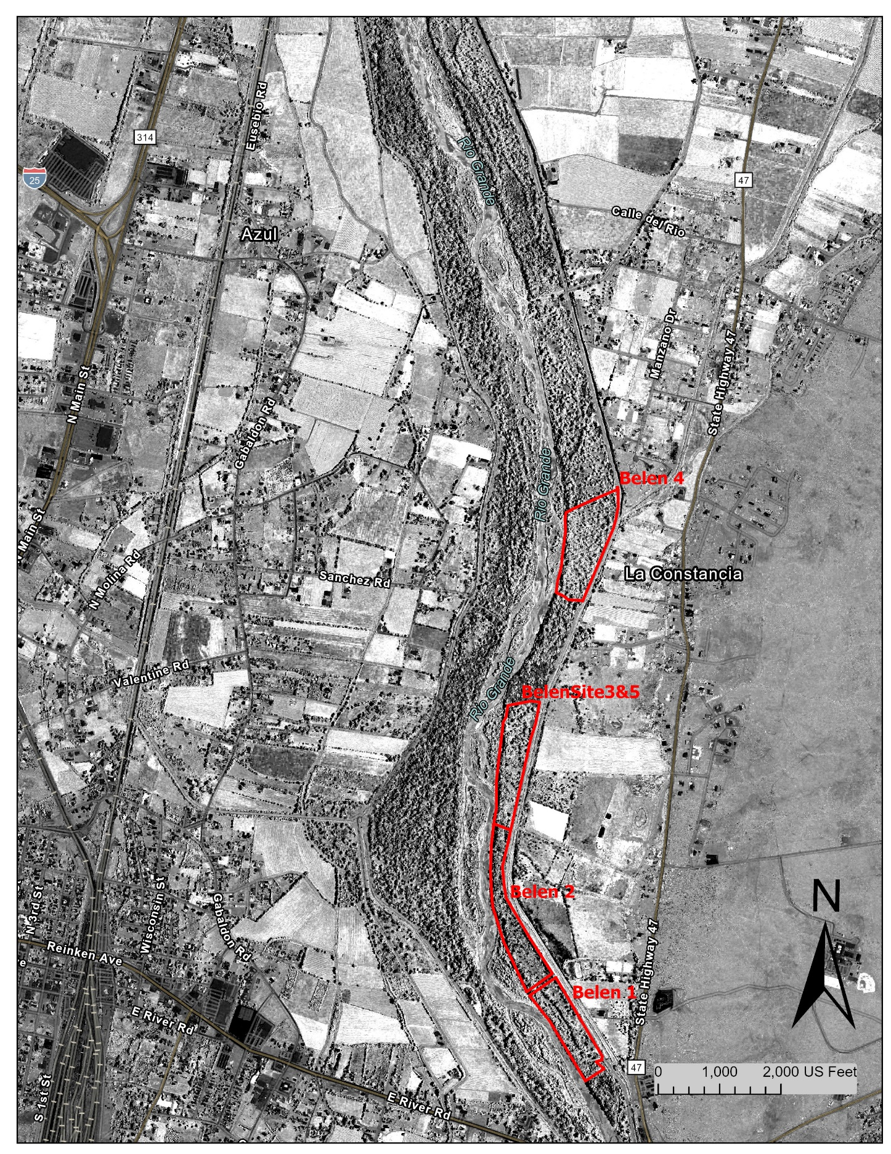

Figure 6. Normalized Difference Vegetation Index Image. Imagery derived from 2018 NAIP imagery. Belen project boundaries marked in red. Lighter whites represent more vegetation. Darker areas are areas absorbing light, such as water.

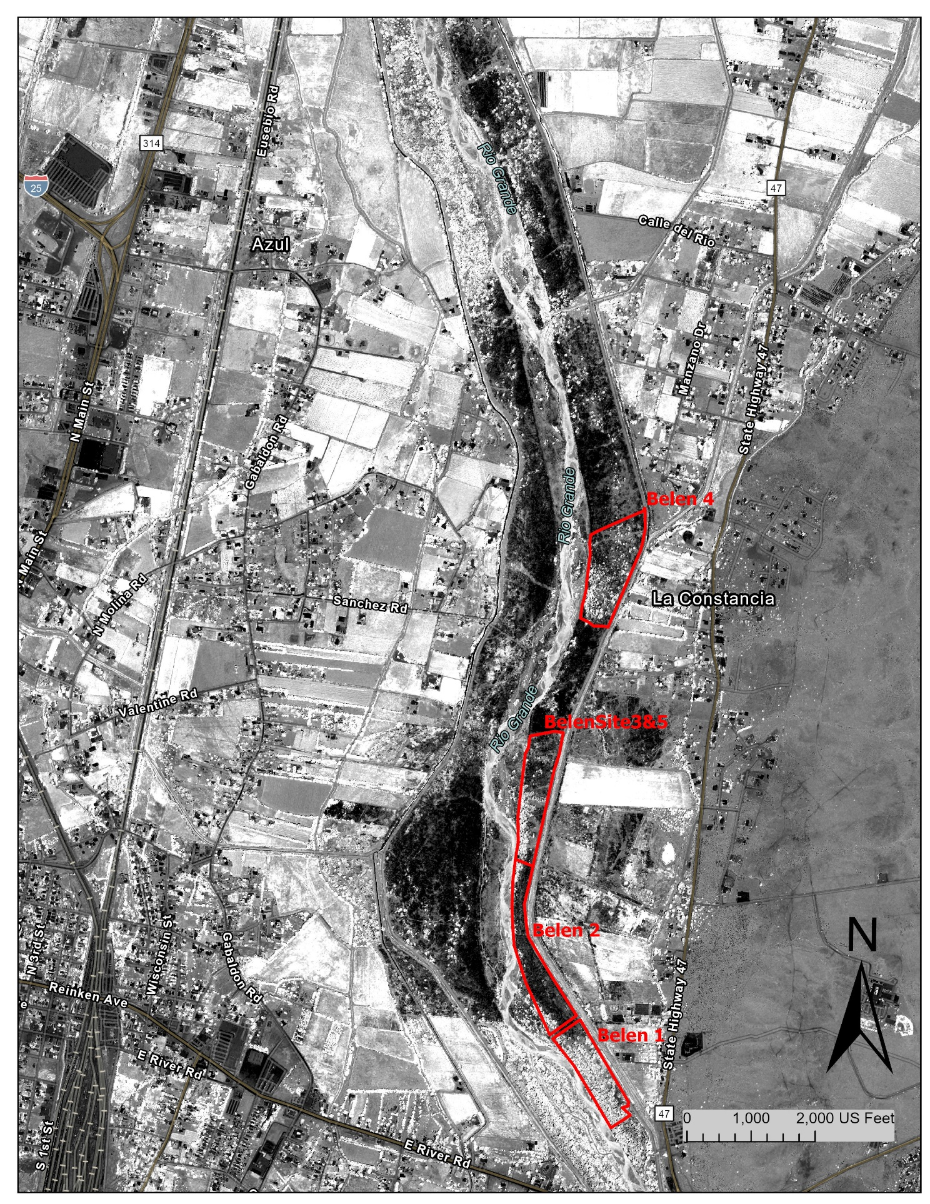
Figure 7. Normalized Difference Vegetation Index image. Imagery derived from 2022 NAIP imagery. Notice the large swathes of dark which are the burned areas, compared to Fig. 6 which was taken prior to the major fires.

Belen 1

Site Summary
2012 Belen 1 Site observations: The project area is moderately to heavily wooded, with a light to moderately dense, multi-tiered understory. It had been treated in the mid-2000s. Much of the area consists of grassy openings. Since monitoring was done so late in the fall, sparse forb and grasses cover may be attributed to seasonal dormancy. The plots were assessed to fall in Hink & Ohmart Structure Classes 1, 2, and 6.

2016 Belen 1 Site observations: This project had several open areas supporting yerba mansa communities. The southern boundary was clearly marked by a solid wall of salt cedar. Resprouts of target species (salt cedar, Russian olive, Siberian elm) were observed on plots 2, 5 and 6. The plots were assessed to fall in Hink and Ohmart Structure classes 3 and 4.

2023 Belen 1 Site Observations: The project site was not involved in the recent fire and was thick with understory vegetation. This site recorded the highest tree species diversity, which included the native F. neomexicana.

Belen_1 2012 & 2023

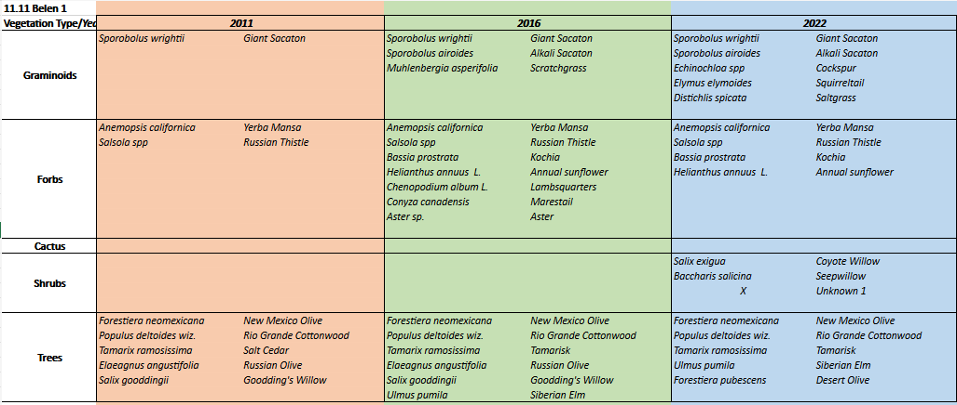
Observed plant species

The majority of the “new” plants observed in 2016 were native species, although kochia and Siberian elm also joined the mix. The target species found in 2012, Russian olive and salt cedar, were still present in 2016, as resprouts. In both years, identification of forb, grasses and some shrub species was impacted by both the plant identification skills of the monitoring team and by the season.
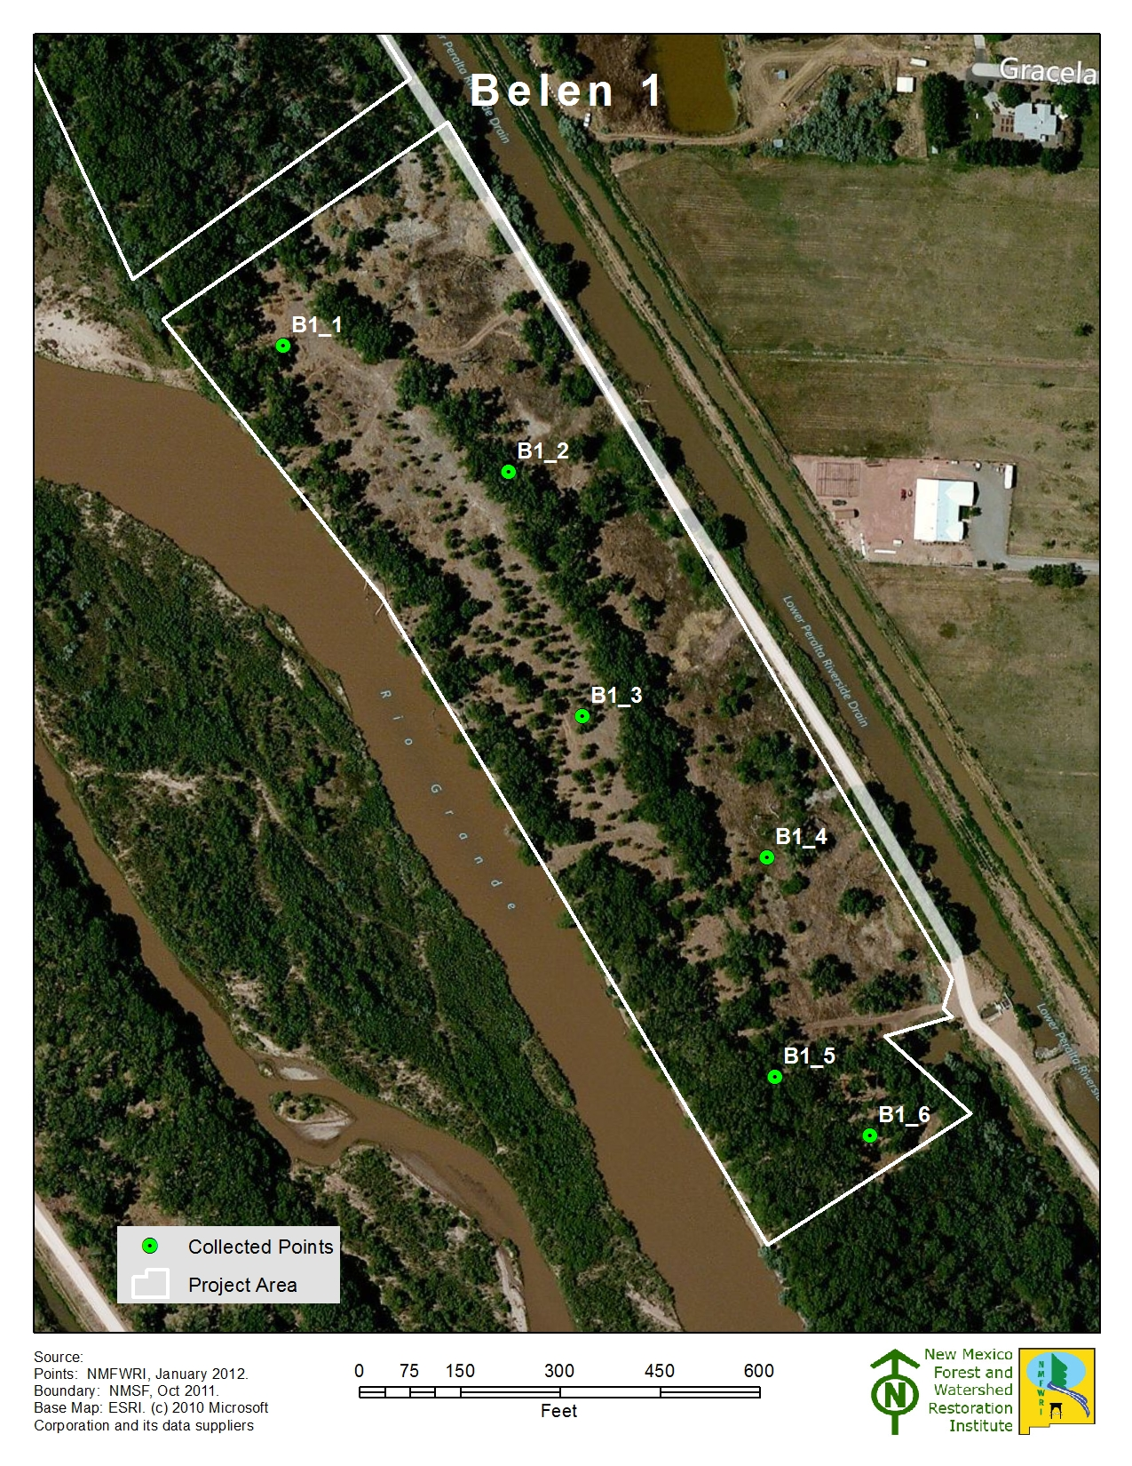
Figure 8. Belen 1 plots.

Tree Component
The tree component consists of data collected on the 1/10 acre plot Measurements of tree’s diameter at breast height (DBH), height, live crown base height, condition (live, sick or dead), and any significant mistletoe damage. We analyze tree density using Trees Per Acre (TPA) and basal density Basal Area Per Acre (BA/AC). Of note is the high density of native F. neomexicana.
Figure 10. Displays average saplings per acre for the entire project separated by species.
Figure 9. Displays average individual trees, seedlings and saplings, for the entire project.
Belen 1 11.15 |  |  |  |  | December 2022
Individual Plot Summary Table
Macro Plot Name | Total number of sample trees on plot |  | Growing Stock
 |  |  | Number of growing stock sample trees on plot |  |  |  | Trees per Acre | Basal Area per Acre
11.11_1 | 6 |  | 6 |  |  |  | 60 | 52.90
11.11_2 | 7 |  | 7 |  |  |  | 70 | 166.40
11.11_3 | 10 |  | 10 |  |  |  | 100 | 39.38
11.11_4 | 1 |  | 1 |  |  |  | 10 | 3.67
11.11_5 | 16 |  | 16 |  |  |  | 160 | 214.00
11.11_6 | 3 |  | 2 |  |  |  | 20 | 48.17
Total | Total number of sample trees on plot | Number of growing stock sample trees on plot |  | Average for all Plots
 |  |  |  | TPA |  | BA/AC
 | 43.00 | 42.00 |  | 70.00 |  | 87.42
Table 1. Displays the Stand Table summaries for each plot within the project. Stand tables are used by foresters to interpret tree data in an understandable format.
Understory and Bosque Floor Components
As described above, percent ground cover was estimated at each plot within the 1/100th acre subplot. Total aerial cover may exceed 100% due to vegetation stacking on top of each other. Of note is the increase in tree canopy and graminoid cover and reduction in litter cover.
Figure 11. Displays the average aerial cover for the entire project.
Figure 12. Displays the average aerial cover for the entire project.
Project: Valencia SWCD Project Unit: Belen 1 Plot: 11.11_1
11.11_1 Aerial & Ground Cover
 | Aerial cover
Year | Tree Canopy | Seedlings <5 | Saplings 5-15' | Shrubs <5 | Shrubs-Saplings 5-15' | Graminoid | Forb
2012 | 48% | 1% | 0% | 0% | 2% | 0% | 3%
2016 | 38% | 0% | 0% | 0% | 0% | 5% | 15%
2023 | 59% | 0% | 0% | 7% | 0% | 40% | 3%

 | Ground cover
Year | Litter | Bare soil | Rock | Gravel | Water or wet soil | Plant basal area
2012 | 95% | 2% | 0% | 0% | 0%
2016 | 95% | 4% | 0% | 0% | 0% | 1%
2023 | 90% | 1% | 0% | 0% | 0% | 9%

-------------------------------------------------------------------------------------------------------------------------------------------
2012 Hink & Ohmart Type: 2
2016 Hink & Ohmart Type: 4 2016 Modified Hink & Ohmart Type: 2
2023 Hink & Ohmart Type: 4 2023 Modified Hink & Ohmart Type: 2
-----------------------------------------------------------------------------------------------------------------------------------------
2012 Comments: None.
2016 Comments: BEMP plots visible on-site.
2023 Comments: Open grassy area with scattered charred cottonwood snags, cottonwoods to the east, dense sunflowers to the north, and a thick layer of litter all around.

Project: Valencia SWCD Project Unit: Belen 1 Plot: 11.11_2
11.11_2 Aerial & Ground Cover
 | Aerial cover
Year | Tree Canopy | Seedlings <5 | Saplings 5-15' | Shrubs <5 | Shrubs-Saplings 5-15' | Graminoid | Forb
2012 | 79% | 0% | 0% | 0% | 0% | 0% | 10%
2016 | 76% | 0% | 10% | 0% | 0% | 5% | 5%
2023 | 86% | 1% | 0% | 0% | 15% | 0% | 0%

 | Ground cover
Year | Litter | Bare soil | Rock | Gravel | Water or wet soil | Plant basal area
2012 | 89% | 1% | 0% | 0% | 0% | n/a
2016 | 90% | 0% | 0% | 0% | 0% | 10%
2023 | 80% | 0% | 0% | 0% | 0% | 20%

-------------------------------------------------------------------------------------------------------------------------------------------
2012 Hink & Ohmart Type: 2
2016 Hink & Ohmart Type: 3 2016 Modified Hink & Ohmart Type: 1
2023 Hink & Ohmart Type: 3 2023 Modified Hink & Ohmart Type: 5
-----------------------------------------------------------------------------------------------------------------------------------------
2012 Comments: None.
2016 Comments: None.
2023 Comments: In the north a canal runs in the background with NM olive and cottonwoods dominating vegetation. Cottonwoods and NM olive also dominate the rest of the area, with some russian olive in the west.

Project: Valencia SWCD Project Unit: Belen 1 Plot: 11.11_3
11.11_3 Aerial & Ground Cover
 | Aerial cover
Year | Tree Canopy | Seedlings <5 | Saplings 5-15' | Shrubs <5 | Shrubs-Saplings 5-15' | Graminoid | Forb
2012 | 59% | 0% | 5% | 0% | 0% | 0% | 2%
2016 | 56% | 0% | 0% | 0% | 0% | 0% | 5%
2023 | 76% | 0% | 10% | 0% | 0% | 0% | 0%

 | Ground cover
Year | Litter | Bare soil | Rock | Gravel | Water or wet soil | Plant basal area
2012 | 96% | 2% | 0% | 0% | 0% | n/a
2016 | 95% | 0% | 0% | 0% | 0% | 5%
2023 | 95% | 0% | 0% | 0% | 0% | 5%

-------------------------------------------------------------------------------------------------------------------------------------------
2012 Hink & Ohmart Type: 2
2016 Hink & Ohmart Type: 4 2016 Modified Hink & Ohmart Type: 2
2023 Hink & Ohmart Type: 3 2023 Modified Hink & Ohmart Type: 5
-----------------------------------------------------------------------------------------------------------------------------------------
2012 Comments: large down woody debris; masticated & mulched material present
2016 Comments: open plot, near road
2023 Comments: Open cottonwood canopy with an understory of kochia, sunflowers, and thick leaf litter.

Project: Valencia SWCD Project Unit: Belen 1 Plot: 11.11_4
11.11_4 Aerial & Ground Cover
 | Aerial cover
Year | Tree Canopy | Seedlings <5 | Saplings 5-15' | Shrubs <5 | Shrubs-Saplings 5-15' | Graminoid | Forb
2012 | 26% | 0% | 0% | 0% | 0% | 0% | 95%
2016 | 12% | 0% | 5% | 0% | 0% | 0% | 75%
2023 | 31% | 0% | 0% | 0% | 0% | 15% | 10%

 | Ground cover
Year | Litter | Bare soil | Rock | Gravel | Water or wet soil | Plant basal area
2012 | 5% | 0% | 0% | 0% | 0% | n/a
2016 | 90% | 0% | 0% | 0% | 0% | 10%
2023 | 5% | 0% | 0% | 0% | 0% | 95%

-------------------------------------------------------------------------------------------------------------------------------------------
2012 Hink & Ohmart Type: 2/6
2016 Hink & Ohmart Type: 4 2016 Modified Hink & Ohmart Type: 2
2023 Hink & Ohmart Type: 6 2023 Modified Hink & Ohmart Type: 6H
-----------------------------------------------------------------------------------------------------------------------------------------
2012 Comments: None.
2016 Comments: Abundant circles of yerba mansa.
2023 Comments: Dense yerba mansa and grass, with a dirt pile covered in kochia with road in background to the west, elms to the south.

Project: Valencia SWCD Project Unit: Belen 1 Plot: B1_5
11.11_5 Aerial & Ground Cover
 | Aerial cover
Year | Tree Canopy | Seedlings <5 | Saplings 5-15' | Shrubs <5 | Shrubs-Saplings 5-15' | Graminoid | Forb
2012 | 85% | 0% | 0% | 2% | 8% | 5% | 3%
2016 | 78% | 0% | 5% | 0% | 0% | 0% | 0%
2023 | 95% | 0% | 5% | 0% | 0% | 0% | 0%

 | Ground cover
Year | Litter | Bare soil | Rock | Gravel | Water or wet soil | Plant basal area
2012 | 91% | 1% | 0% | 0% | 0% | n/a
2016 | 95% | 0% | 0% | 0% | 0% | 5%
2023 | 92% | 3% | 0% | 0% | 0% | 5%

-------------------------------------------------------------------------------------------------------------------------------------------
2012 Hink & Ohmart Type: 1
2016 Hink & Ohmart Type: 3 2016 Modified Hink & Ohmart Type: 1
2023 Hink & Ohmart Type: 3 2023 Modified Hink & Ohmart Type: 1
-----------------------------------------------------------------------------------------------------------------------------------------
2012 Comments: None.
2016 Comments: BEMP pipes on plots; lots of leaf litter.
2023 Comments: PC moved one chain on an azimuth of 260.

Project: Valencia SWCD Project Unit: Belen 1 Plot: 11.11_6
11.11_6 Aerial & Ground Cover
 | Aerial cover
Year | Tree Canopy | Seedlings <5 | Saplings 5-15' | Shrubs <5 | Shrubs-Saplings 5-15' | Graminoid | Forb
2012 | 63% | 0% | 0% | 0% | 0% | 8% | 3%
2016 | 62% | 0% | 0% | 0% | 0% | 10% | 10%
2023 | 48% | 0% | 0% | 0% | 0% | 2% | 3%

 | Ground cover
Year | Litter | Bare soil | Rock | Gravel | Water or wet soil | Plant basal area
2012 | 89% | 0% | 0% | 0% | 0% | n/a
2016 | 85% | 10% | 0% | 0% | 0% | 5%
2023 | 99% | 0% | 0% | 0% | 0% | 1%

-------------------------------------------------------------------------------------------------------------------------------------------
2012 Hink & Ohmart Type: 1/2
2016 Hink & Ohmart Type: 3 2016 Modified Hink & Ohmart Type: 6
2023 Hink & Ohmart Type: 2 2023 Modified Hink & Ohmart Type: 2
-----------------------------------------------------------------------------------------------------------------------------------------
2012 Comments: None.
2016 Comments: Old road present but not used recently, except perhaps by ORV for recreation. Wall of tall untreated salt cedar to the southwest of the plot.
2023 Comments: Bunchgrasses and fallen woody debris dominate the understory, with a Russian olive thicket to the west and tamarisk to the north, with mature cottonwoods creating an open canopy. A road runs west of the plot.

Belen 2

Site Summary
2012 Belen 2 Site observations: The project area is densely wooded, with an abundance of fallen trees and tree limbs. No shrubs or herbaceous plants were observed in the understory. The site does not show evidence of having been treated. Jetty jacks, joined by cables, also traverse the site in the vicinity of plot B2_1. Since monitoring was done so late in the fall, lack of forb and grasses cover may be attributed to seasonal dormancy. The dense overstory canopy and large amount of coarse woody debris may also contribute to the sparse understory. The plots were assessed to fall in Hink & Ohmart Structure Class 2.

2016 Belen 2 Site observations: This project area was fairly open, with some cottonwood overstory and very little woody understory. Plots 1 and 2 had lots of down wood debris and cottonwood leaves; plots 3 and 4 had lots of kochia which made travel difficult and/or unpleasant. Jetty jacks are present throughout this project, some mostly buried and others full of limbs and debris. A lack of grass may be related to the seasonality, but more likely has to do with the heavy ground cover by other materials. The plots were assessed to fall in Hink and Ohmart classes 2, 4 and 6.
2022 Belen 2 Site observation: The project site was heavily burned from a recent fire. There was little litter coverage and many of the cottonwoods were resprouting. The site had levee jacks in place and was near to the Rio Grande.

Belen_2 2012-2022

Observed plant species

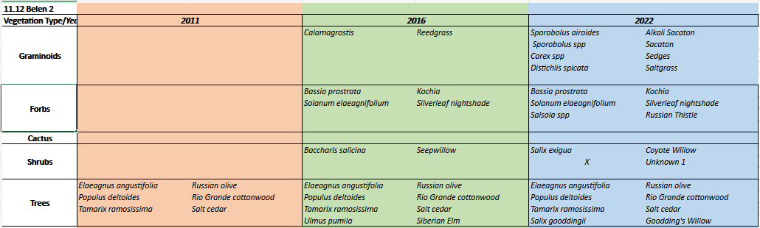
At least two of the “new” plants observed in 2016 were native species; two or three were exotics including kochia and Siberian elm (the nativity status of reed grass is not clear). The target species found in 2012, Russian olive and salt cedar, were still present in 2016, as resprouts. In both years, identification of forb, grasses and some shrub species were impacted by both the plant identification skills of the monitoring team and by the season.
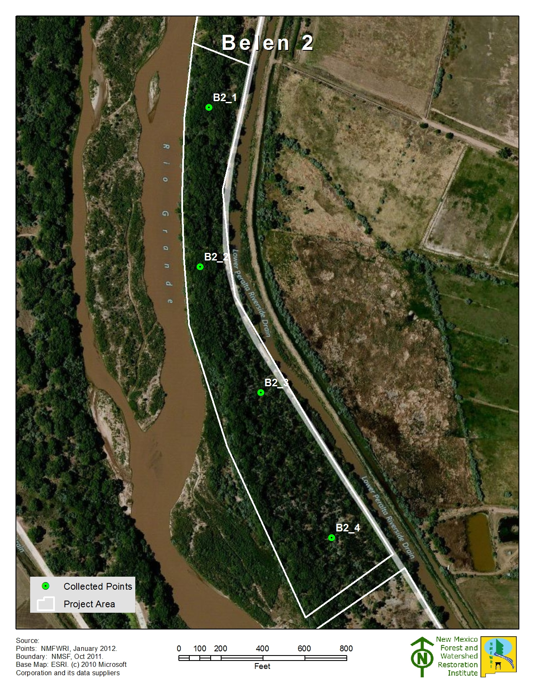
Figure 9. Belen 2 plots.

Tree Component
The tree component consists of data collected on the 1/10 acre plot Measurements of tree’s diameter at breast height (DBH), height, live crown base height, condition (live, sick or dead), and any significant mistletoe damage. We analyze tree density using Trees Per Acre (TPA) and basal density Basal Area Per Acre (BA/AC).

Figure 11. Displays the average trees per acre by species.
Figure 10. Displays the average trees, seedlings and saplings per acre for the entire project.
11.12 Belen 2 |  |  |  | 2022/2023
Individual Plot Summary Table
Macro Plot Name | Total number of sample trees on plot | Growing Stock
 |  | Number of growing stock sample trees on plot | Trees per Acre |  | Basal Area per Acre
11.12_1 | 7 | 7 | 70 |  | 150.67
11.12_2 | 14 | 14 | 140 |  | 224.27
11.12_3 | 2 | 2 | 20 |  | 40.22
11.12_4 | 1 | 1 | 10 |  | 29.36
Total | Total number of sample trees on plot | Number of growing stock sample trees on plot | Average for all Plots
 |  |  | TPA |  | BA/AC
 | 24.00 | 24.00 | 60.00 |  | 111.13
Table 2. Displays the Stand Table summaries for each plot within the project. Stand tables are used by foresters to interpret tree data in an understandable format.
Understory and Bosque Floor Components
As described above, percent ground cover was estimated at each plot within the 1/100th acre subplot. Total aerial cover may exceed 100% due to vegetation stacking on top of each other. A big drop in canopy cover was seen between 2012 and 2023. Of note is the appearance and disappearance of forbs. Within the ground cover measurements, litter coverage reduced by a large amount and bare soil increased from 4 to 82% seen in figure 7.
Figure 13. Displays average aerial cover for the entire project.
Figure 12. Displays average aerial cover for the entire project.
Project: Valencia SWCD Project Unit: Belen 2 Plot: 11.12_1
11.12_1 Aerial & Ground Cover
 | Aerial Cover
Year | Tree Canopy | Seedlings <5 | Saplings 5-15' | Shrubs <5 | Shrubs-Saplings 5-15' | Graminoid | Forb
2012 | 96% | 0% | 0% | 0% | 0% | 0% | 0%
2016 | 92% | 0% | 0% | 0% | 0% | 0% | 0%
2023 | 79% | 0% | 5% | 0% | 0% | 1% | 2%

 | Ground Cover
Year | Litter | Bare soil | Rock | Gravel | Water or wet soil | Plant basal area
2012 | 100% | 0% | 0% | 0% | 0% | n/a
2016 | 100% | 0% | 0% | 0% | 0% | 0%
2023 | 20% | 78% | 0% | 0% | 0% | 2%

-------------------------------------------------------------------------------------------------------------------------------------------
2012 Hink & Ohmart Type: 2
2016 Hink & Ohmart Type: 2 2016 Modified Hink & Ohmart Type: 2
2023 Hink & Ohmart Type: 2 2023 Modified Hink & Ohmart Type: 2
-----------------------------------------------------------------------------------------------------------------------------------------
2012 Comments: Heavy down woody debris; jetty jacks present.
2016 Comments: Heavy litter cover with very little vegetation; jetty jacks present, full of branches and wrack.
2023 Comments: Levy jacks and an open understory characterize this site. Cottonwoods and russian olive dominate the canopy and understory of the western side.

Project: Valencia SWCD Project Unit: Belen 2 Plot: 11.12_2
11.12_2 Aerial & Ground Cover
 | Aerial Cover
Year | Tree Canopy | Seedlings <5 | Saplings 5-15' | Shrubs <5 | Shrubs-Saplings 5-15' | Graminoid | Forb
2012 | 96% | 0% | 0% | 0% | 0% | 0% | 0%
2016 | 92% | 0% | 0% | 0% | 0% | 3% | 0%
2023 | 95% | 0% | 0% | 0% | 0% | 0% | 0%

 | Ground Cover
Year | Litter | Bare soil | Rock | Gravel | Water or wet soil | Plant basal area
2012 | 100 | 0 | 0 | 0 | 0 | n/a
2016 | 95% | 5% | 0% | 0% | 0% | 1%
2023 | 15% | 85% | 0% | 0% | 0% | 0%

-------------------------------------------------------------------------------------------------------------------------------------------
2012 Hink & Ohmart Type: 2
2016 Hink & Ohmart Type: 4 2016 Modified Hink & Ohmart Type: 2
2023 Hink & Ohmart Type: 2 2023 Modified Hink & Ohmart Type: 2
-----------------------------------------------------------------------------------------------------------------------------------------
2012 Comments: Heavy down woody debris; jetty jacks present. Densiometer was lost so canopy cover was estimated.
2016 Comments: There appears to be an old trail through the plot; jetty jacks are present but mostly buried. Plot is near the river; there is very little vegetation and lots of cover by woody debris and leaves.
2023 Comments: North, east and south are characterized by charred open terrain with cottonwood, russian olive, and tamarisk resprouts. Very open canopy. To the west is the Rio Grande. The sandhill cranes are wonderful this time of year.

Project: Valencia SWCD Project Unit: Belen 2 Plot:11.12_3
11.12_3 Aerial & Ground Cover
 | Aerial cover
Year | Tree Canopy | Seedlings <5 | Saplings 5-15' | Shrubs <5 | Shrubs-Saplings 5-15' | Graminoid | Forb
2012 | 96% | 0% | 6% | 0% | 0% | 0% | 0%
2016 | 34% | 0% | 0% | 0% | 0% | 0% | 100%
2023 | 28% | 0% | 0% | 0% | 0% | 45% | 0%

 | Ground cover
Year | Litter | Bare soil | Rock | Gravel | Water or wet soil | Plant basal area
2012 | 100% | 0% | 0% | 0% | 0% | n/a
2016 | 95% | 0% | 0% | 0% | 0% | 5%
2023 | 1% | 69% | 0% | 0% | 0% | 30%

-------------------------------------------------------------------------------------------------------------------------------------------
2012 Hink & Ohmart Type: 2
2016 Hink & Ohmart Type: 4 2016 Modified Hink & Ohmart Type: 2
2023 Hink & Ohmart Type: 5 2023 Modified Hink & Ohmart Type: 5
-----------------------------------------------------------------------------------------------------------------------------------------
2012 Comments: Heavy down woody debris; jetty jacks present. Densiometer was lost so canopy cover was estimated. Old hummingbird nest found on-site.
2016 Comments: This plot was covered in 6-foot-tall kochia and heavy down woody debris (cottonwoods). Finding flags for plot, and even walking through the plot, was difficult.
2023 Comments: Open cottonwood canopy with many burned cottonwoods and willow. Silverleaf nightshade and saltgrass grow in dense patches.

Project: Valencia SWCD Project Unit: Belen 2 Plot: 11.12_4
11.12_4 Aerial & Ground Cover
 | Aerial cover
Year | Tree Canopy | Seedlings <5 | Saplings 5-15' | Shrubs <5 | Shrubs-Saplings 5-15' | Graminoid | Forb
2012 | 60% | 0% | 6% | 0% | 0% | 0% | 0%
2016 | 6% | 0% | 0% | 0% | 0% | 0% | 90%
2023 | 8% | 5% | 0% | 0% | 0% | 0% | 0%

 | Ground cover
Year | Litter | Bare soil | Rock | Gravel | Water or wet soil | Plant basal area
2012 | 99% | 1% | 0% | 0% | 0% | n/a
2016 | 85% | 10% | 0% | 0% | 0% | 5%
2023 | 3% | 96% | 0% | 0% | 0% | 1%

-------------------------------------------------------------------------------------------------------------------------------------------
2012 Hink & Ohmart Type: 2
2016 Hink & Ohmart Type: 4/6 2016 Modified Hink & Ohmart Type: 6H
2023 Hink & Ohmart Type: 6 2023 Modified Hink & Ohmart Type: 6H
-----------------------------------------------------------------------------------------------------------------------------------------
2012 Comments: Heavy down woody debris; jetty jacks present. Densiometer was lost so canopy cover was estimated. Cottonwood snags present.
2016 Comments: Russian olive slash present on-site; one crew member got Russian olive thorns in his foot through the sole of his boot. The plot was covered in kochia plants 2-4 feet tall; difficult walking.
2023 Comments: Open bare ground with many young cottonwood trees resprouting. Burned russian olive and tamarisk trees in the east and west respectively.

Belen 3

Site Summary
2012 Belen 3 Site Observations: The project area is moderately wooded, with a light multi-tiered to mostly open, understory. Wetland areas exist in the northern portion of the project area. It had been treated in the mid-2000s. Much of the area consists of grassy openings. Since monitoring was done so late in the fall, sparse forb and grasses cover may be attributed to seasonal dormancy. The plots were assessed to fall in Hink & Ohmart Structure Classes 1, 2, and 3.
2016 Belen 3 Site Observations: This project has a relatively open cottonwood overstory, with many small to midsized Russian olives, as well as a variety of grasses, in the understory. Yerba mansa is also present in the vicinity of plot 3. The plots were assessed to fall into Hink and Ohmart class 4.
2023 Belen 3 Site Observations: The site was very burned from a recent fire and many of the cottonwoods had resprouts around their bases but many are not expected to live long. The site was otherwise open. Without foliage it was difficult to tell whether the cottonwood’s canopy’s were charred in the fire.

Belen_3 2012-2023

Observed plant species
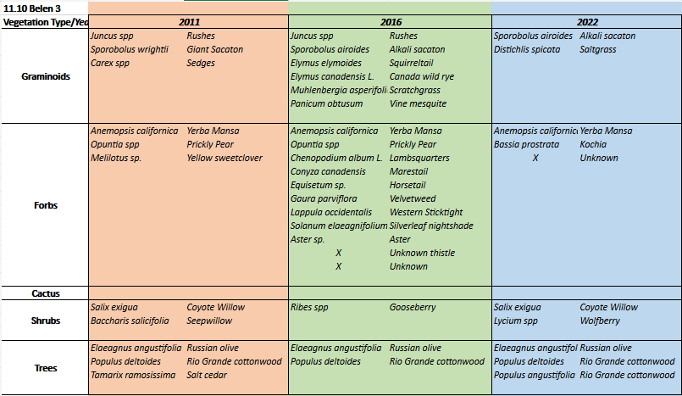

All 13 of the “new” plants identified in 2016 were additional native species; two species were found, including a thistle, which could not be identified. The 2012 target species found on plot, Russian olive and salt cedar, saw mixed results: salt cedar was not observed in 2016, but Russian olive resprouts were. In both years, identification of forb, grasses and some shrub species was impacted by both the plant identification skills of the monitoring team and by the season. In 2023 identification was limited due to the time of year. Less forbs were observed on the project possibly due to a recent fire.

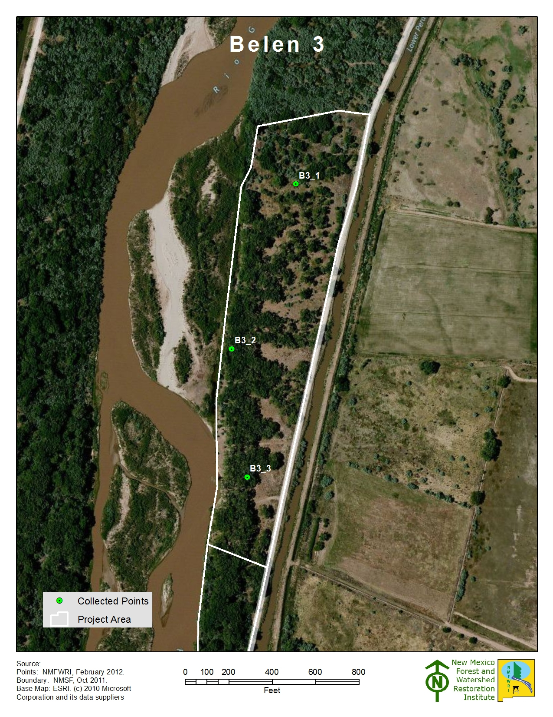
Figure 14. Belen 3 plots.

Tree Component
The tree component consists of data collected on the 1/10 acre plot Measurements of tree’s diameter at breast height (DBH), height, live crown base height, condition (live, sick or dead), and any significant mistletoe damage. We analyze tree density using Trees Per Acre (TPA) and basal density Basal Area Per Acre (BA/AC). Many of the trees were charred or completely burned.

Figure 16. Displays the average seeding density for the entire project, by species.
Figure 15. Displays the averages for Individual tree, seedling and saplings for the entire project
11.10 Belen 3 |  |  |  | January 2023
Individual Plot Summary Table
Macro Plot Name | Total number of sample trees on plot | Growing Stock
 |  | Number of growing stock sample trees on plot | Trees per Acre |  | Basal Area per Acre
11.10_1 | 0 | 0 | 0 |  | 0.00
11.10_2 | 20 | 20 | 200 |  | 230.79
11.10_3 | 16 | 16 | 160 |  | 291.36
Total | Total number of sample trees on plot | Number of growing stock sample trees on plot | Average for all Plots
 |  |  | TPA |  | BA/AC
 | 36.00 | 36.00 | 120.00 |  | 174.05
Table 3. Displays the Stand Table summaries for each plot

Understory and Bosque Floor Components
As described above, percent ground cover was estimated at each plot within the 1/100th acre subplot. Total aerial cover may exceed 100% due to vegetation stacking on top of each other. Of note is the decrease in litter cover and increase in bare soil, this is probably due to the recent burn that took place, eliminating much of the litter.

Figure 18. Displays the average ground cover for the entire project
Figure 17. Displays the average aerial cover for the entire project
Project: Valencia SWCD Project Unit: Belen 3 Plot: 11.10_1
11.10_1 Aerial & Ground Cover
 | Aerial cover
Year | Tree Canopy | Seedlings <5 | Saplings 5-15' | Shrubs <5 | Shrubs-Saplings 5-15' | Graminoid | Forb
2012 | 10% | 0% | 0% | 0% | 5% | 87% | 5%
2016 | 56% | 2% | 3% | 3% | 0% | 80% | 10%
2023 | 8% | 1% | 0% | 1% | 0% | 95% | 5%

 | Ground cover
Year | Litter | Bare soil | Rock | Gravel | Water or wet soil | Plant basal area
2012 | 8% | 0% | 0% | 0% | 0% | n/a
2016 | 75% | 0% | 0% | 0% | 0% | 25%
2023 | 2% | 0% | 0% | 0% | 0% | 98%

-------------------------------------------------------------------------------------------------------------------------------------------
2012 Hink & Ohmart Type: 2/3
2016 Hink & Ohmart Type: 4 2016 Modified Hink & Ohmart Type: 2/6W
2023 Hink & Ohmart Type: 6 2023 Modified Hink & Ohmart Type: 6H
-----------------------------------------------------------------------------------------------------------------------------------------
2012 Comments: Transition area between Hink & Ohmart types 2 and 3; wetland area; gophers present.
2016 Comments: None.
2023 Comments: The north and east side have dense russian olive with open grassy areas between thickets. Otherwise, the site is open and grassy with cottonwoods and russian olive scattered. Alkali sacaton resides in the empty open spaces between trees.

Project: Valencia SWCD Project Unit: Belen 3 Plot: 11.10_2
11.10_2 Aerial & Ground Cover
 | Aerial cover
Year | Tree Canopy | Seedlings <5 | Saplings 5-15' | Shrubs <5 | Shrubs-Saplings 5-15' | Graminoid | Forb
2012 | 95% | 0% | 0% | 0% | 0% | 1% | 1%
2016 | 68% | 10% | 0% | 0% | 0% | 15% | 15%
2023 | 85% | 0% | 5% | 0% | 0% | 3% | 0%

 | Ground cover
Year | Litter | Bare soil | Rock | Gravel | Water or wet soil | Plant basal area
2012 | 91% | 7% | 0% | 0% | 0% | n/a
2016 | 60% | 10% | 0% | 0% | 0% | 30%
2023 | 25% | 72% | 0% | 0% | 0% | 3%

-------------------------------------------------------------------------------------------------------------------------------------------
2012 Hink & Ohmart Type: 1
2016 Hink & Ohmart Type: 4 2016 Modified Hink & Ohmart Type: 2
2023 Hink & Ohmart Type: 3 2023 Modified Hink & Ohmart Type: 2
-----------------------------------------------------------------------------------------------------------------------------------------
2012 Comments: Porcupine sign; old beaver sign.
2016 Comments: Old beaver sign (large stumps) on plot; lots of down woody debris.
2023 Comments: Open canopy with russian olive sitting underneath cottonwoods, with sporobolus in the understory. To the west is an open grassy embankment, and the Rio Grande beyond.

Project: Valencia SWCD Project Unit: Belen 3 Plot: 11.10_3
11.10_3 Aerial & Ground Cover
 | Aerial cover
Year | Tree Canopy | Seedlings <5 | Saplings 5-15' | Shrubs <5 | Shrubs-Saplings 5-15' | Graminoid | Forb
2012 | 93% | 0% | 0% | 0% | 0% | 4% | 0%
2016 | 72% | 0% | 0% | 1% | 0% | 20% | 5%
2023 | 80% | 0% | 0% | 0% | 0% | 3% | 1%

 | Ground cover
Year | Litter | Bare soil | Rock | Gravel | Water or wet soil | Plant basal area
2012 | 94% | 2% | 0% | 0% | 0% | n/a
2016 | 80% | 15% | 0% | 0% | 0% | 5%
2023 | 70% | 30% | 0% | 0% | 0% | 3%

-------------------------------------------------------------------------------------------------------------------------------------------
2012 Hink & Ohmart Type: 2
2016 Hink & Ohmart Type: 4 2016 Modified Hink & Ohmart Type: 2
2023 Hink & Ohmart Type: 2 2023 Modified Hink & Ohmart Type: 2
-----------------------------------------------------------------------------------------------------------------------------------------
2012 Comments: Very open understory.
2016 Comments: This is the nearest plot to the river; also near the road. This site has lots of bare ground and trash.
2023 Comments: Open terrain, with a forked cottonwood to the north and a patch of russian thistle to the east. There is a dirt mound to the south and the Rio Grande to the west?

Belen 4

Site Summary
2012 Belen 4 Site Observations: The project area is moderately to lightly wooded, with a light multi-tiered to mostly open, understory. Wetland areas exist in the northern portion of the project area. It had been treated in the mid-2000s. Much of the area consists of grassy openings and scattered trees and shrubs. The soil is moist in some areas. Portions of the area are sandy with hummocks and salt on the surface. There is evidence of possible historic stream channels. Since monitoring was done so late in the fall, sparse forb and grasses cover may be attributed to seasonal dormancy. The plots were assessed to fall in Hink & Ohmart Structure Classes 2, 5, and 6.

2016 Belen 4 Site Observations: This project has a tall cottonwood overstory with a more open understory, although tall grasses have become a noticeable part of the community. Jetty jacks were found on plots 1 and 3. Otherwise bare areas are covered in cottonwood duff. Plots were assessed to fall into Hink and Ohmart class 4.

2023 Belen 4 Site Observations: The project area was open and grassy between scattered cottonwoods and levee jacks. Wolfberry and phragmites were in the understory in plot 1. Living and burned cottonwoods and tamarisk were scattered across the plot making the canopy open, with kochia and bunchgrasses constituting the understory in plot 2. Open grassy terrain with charred logs and trees in Plot 3. There were also tamarisk re-sprouts on the east side of the plot. Levee jacks were present on the south side and a stand of cottonwoods with a grassy understory in the west.

Belen_4 2012-2023

Observed plant species
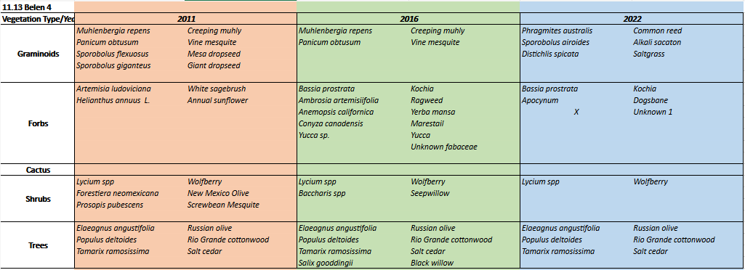

The majority of the “new” plants identified in 2016 were additional native species; kochia and ravennagrass also joined the community as exotics, although it is likely ravennagrass was simplify misidentified in 2012. One species was not identified. The 2012 target species found on plot, Russian olive and salt cedar, were both still present post-treatment as resprouts. In both years, identification of forb, grasses and some shrub species was impacted by both the plant identification skills of the monitoring team and by the season. In 2023 there were less forbs and shrubs encounter, possibly due to the recent fire in the area. The persistence of exotic species such as E. angustifolia and T. ramosissima were noted and their average trees per acre calculation was 400 and 233 respectively.
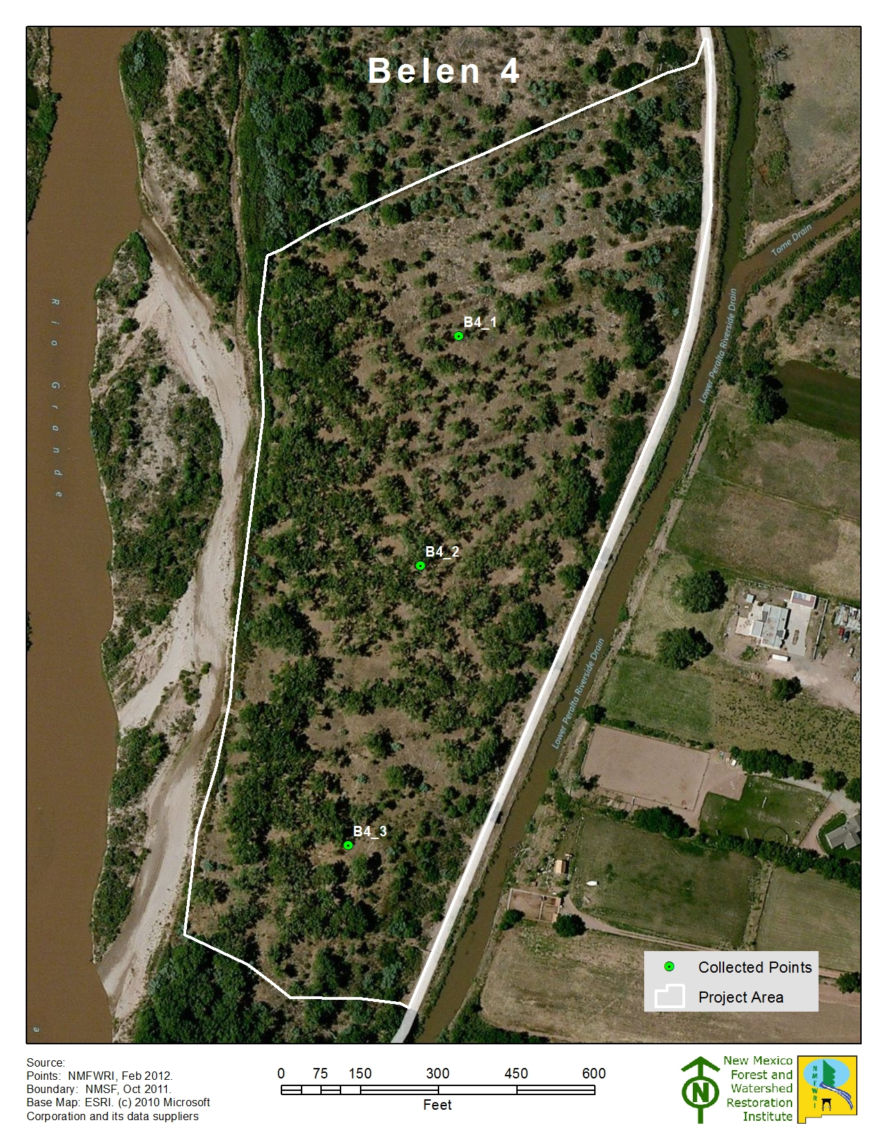
Figure 19. Belen 4 plots.

Tree Component
The tree component consists of data collected on the 1/10 acre plot Measurements of tree’s diameter at breast height (DBH), height, live crown base height, condition (live, sick or dead), and any significant mistletoe damage. We analyze tree density using Trees Per Acre (TPA) and basal density Basal Area Per Acre (BA/AC). The high density of seedlings might be the result of the burn. Resprouts of P. deltoids sbp. Wislizeni and Salix spp. were observed throughout the project.

Figure 21. Displays the average seedling species per acre for the entire project.
Figure 20. Displays the average trees, seedlings and saplings per acre for the entire project
11.13 Belen 4 |  |  |  | January 2023
Individual Plot Summary Table
Macro Plot Name | Total number of sample trees on plot | Growing Stock
 |  | Number of growing stock sample trees on plot | Trees per Acre |  | Basal Area per Acre
11.13_1 | 6 | 6 | 60 |  | 47.17
11.13_2 | 11 | 10 | 100 |  | 97.22
11.13_3 | 3 | 3 | 30 |  | 28.03
Total | Total number of sample trees on plot | Number of growing stock sample trees on plot | Average for all Plots
 |  |  | TPA |  | BA/AC
 | 20.00 | 19.00 | 63.33 |  | 57.47
Table 4. Displays the Stand Table summaries for each plot
Understory and Bosque Floor Components
As described above, percent ground cover was estimated at each plot within the 1/100th acre subplot. Total aerial cover may exceed 100% due to vegetation stacking on top of each other. Bare soil increase between 2016 and 2023. Recently there was a fire within the project boundaries and this could explain the increase.
Figure 22. Displays average aerial cover for the entire project
Figure 23. Displays the average aerial cover for the entire project

Project: Valencia SWCD Project Unit: Belen 4 Plot: 11.13_1
11.13_1 Aerial & Ground Cover
 | Aerial cover
Year | Tree Canopy | Seedlings <5 | Saplings 5-15' | Shrubs <5 | Shrubs-Saplings 5-15' | Graminoid | Forb
2012 | 46% | 0% | 3% | 15% | 0% | 20% | 3%
2016 | 45% | 5% | 5% | 25% | 1% | 75% | 2%
2023 | 30% | 1% | 0% | 35% | 0% | 3% | 1%

 | Ground cover
Year | Litter | Bare soil | Rock | Gravel | Water or wet soil | Plant basal area
2012 | 69% | 8% | 0% | 0% | 0% | n/a
2016 | 50% | 5% | 0% | 0% | 0% | 45%
2023 | 5% | 85% | 0% | 0% | 0% | 10%

-------------------------------------------------------------------------------------------------------------------------------------------
2012 Hink & Ohmart Type: 2
2016 Hink & Ohmart Type: 4 2016 Modified Hink & Ohmart Type: 2
2023 Hink & Ohmart Type: 4 2023 Modified Hink & Ohmart Type: 2
-----------------------------------------------------------------------------------------------------------------------------------------
2012 Comments: Jetty jacks present on site. Very sandy with open hummocks and patches of salt crust.
2016 Comments: This plot is near and crossed by jetty jacks.
2023 Comments: Open and grassy areas between scattered cottonwoods and levee jacks, with wolfberry and phragmites in the understory.

Project: Valencia SWCD Project Unit: Belen 4 Plot: 11.13_2
11.13_2 Aerial & Ground Cover
 | Aerial cover
Year | Tree Canopy | Seedlings <5 | Saplings 5-15' | Shrubs <5 | Shrubs-Saplings 5-15' | Graminoid | Forb
2012 | 69% | 1% | 2% | 0% | 0% | 3% | 0%
2016 | 59% | 5% | 10% | 0% | 0% | 75% | 5%
2023 | 65% | 3% | 2% | 0% | 0% | 45% | 10%

 | Ground cover
Year | Litter | Bare soil | Rock | Gravel | Water or wet soil | Plant basal area
2012 | 96% | 1% | 0% | 0% | 0% | n/a
2016 | 60% | 5% | 0% | 0% | 0% | 35%
2023 | 60% | 3% | 0% | 0% | 0% | 37%

-------------------------------------------------------------------------------------------------------------------------------------------
2012 Hink & Ohmart Type: 2
2016 Hink & Ohmart Type: 4 2016 Modified Hink & Ohmart Type: 2
2023 Hink & Ohmart Type: 4 2023 Modified Hink & Ohmart Type: 2
-----------------------------------------------------------------------------------------------------------------------------------------
2012 Comments: Coarse woody debris; swale; possible old channel. Open understory.
2016 Comments: In photos, center photo was mislabeled on whiteboard.
2023 Comments: Living and burned cottonwoods and tamarisk are scattered across the plot forming a very open canopy, with kochia and bunchgrasses constituting the understory.

Project: Valencia SWCD Project Unit: Belen 4 Plot: 11.13_3
11.13_3 Aerial & Ground Cover
 | Aerial cover
Year | Tree Canopy | Seedlings <5 | Saplings 5-15' | Shrubs <5 | Shrubs-Saplings 5-15' | Graminoid | Forb
2012 | 36% | 1% | 0% | 0% | 0% | 90% | 0%
2016 | 48% | 0% | 0% | 0% | 0% | 80% | 5%
2023 | 32% | 0% | 0% | 0% | 0% | 90% | 0%

 | Ground cover
Year | Litter | Bare soil | Rock | Gravel | Water or wet soil | Plant basal area
2012 | 10% | 0% | 0% | 0% | 0% | n/a
2016 | 80% | 5% | 0% | 0% | 0% | 15%
2023 | 85% | 5% | 0% | 0% | 0% | 10%

-------------------------------------------------------------------------------------------------------------------------------------------
2012 Hink & Ohmart Type: 2/5/6
2016 Hink & Ohmart Type: 4 2016 Modified Hink & Ohmart Type: 2
2023 Hink & Ohmart Type: 6 2023 Modified Hink & Ohmart Type: 6H
-----------------------------------------------------------------------------------------------------------------------------------------
2012 Comments: Transition area between Hink and Ohmart classes. Swale/wetland area with possible historic channels; generally damp soil.
2016 Comments: More open than other plots.
2023 Comments: Open grassy terrain with charred logs and trees, tamarisk resprouts in the east side. Levee jacks present on the south side and a stand of cottonwoods with a grassy understory in the west.

Next steps (monitoring)
Continuing forward, the goal of the GRGWA/ NMFWRI is that all sites will be revisited for post-treatment monitoring in 5-year intervals. It is our intention and expectation that the data collected in these intervals will reflect any significant changes in disturbance and ecological function of the site.
Having collected data on three separate occasions (2011, 2016, 2022) our next steps will be to summarize the data collected and describe the progression of the site.

References
Audubon New Mexico. (2013). Water Matters: Water for New Mexico Rivers. Albuquerque, New Mexico: Utton Transboundary Resources Center.
Committee on Riparian Zone Functioning and Strategies for Management, et al. (2002). Riparian Areas: Functions and Strategies for Management. Washington, D.C.: National Academy Press.
Lightfoot, David & Stropki, C. (2012). Field Manual for Greater Rio Grande Watershed Alliance Riparian Restoration Effectiveness Monitoring. Albuquerque, NM: SWCA Environmental Consultants.
New Mexico Department of Game and Fish Conservation Services Division. (2012). Bridge and Road Construction/Reconstruction Guidelines for Wetland and Riparian Areas.
U.S. Climate Data. (2017). Climate New Mexico. Retrieved from U.S. Climate Data: http://www.usclimatedata.com/climate/new-mexico/united-states/3201
USDA NRCS. (2016, 8 10). Web soil Survey. Retrieved from https://websoilsurvey.sc.egov.usda.gov/App/HomePage.htm
USDA NRCS n.d. (n.d.). Ecological Site Description Salty Bottomland R042XA055NM .
USDA USFS. (1996, September). Ecology, Diversity, and Sustainability of the Middle Rio Grande Basin, RM-GTR-268. (D. M. Finch, & J. A. Tainter, Eds.) Fort Collins, Colorado.

Appendix I – Plot Coordinates Table

Plot_Name | Latitude | Longitude
B1_1 | 34.6598 | -106.7420
B1_2 | 34.6593 | -106.7410
B1_3 | 34.6583 | -106.7410
B1_4 | 34.6577 | -106.7400
B1_5 | 34.6568 | -106.7400
B1_6 | 34.6566 | -106.7390
B2_1 | 34.6667 | -106.7450
B2_2 | 34.6646 | -106.7450
B2_3 | 34.6630 | -106.7440
B2_4 | 34.6611 | -106.7430
B3_1 | 34.6721 | -106.7440
B3_2 | 34.6700 | -106.7450
B3_3 | 34.6684 | -106.7450
B4_1 | 34.6811 | -106.7400
B4_2 | 34.6799 | -106.7410
B4_3 | 34.6784 | -106.7410

Appendix II - Modified Hink and Ohmart categories, from NMRAM
The following is pages 39-41 in Muldavin et al.’s 2014 NMRAM for Montane Riverine Wetlands v 2.0 Manual (draft, not yet published)

Vegetation Vertical Structure Type Definitions for NMRAM

Multiple-Story Communities (Woodlands/Forests)

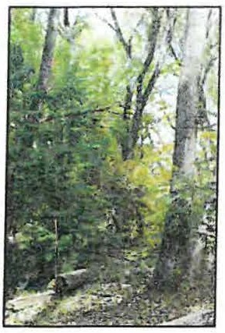
Type 1- High Structure Forest with a well-developed understory.

Tall mature to intermediate-aged trees (>5 m [>15 feet]) with canopy covering >25% of the area of the community (polygon)and understory layer (0-5 m [0-15 feet]) covering >25% of the area of the community (polygon). Substantial foliage is in all height layers. (This type incorporates Hink and Ohmart structure types 1and 3.) Photograph on Gila River by Y. Chauvin,2012.

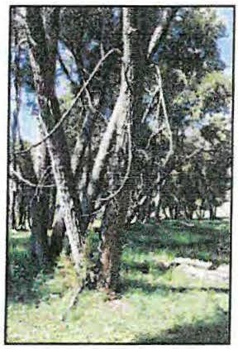
Type 2 -Low Structure Forest with little or no understory.

Tall mature to intermediate-aged trees (>5 m [>15 feet]) with canopy covering >25% of the area of the community (polygon) and understory layer (1-5 m [3-15 feet]) covering <25% of the area of the community (polygon). Majority of foliage is over 5 m (15 feet) above the ground. (This type incorporates Hink and Ohmart structure types 2 and 4.) Photograph on Diamond Creek by Y. Chauvin, 2012.

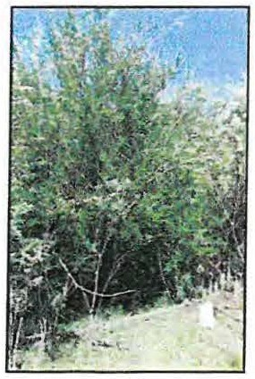
Single-story Communities (Shrublands, Herbaceous and Bare Ground)

Type 5 -Tall Shrub Stands.

Young tree and shrub layer only (1.5-5 m [4.5-15 feet]) covering >25% of the area of the community (polygon). Stands dominated by tall shrubs and young trees, may include herbaceous vegetation underneath the woody vegetation. Photograph on San Francisco River by Y. Chauvin, 2012.

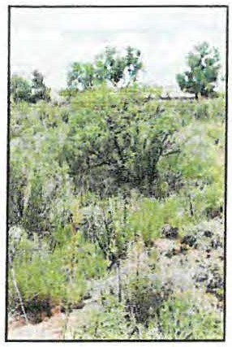
Type 6S- Short Shrub Stands.

Short stature shrubs or very young shrubs and trees (up to 1.5 m [up to
4.5 feet]) covering >10% of the area of the community (polygon). Stands dominated by short woody vegetation, may include herbaceous vegetation underneath the woody vegetation. Photograph on Lower Pecos River by E. Lindahl,2008.

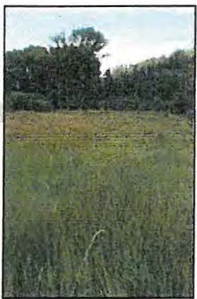
Type 6W- Herbaceous Wetland.

Herbaceous wetland vegetation covering >10% of the area of the community (polygon). Stands dominated by obligate wetland herbaceous species. Woody species absent, or <10% cover. Photograph of Carex nebrascensis meadow on upper Rio Santa Barbara by Y. Chauvin, 2009.

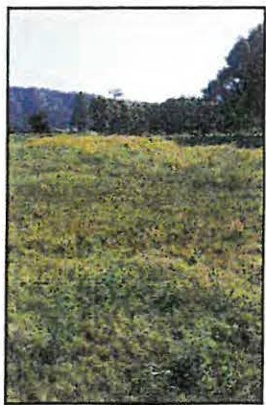
Type 6H- Herbaceous.

Herbaceous vegetation covering >10% of the area of the community (polygon). Stands dominated by herbaceous vegetation of any type except obligate wetland species. Woody species absent or <10% cover. Photograph on Diamond Creek by Y. Chauvin,2012.

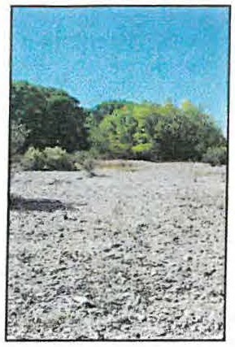
Type 7-Sparse Vegetation/Bare Ground.

Bare ground, may include sparse woody or herbaceous vegetation, but total vegetation cover <10%. May be natural in origin (cobble bars) or anthropogenic in origin (graded or plowed earth) Photograph on Lower Gila River by Y. Chauvin,2012.

Appendix III – Sample Datasheet
2011 Datasheet with original Hink & Ohmart
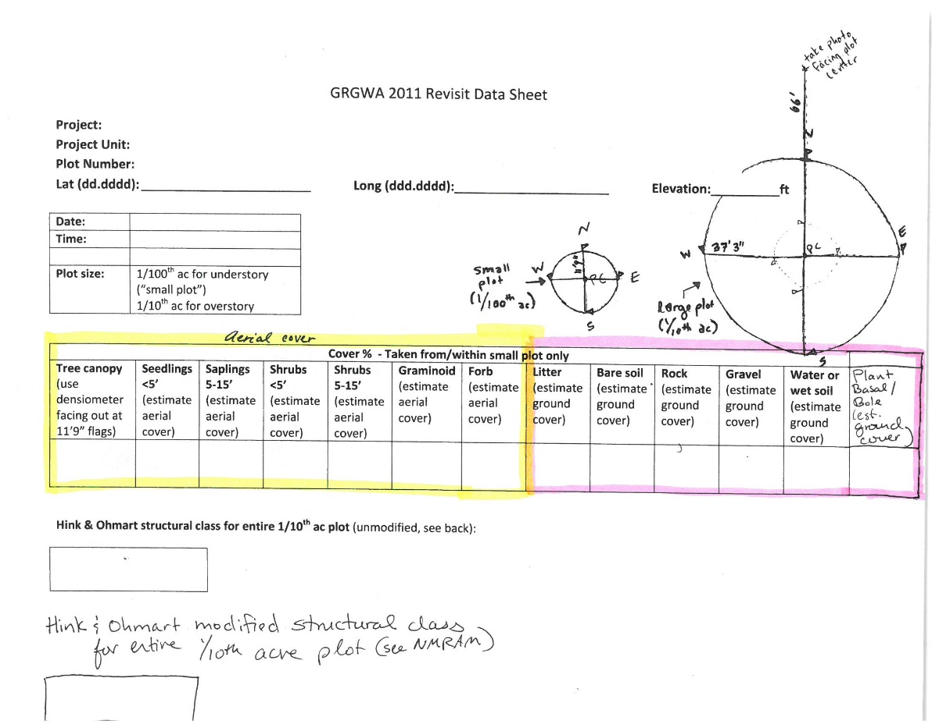
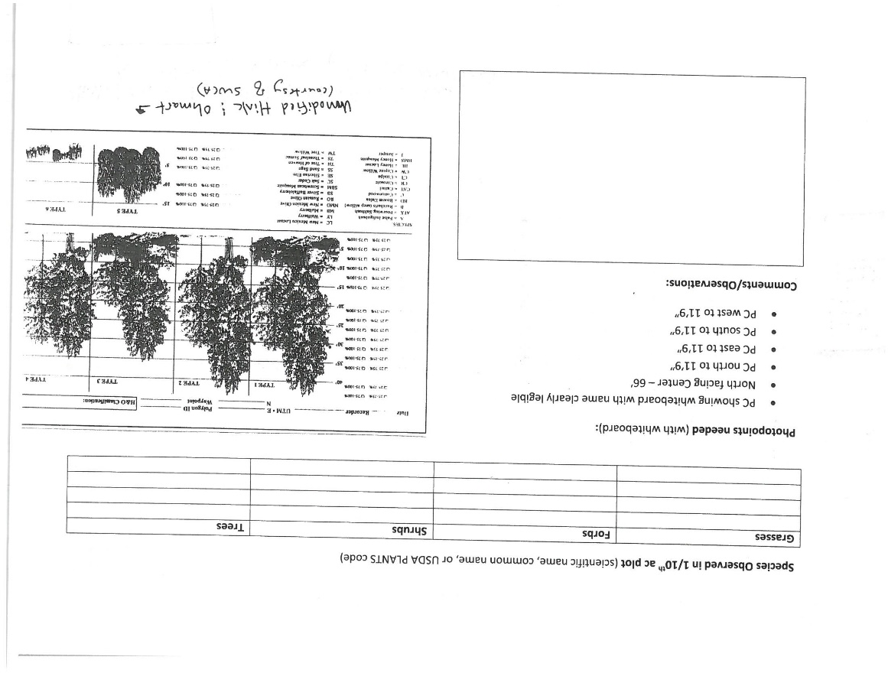
2022 Sample datasheet
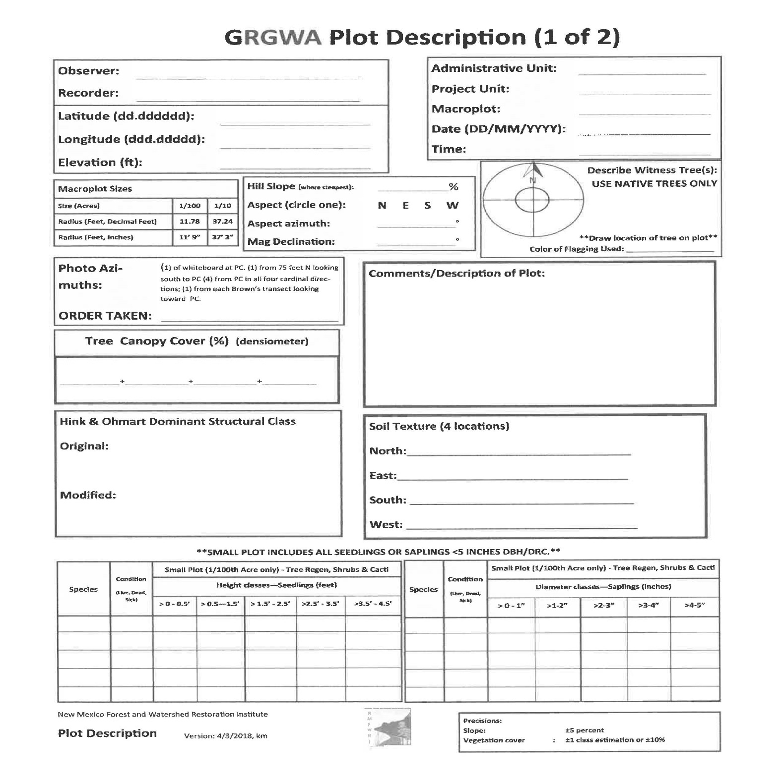
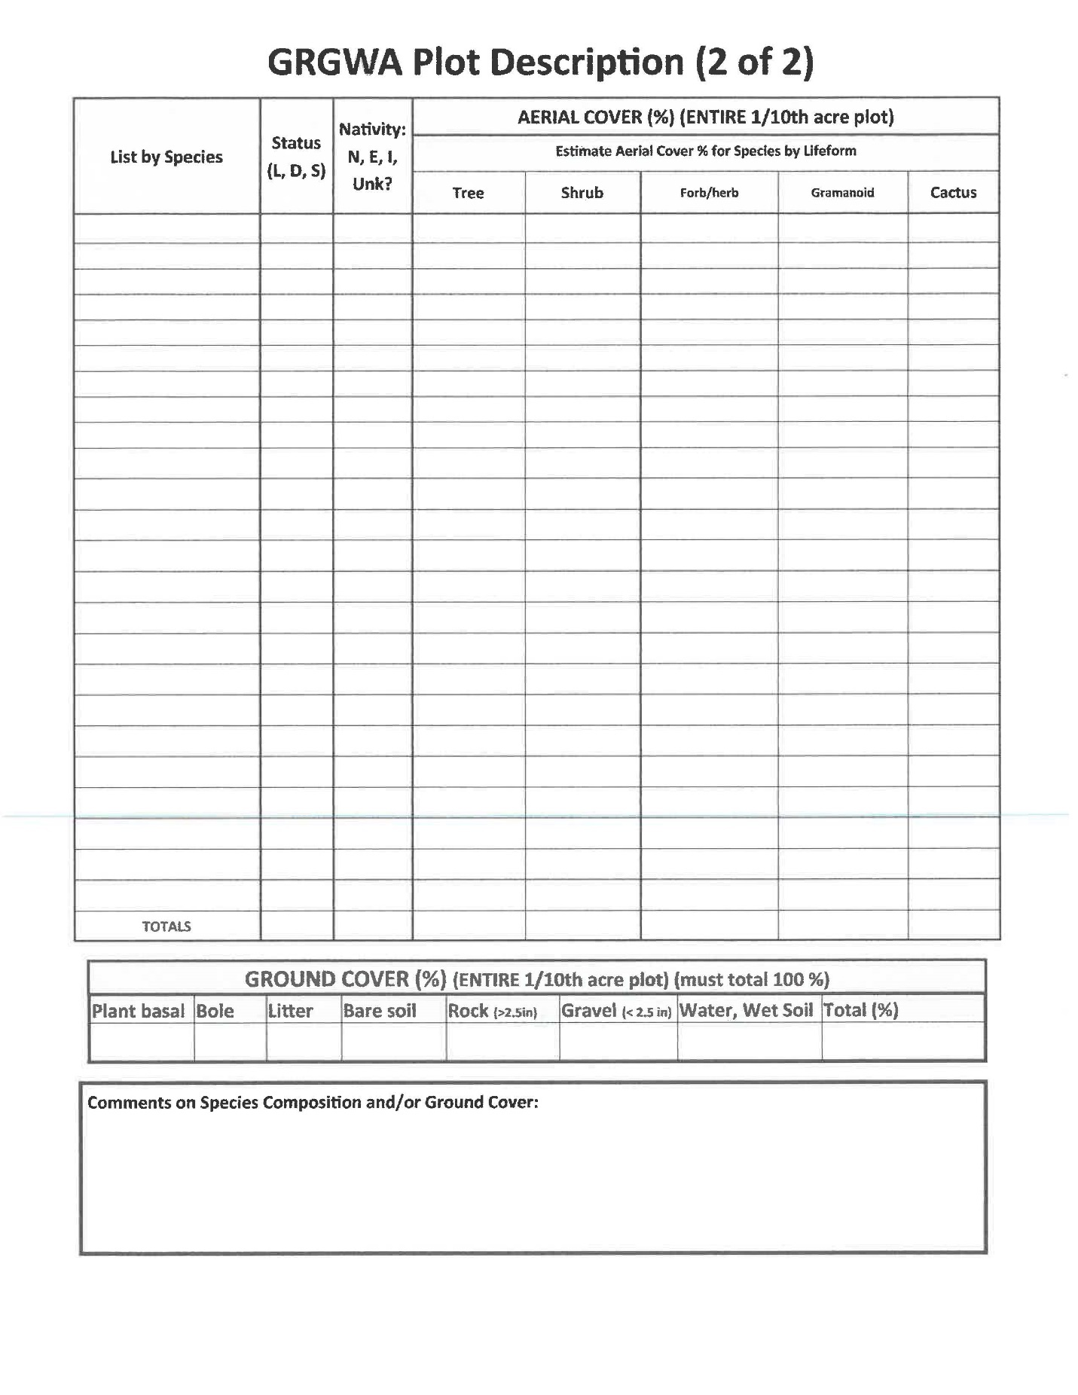
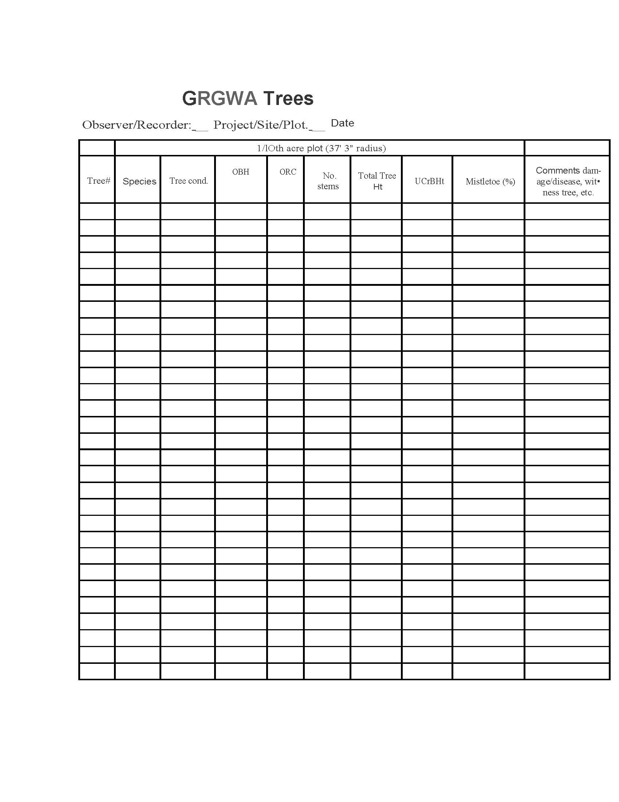

Appendix IV – Surface Fuels

Appendix V – Photo Pages
See the attached photo comparison pages for each site.
Belen 1
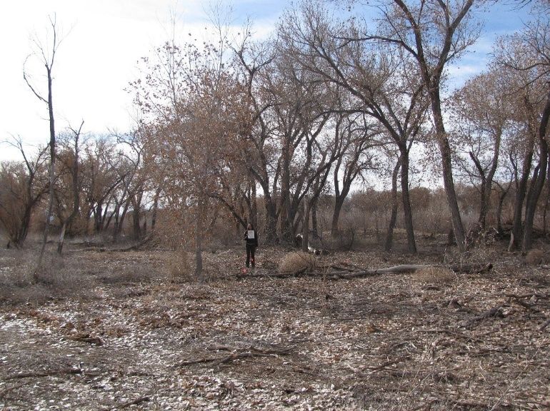11.11_1C, facing center from north at 66’ (2011)
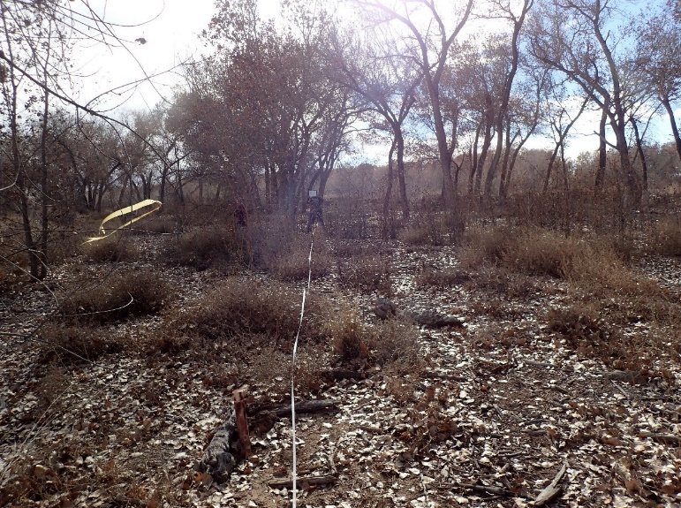11.11_1C, facing center from north at 66’ (2016)
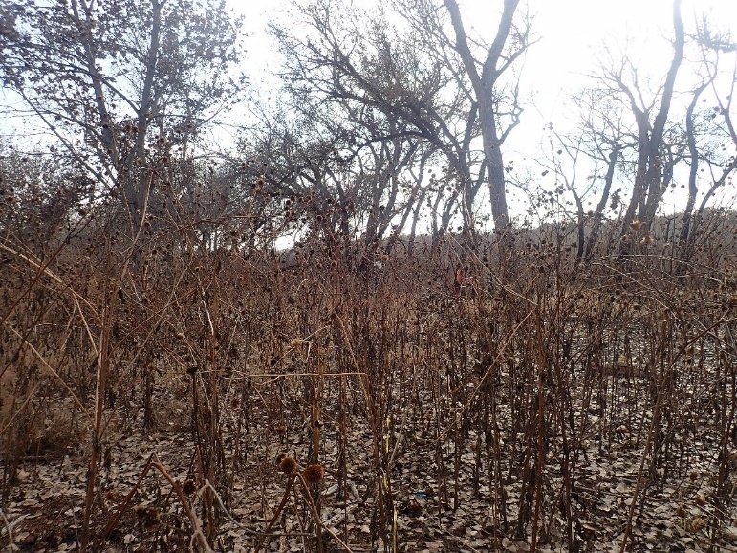11.11_1C, facing center from north at 66’ (2022)
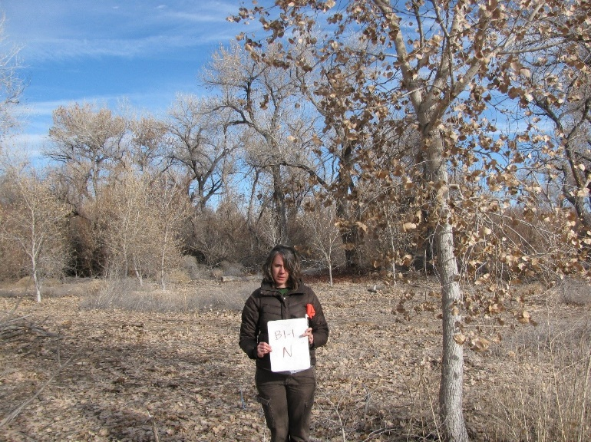11.11_1N, facing north from center at 11.8’ (2011)
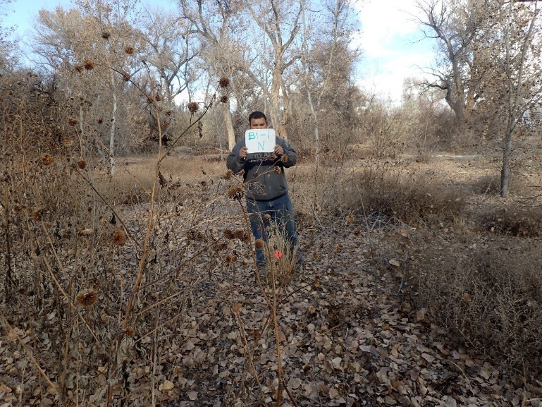11.11_1N, facing north from center at 11.8’ (2016)
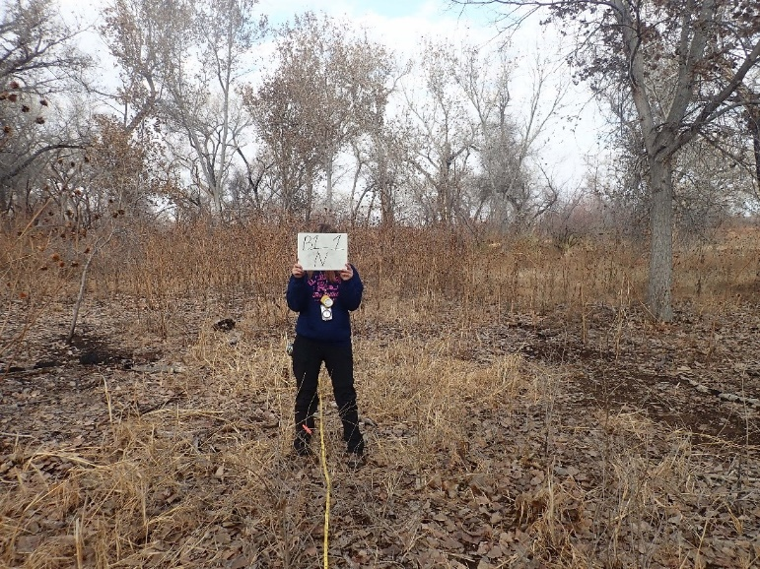11.11_1N, facing north from center at 11.8’ (2022)
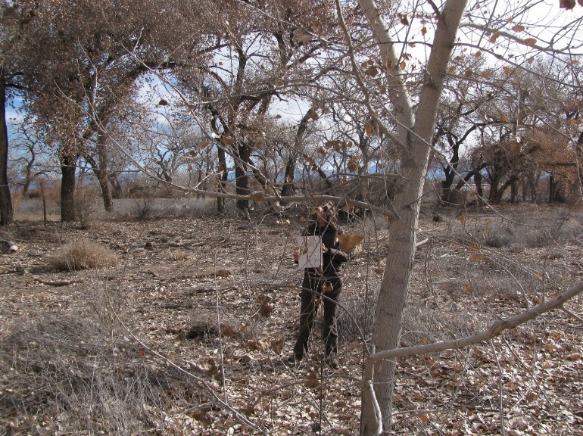11.11_1E, facing east from center at 11.8’ (2011)
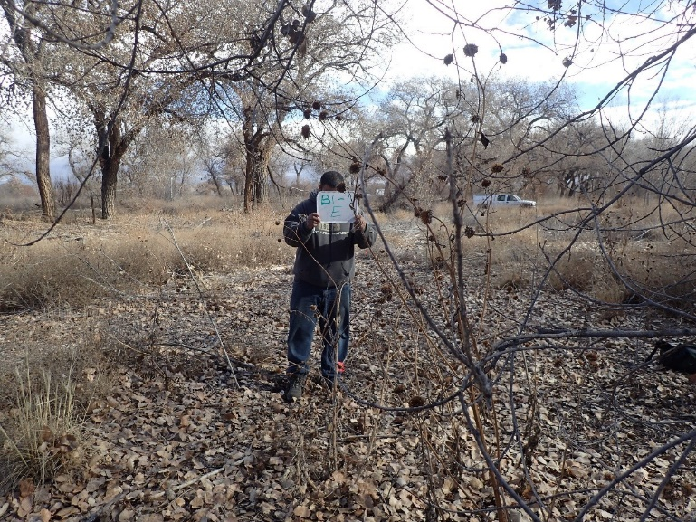11.11_1E, facing east from center at 11.8’ (2016)
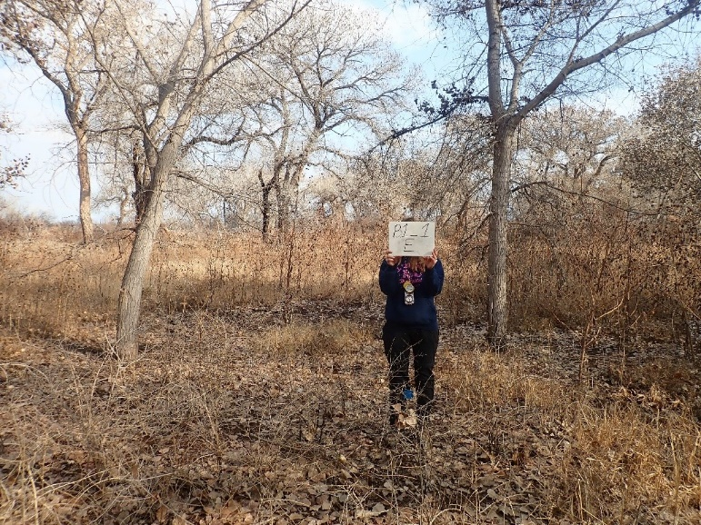11.11_1E, facing east from center at 11.8’ (2022)
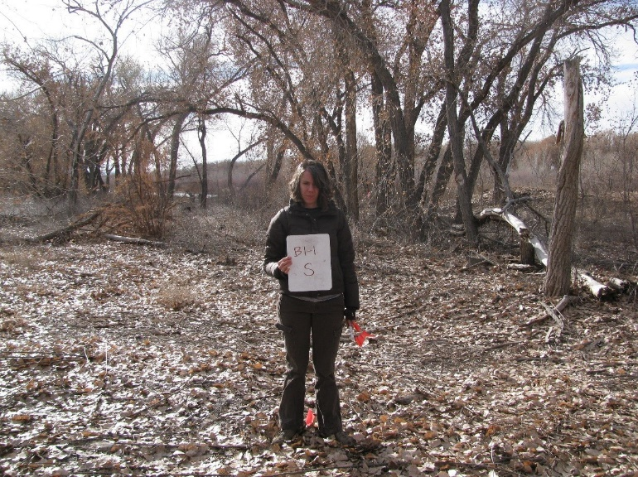11.11_1S, facing south from center at 11.8’ (2011)
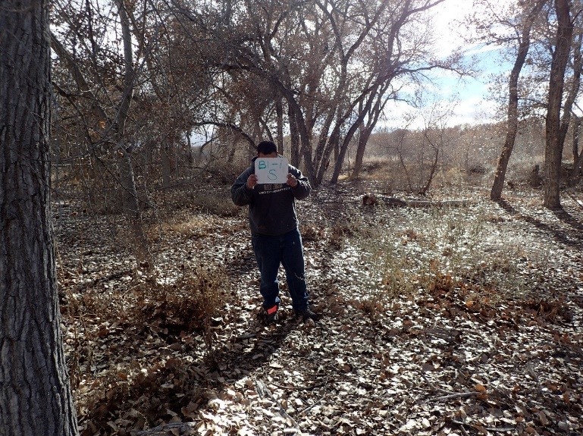11.11_1S, facing south from center at 11.8’ (2016)
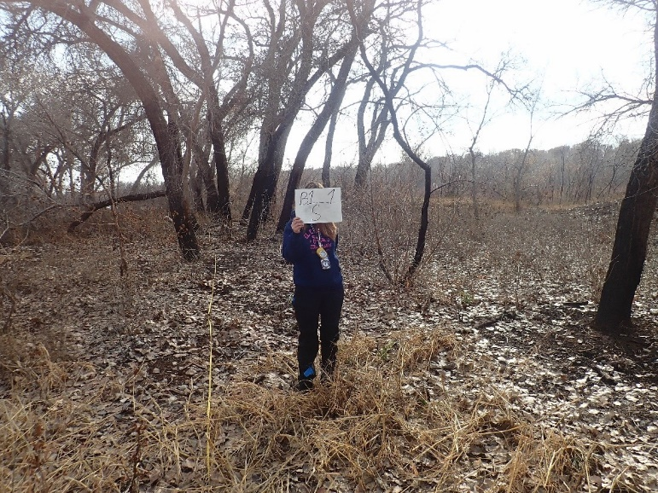11.11_1S, facing south from center at 11.8’ (2022)
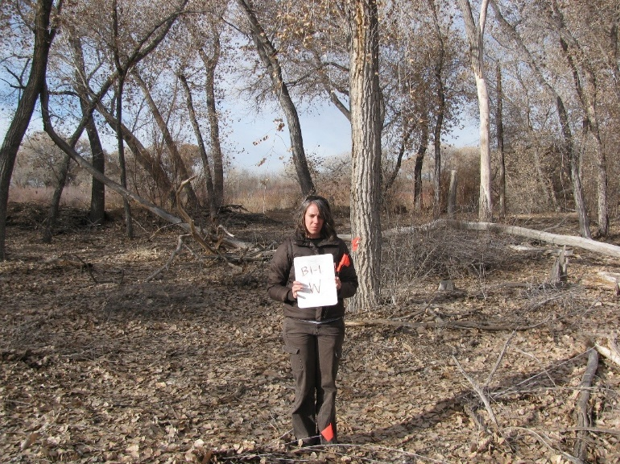11.11_1W, facing west from center at 11.8’ (2011)
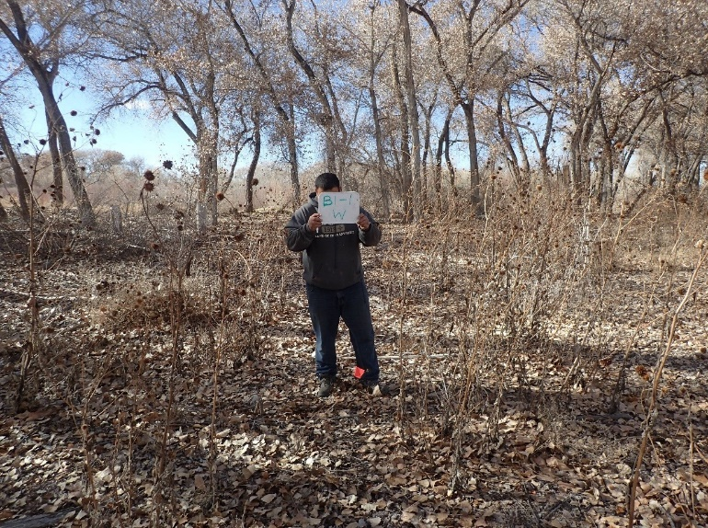11.11_1W, facing west from center at 11.8’ (2016)
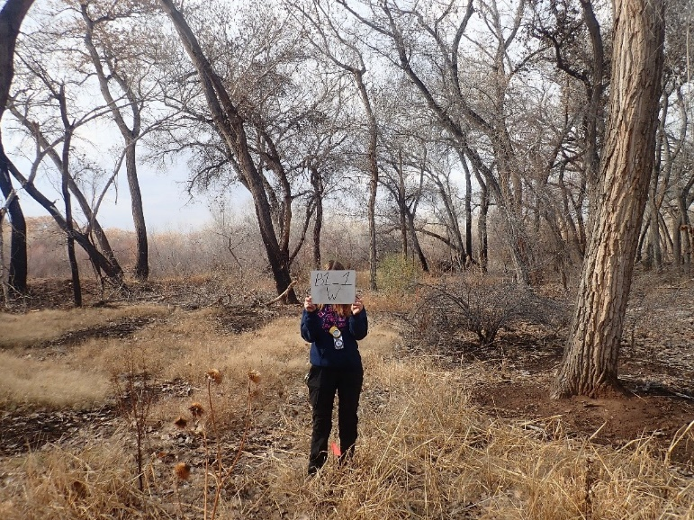11.11_1W, facing west from center at 11.8 ’ (2022)
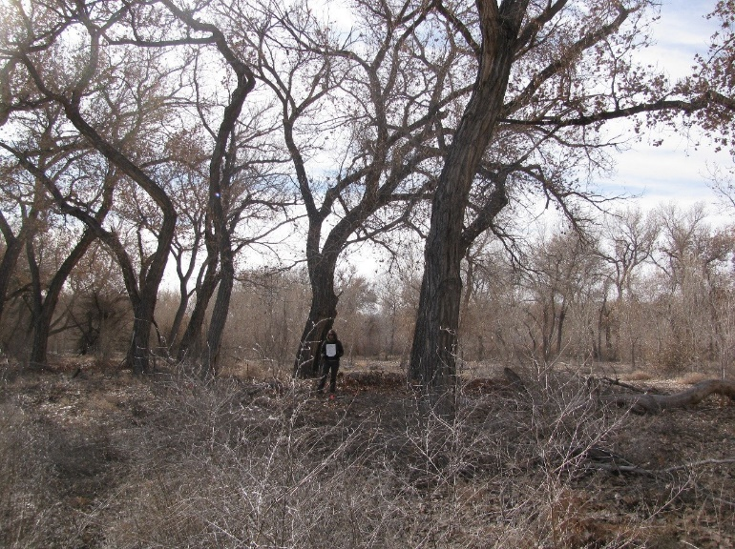11.11_2C, facing center from north at 66’ (2011)
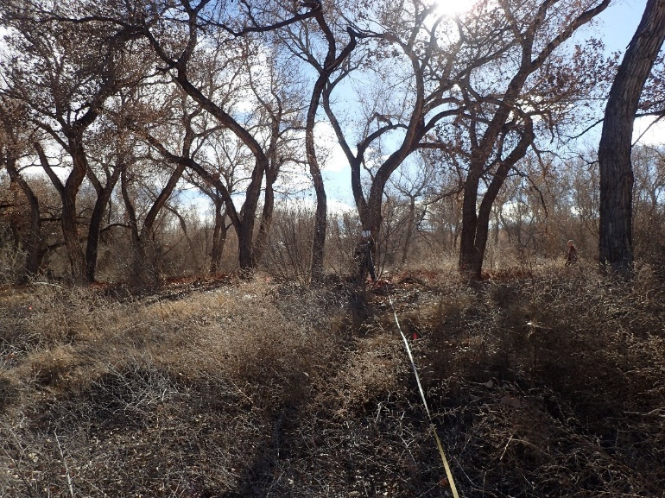11.11_2C, facing center from north at 66’ (2016)
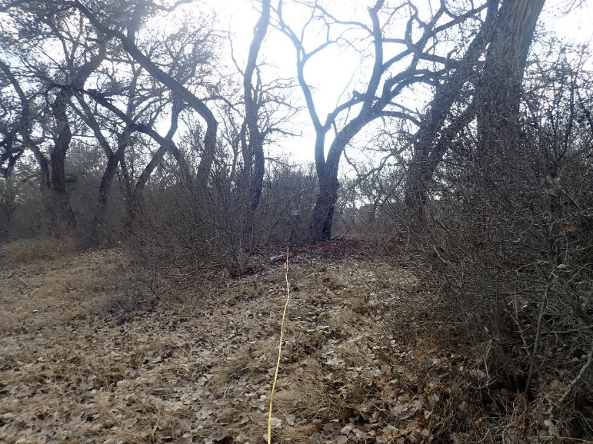11.11_2C, facing center from north at 66’ (2022)
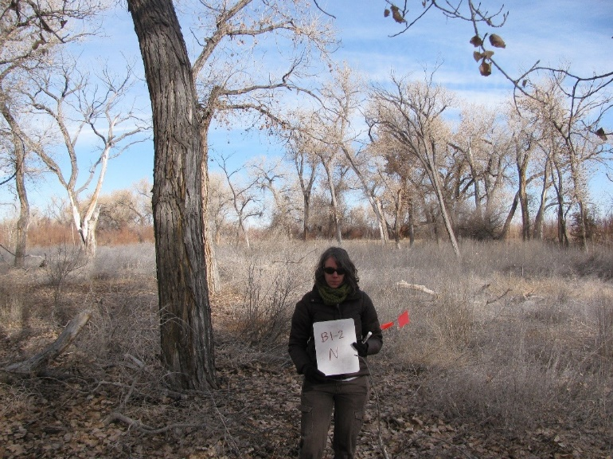11.11_2N, facing north from center at 11.8’ (2011)
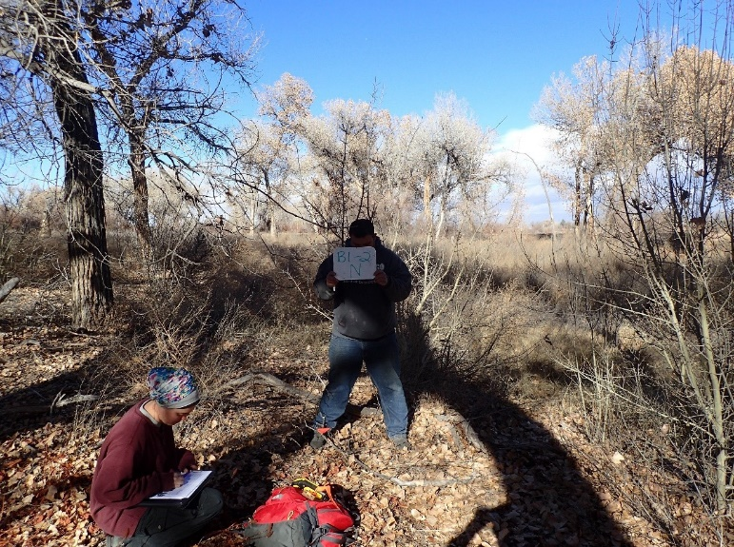11.11_2N, facing north from center at 11.8’ (2016)
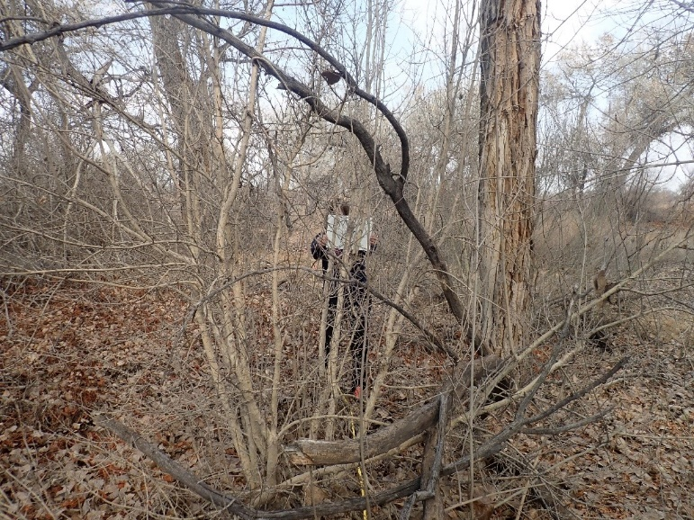11.11_2N, facing north from center at 11.8’ (2022)
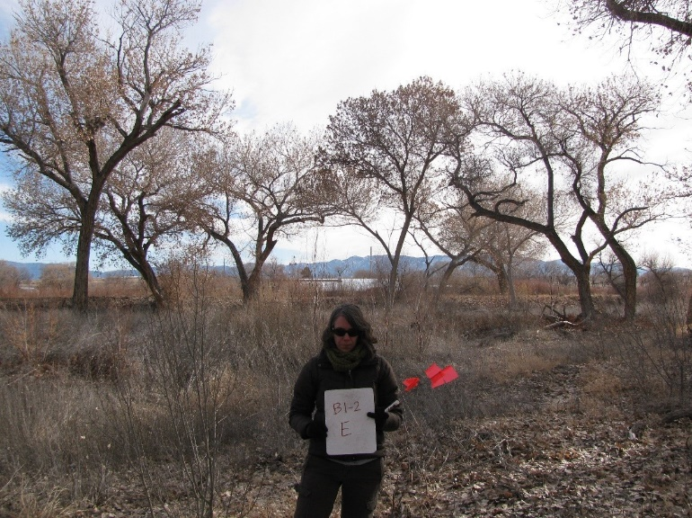11.11_2E, facing east from center at 11.8’ (2011)
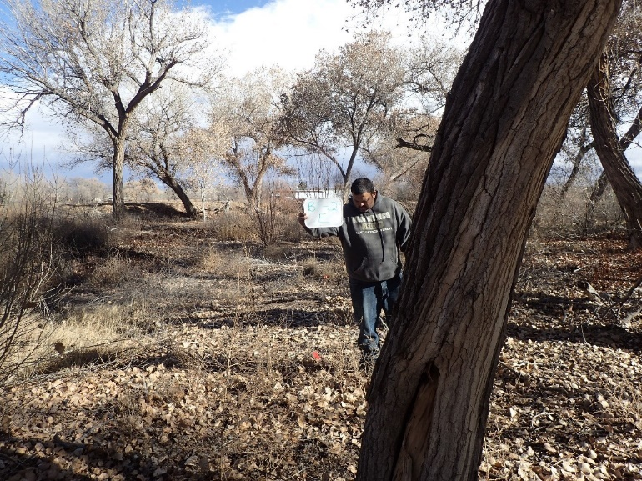11.11_2E (2016)
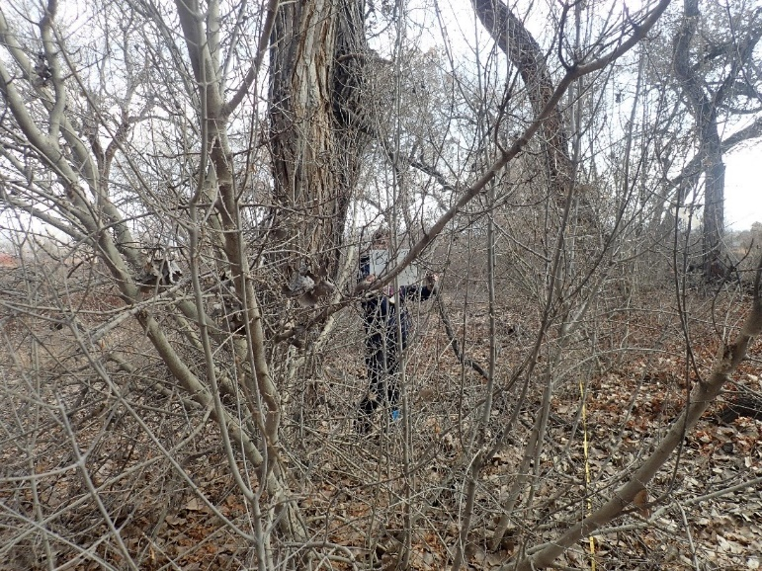11.11_2E, facing east from center at 11.8’ (2022)
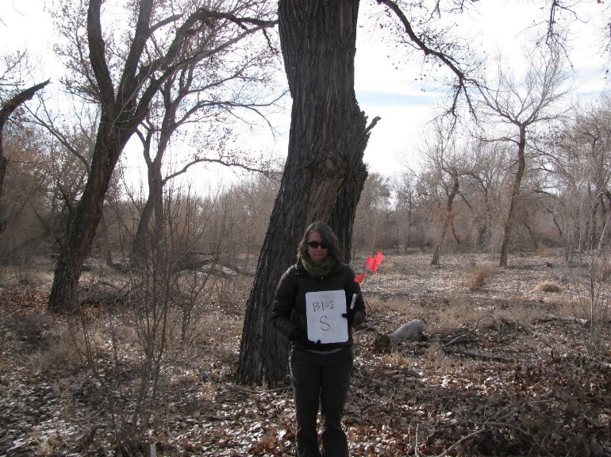11.11_2S, facing south from center at 11.8’ (2011)
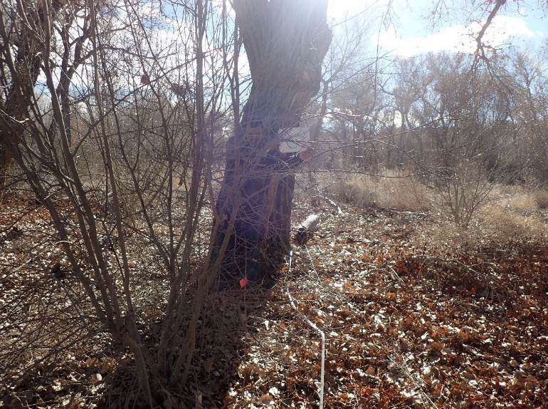11.11_2S, facing south from center at 11.8’ (2016)
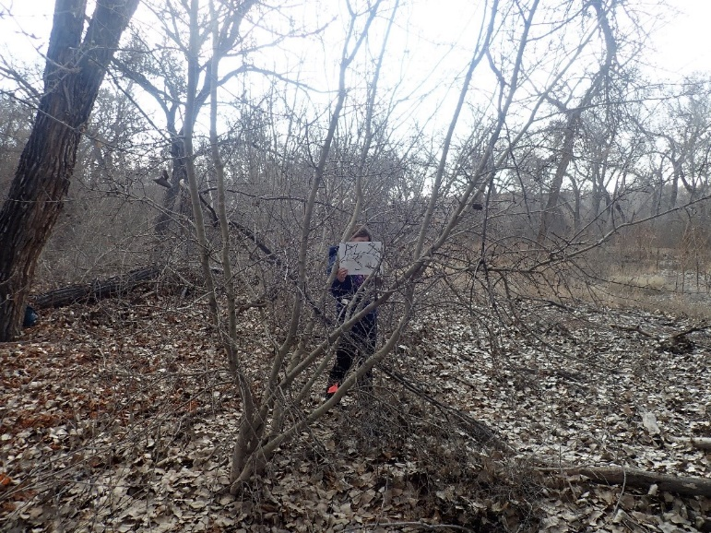11.11_2S, facing south from center at 11.8’ (2022)
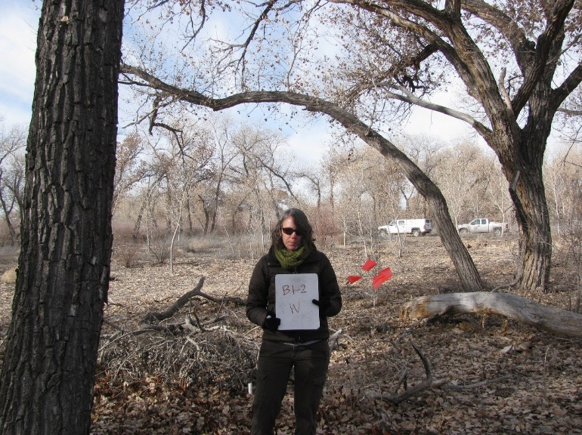11.11_2W, facing west from center at 11.8’ (2011)
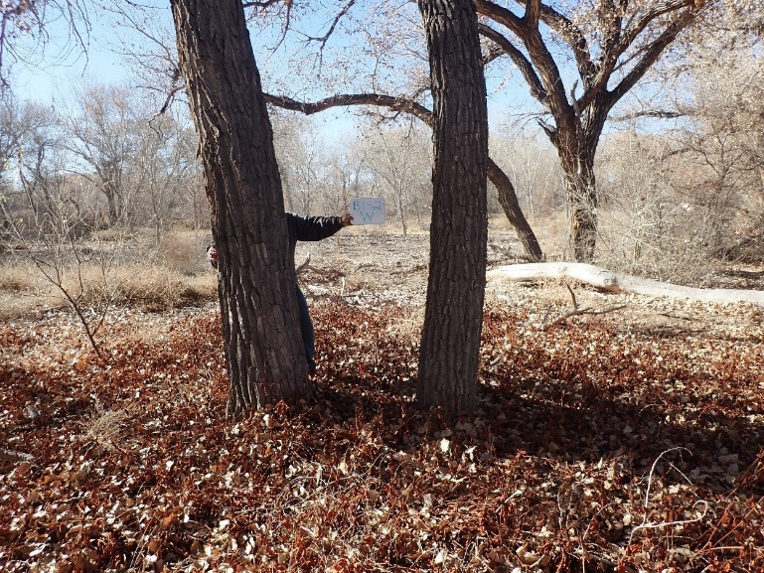11.11_2W, facing west from center at 11.8’ (2016)
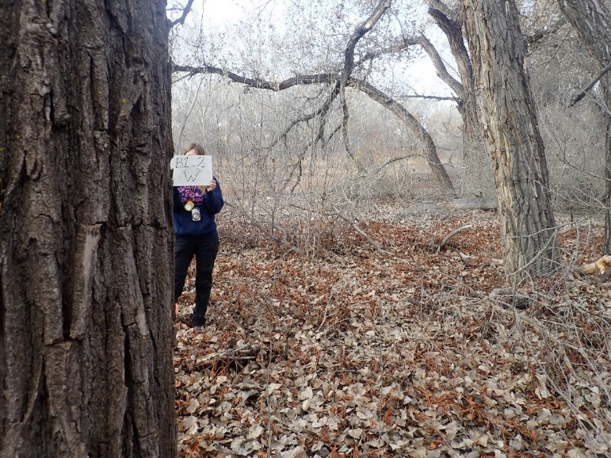11.11_2W, facing west from center at 11.8’ (2022)
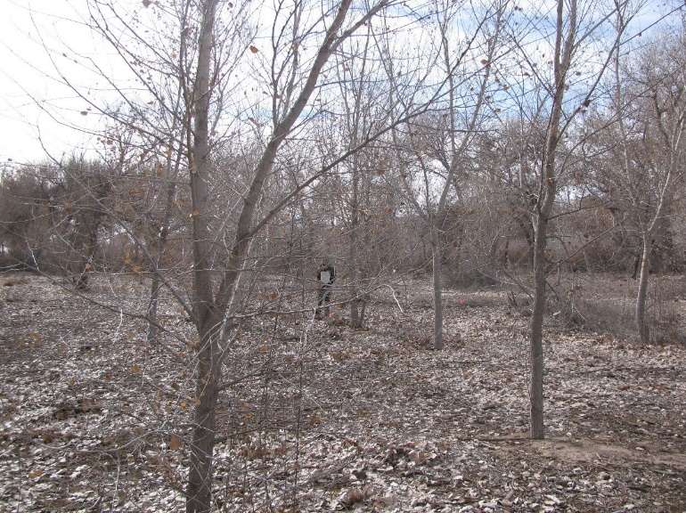11.11_3C, facing center from north at 66’ (2011)
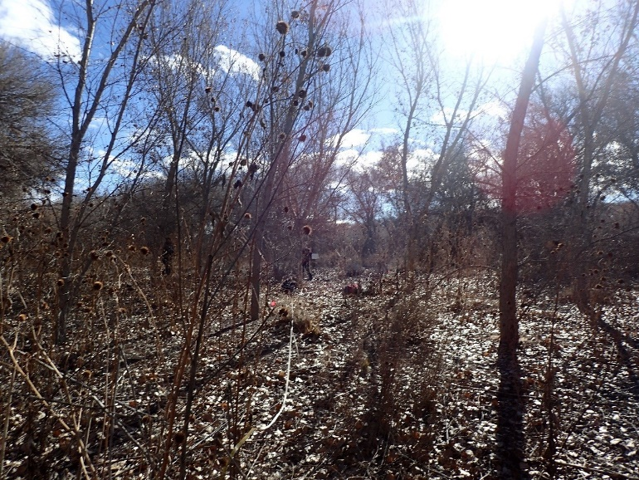11.11_3C, facing center from north at 66’ (2016)
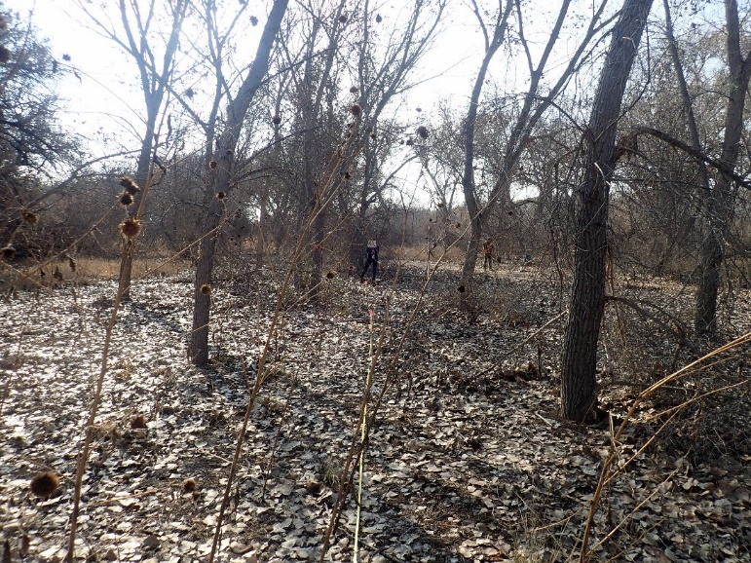11.11_3C, facing center from north at 66’ (2022)
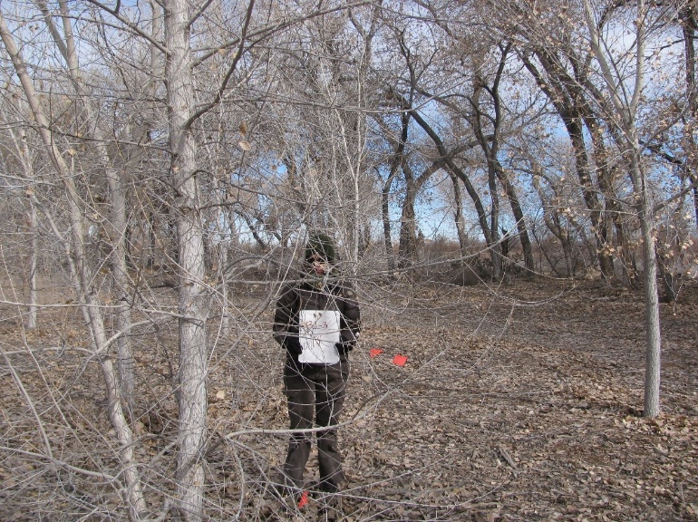11.11_3N, facing north from center at 11.8’ (2011)
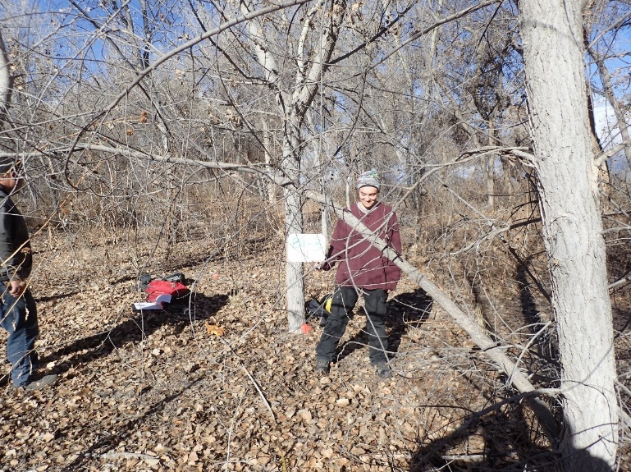11.11_3N, facing north from center at 11.8’ (2016)
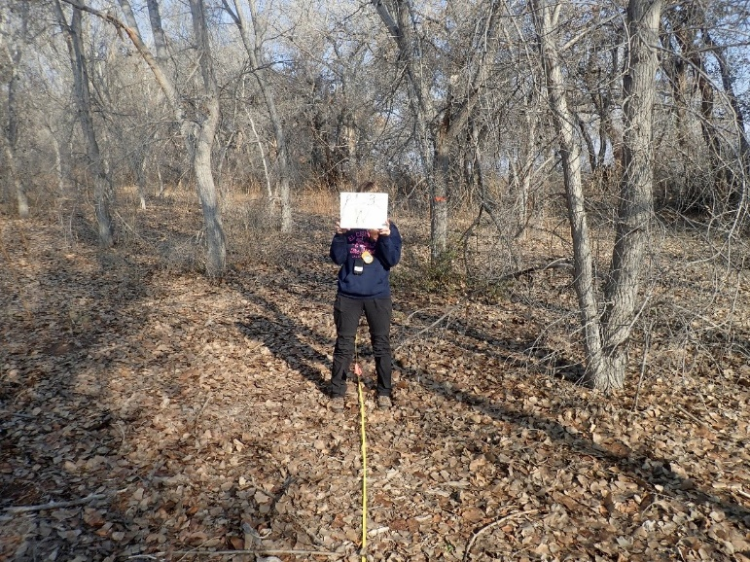11.11_3N, facing north from center at 11.8’ (2022)
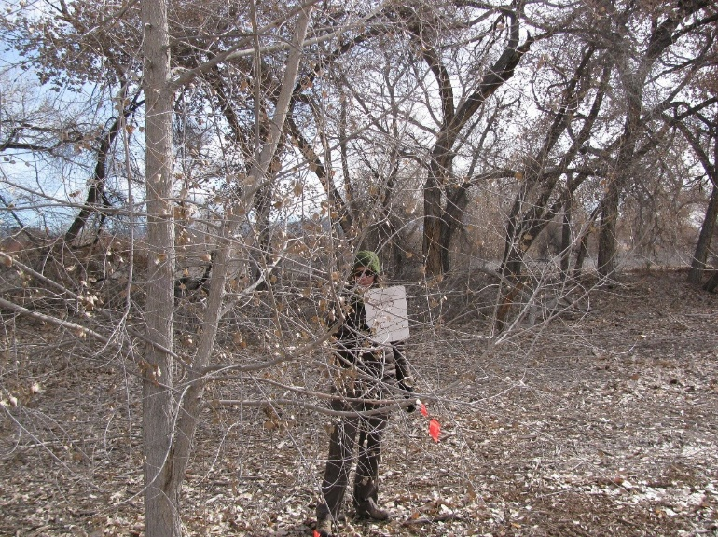11.11_3E, facing east from center at 11.8’ (2011)
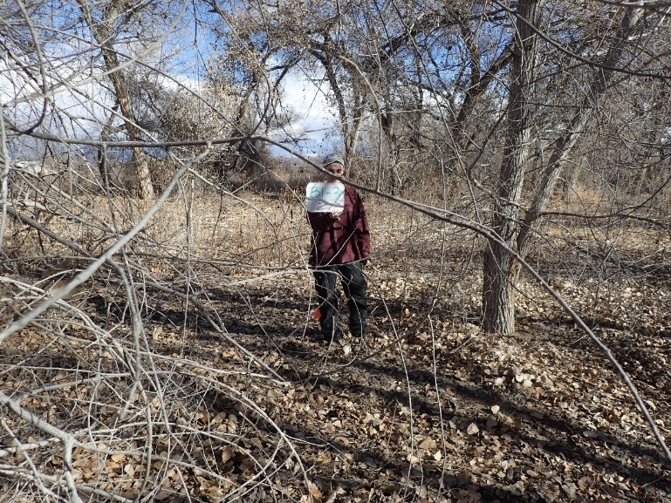11.11_3E, facing east from center at 11.8 (2016)
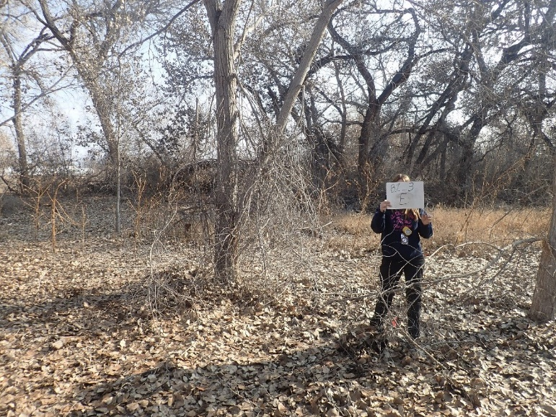11.11_3E, facing east from center at 11.8’ (2022)
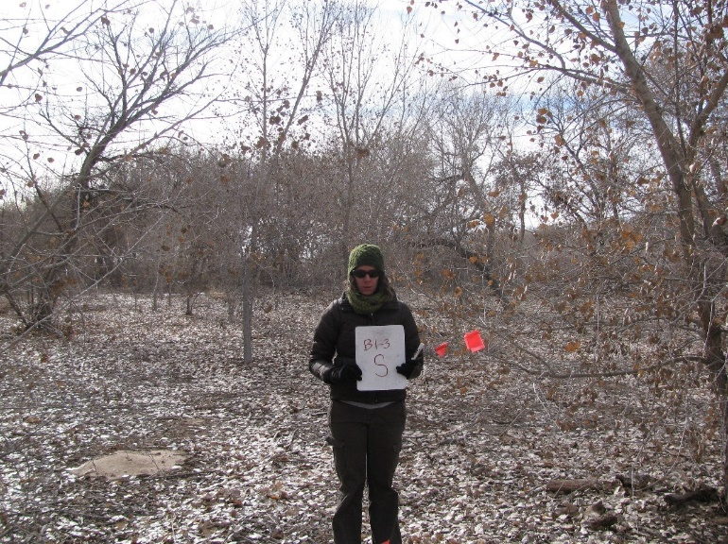11.11_3S, facing south from center at 11.8’ (2011)
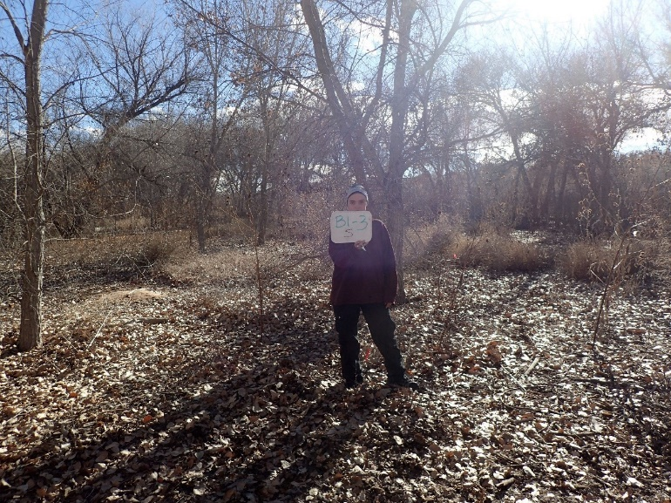11.11_3S, facing south from center at 11.8’ (2016)
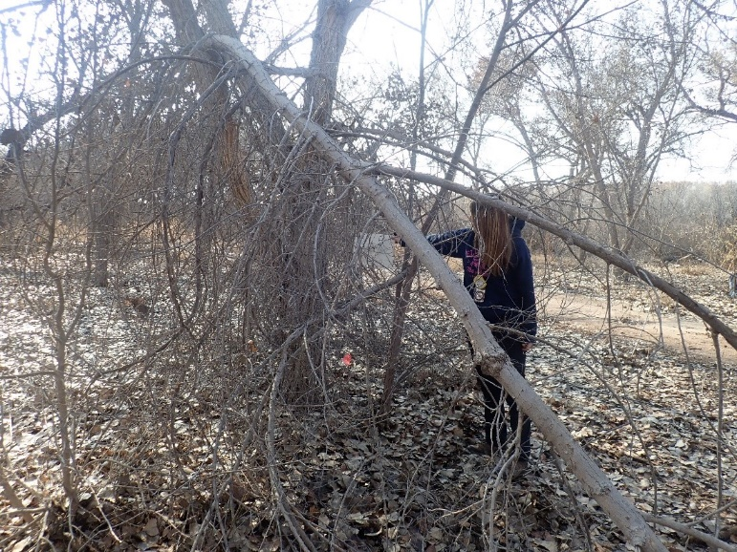11.11_3S, facing center from south at 11.8’ (2022)
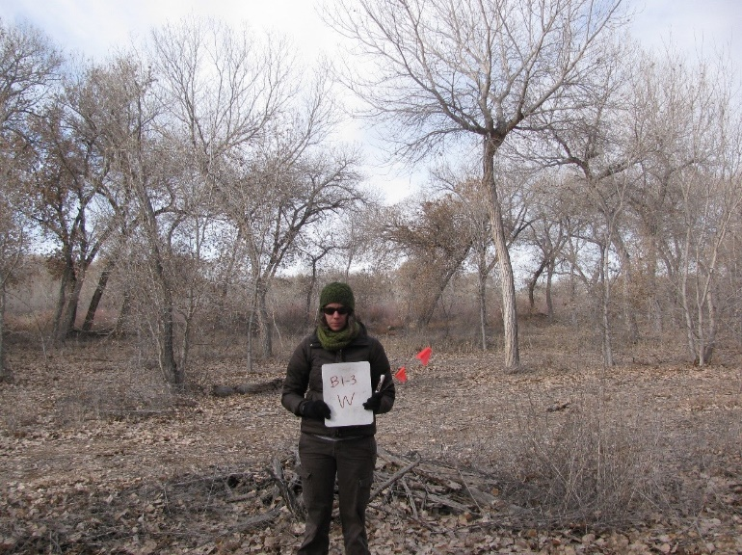11.11_3W, facing west from center at 11.8’ (2011)
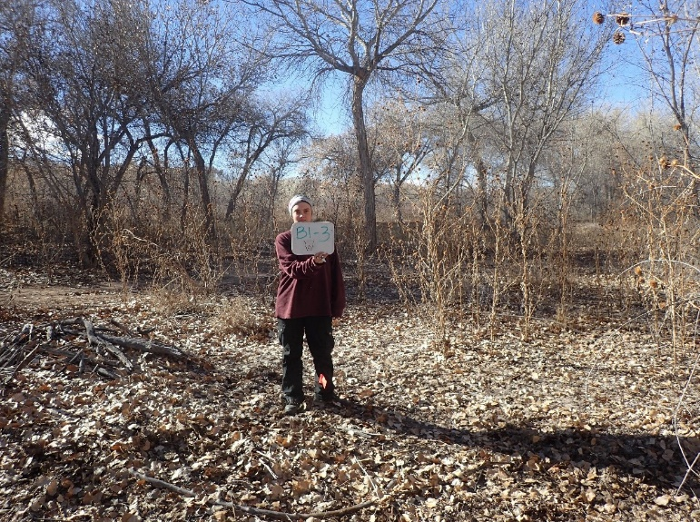11.11_3W, facing west from center at 11.8’ (2016)
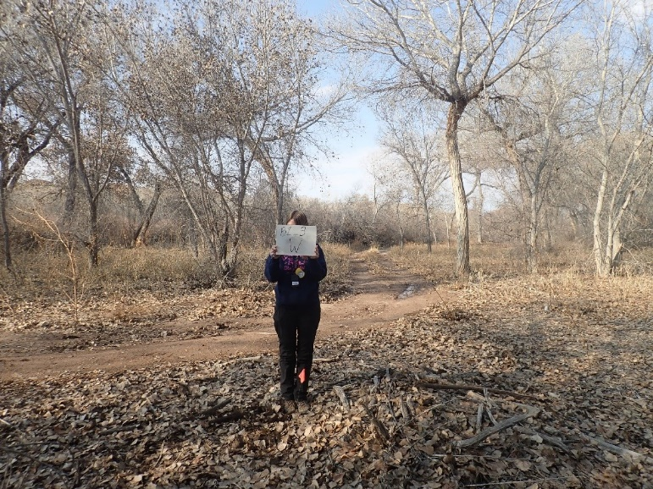11.11_3W, facing west from center at 11.8’ (2022)
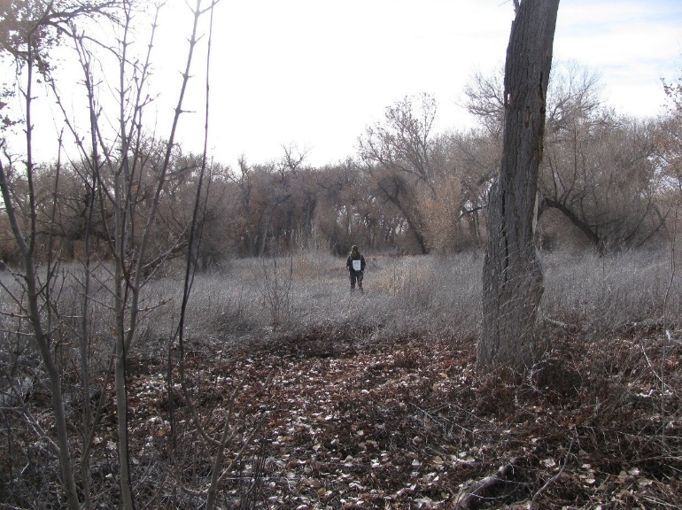11.11_4C, facing center from north at 66’ (2011)
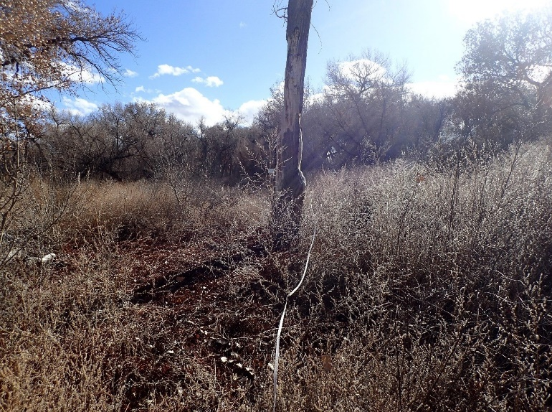11.11_4C, facing center from north at 66’ (2016)
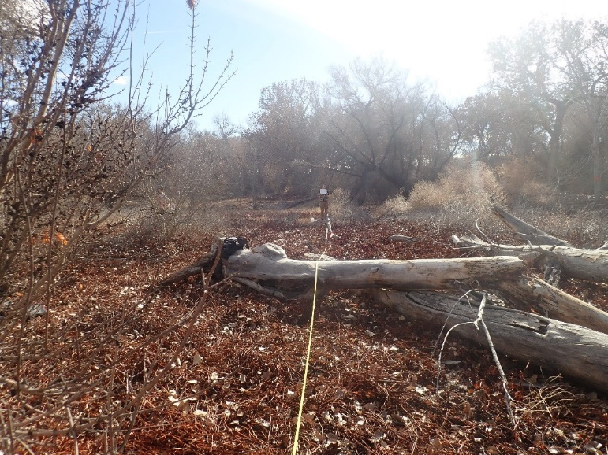11.11_4C, facing center from north at 66’ (2022)
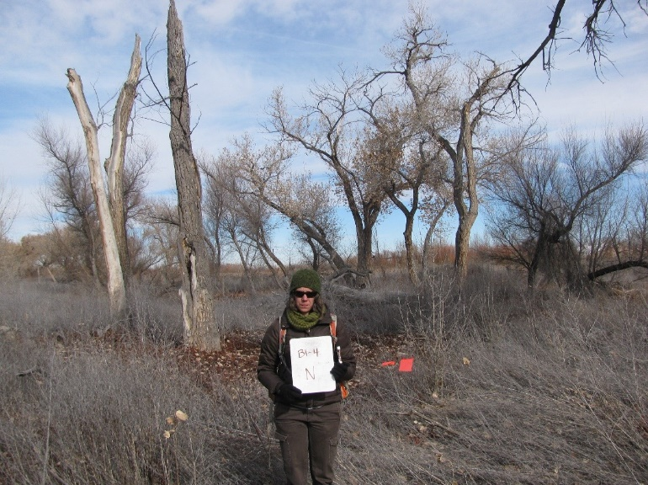11.11_4N, facing north from center at 11.8’ (2011)
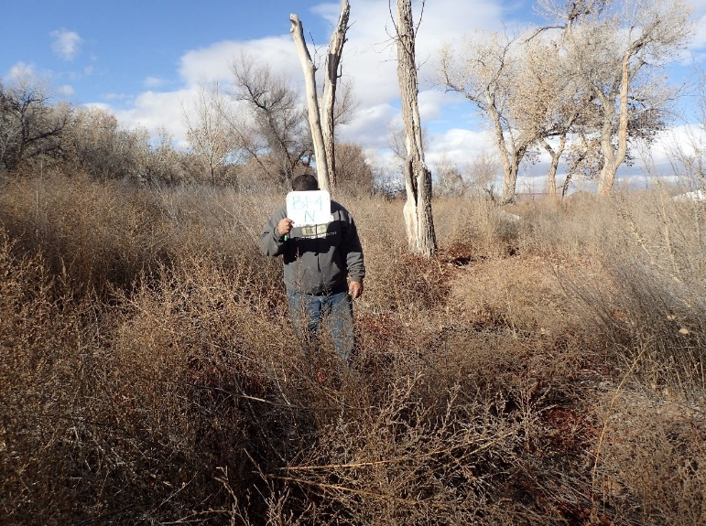11.1_4N, facing north from center at 11.8’ (2016)
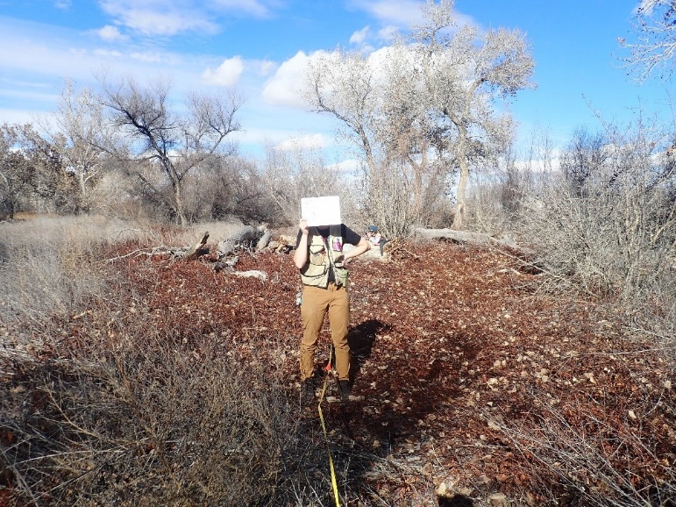11.11_4N, facing north from center at 11.8’ (2022)
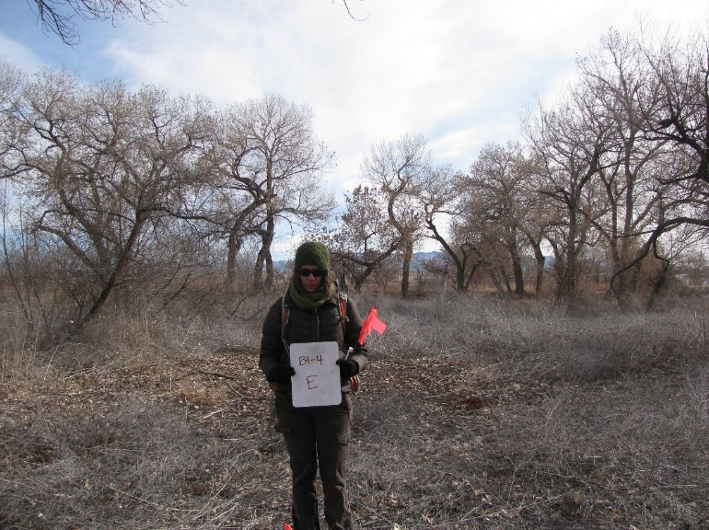11.11_4E, facing east from center at 11.8’ (2011)
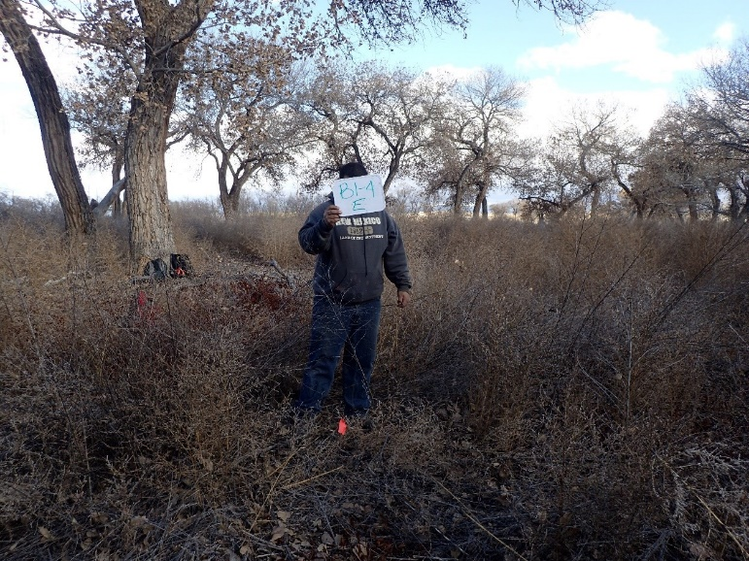11.11_4E, facing east from center at 11.8’ (2016)
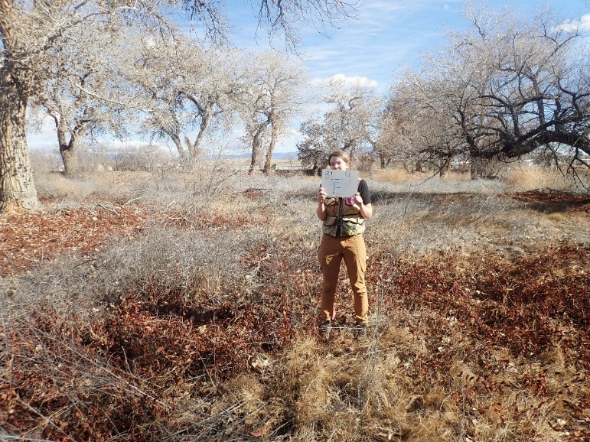11.11_4E, facing east from center at 11.8’ (2022)
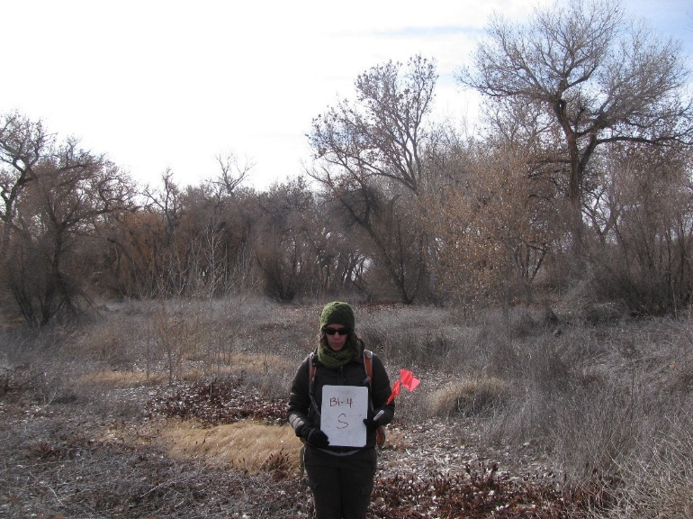11.11_4S, facing south from center at 11.8’ (2011)
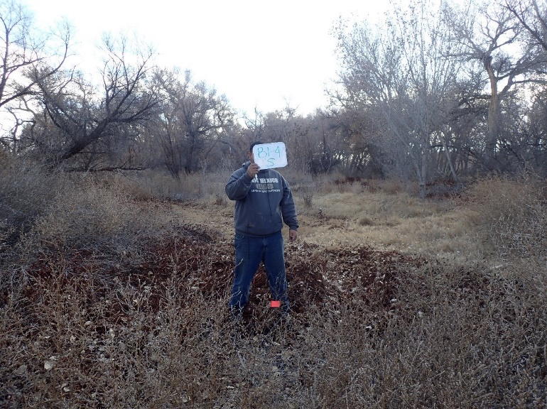11.11_4S, facing south from center at 11.8’ (2016)
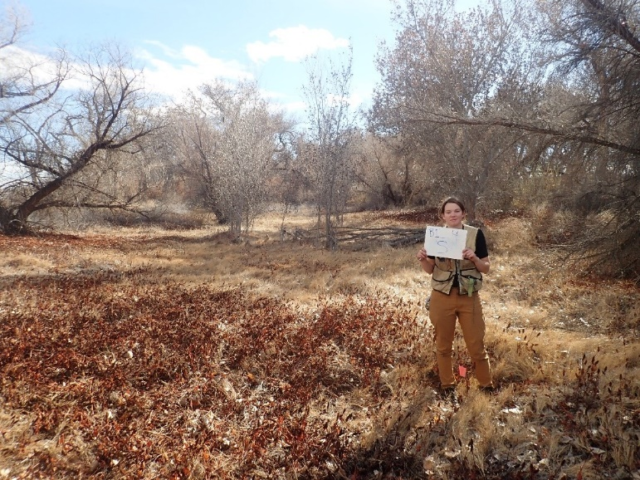11.11_4S, facing south from center at 11.8’ (2022)
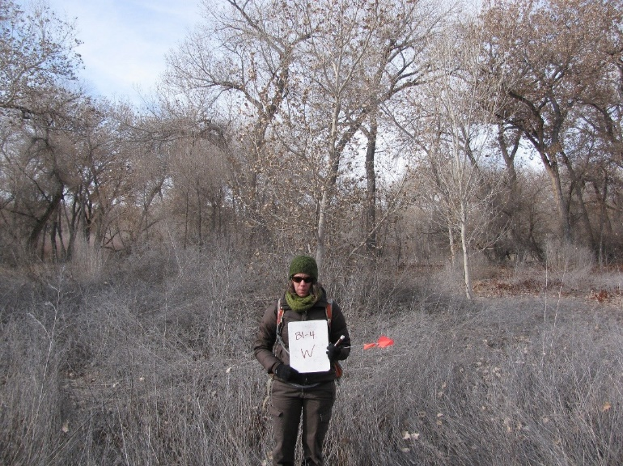11.11_4W, facing west from center at 11.8’ (2011)
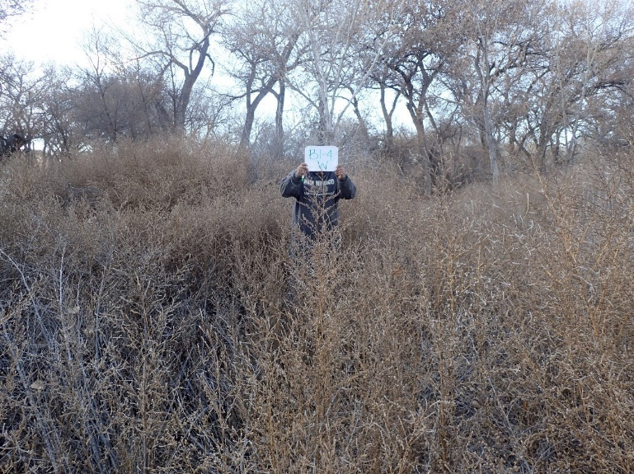11.11_4W, facing west from center at 11.8’ (2016)
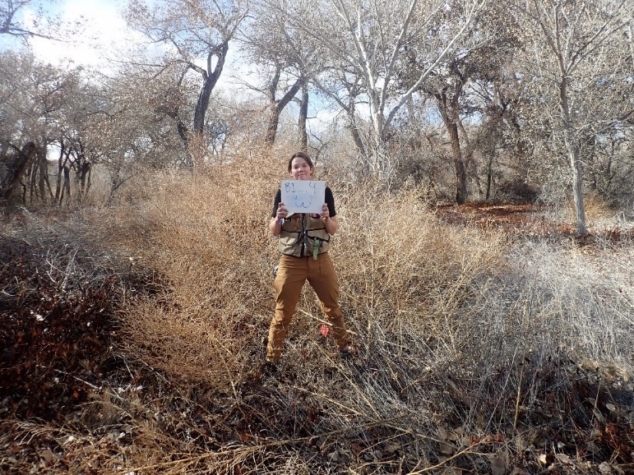11.11_4W, facing west from center at 11.8’ (2022)
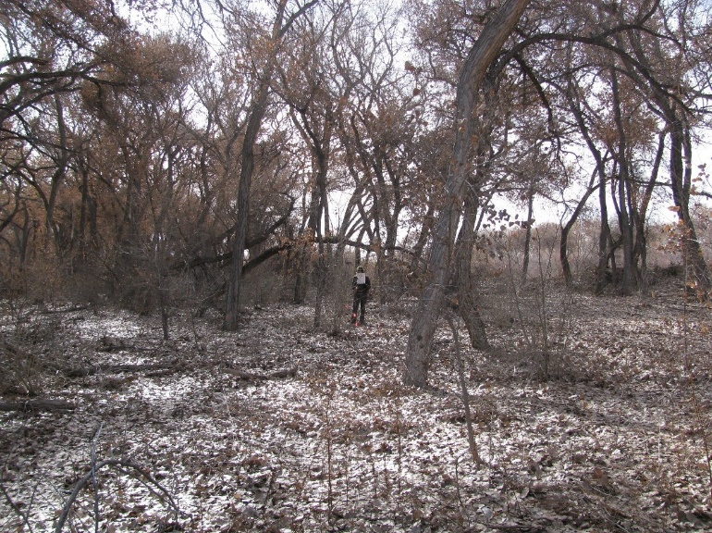11.11_5C, facing center from north at 66’ (2011)
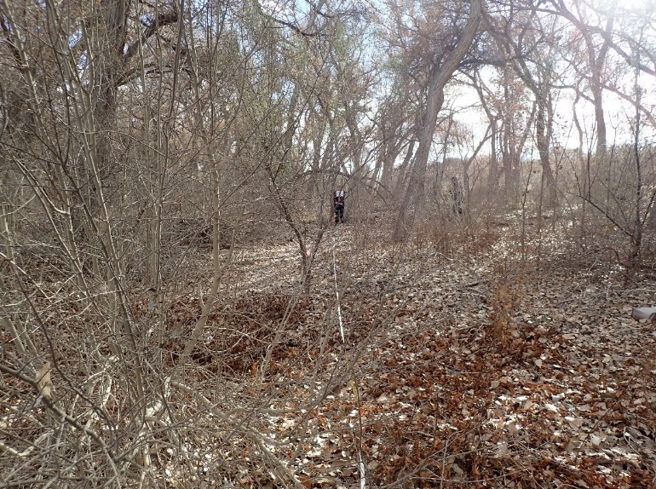11.11_5C, facing center from north at 66’ (2016)
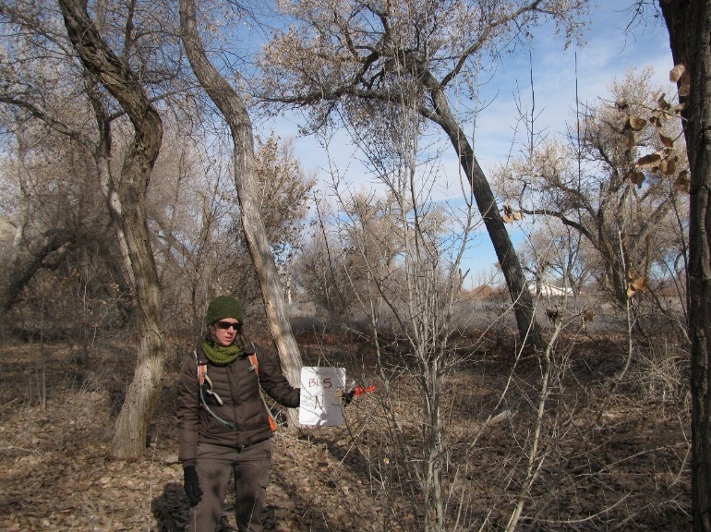11.11_5N, facing north from center at 11.8’ (2011)
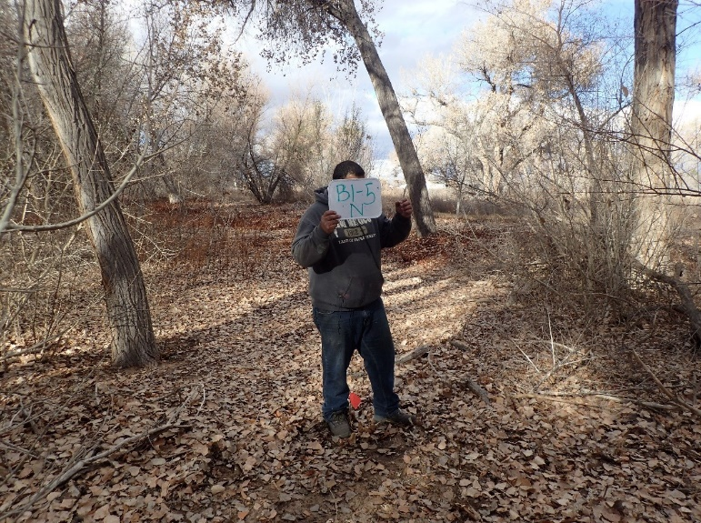11.11_5N, facing north from center at 11.8’ (2016)
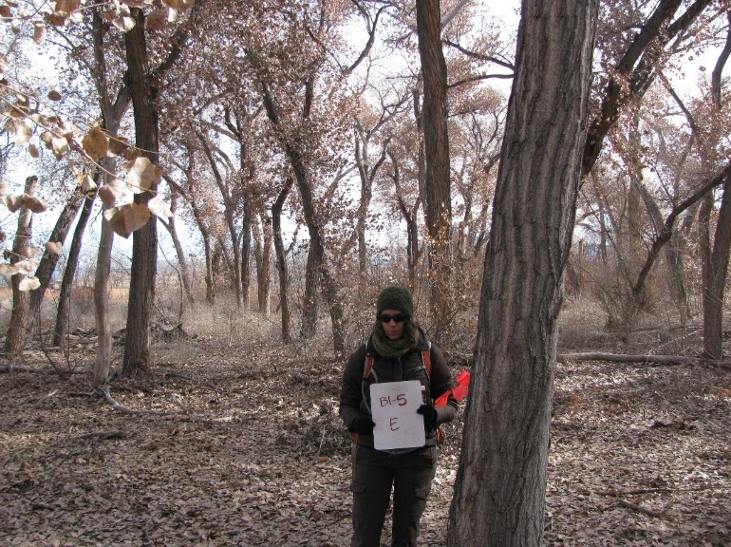11.11_5E, facing east from center at 11.8’ (2011)
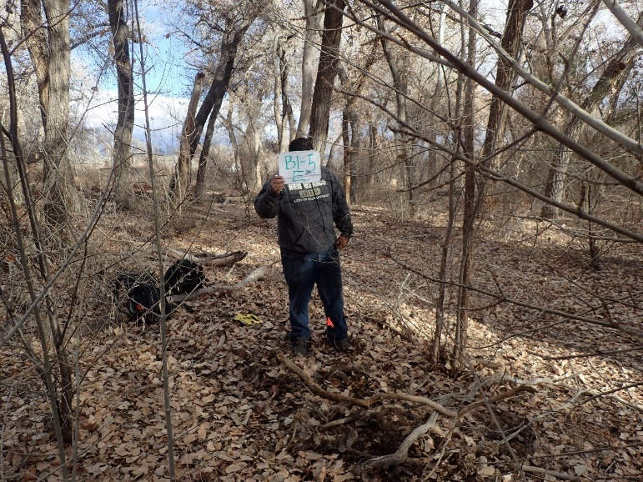11.11_5E, facing east from center at 11.8’ (2016)
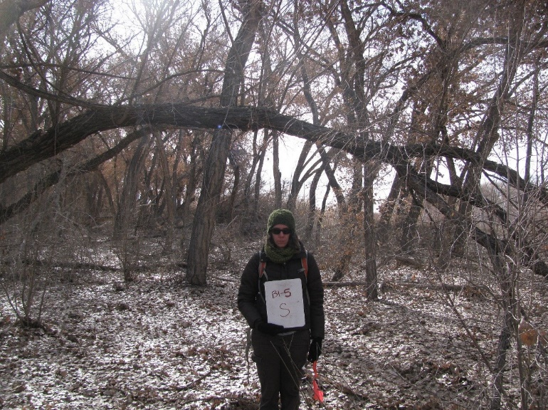11.11_5S, facing south from center at 11.8’ (2011)
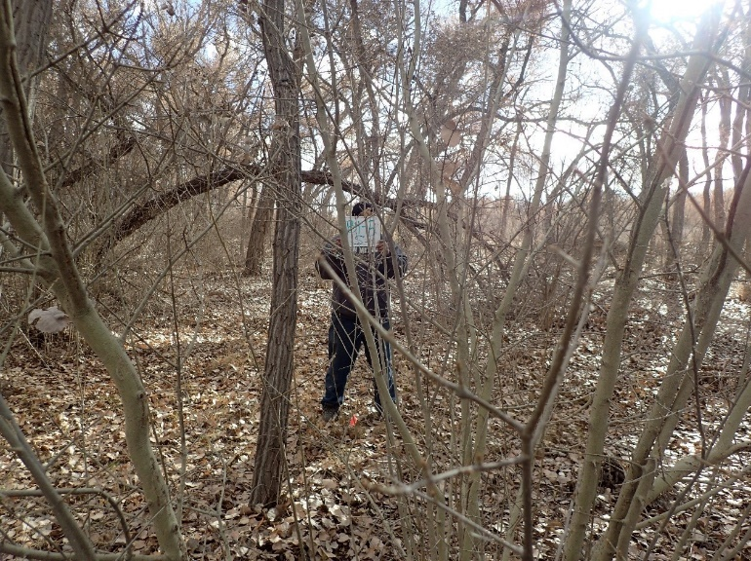11.11_5S, facing south from center at 11.8’ (2016)
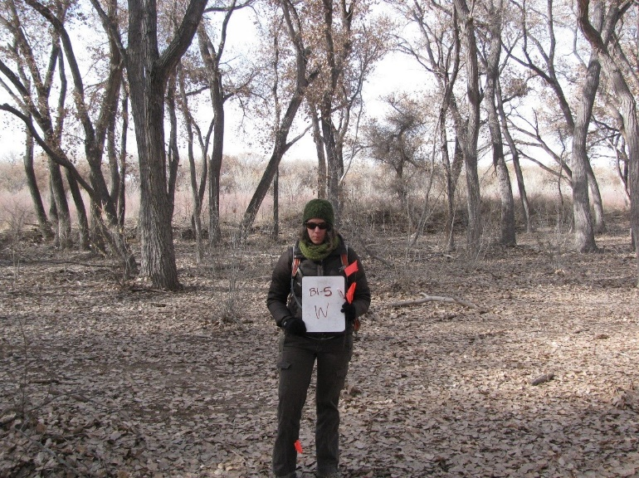11.11_5W, facing west from center at 11.8’ (2011)
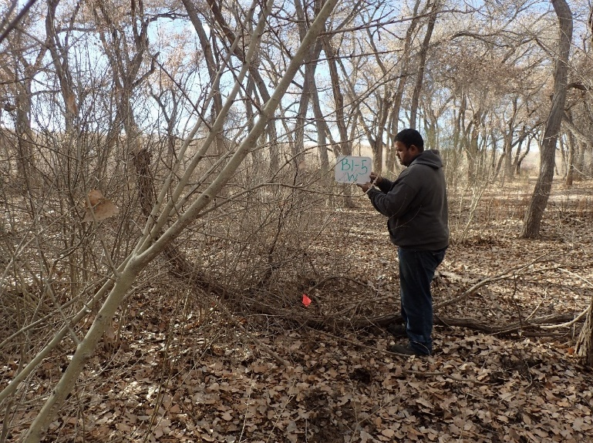11.11_5W, facing west from center at 11.8’ (2016)
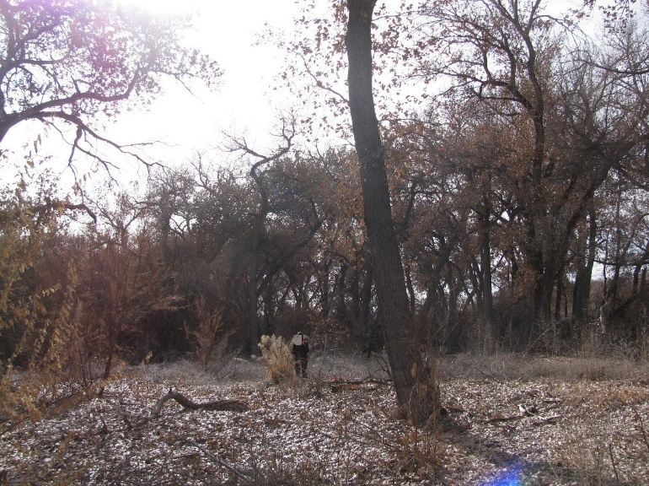11.11_6C, facing center from north at 66’ (2011)
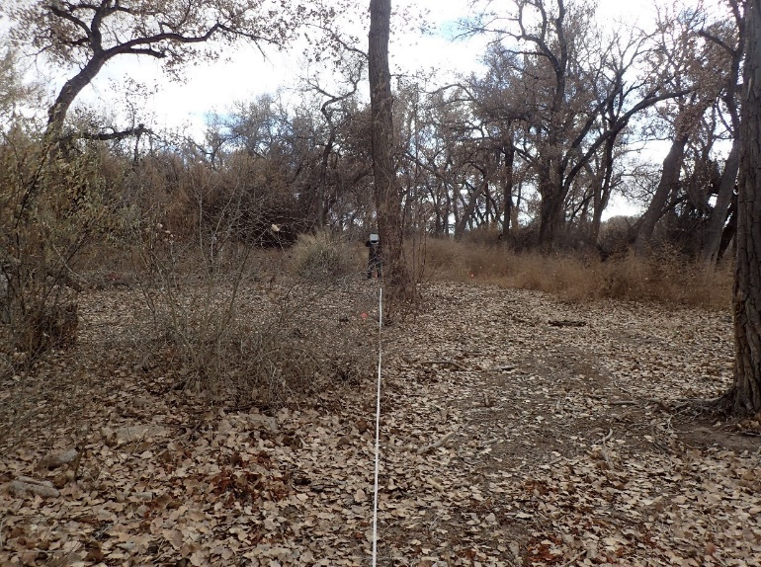11.11_6C, facing center from north at 66’ (2016)
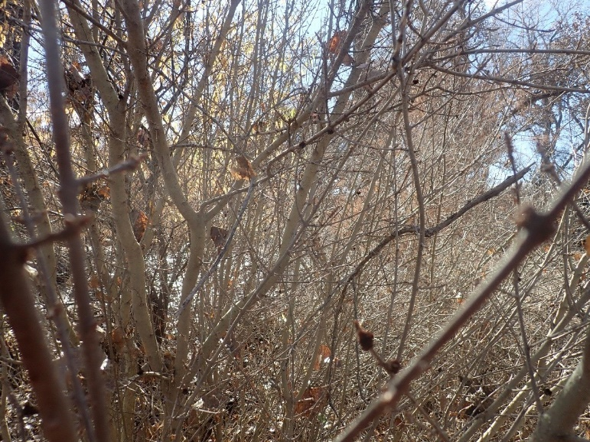11.11_6C, facing center from north at 66’ (2022)
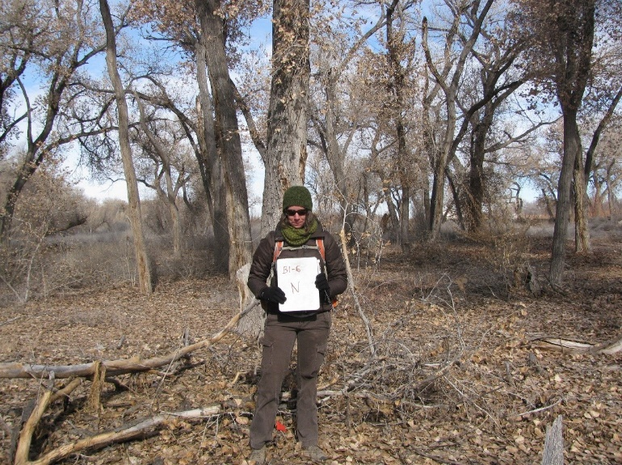11.11_6N, facing north from center at 11.8’ (2011)
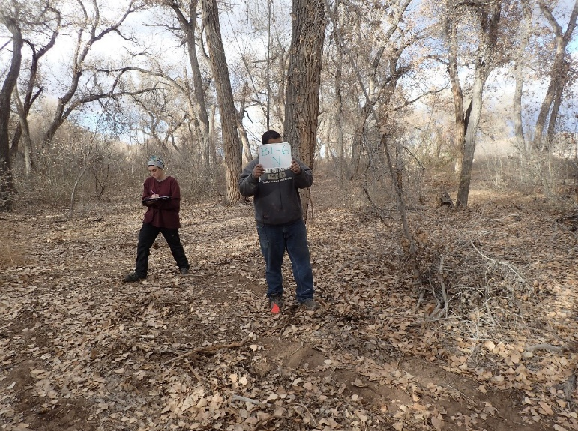11.11_6N, facing north from center at 11.8’ (2016)
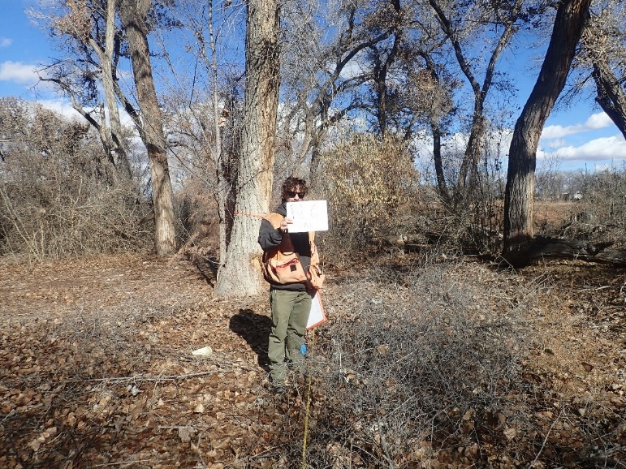11.11_6N, facing north from center at 11.8’ (2022)
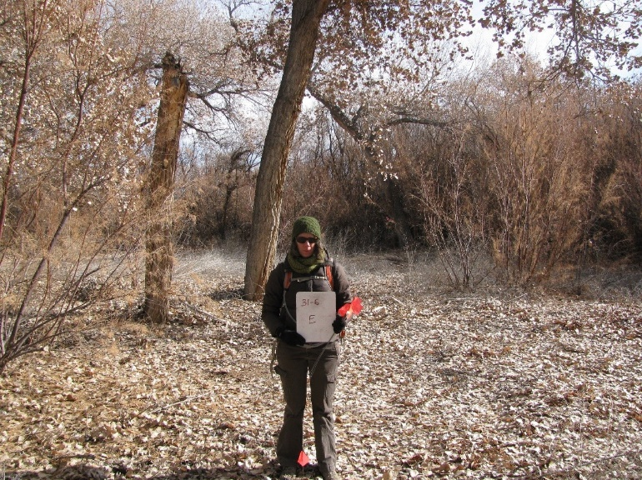11.11_6E
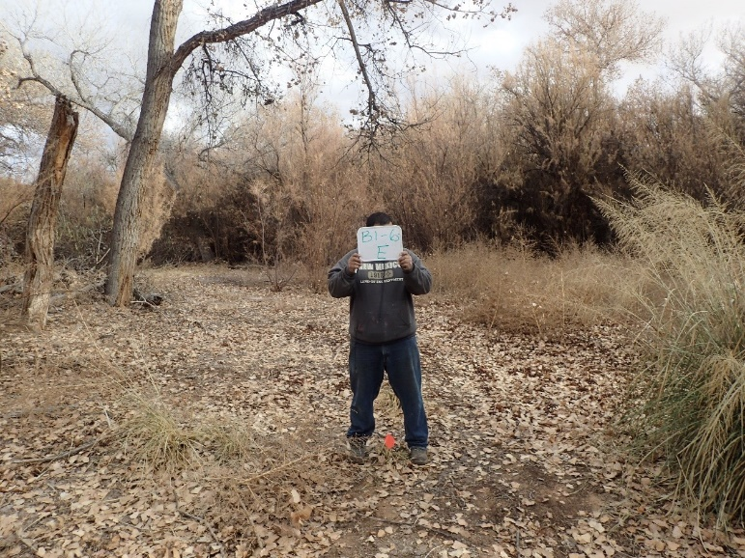11.11_6E, facing east from center at 11.8’ (2016)
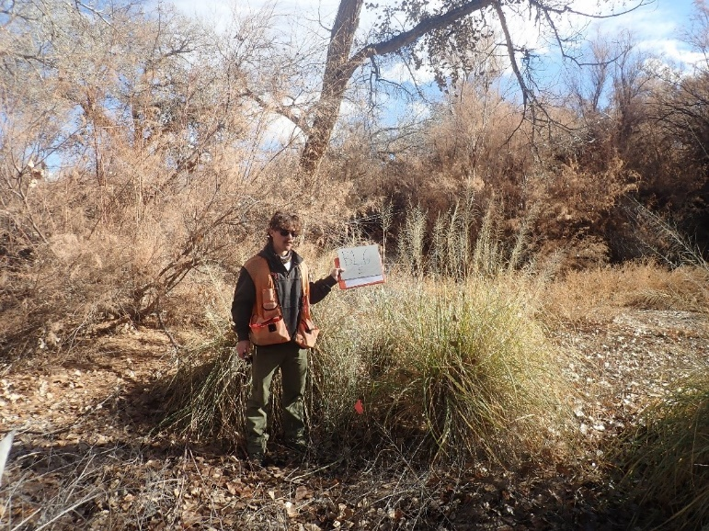11.11_6E, facing east from center at 11.8’ (2022)
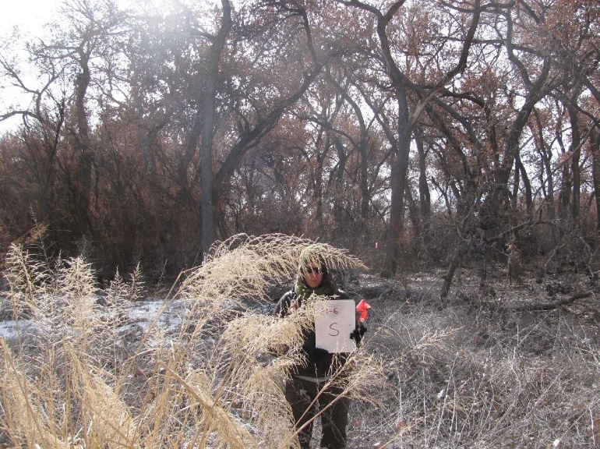11.11_6S, facing south from center at 11.8’ (2011)
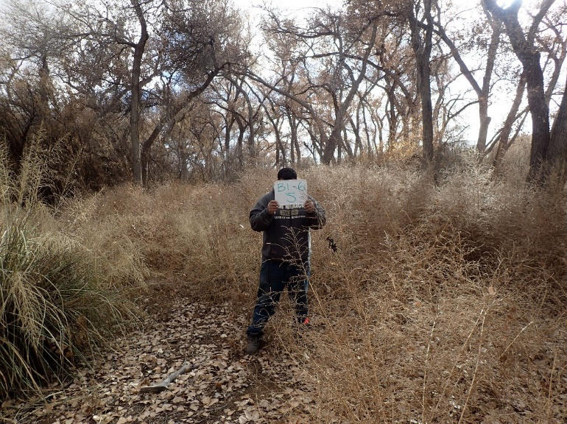11.11_6S, facing south from center at 11.8’ (2016)
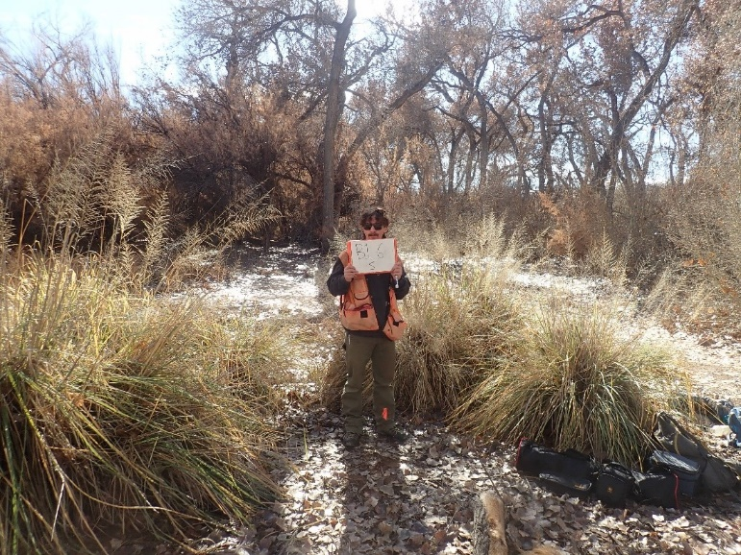11.11_6S, facing south from center at 11.8’ (2022)
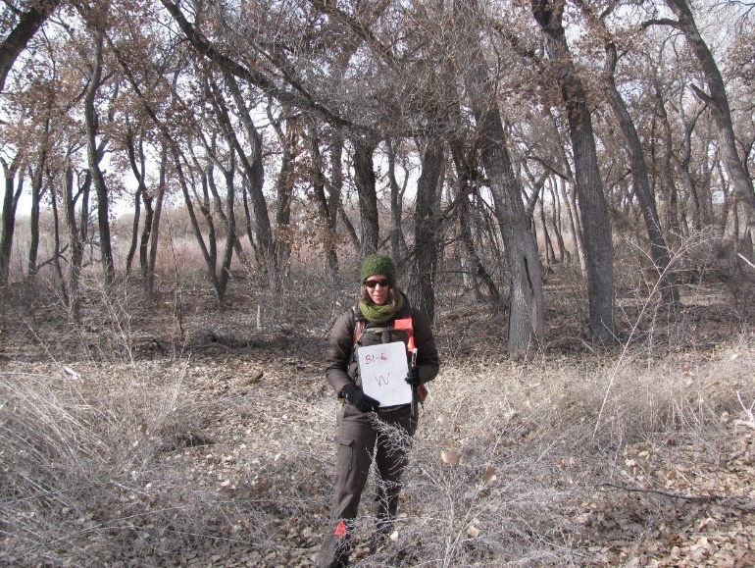11.11_6W, facing west from center at 11.8’ (2011)
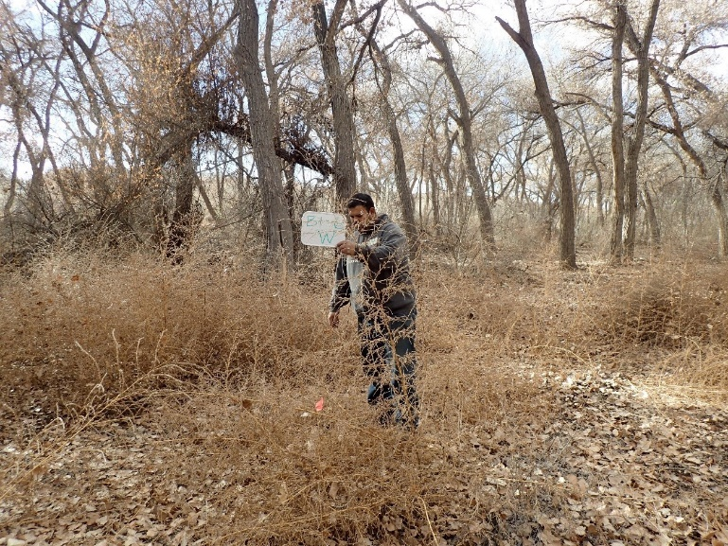11.11_6W, facing west from center at 11.8’ (2016)
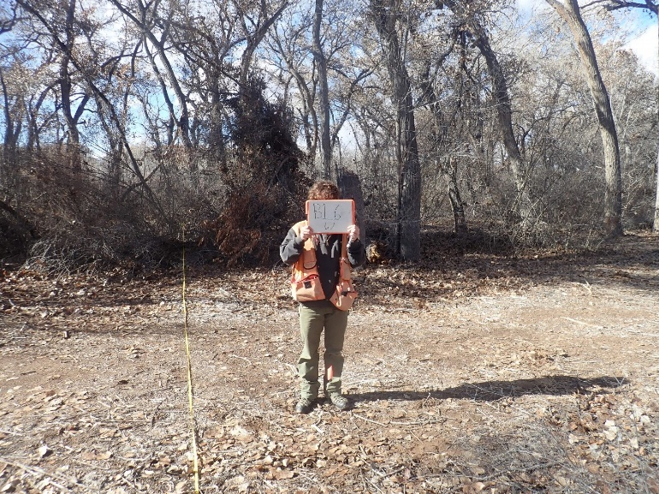11.11_6W, facing west from center at 11.8’ (2022)

Belen 2
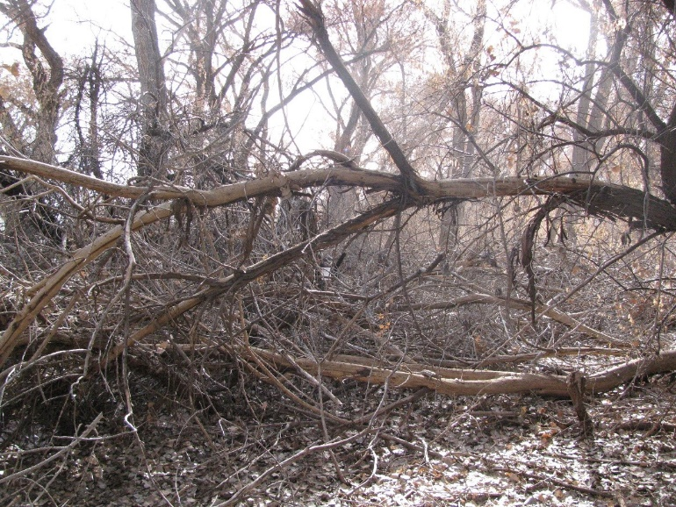11.12_1C, facing center from north at 66’ (2011)
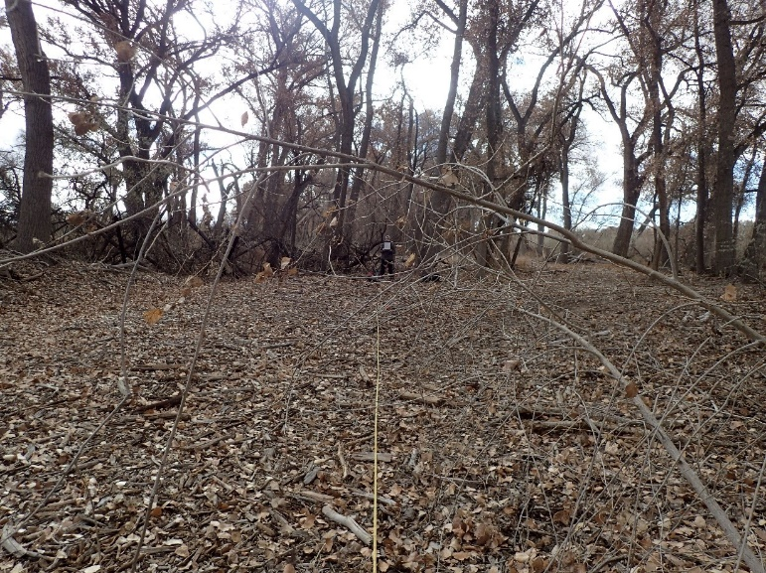11.12_1C, facing center from north at 66’ (2016)
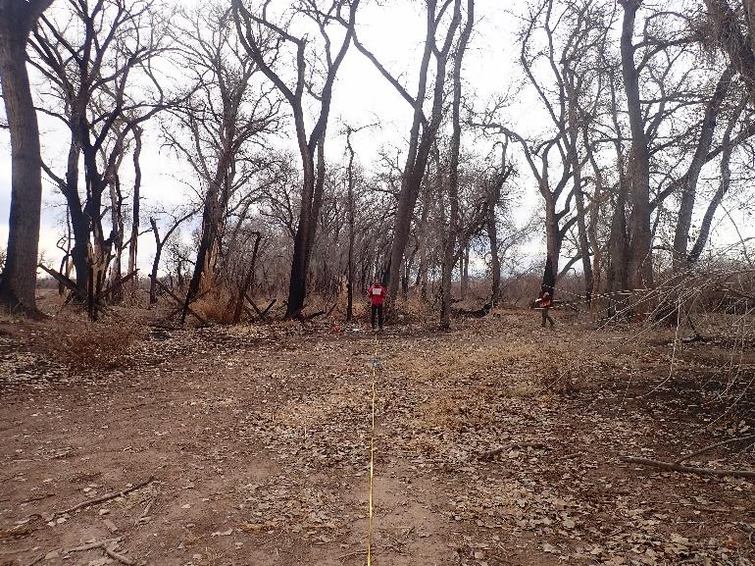11.12_1C, facing center from north at 66’ (2022)
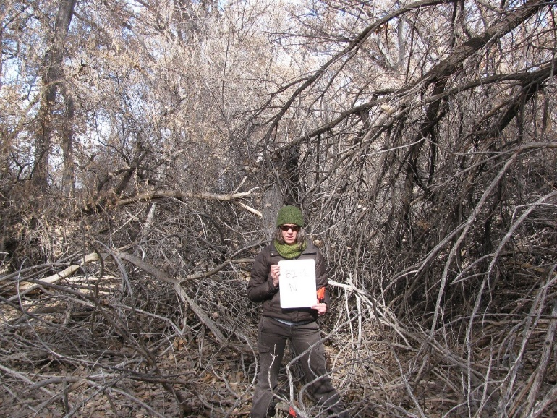11.12_1N, facing north from center at 11.8’ (2011)
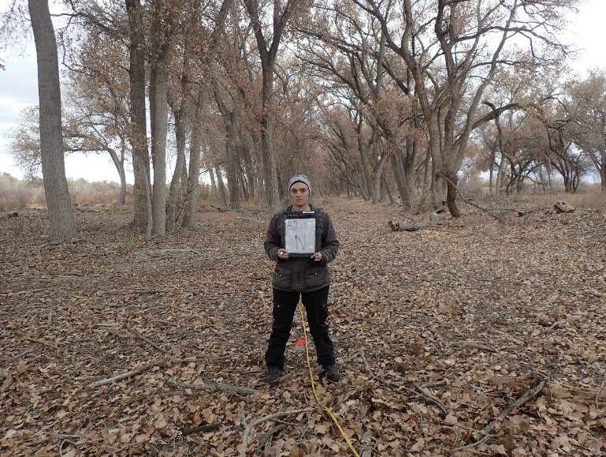11.12_1N, facing north from center at 11.8’ (2016)
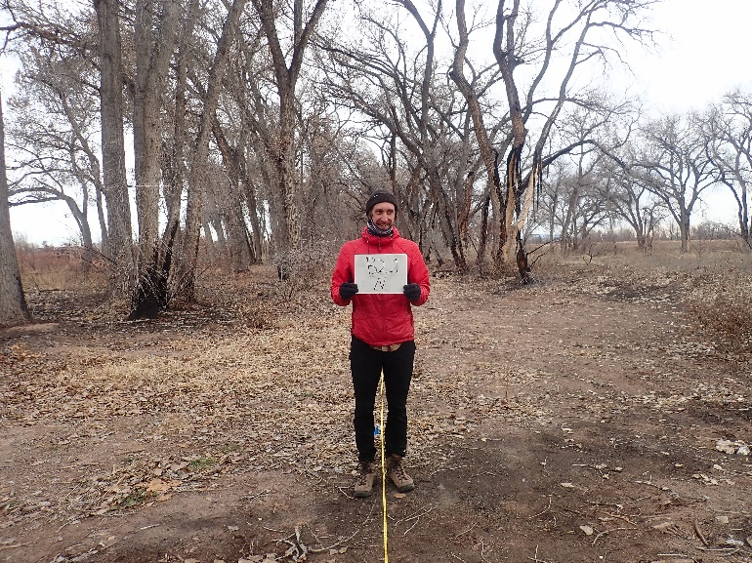11.12_1N, facing north from center at 11.8’ (2022)
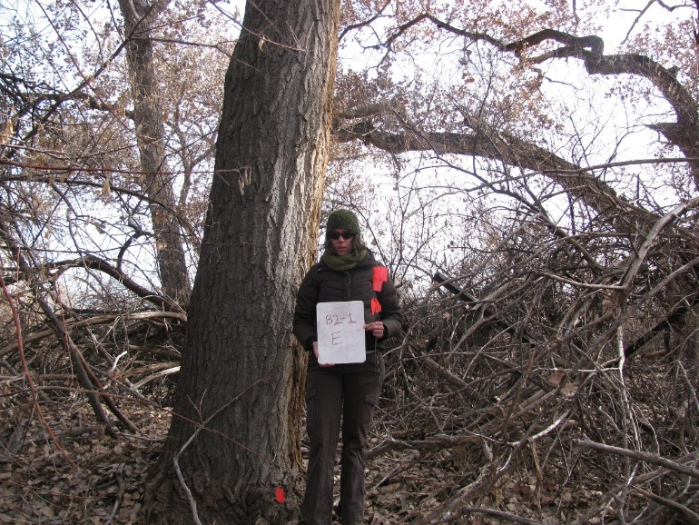11.12_1E, Facing east from center at 11.8’ (2011)
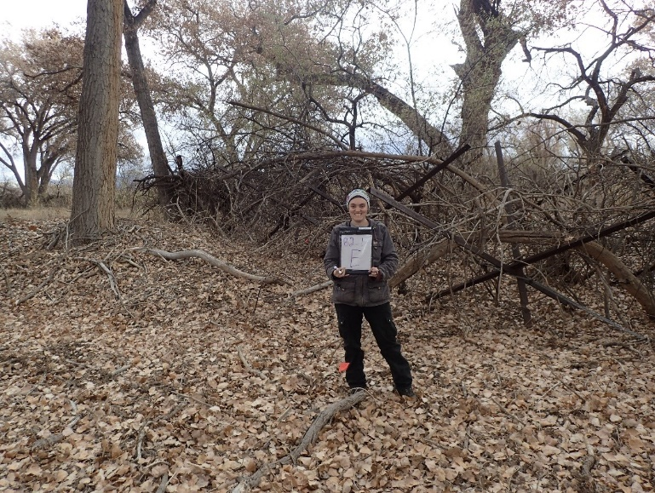11.12_1E, facing east from center at 11.8’ (2016)
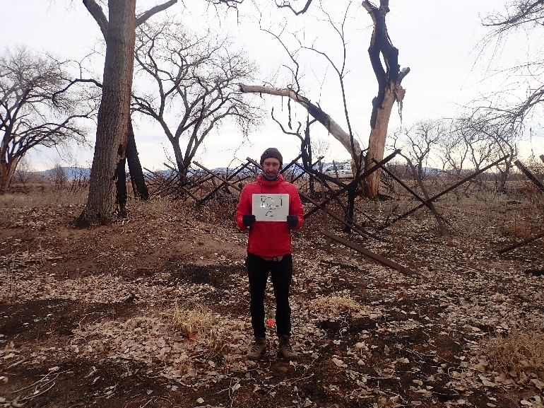11.12_1E, Facing east from center at 11.8’ (2022)
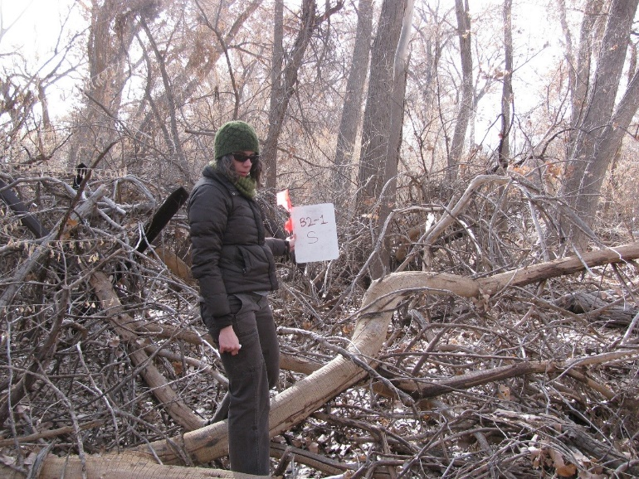11.12_1S, facing south from center at 11.8’ (2011)
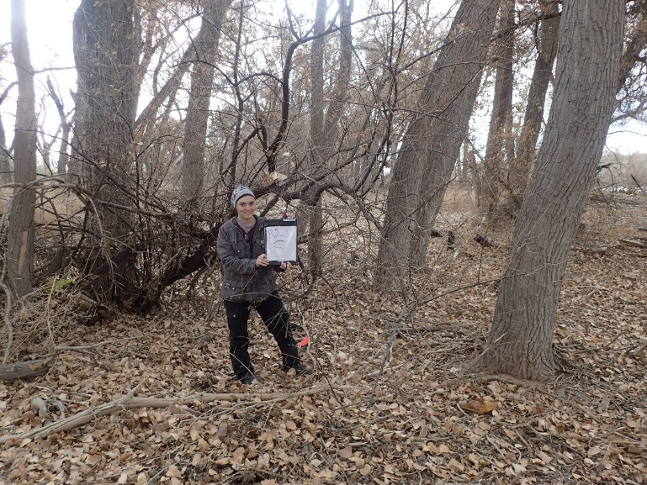11.12_1S, facing south from center at 11.8’ (2016)
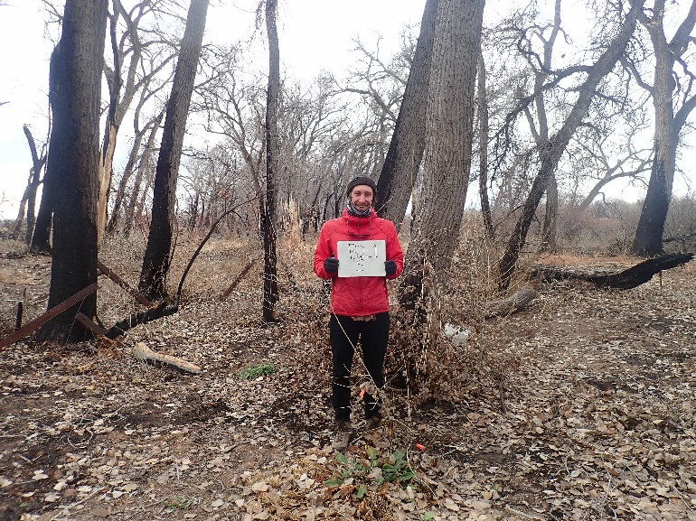11.12_1S, facing south from center at 11.8’ (2022)
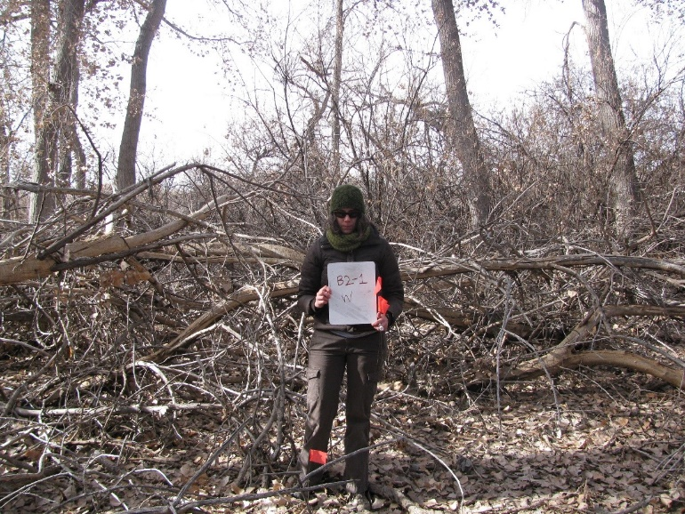11.12_1W, facing west from center at 11.8’ (2011)
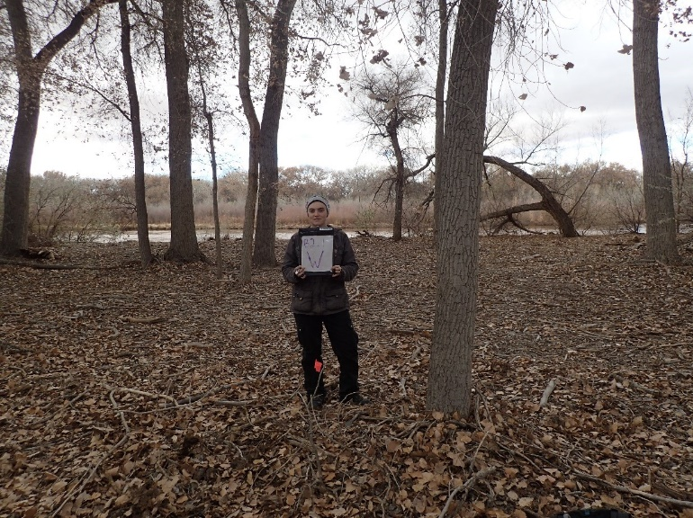11.12_1W, facing west from center at 11.8’ (2016)
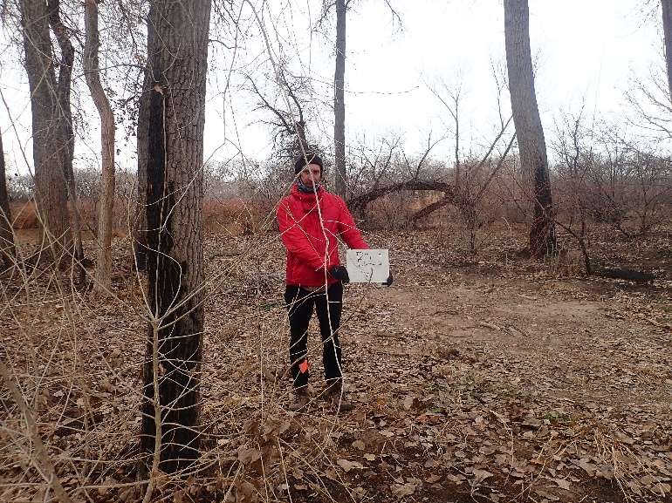11.12_1W, facing west from center at 11.8’ (2022)
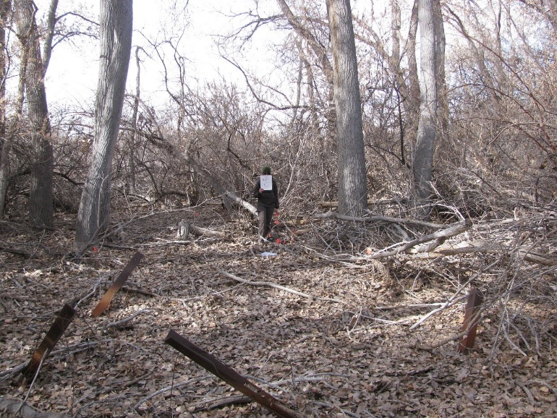11.12_2C, facing center from north at 66’ (2011)
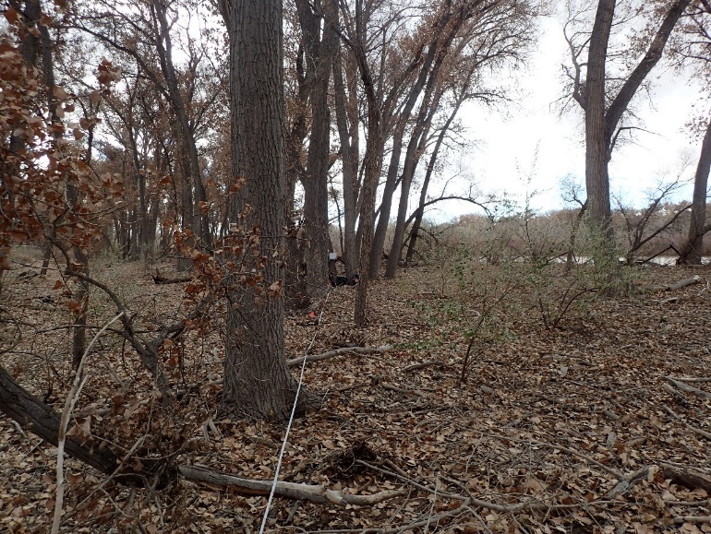11.12_2C, facing center from north at 66’ (2016)
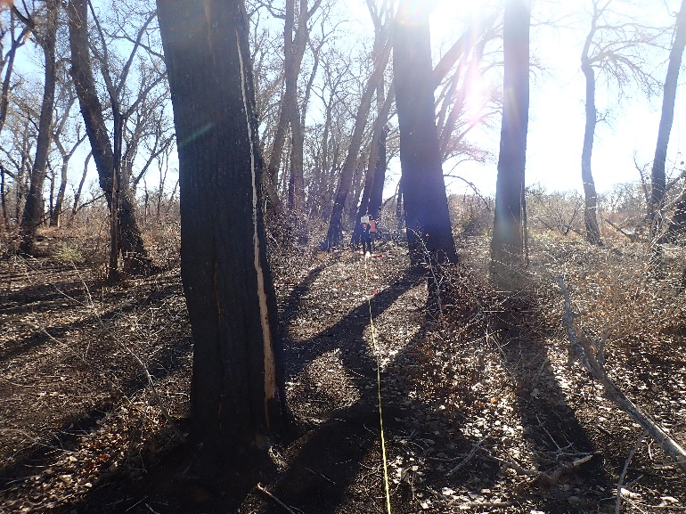11.12_2C, facing center from north at 66’ (2022)
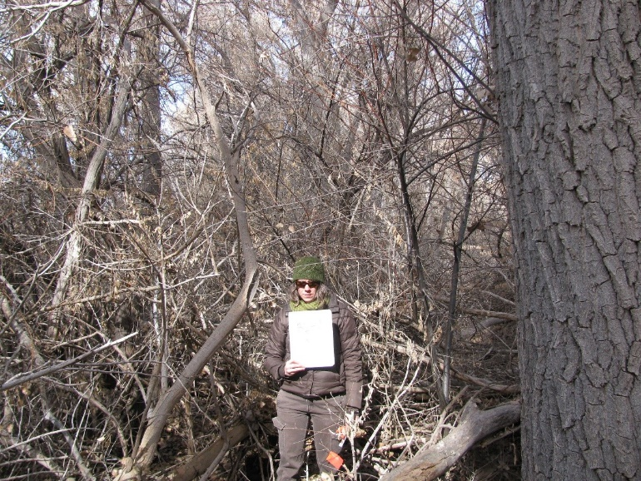11.12_2N, facing north from center at 11.8’ (2011)
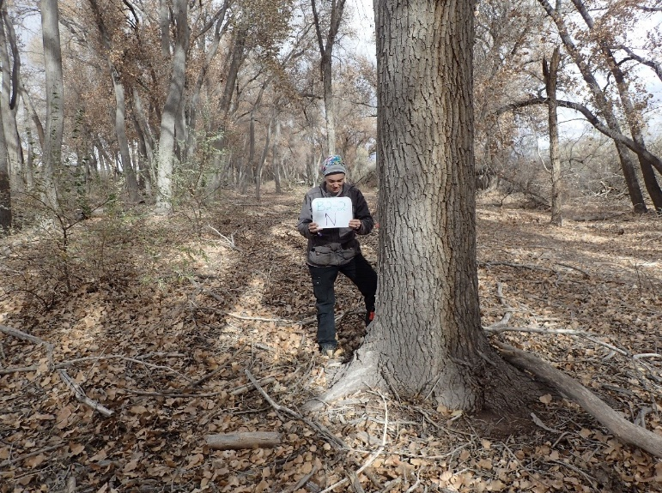11.12_2N, facing north from center at 11.8’ (2016)
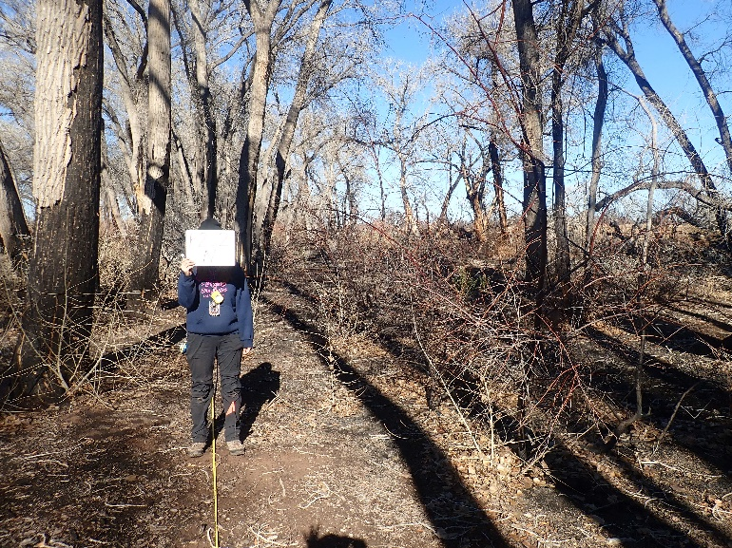11.12_2N, facing north from center at 11.8’ (2022)
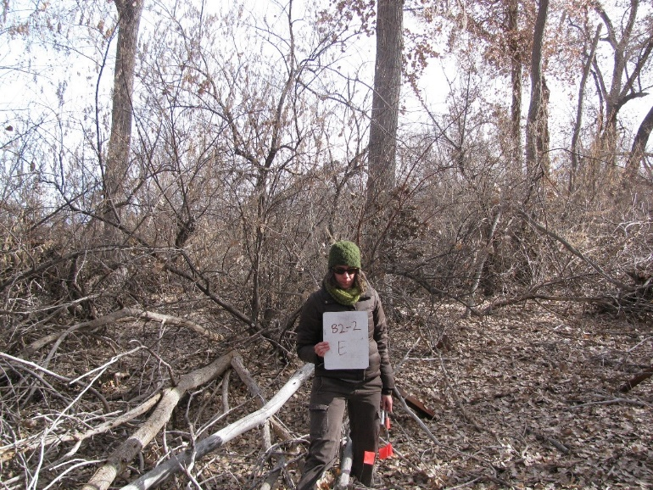11.12_2E, facing east from center at 11.8’ (2011)
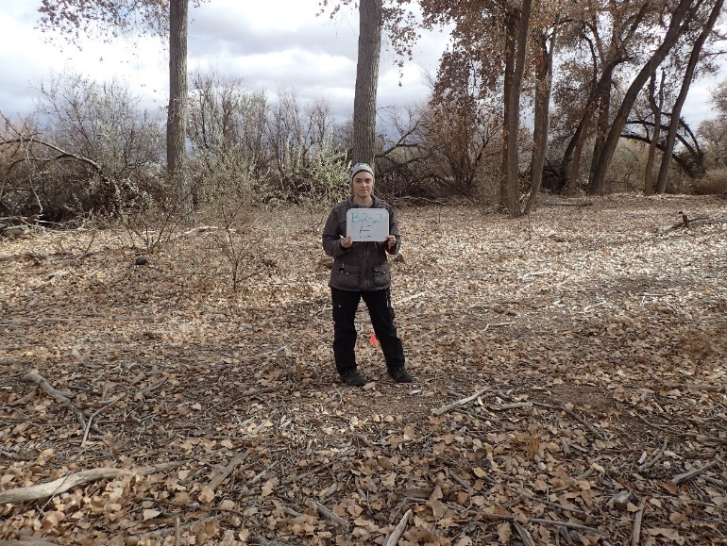11.12_2E, facing east from center at 11.8’ (2016)
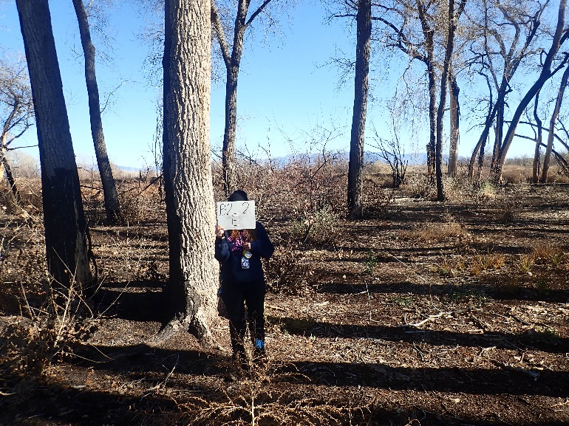11.12_2E, facing east from center at 11.8’ (2022)
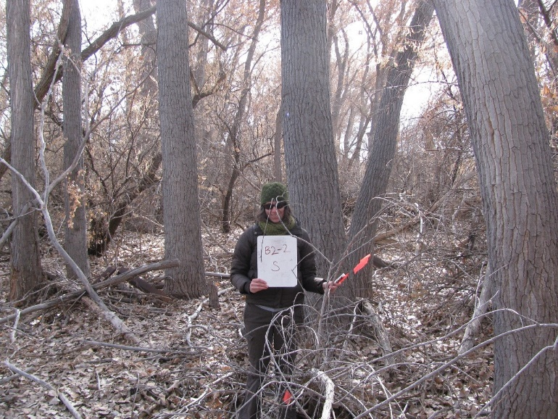11.12_2S, facing south from center at 11.8’ (2011)
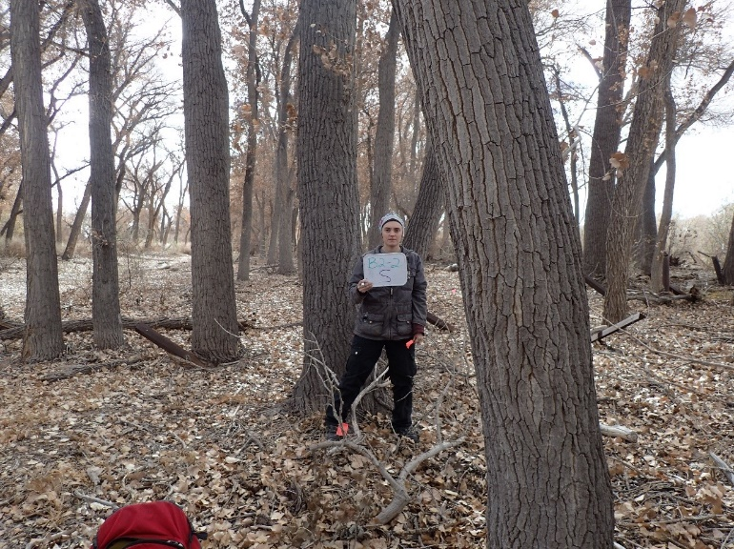11.12_2S, facing south from center at 11.8’ (2016)
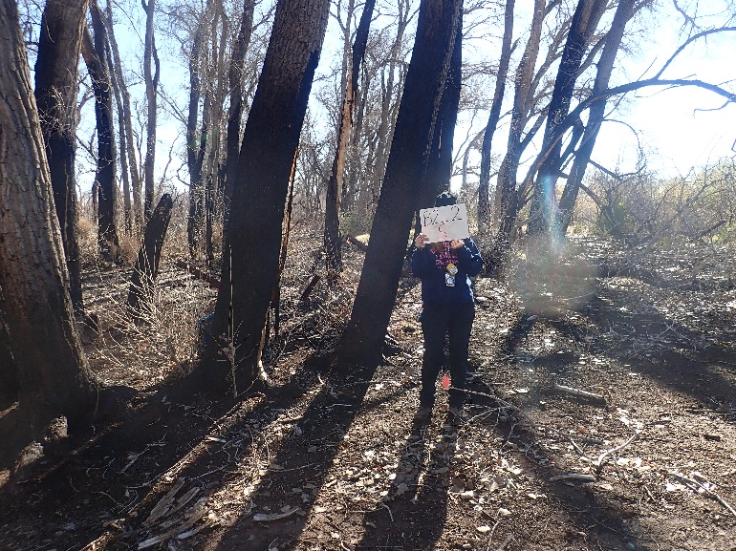11.12_2S, facing south from center at 11.8’ (2022)
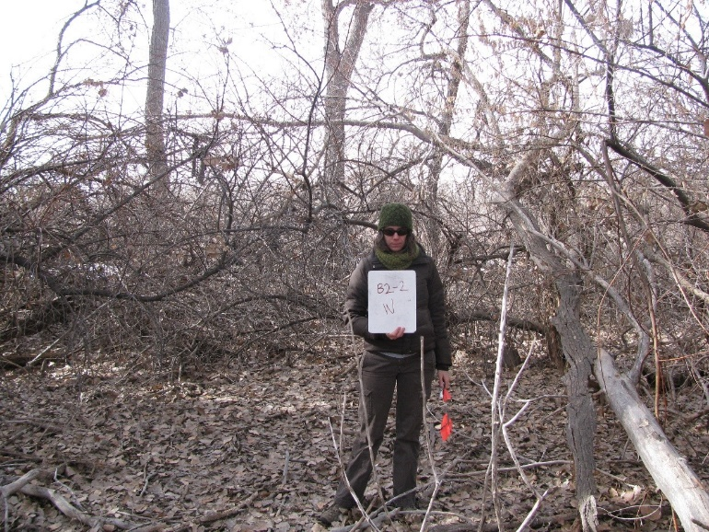11.12_2W, facing west from center at 11.8’ (2011)
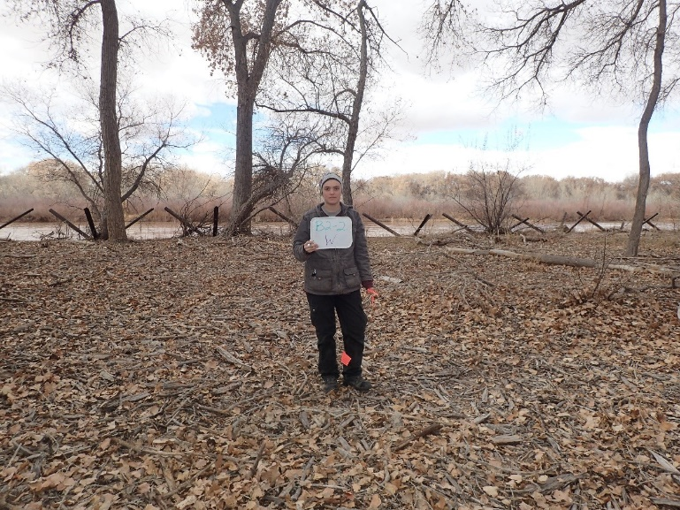11.12_2W, facing west from center at 11.8’ (2016)
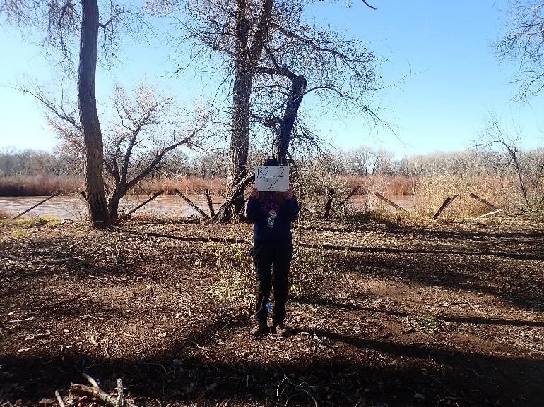11.12_2W, facing west from center at 11.8’ (2022)
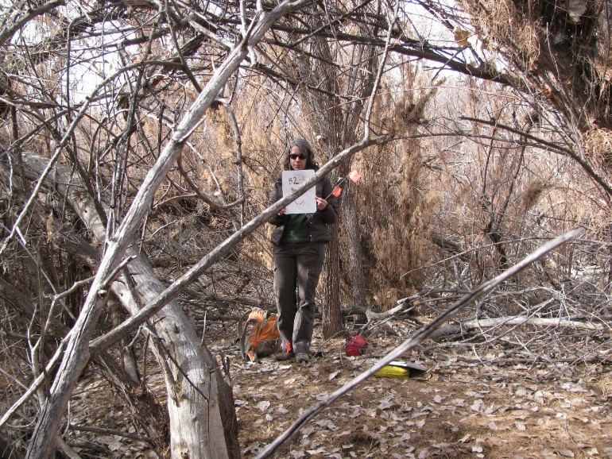11.12_3C, facing center from north at 66’ (2011)
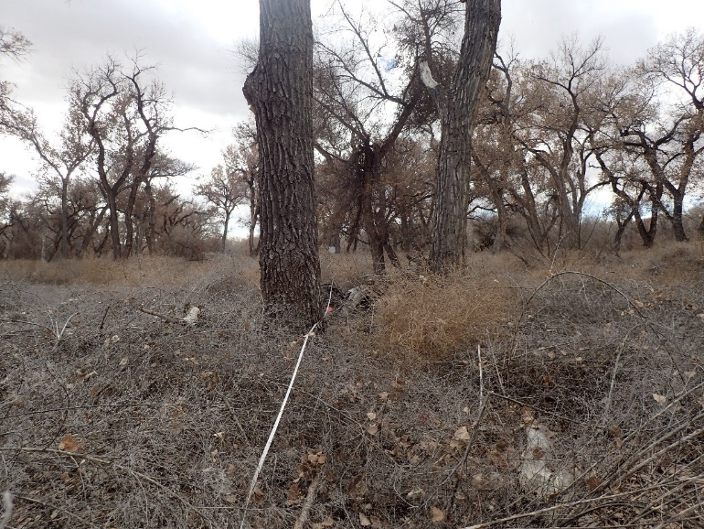11.12_3C, facing center from north at 66’ (2016)
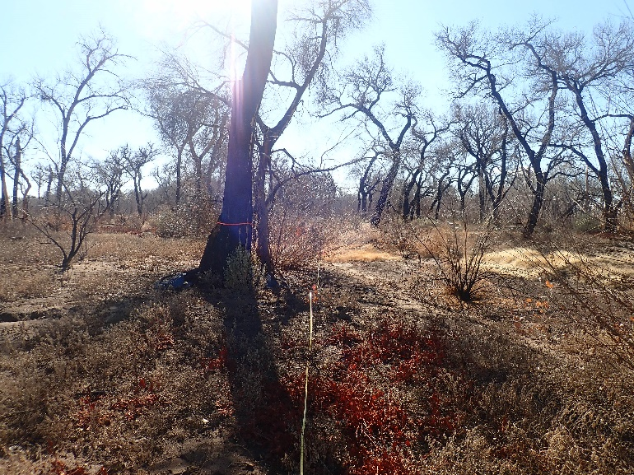11.12_3C, facing center from north at 66’ (2022)
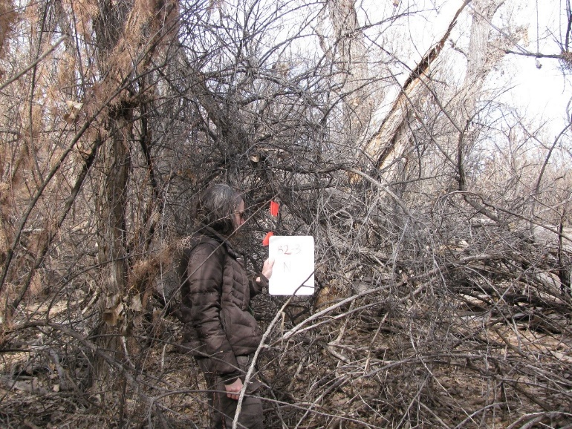11.12_3N, facing north from center at 11.8’ (2011)
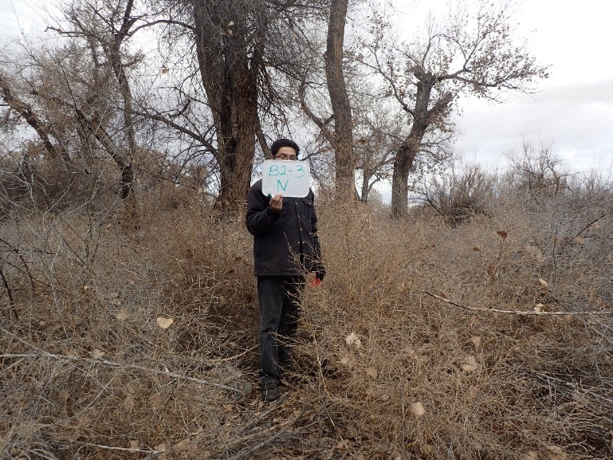11.12_3N, facing north from center at 11.8’ (2016)
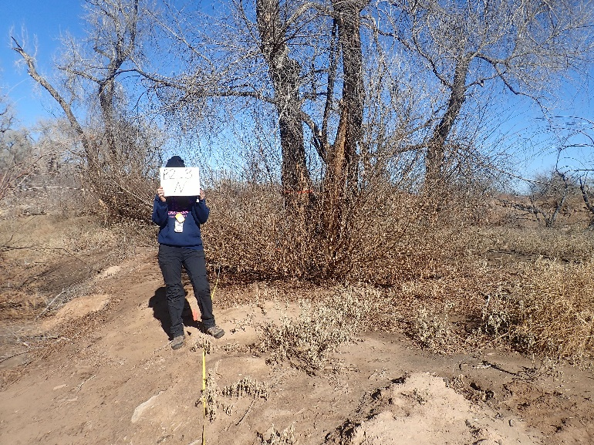11.12_3N, facing north from center at 11.8’ (2022)
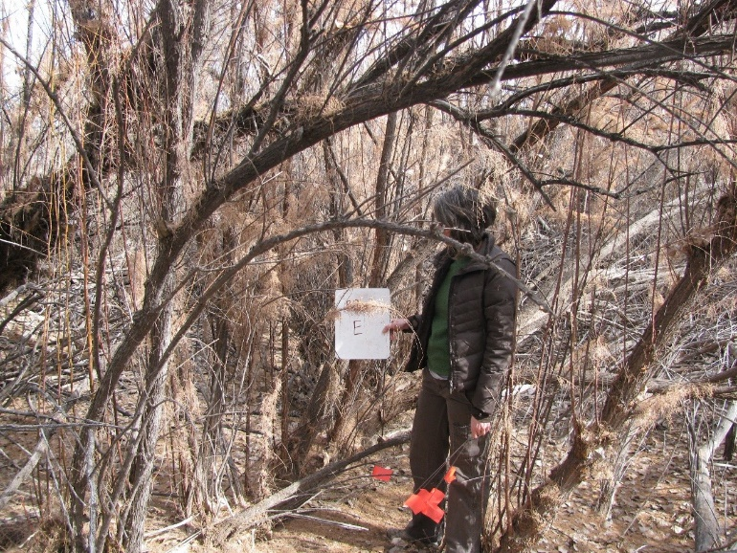11.12_3E, facing east from center at 11.8’ (2011)
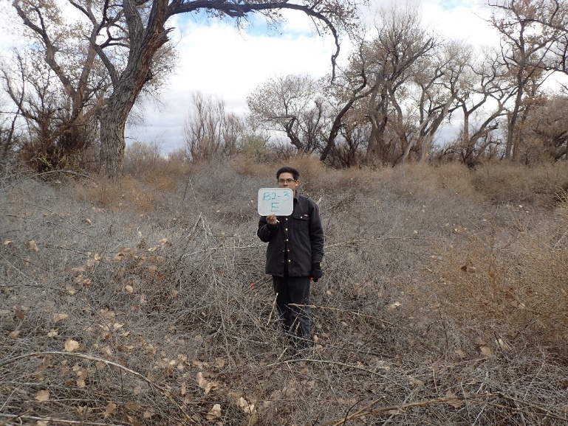11.12_3E, facing east from center at 11.8’ (2016)
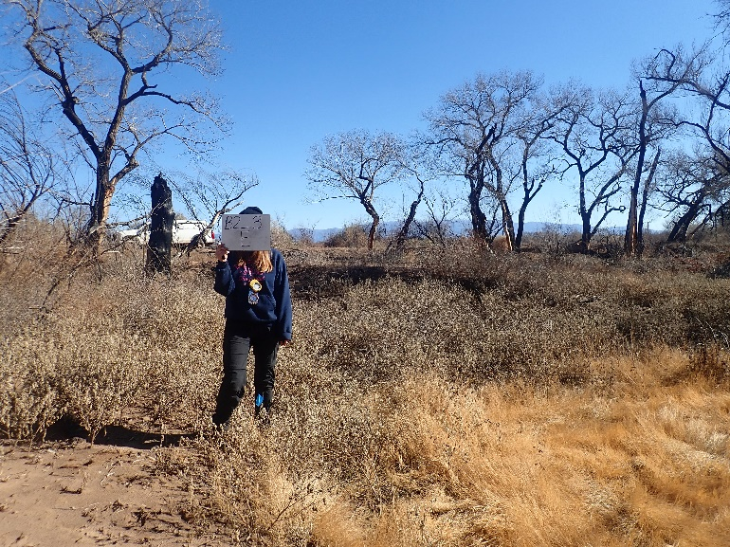11.12_3E, facing east from center at 11.8’ (2022)
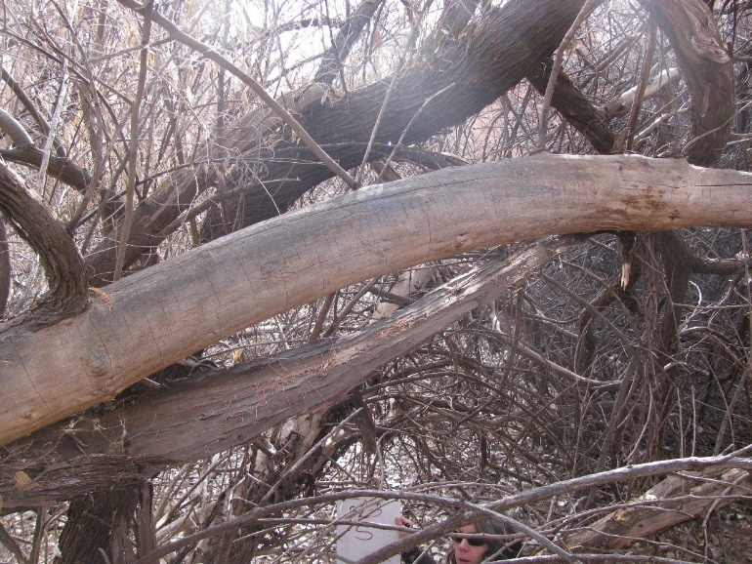11.12_3S, facing south from center at 11.8’ (2011)
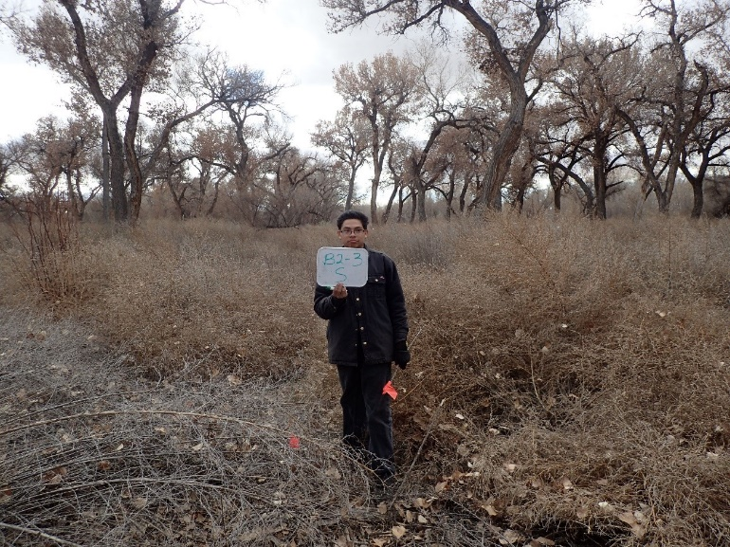11.12_3S, facing south from center at 11.8’ (2016)
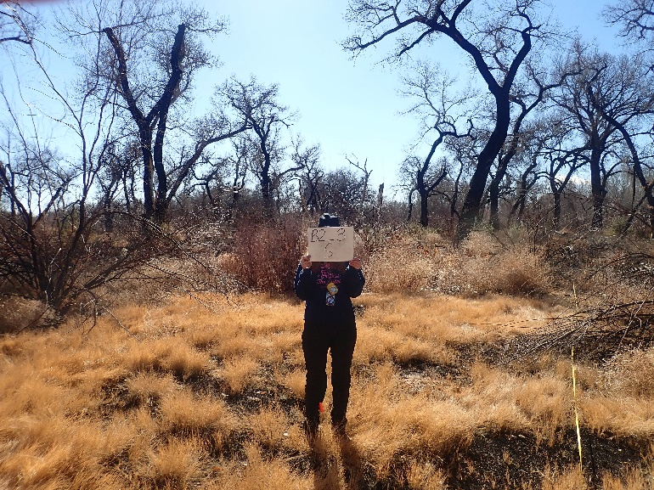11.12_3S, facing south from center at 11.8’ (2022)
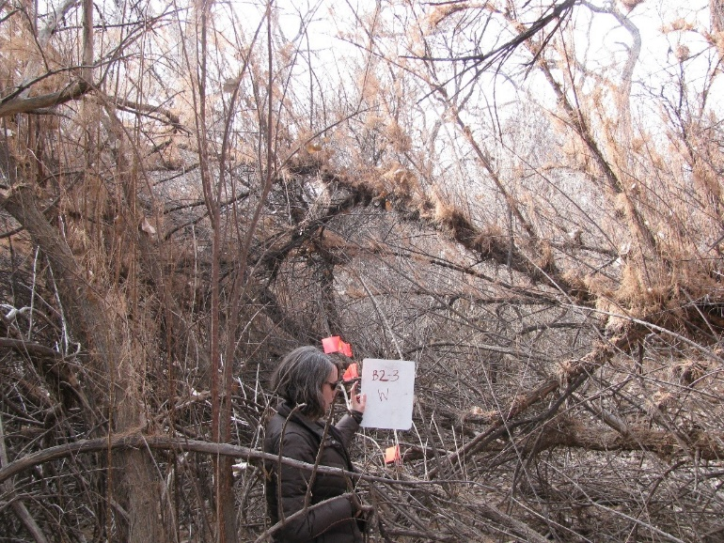11.12_3W, facing west from center at 11.8’ (2011)
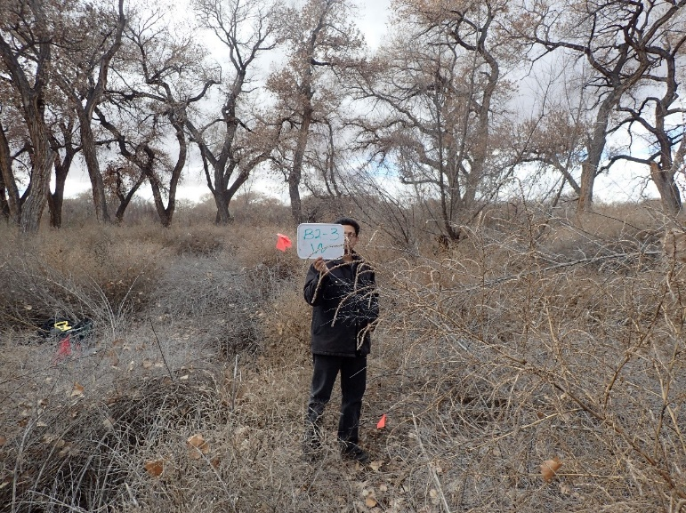11.12_3W, facing west from center at 11.8’ (2016)
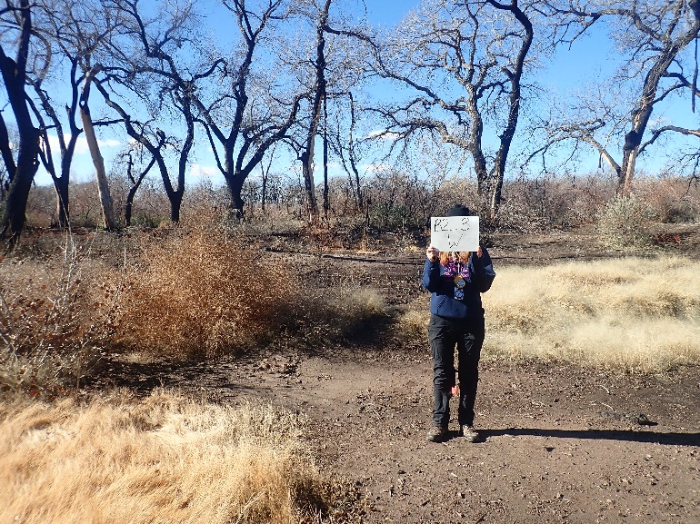11.12_3W, facing west from center at 11.8’ (2022)
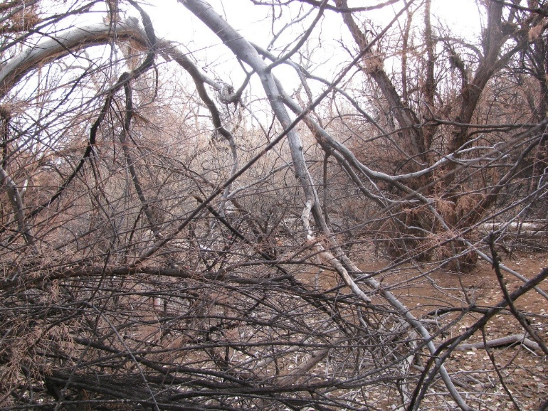11.12_4C, facing center from north at 66’ (2011)
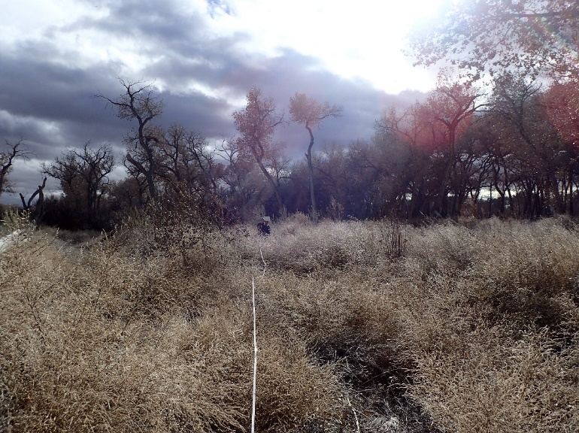11.12_4C, facing center from north at 66’ (2016)
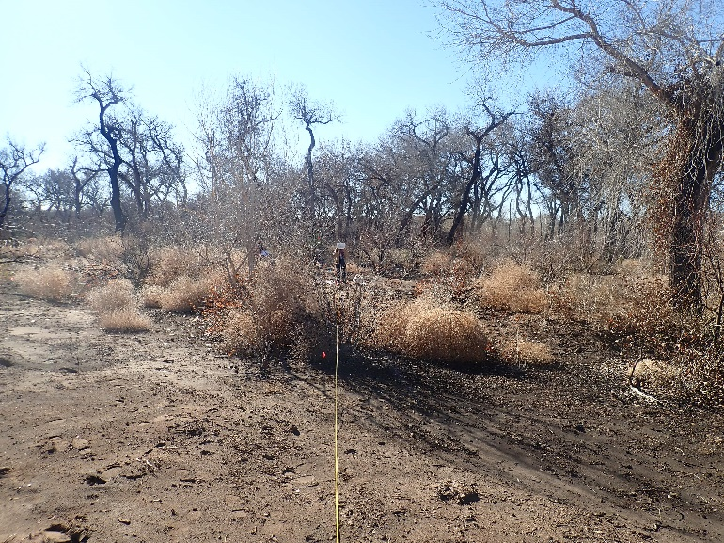11.12_4C, facing center from north at 66’ (2022)
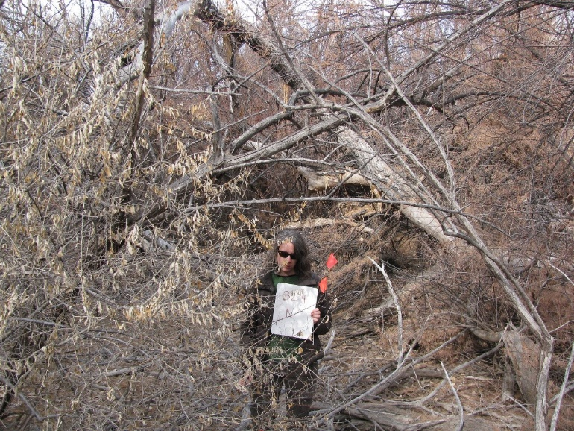11.12_4N, facing north from center at 11.8’ (2011)
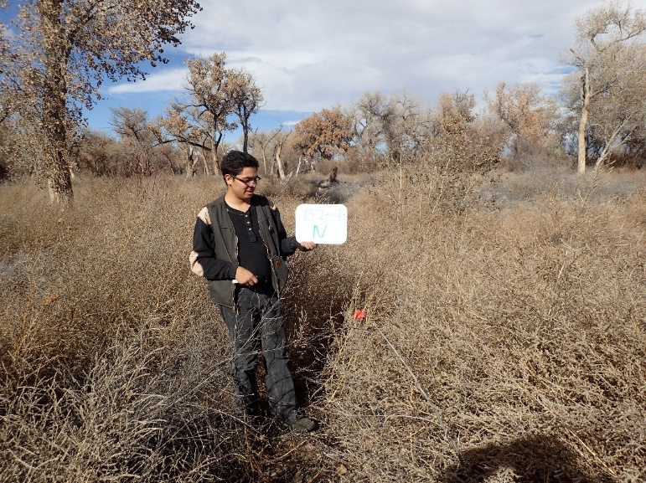11.12_4N, facing north from center at 11.8’ (2016)
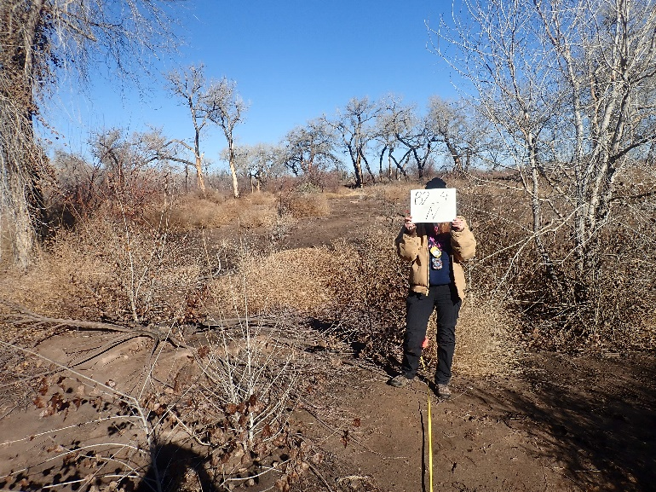11.12_4N, facing north from center at 11.8’ (2022)
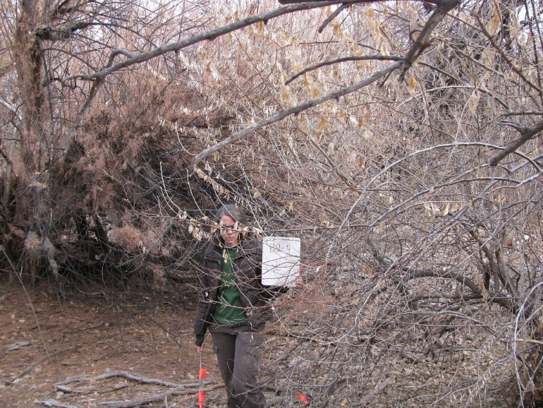11.12_4E, facing east from center at 11.8’ (2011)
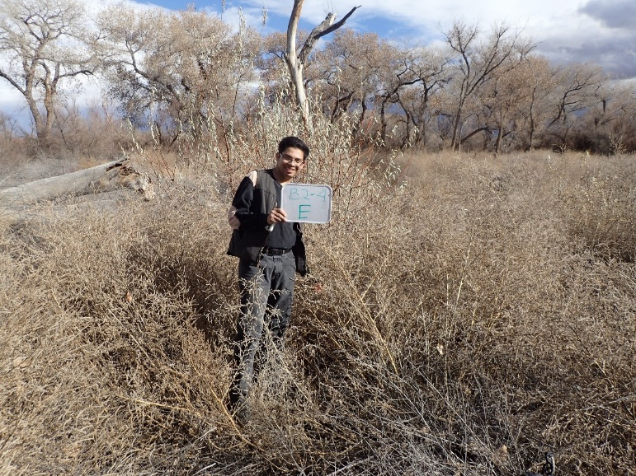11.12_4E, facing east from center at 11.8’ (2016)
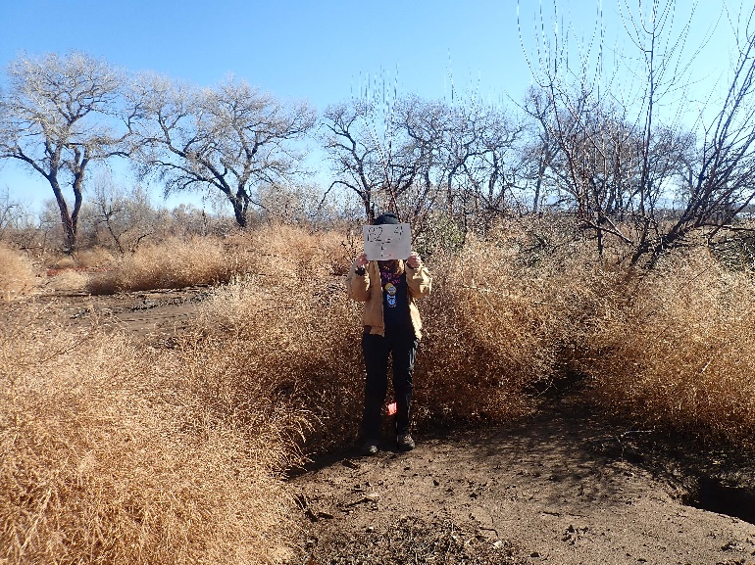11.12_4E, facing east from center at 11.8’ (2022)
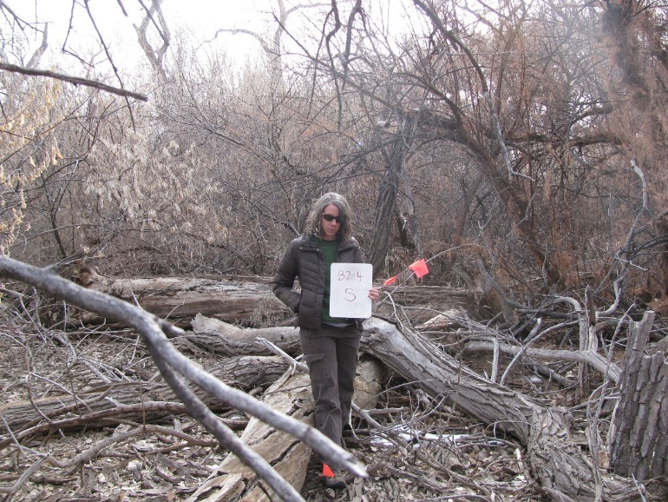11.12_4S, facing south from center at 11.8’ (2011)
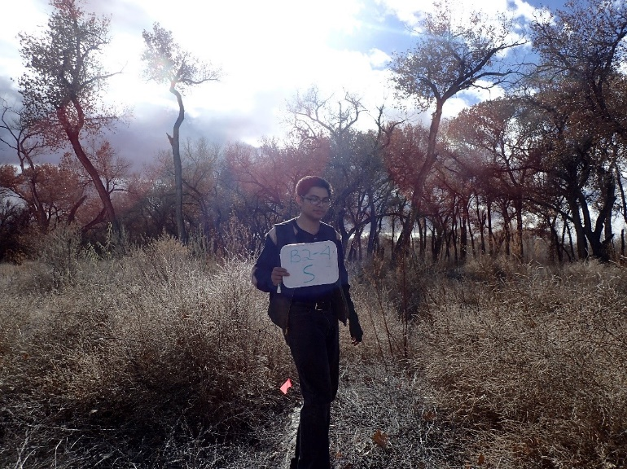11.12_4S, facing south from center at 11.8’ (2016)
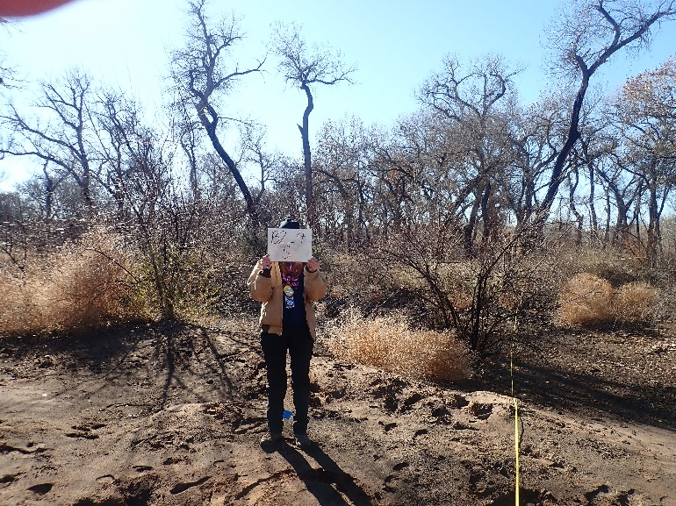11.12_4S, facing south from center at 11.8’ (2022)
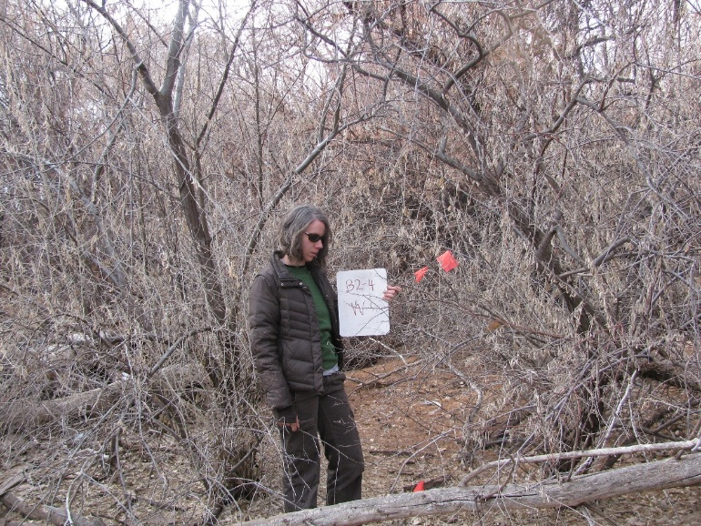11.12_4W, facing west from center at 11.8’ (2011)
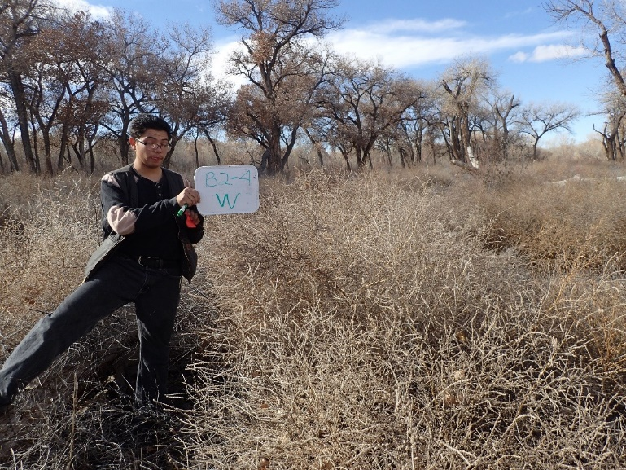11.12_4W, facing west from center at 11.8’ (2016)
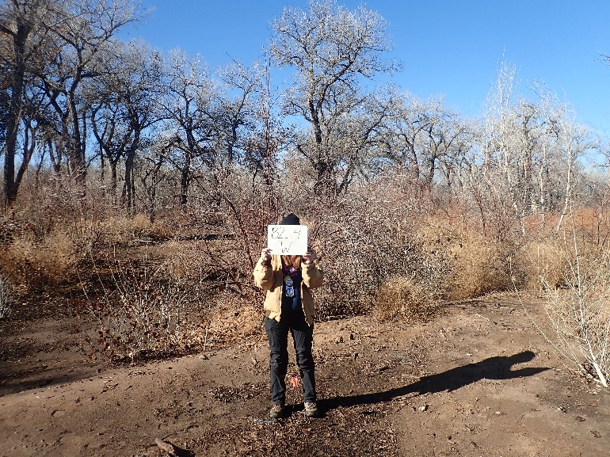11.12_4W, facing south from center at 11.8’ (2022)
Belen 3
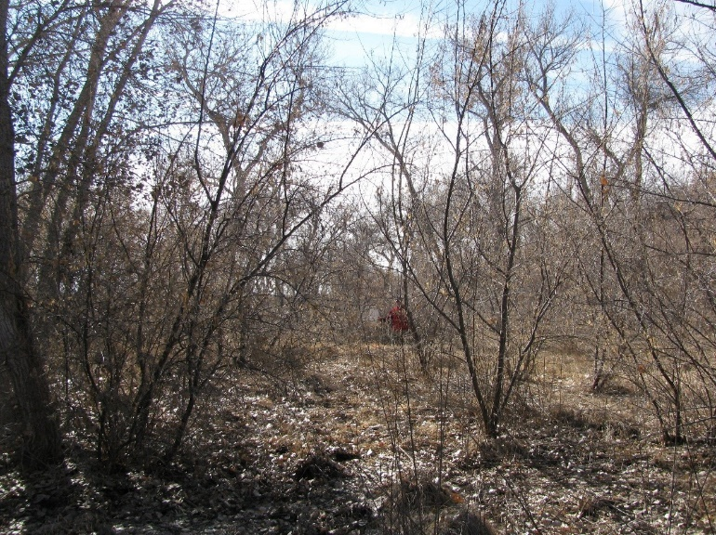11.10_1C, facing center from north at 66’ (2011)
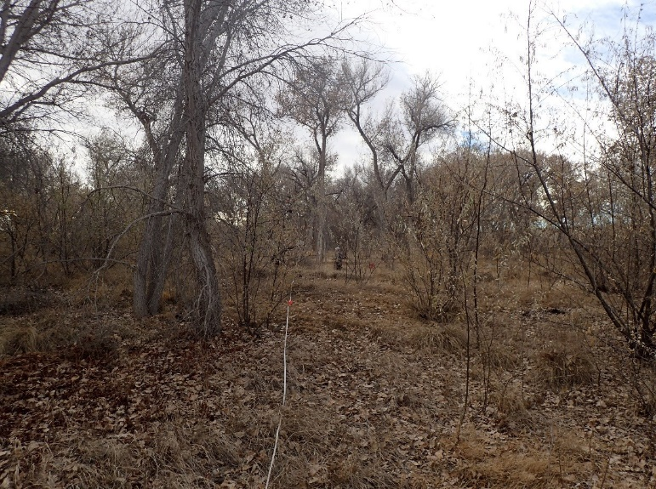11.10_1C, facing center from north at 66’ (2016)
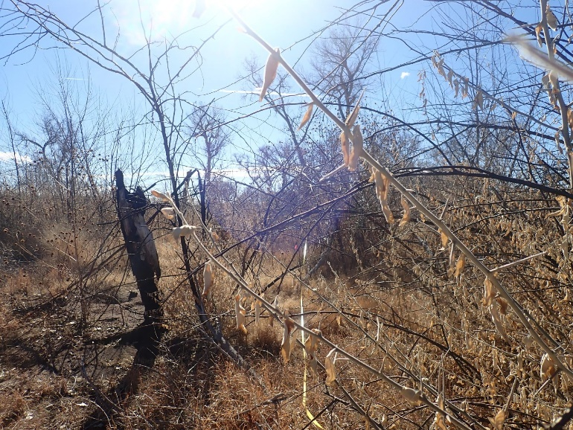11.10_1C, facing center from north at 66’ (2022)
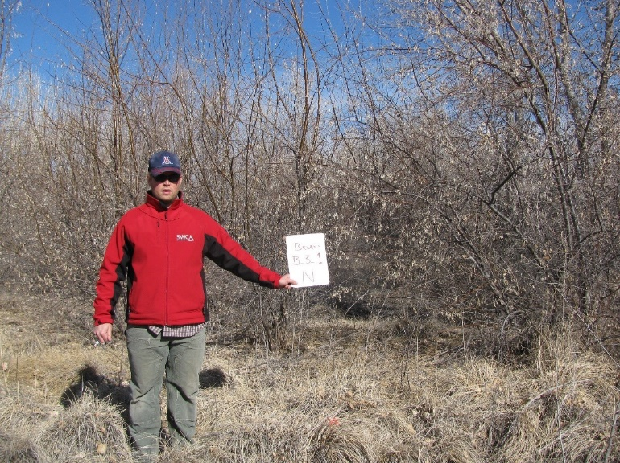11.10_1N, facing north from center at 11.8’ (2011)
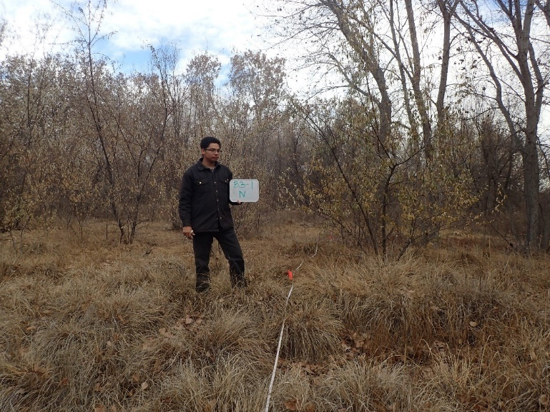11.10_1N, facing north from center at 11.8’ (2016)
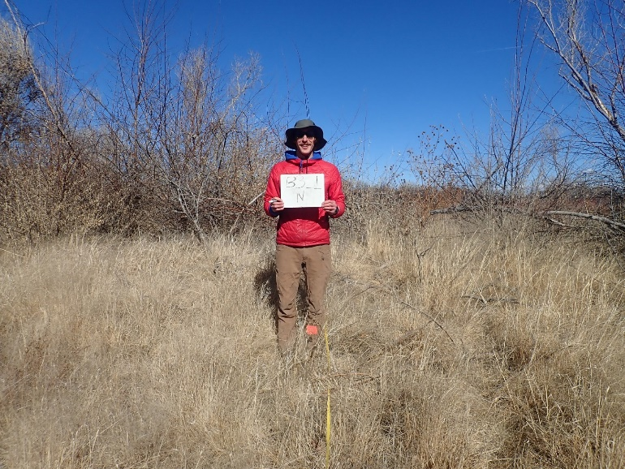11.10_1N, facing north from center at 11.8’ (2022)
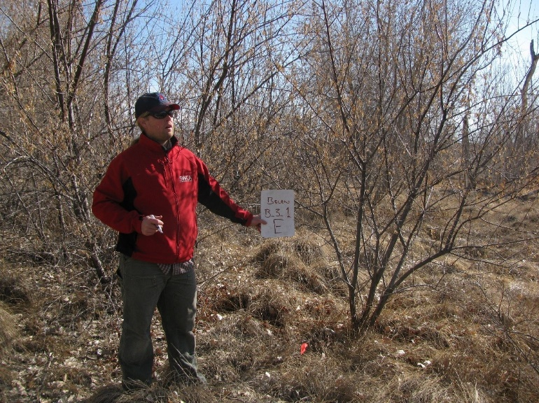11.10_1E, facing east from center at 11.8’ (2011)
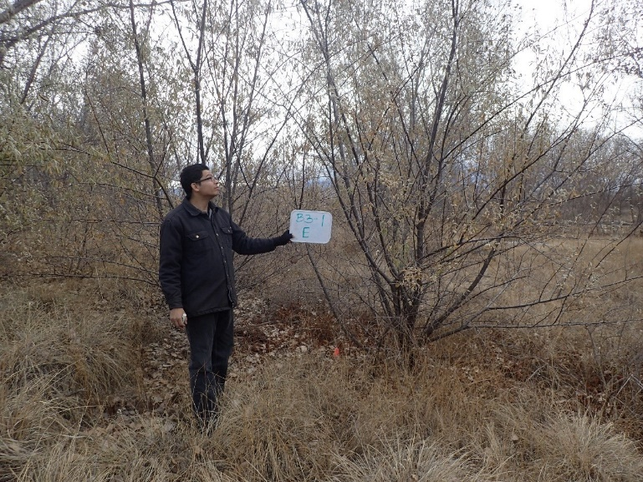11.10_1E, facing east from center at 11.8’ (2016)
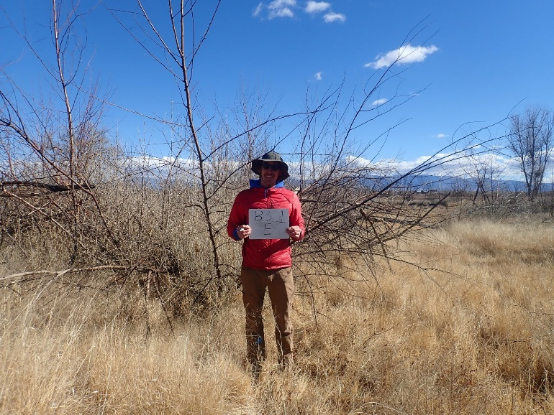11.10_1E, facing east from center at 11.8’ (2022)
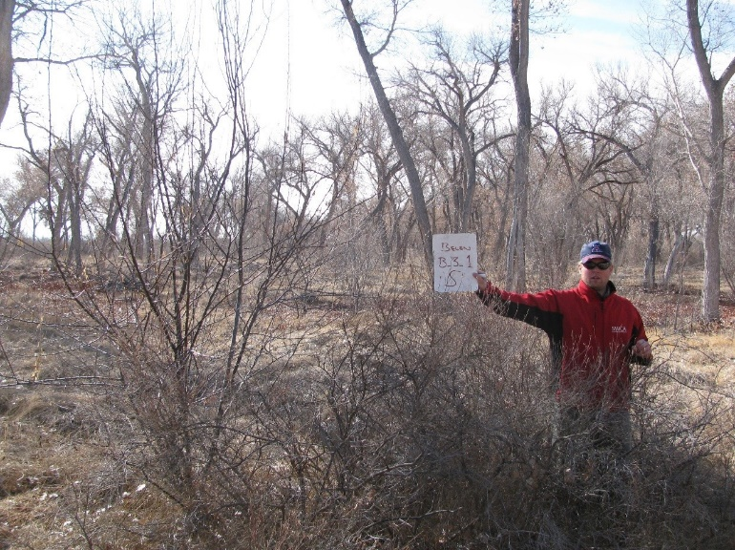11.10_1S, facing south from center at 11.8’ (2011)
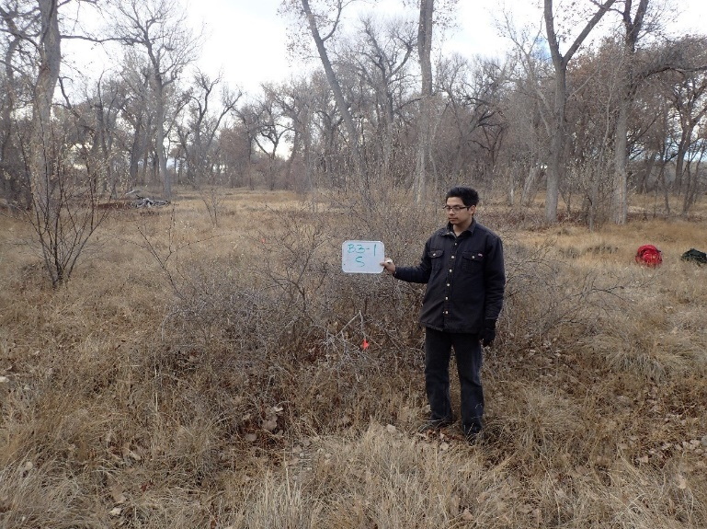11.10_1S, facing south from center at 11.8’ (2016)
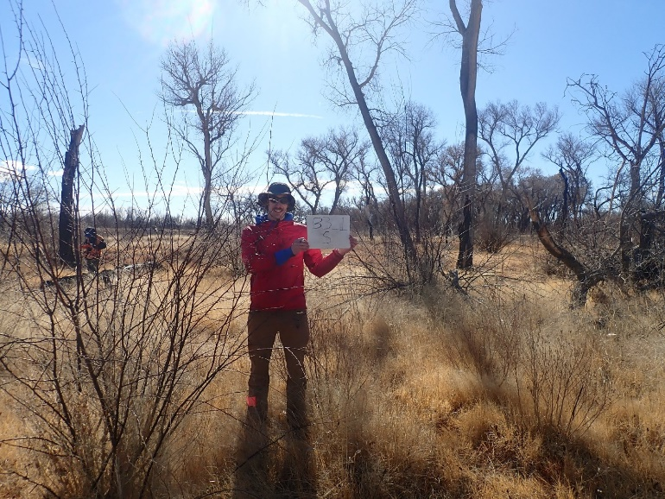11.10_1S, facing south from center at 11.8’ (2022)
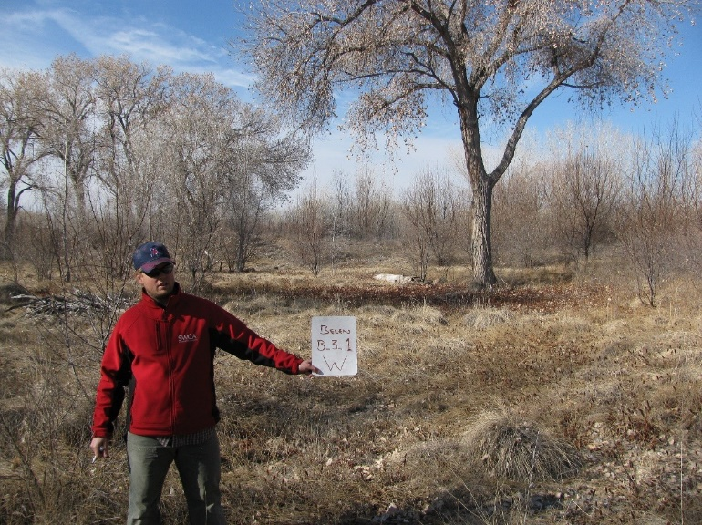11.10_1W, facing west from center at 11.8’ (2011)
11.10_1W, facing west from center at 11.8’ (2016)
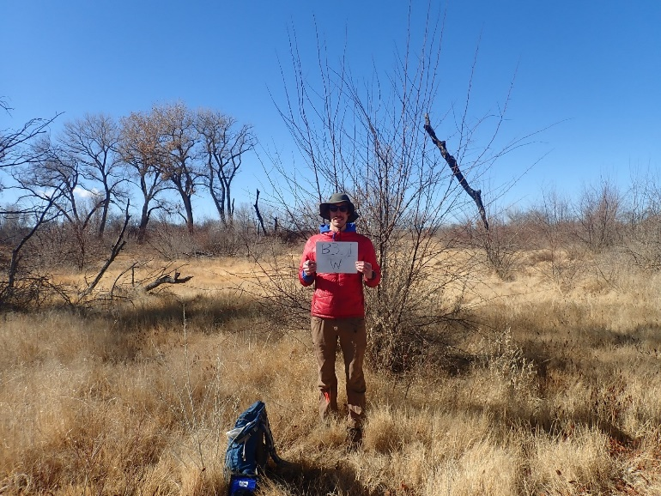11.10_1W, facing west from center at 11.8’ (2022)
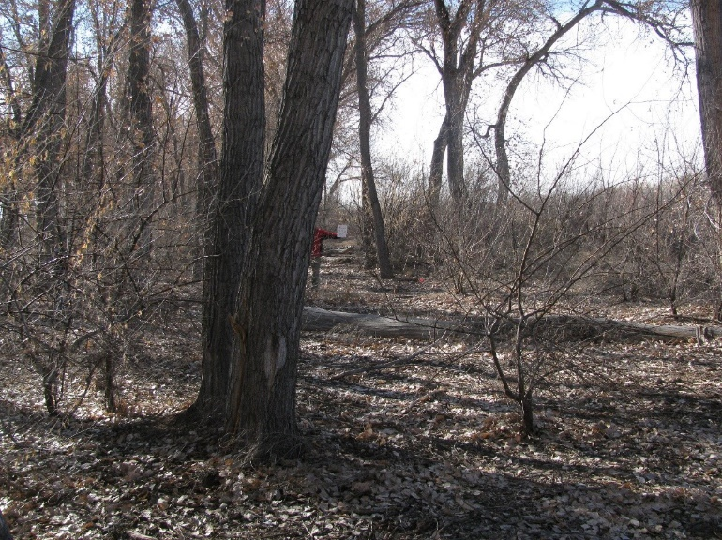11.10_2C, facing center from north at 66’ (2011)
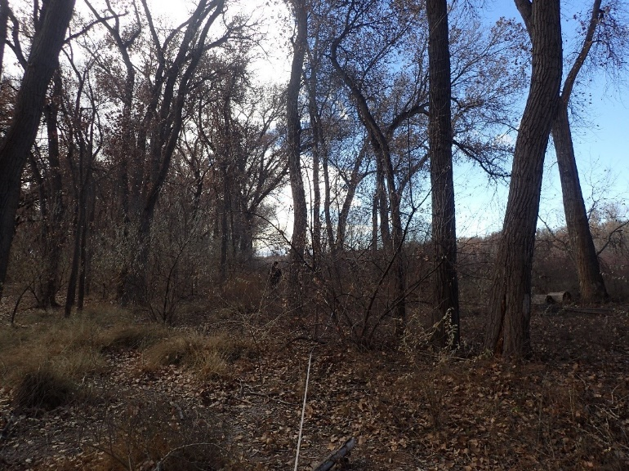11.10_2C, facing center from north at 11.8’ (2016)
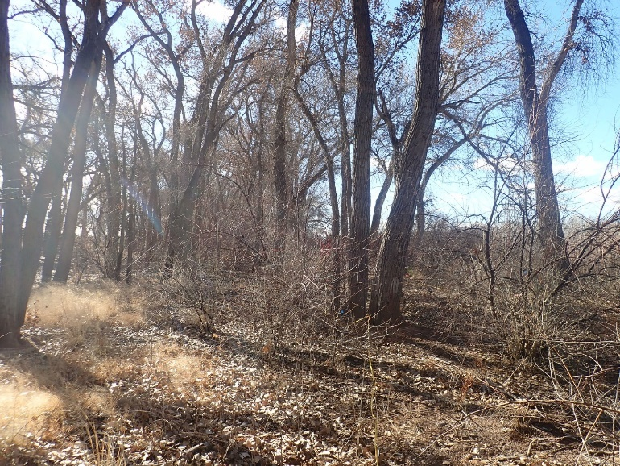11.10_2C, facing center from north at 11.8’ (2022)
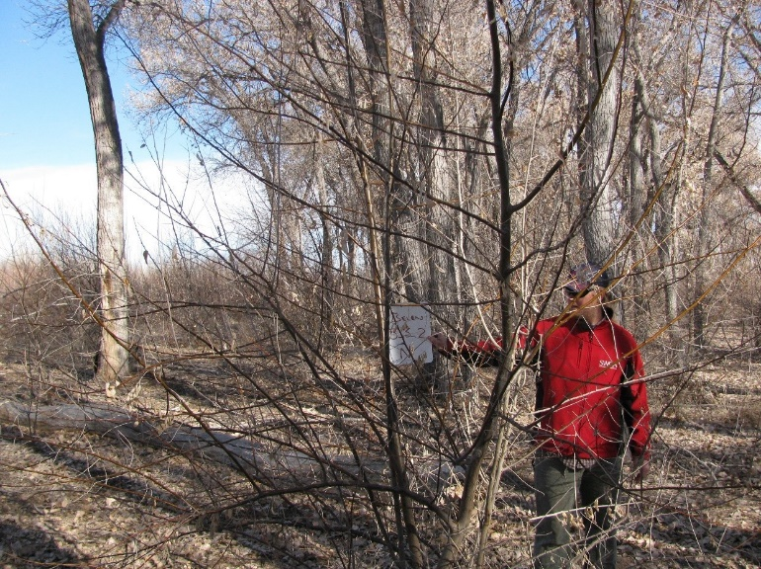11.10_2N, facing north from center at 11.8’ (2011)
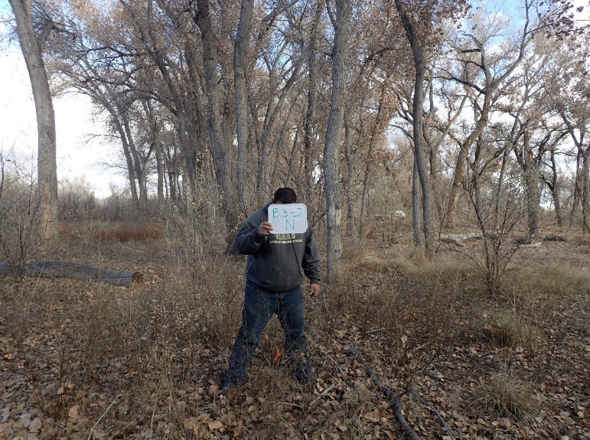11.10_2N, facing north from center at 11.8’ (2016)
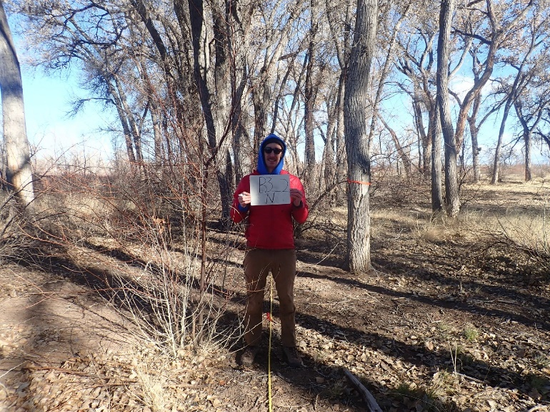11.10_2N, facing north from 11.8’ (2022)
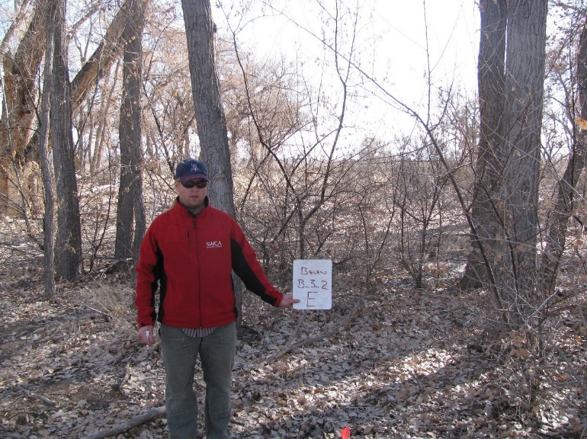11.10_2E, facing east from center at 11.8’ (2011)
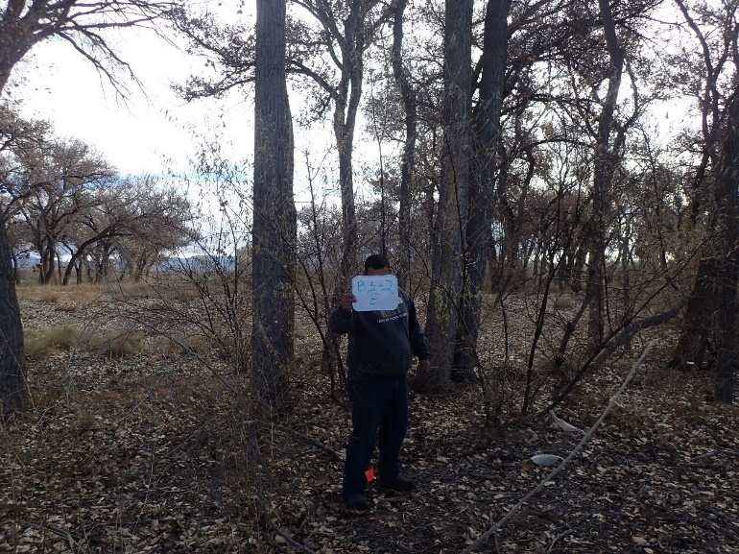11.10_2E, facing east from center at 11.8’ (2016)
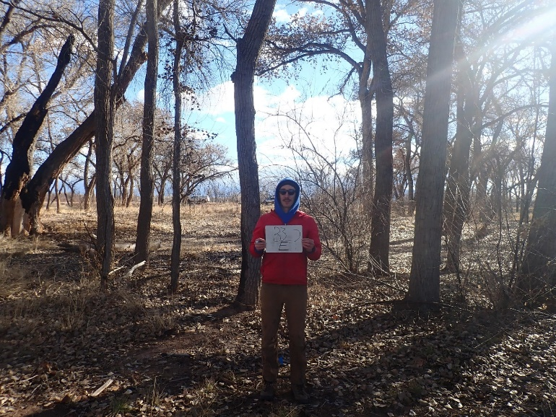11.10_2E, facing east from center at 11.8’ (2022)
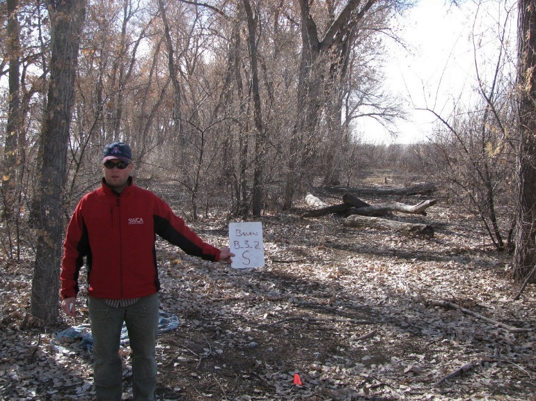11.10_2S, facing south from center at 11.8’ (2011)
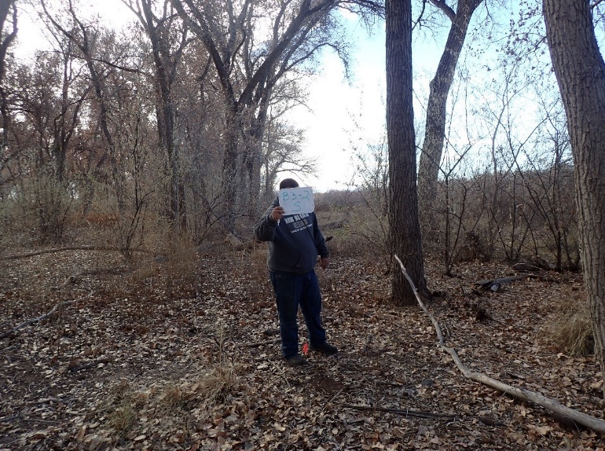11.10_2S, facing south from center at 11.8’ (2016)
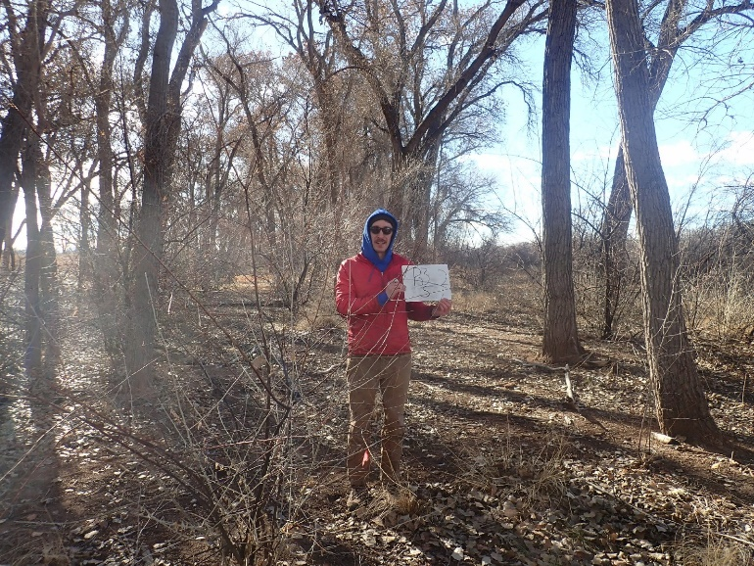11.10_2S, facing south from center at 11.8’ (2022)
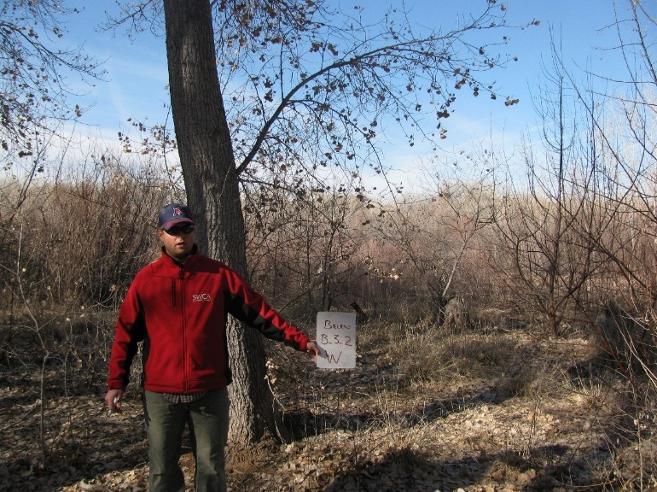11.10_2W, facing west from center at 11.8’ (2011)
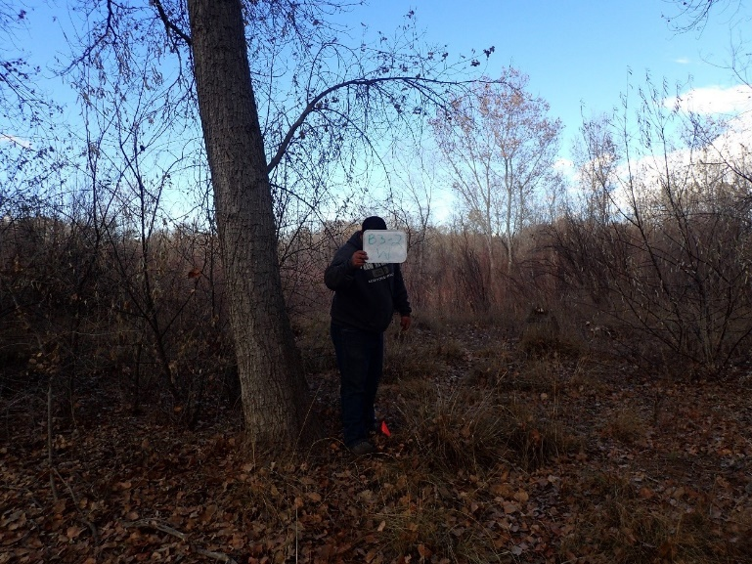11.10_2W, facing west from center at 11.8’ (2016)
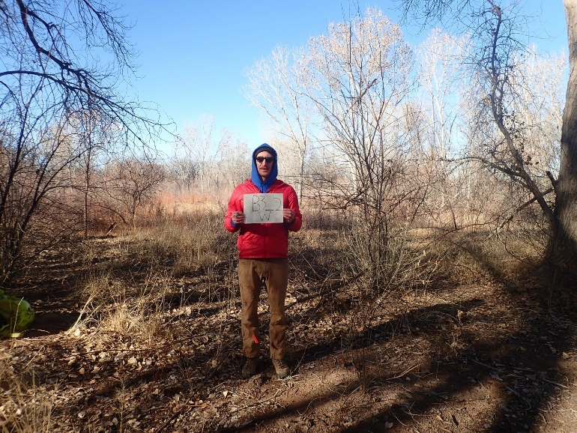11.10_2W, facing west from center at 11.8’ (2022)
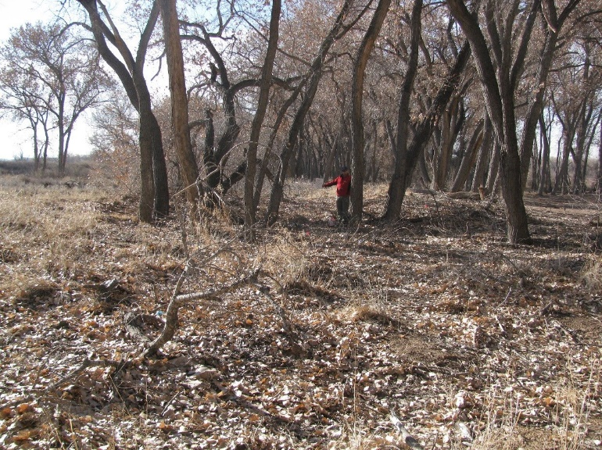11.10_3C, facing center from north at 66’ (2011)
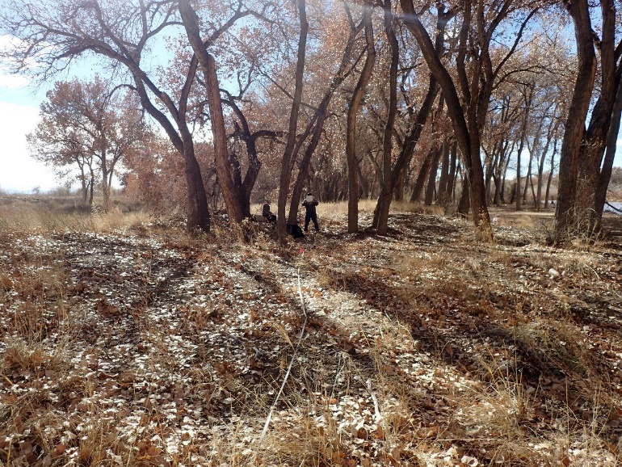11.10_3C, facing center from north at 66’ (2016)
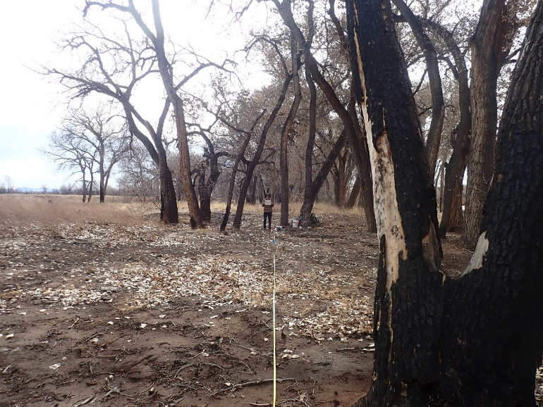11.10_3C, facing center from north at 66‘’ (2022)
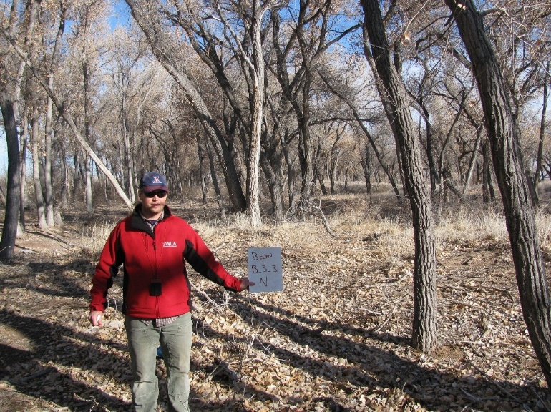11.10_3N, facing north from center at 11.8’ (2011)
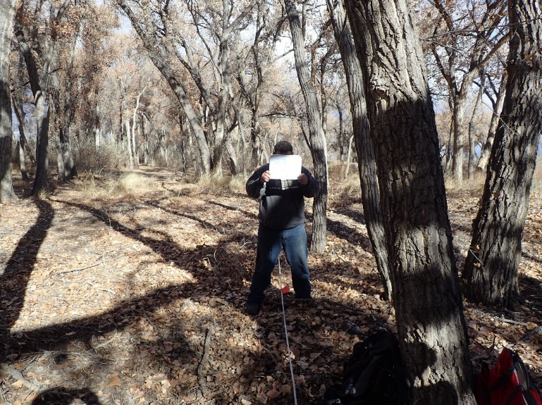11.10_3N, facing north from center at 11.8’ (2016)
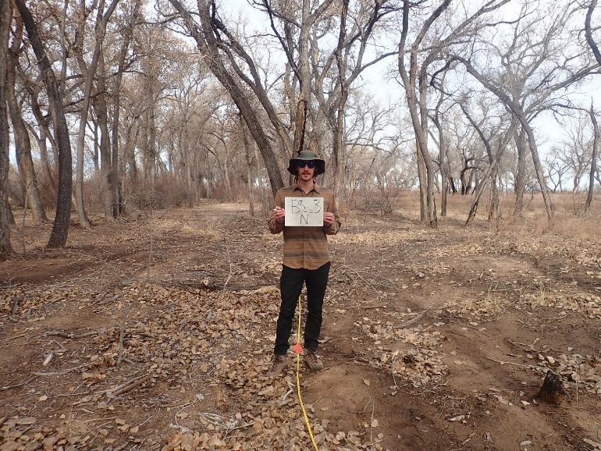11.10_3N, facing north from center at (2022)
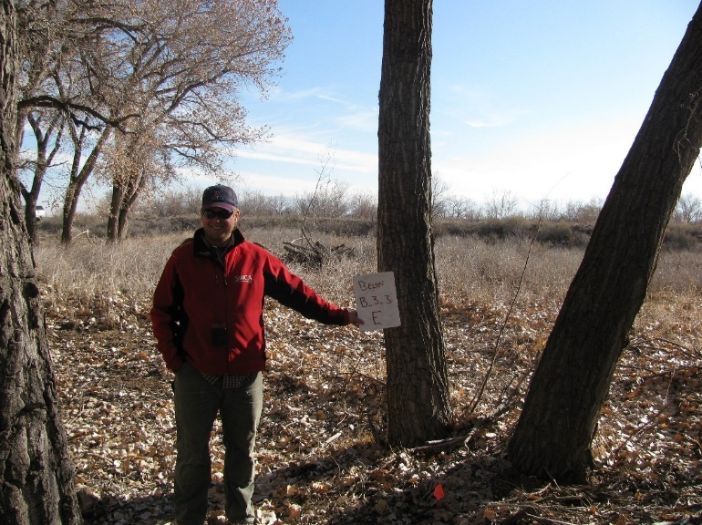11.10_3E, facing east from center at 11.8’ (2011)
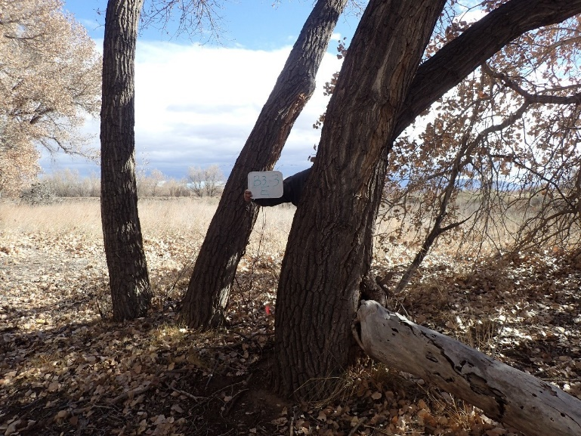11.10_3E, facing east from center at 11.8’ (2016)
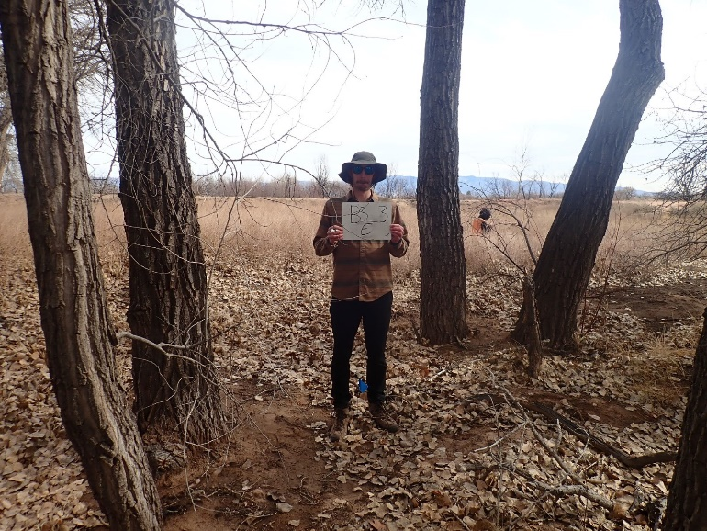11.10_3E, facing east from center at 11.8’ (2022)
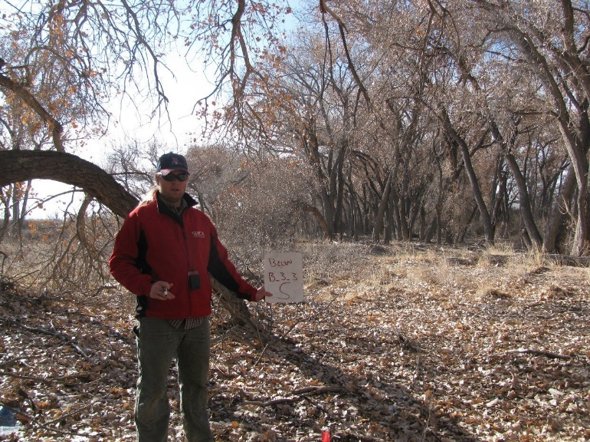11.10_3S, facing south from center at 11.8’ (2011)
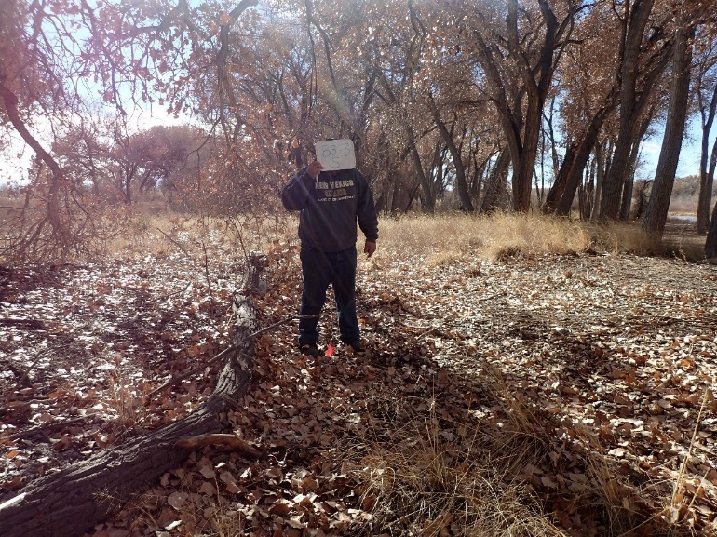11.10_3S, facing south from center at 11.8’ (2016)
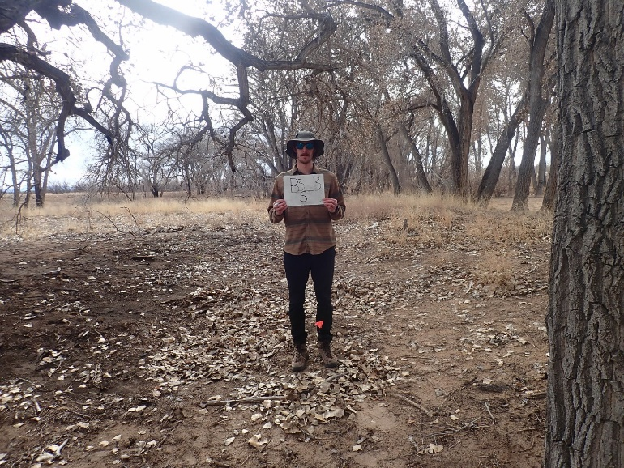11.10_3S, facing south from center at 11.8’ (2022)
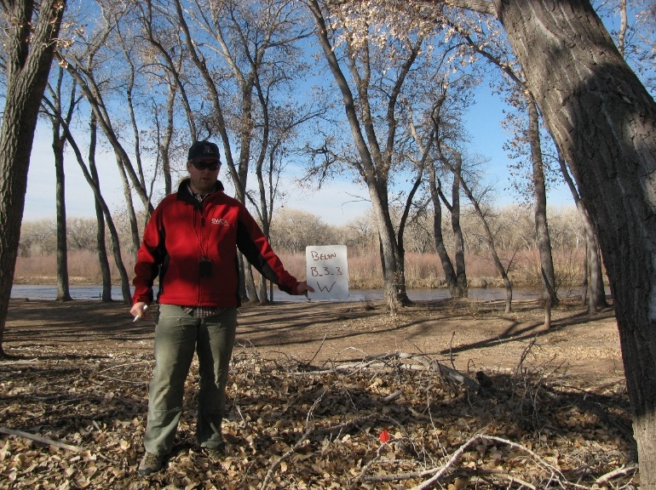11.10_3W, facing west from center at 11.8’ (2011)
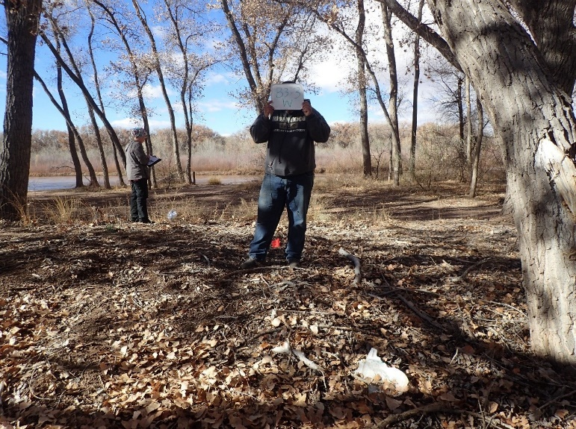11.10_3W, facing west from center at 11.8’ (2016)
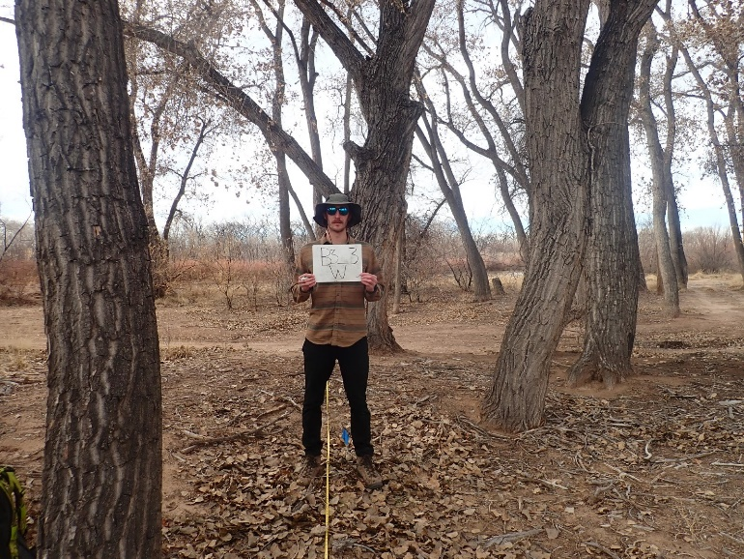11.10_3W, facing west from center at 11.8’ (2022)
Belen 4
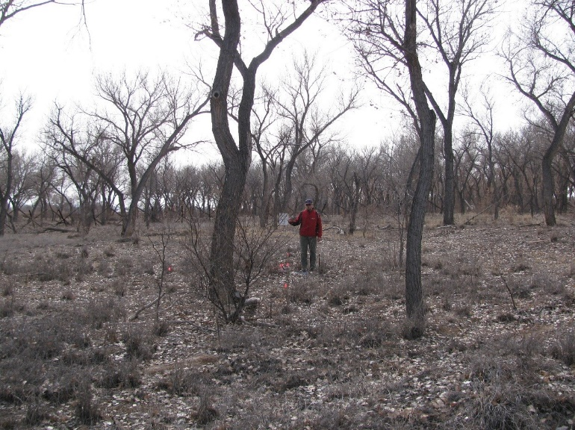11.13_1C, facing center from north at 66’ (2011)
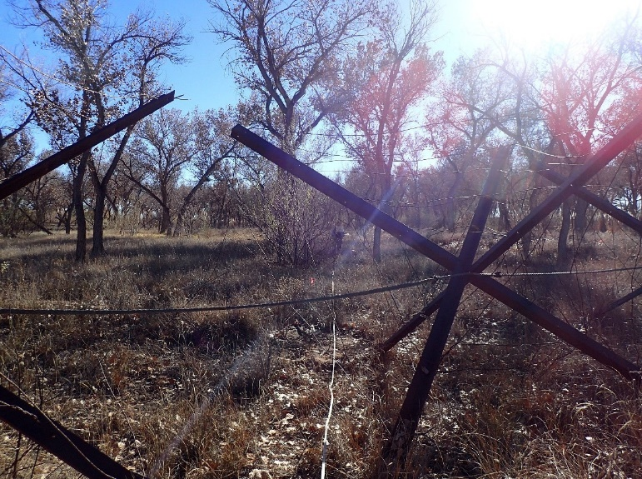11.13_1C, facing center from north at 66’ (2016)
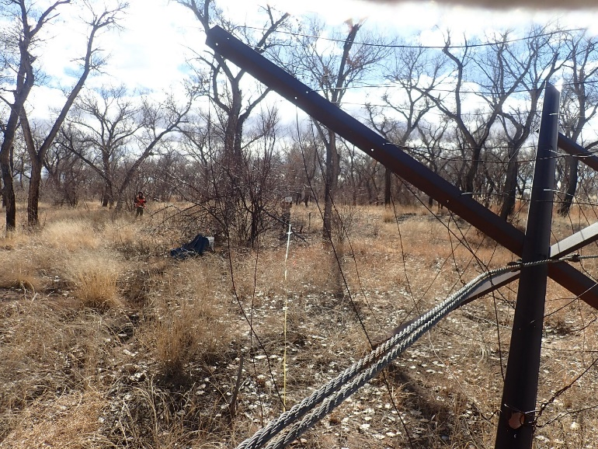11.13_1C, facing center from north at 11.8’ (2022)
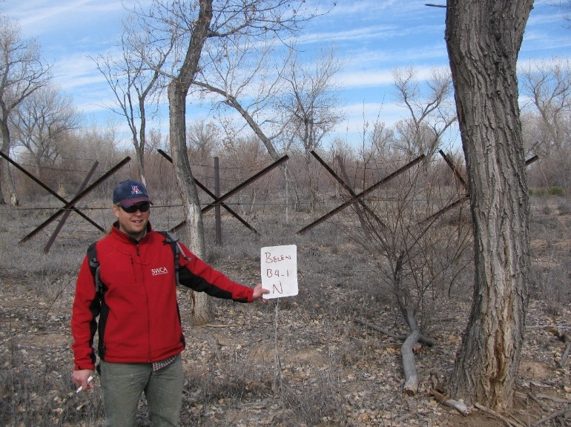11.13_1N, facing north from center at 11.8’ (2011)
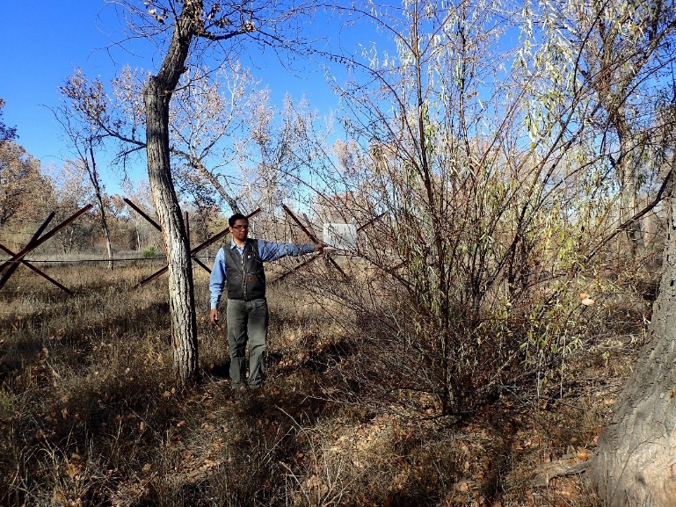11.13_1N, facing north from center at 11.8’ (2016)
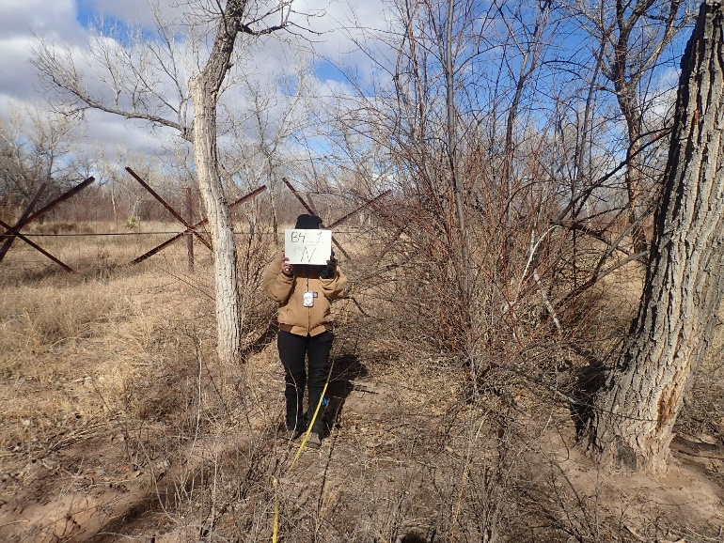11.13_1N, facing north from center at 11.8’ (2022)
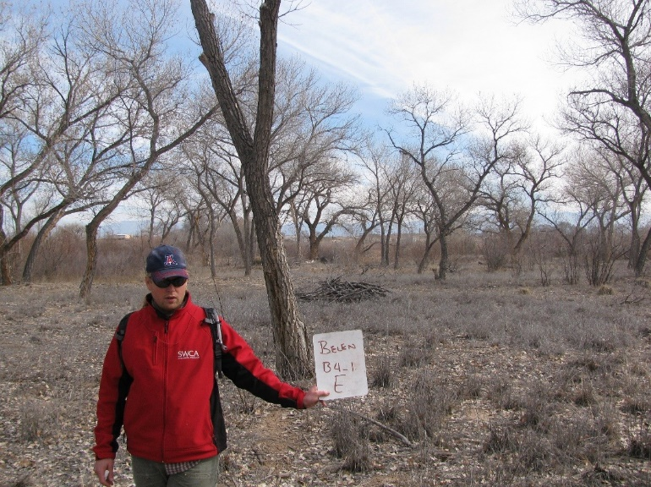11.13_1E, facing east from center at 11.8’ (2011)
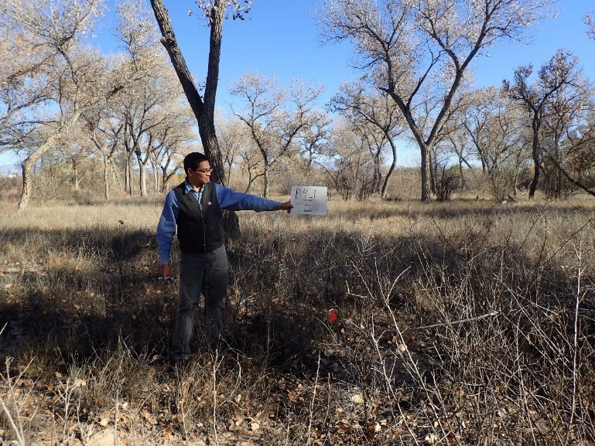11.13_1E, facing east from center at 11.8’ (2016)
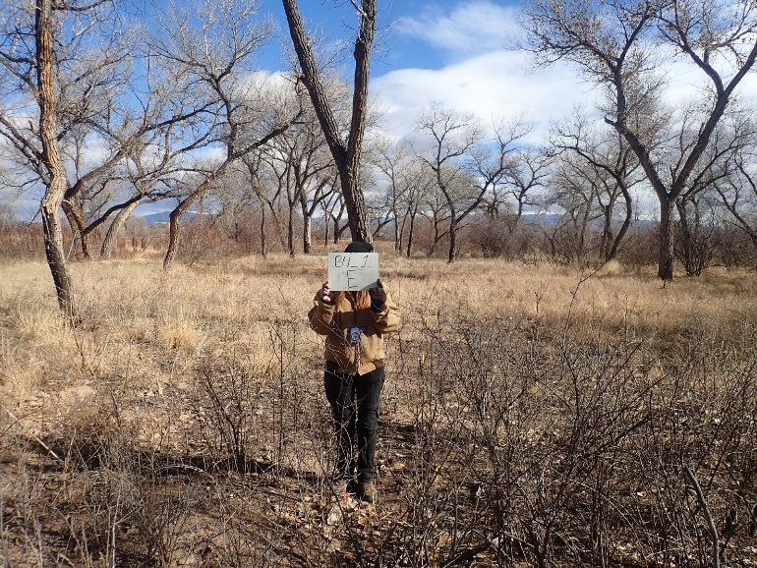11.13_1E, facing east from center at 11.8’ (2022)
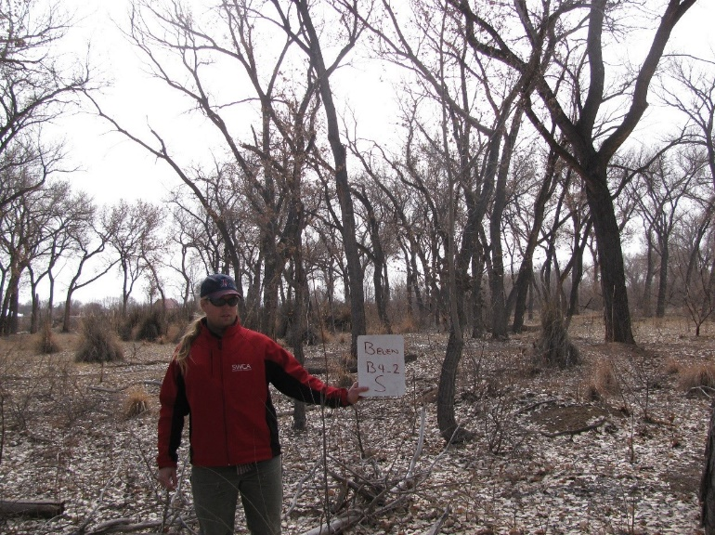11.13_2S, facing south from center at 11.8’ (2011)
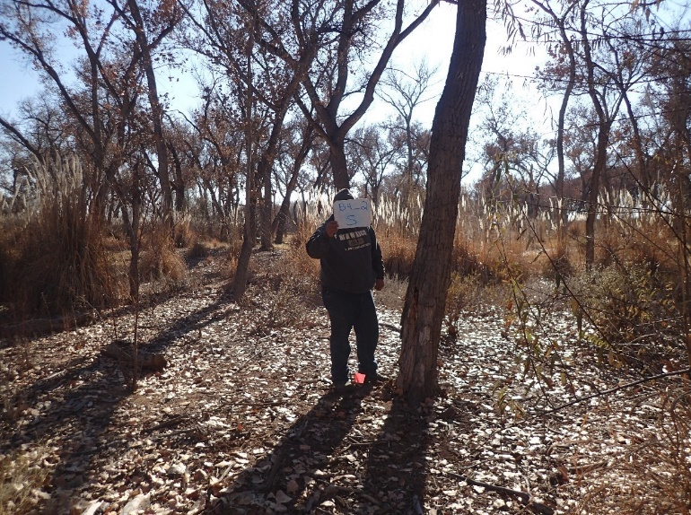11.13_2S, facing south at 11.8’ (2016)
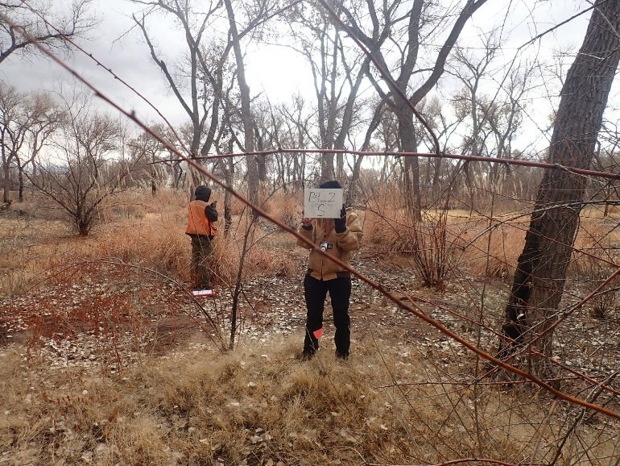11.13_2S, facing south from center at 11.8’ (2022)
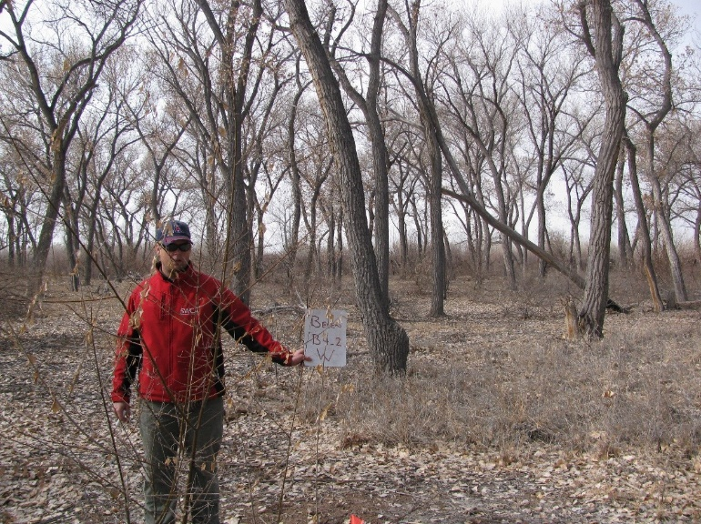11.13_2W, facing west from center at 11.8’ (2011)
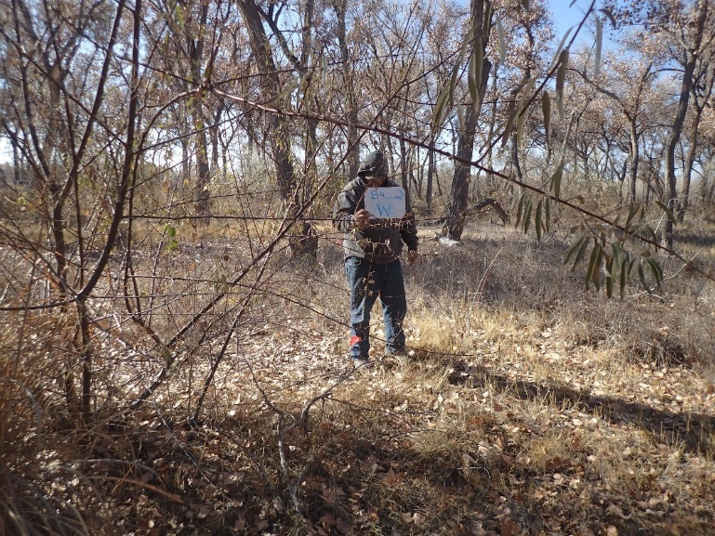11.13_2W, facing west from center at 11.8’ (2016)
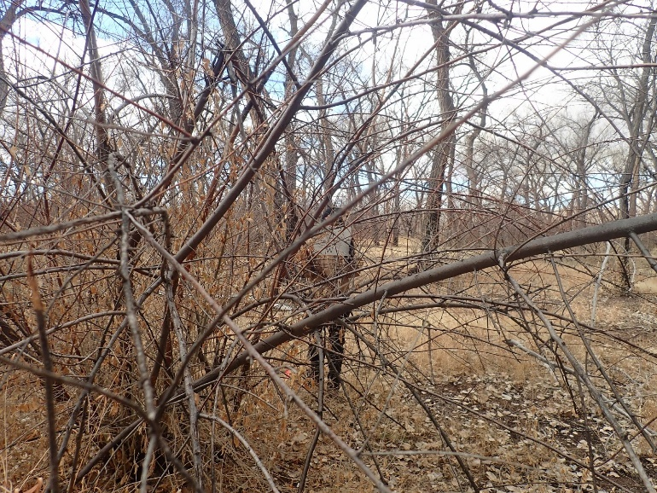11.13_2W, facing west from center at 11.8’ (2022)
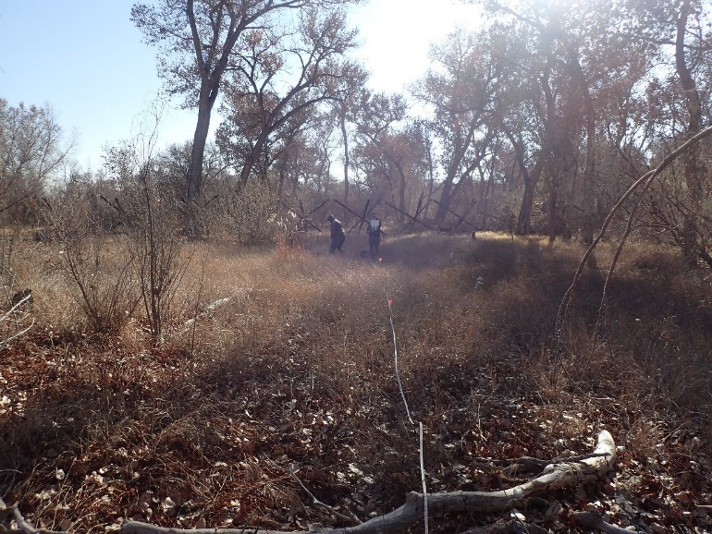11.13_3C, facing center from north at 66’ (2016)
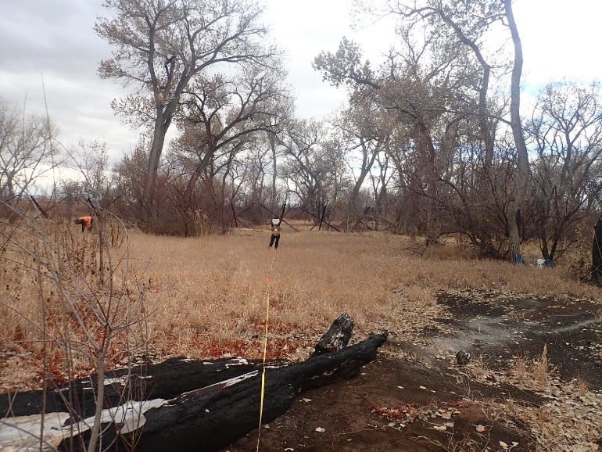11.13_3C, facing center from north at 66’ (2022)
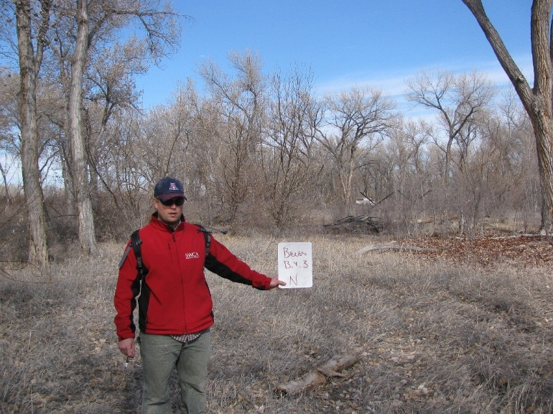11.13_3N, facing north from center at 11.8’ (2011)
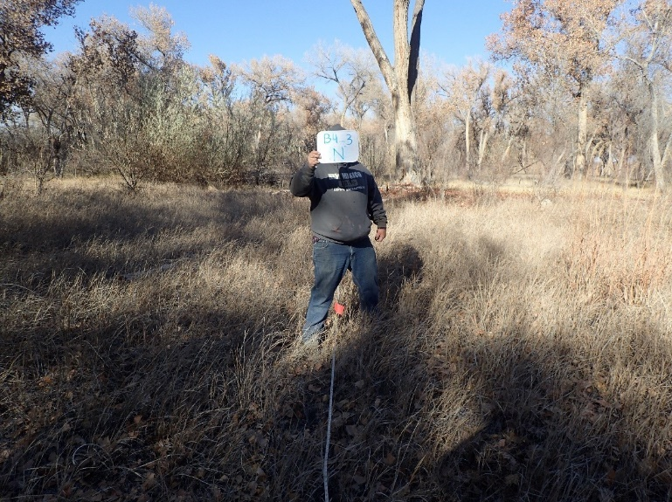11.13_3N, facing north from center at 11.8’ (2016)
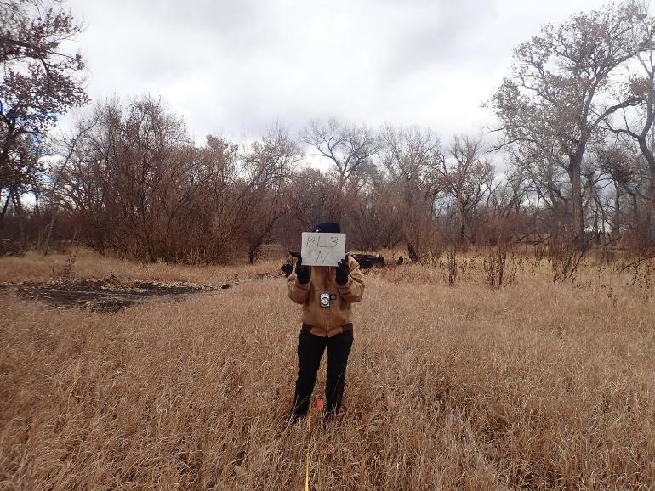11.13_3N, facing north from center at 11.8’ (2022)
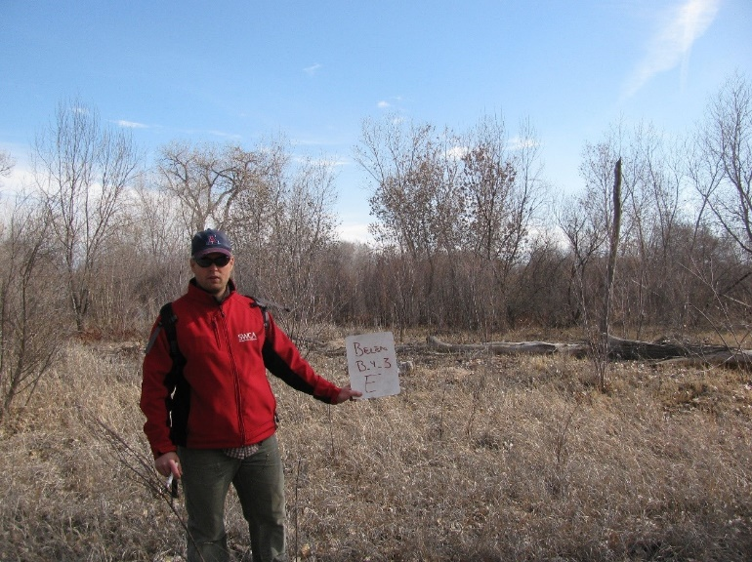11.13_3E, facing east from center at 11.8’ (2011)
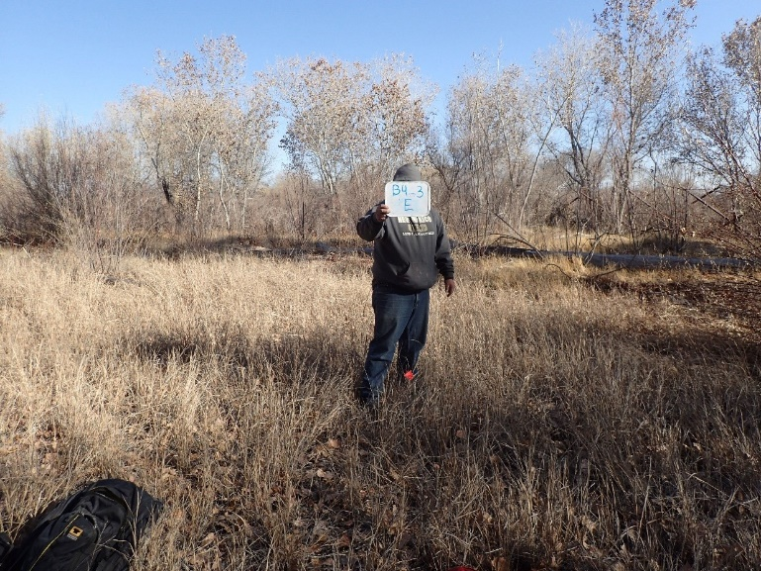11.13_3E, facing east from center at 11.8’ (2016)
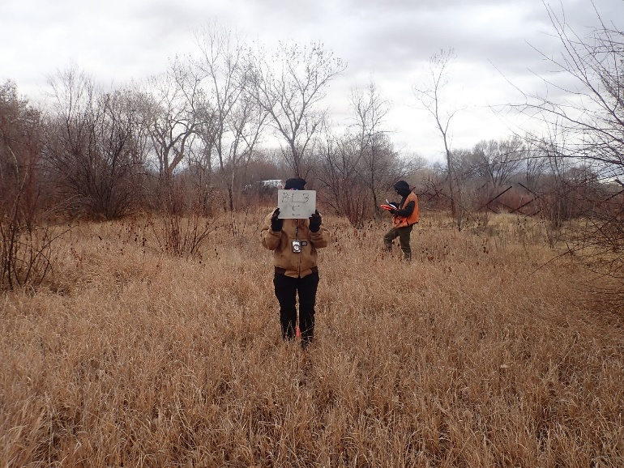11.13_3E, facing east from center at 11.8’ (2022)
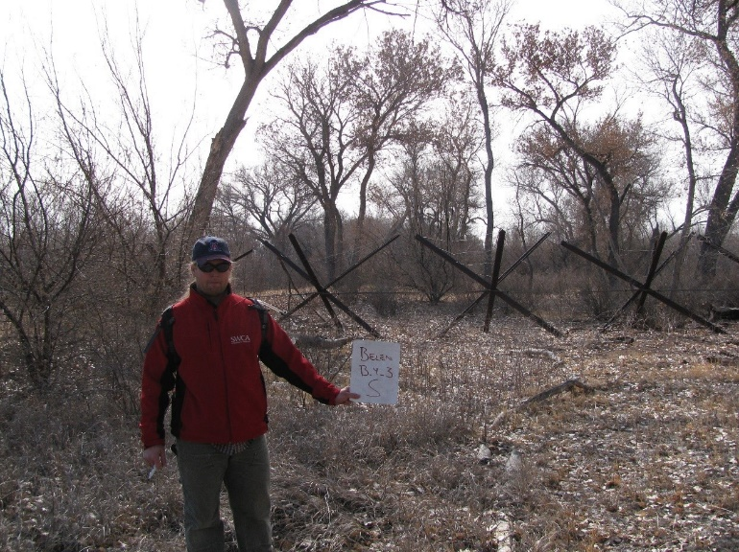11.13_3S, facing south from center at 11.8’ (2011)
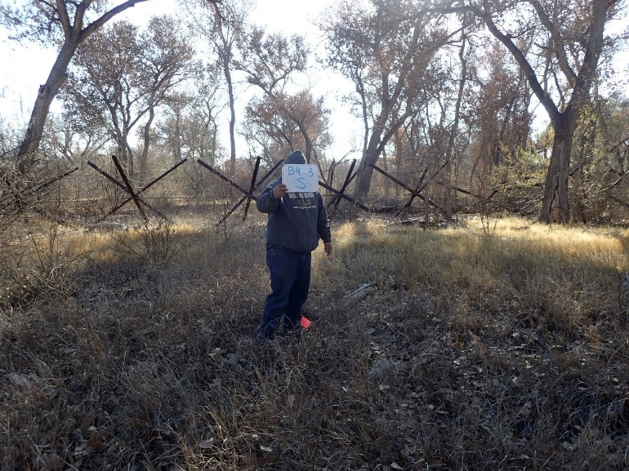11.13_3S, facing south from center at 11.8’ (2016)
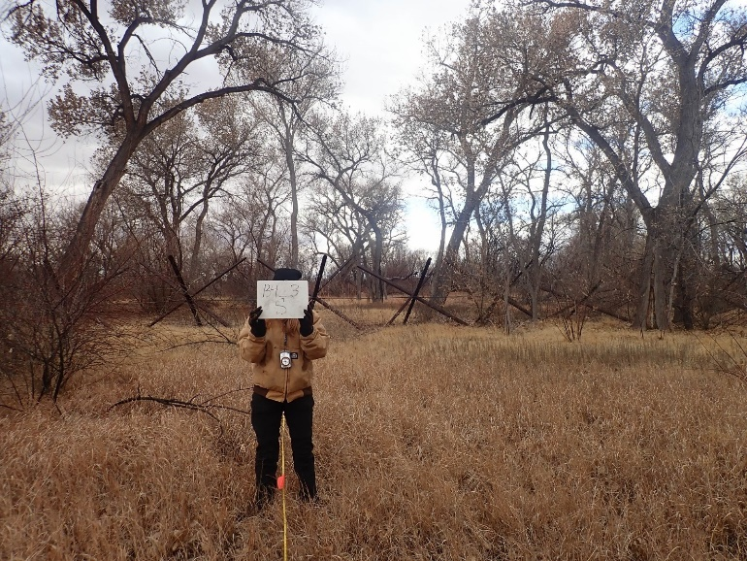11.13_3S, facing south from center at 11.8’ (2022)
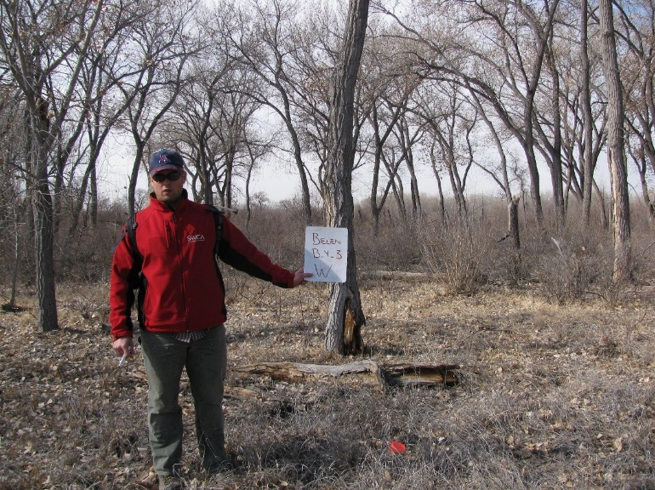11.13_3W, facing west from center at 11.8’ (2011)
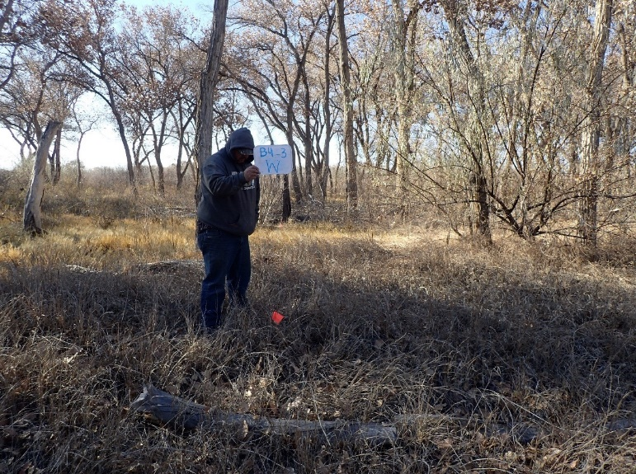11.13_3W, facing west from center at 11.8’ (2016)
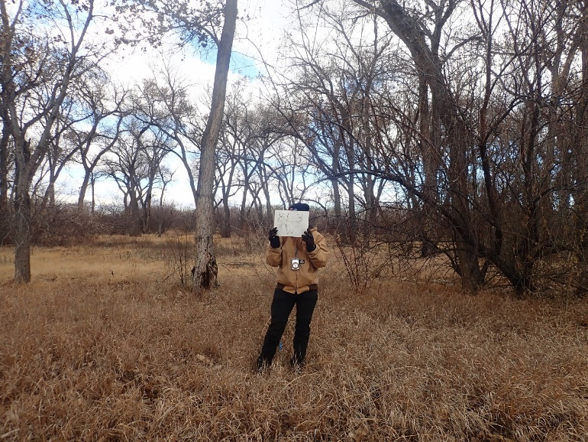11.13_3W, facing west from center at 11.8’ (2022)

