11.07 Willie Chavez Park South - Belen
10-year Monitoring Report
2022
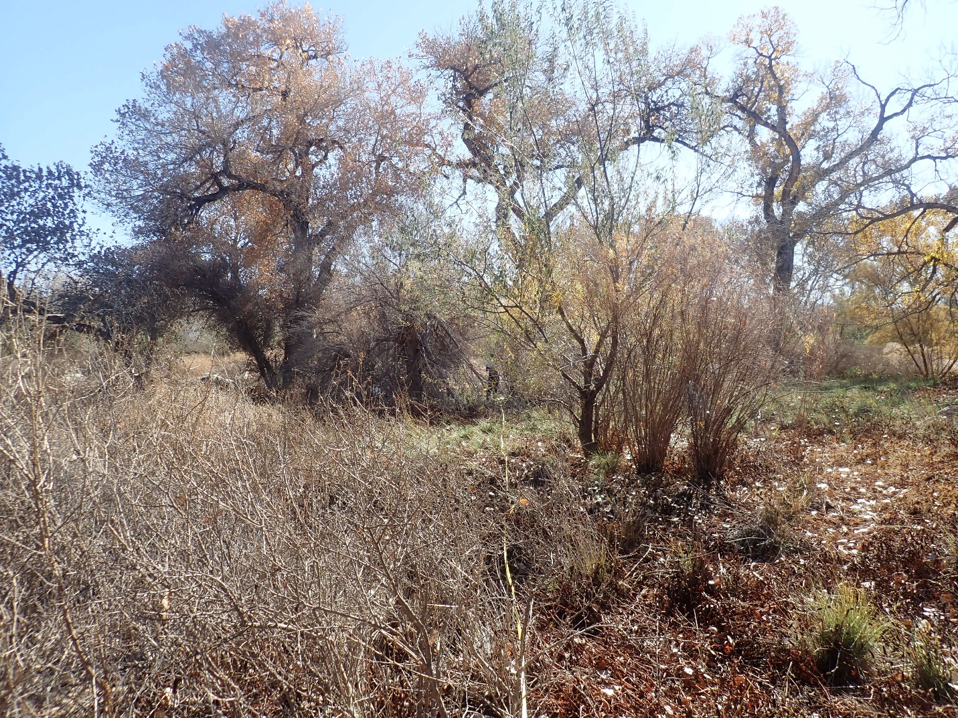

Prepared by
Alex Makowicki & Patrick Clay Goetsch
With the 2016 work of Kathryn R Mahan & Daniel Hernandez
and 2011/2012 work of Joe Zebrowski,
New Mexico Forest and watershed Restoration Institute
for the Greater Rio Grande Watershed Alliance
Contents
Acronyms and Abbreviations 3
Purpose of Report 4
Ecological Context of Bosque Restoration 4
Monitoring and Field Methods 5
Original (2011) protocols 5
5 and 10-year revisits (2016 and 2022) protocols 6
Personnel Involved 7
Bosque Ecological Monitoring Program Sites 8
Willie Chavez Project 9
Site Summary 11
Willie Chavez 2011 & 2022 - Observed plant species summary 12
Tree Component 14
Understory and Bosque Floor Components 16
Discussion 18
References 20
Appendix I – Photopoint Coordinates Table 21
Appendix II – Modified Hink and Ohmart Categories, from NMRAM 22
Appendix III – Sample Datasheets 26
Appendix IV – Fuels Transect Data Sheet 30
Appendix V- Photos 31

Acronyms and Abbreviations

Acronym, Abbreviation, or Term | Explanation or Definition as used by NMFWRI
BBIRD plots | Breeding Biology Research and Monitoring Database, larger circular plot types
BEMP plots | Bosque Ecosystem Monitoring Program, small rectangular plot types
FEAT | Fire Ecology Assessment Tool
FFI | FEAT/ FIREMON Integrated
FIREMON | Fire Effects Monitoring and Inventory System
FSA | Farm Service Agency, a department of the USDA
GIS | Geographic Information Systems
GRGWA | Greater Rio Grande Watershed Alliance
LIDAR | Light detecting and ranging, a remote sensing technique using light to gather elevation data
NAIP | National Agriculture Imagery Program (aerial imagery)
NDVI | Normalized Difference Vegetation Index; GIS term for a band ratio of the visible red and the near infrared spectral bands and is calculated using the following formula: (NIR – Red)/(NIR+Red)
NHNM | Natural Heritage New Mexico
NMDGF | New Mexico Department of Game and Fish
NMED SWQB | New Mexico Environment Department Surface Water Quality Bureau
NMFWRI | New Mexico Forest and Watershed Restoration Institute
NMHU | New Mexico Highlands University
NMRAM | New Mexico Rapid Assessment Method, version 2.0
NRCS | Natural Resource Conservation Service
PC | Plot center
RGIS | Resource Geographic Information System
SWCD | Soil and Water Conservation District
TIFF | Tagged image file format
USDA | United States Department of Agriculture
USGS | United States Geological Survey
WQCC | Water Quality Control Commission
WSS | Web Soil Survey, a soils database of the NRCS

Purpose of Report
This report covers pre-treatment and 5 and 10-year-post-treatment vegetation monitoring assessments performed on non-native phreatophyte removal projects near Belen, NM submitted by the Valencia Soil and Water Conservation District to the Greater Rio Grande Watershed Alliance in 2011. Following a discussion of the ecological context, and our monitoring methods, we present pertinent background, observations, and assessment results for each project.

Ecological Context of Bosque Restoration
Neither the challenges nor the importance of working in the bosque and other riparian areas in New Mexico today should be underestimated. According to the New Mexico Department of Game and Fish Conservation Division, wetlands and riparian areas comprise approximately 0.6 percent of all land in New Mexico (2012). Despite this small percentage, estimates of New Mexican vertebrate species depending on wetland and riparian habitat for their survival ranges from 55% (New Mexico Department of Game and Fish Conservation Services Division, 2012) to 80% (Audubon New Mexico, 2013). These areas also provide flood mitigation, filtration of sediment and pollutants, and water for a variety of purposes including groundwater recharge (Audubon New Mexico, 2013). In addition, native vegetation such as cottonwoods have cultural significance to many communities.
As much as these areas are disproportionately important to ecosystems and human communities, they are equally disproportionately impacted by disturbance. Anthropogenic impacts with major consequences for our riparian areas include dams, reservoirs, levees, channelization, acequias and ditches, jetty jacks, riprap and Gabion baskets, urbanization, removal of native phreatophytes, grazing by domestic livestock, excessive grazing pressure by native ungulate populations absent natural predation cycles, beaver removal, logging, mining, recreation, transportation, introduction and spread of invasive exotic species, groundwater extraction, altered fire and flood regimes drought and climate change (Committee on Riparian Zone Functioning and Strategies for Management, et al., 2002). Statewide, it is estimated that as much as 90% of New Mexico’s historical riparian areas have been lost (Audubon New Mexico, 2013), and approximately 39% of our remaining perennial stream miles are impaired (New Mexico Department of Game and Fish Conservation Services Division, 2012).
New Mexico is fortunate enough to have the Middle Rio Grande Bosque, the largest remaining bosque in the Southwest (USDA USFS, 1996). However, over the past two decades, the number of fires in the bosque has been increasing. Historically, the primary disturbance regime in the bosque has been flooding, not fire, which means the system is not fire-adapted. In fact, native species like cottonwood resprout from their roots after floods and need wet soils to germinate from seed. Flooding also promotes decomposition of organic material and keeps the soil moist which reduces the likelihood of fire. Today, overbank flow is uncommon in many areas of the Rio Grande due to the heavy alteration of the channel and flow regimes (two obvious examples are the structures defining the upper and lower extent of the Middle Rio Grande: Cochiti Dam and Elephant Butte Reservoir). This has led to low fuel moisture content and high fuel loads, as well as increased human presence in the riparian area. As a result, bosque fires are more common and more severe: they kill cottonwoods and other native species, creating spaces which are filled by non-native species such as salt cedar, Russian olive, Siberian elm, and Tree-of-Heaven. We are constantly learning more about how these species can exploit and encourage a riparian fire regime, in addition to many other changes they bring to ecosystems.
Efforts geared toward the removal of these nonnative species can help to reduce fire risk, preserve native vegetation, and be part of a larger effort to restore the bosque and the watershed as a whole to a more natural and functional ecosystem. The Greater Rio Grande Watershed Alliance (GRGWA) has been working on these issues with a variety of collaborating organizations and agencies within the Rio Grande basin for several years. Since 2013, the New Mexico Forest and Watershed Restoration Institute (NMFWRI) has been working with GRGWA and the Claunch-Pinto Soil and Water Conservation District (SWCD) to begin construction of a geodatabase for all of GRGWA’s non-native phreatophyte removal projects as well as to perform the formal pre- and post-treatment monitoring, utilizing a range of field methods as well as LIDAR analysis where appropriate and available.

Monitoring and Field Methods

Original (2011) protocols
Due to the short timeframe between project selection and implementation in 2011/2012, only a narrow window was available to perform pre-treatment monitoring. That window was outside the optimum season for performing vegetation monitoring in this type of landscape. For that reason, a hasty monitoring protocol was developed. This protocol was based on placing photo point plots at locations distributed across the project area and representative of the diversity of the project area. In addition, an estimate of ground and canopy cover by percent within a 1/10-acre circular plot centered at the photo point was determined using ocular estimates. Overstory canopy was determined for a 1/10-acre circular area, also centered at the photo point. Finally, a Hink & Ohmart style vegetation structure assessment was performed. Vegetation species that were observed at each plot and in the project area were recorded. The plot size and density of observations limit the utility of this monitoring for describing overall site conditions or for generating any meaningful statistics.

Cover (%)
Tree  canopy | Seedlings/saplings  <5’/5 – 15’ |  | Shrubs |  | Gramanoid | Forbs | Litter | Bare Soil | Rock | Gravel | Water or wet  soil
Figure 1. Categories used for percent cover estimates.

A base map of the project location was constructed using project boundary data provided by New Mexico State Forestry. Planned photo points were selected by visual inspection of May 2011 true-color digital orthorectified aerial photography obtained from the United States Department of Agriculture (http://datagateway.nrcs.usda.gov/). A GIS file for the photo point plots was created using ArcGIS software. Coordinates were derived from the GIS file and loaded into a Garmin GPS 60 CSx Global Positioning System and a Trimble 2005 GeoXM Global Positioning System. The Garmin GPS was used to navigate to the general location of the planned photo point. The actual location of the photo point was determined by visual inspection of the area and selection was based on the ability to physically occupy a position at or near the planned point. The coordinates of the photo point were then collected using the more precise Trimble GeoXM GPS.

Once the plot location was determined, a 1/100-acre radius plot was established by placing pin-flags at 11’ 9” from plot center in each cardinal direction. Photos were taken from plot center in each cardinal direction and from a distance north of plot center (66’, where possible) toward plot center. Ocular estimates were made of understory canopy and ground cover within the 1/100 plot. Overstory canopy cover was estimated using a concave spherical densiometer, with measurements made in four cardinal directions, approximately mid-way between plot center and the edge of the 1/100-acre plot. This method provides an estimate of canopy cover for a 1/10-acre area centered on the plot. A Hink & Ohmart structure class determination was made using a worksheet developed by SWCA Environmental Consultants (Appendix IV). Finally, plant species observed within the 1/10 area around the plot were recorded, as were other comments document conditions at the plot.

Figure 2. example of plot layout. The outer circle represents the 1/10-acre plot and the blue circle is the 1/100-acre plot

5 and 10-year revisits (2016 and 2022) protocols
To allow comparisons between site conditions, the original site protocols were employed for the 5 and 10-year revisits as well as newer protocols for the 10-year revisit.
Plot locations as recorded in 2011 and 2016 were found using a Garmin GPS, and all plot setup and measurements were the same as in 2011 and 2016, with a few exceptions. In 2016 a ground cover category was added for plant basal/bole, which was omitted from the ground cover in 2011. Further, for both 2016 and 2022 monitoring, in addition to the original Hink and Ohmart structural classification, we recorded the structure type within a modified Hink and Ohmart classification system (see Appendix II). This second Hink and Ohmart-based system is used by the NMED as part of the modified NMRAM protocol employed for pre-treatment monitoring on GRGWA projects beginning in 2013. Additions in 2022 were the inclusion of NMFWRI's Riparian Common Stand Exam-based protocols (https://nmfwri.org/wpcontent/uploads/2020/07/GRGWA_plotprotocols_Instructions_datasheets_withcheatsheets_3.1.2020km.pdf) which added measurements of soil texture; ground and aerial cover on the entire plot as well as aerial cover by individual species, seedling and sapling tallies and individual tree measurements (Appendix III). Individual tree measurements included establishing a witness tree when available, measuring tree height, diameter at breast height (DBH), live crown base height and overall health of the tree. Fuel transects were also established. (Appendix IV).
For the sake of continuity, site visits were made around the same time of year as 5 and 10 years prior, even though this was not the ideal season for plant identification in either case. It is worth noting that the winter of 2016/2017 was warmer than the winter of 2011/2012, so even though site visits were conducted around the same time of year, plant communities differed. This is especially obvious in the
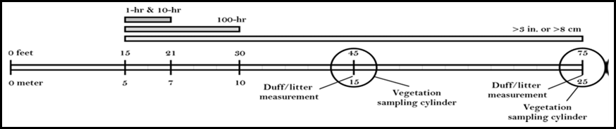

Figure 3. Example of fuels transect

Personnel Involved
2012 Monitoring Team:
- Joe Zebrowski, New Mexico Forest and Watershed Restoration Institute
- Jill Wick, New Mexico Department of Game and Fish
2016 Team:
- Kathryn R Mahan, Ecological Monitoring Specialist
- Christopher B Martinez, Monitoring Technician (NMHU Student Intern)
- Daniel Hernandez, Ecological Monitoring Technician
2022 Monitoring Team:
- Alex Makowicki, Ecological Monitoring Technician
- Clay Goetsch, Ecological Monitoring Technician
- Jordan Martinez, Ecological Monitoring Technician
Persons contacted 2011:
- Charlie Lujan, Valencia Soil and Water Conservation District
- Madeline Miller, Valencia Soil and Water Conservation District
Persons contacted 2016:
- Madeline Miller, Valencia Soil and Water Conservation District
Persons contacted 2022:
- Yasmeen Najmi, Middle Rio Grande Conservancy District

Bosque Ecological Monitoring Program Sites
Two Bosque Ecological Monitoring Program (BEMP) monitoring sites were located: WC_1 and WC_2. Both sites are on the west side of the Rio Grande, between the levee road and the drain. These sites were likely disturbed during the treatment activity. Future GRGWA monitoring should strive to integrate BEMP monitoring into the overall project monitoring scheme.
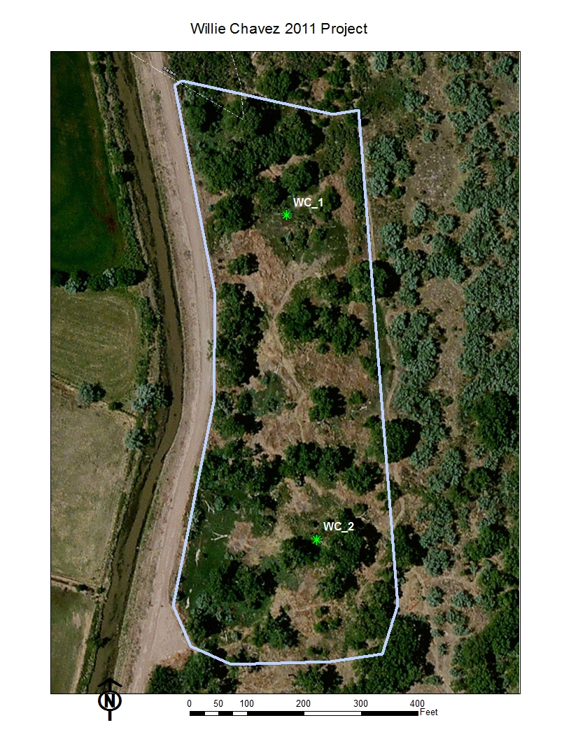
Figure 4. BEMP sites present on Willie Chavez.

Willie Chavez Project
The project is located within Valencia County, NM, east of the city of Los Lunas (see Figure 2 below). It is on the west side of the Rio Grande, between the levee road and drain.
The nearby city of Los Lunas receives an average of 9.75 inches of precipitation annually. The average high temperature is 94 degrees in July, and the average low is 18 in December and January (U.S. Climate Data, 2017). According to the NRCS Web Soil Survey, the two project areas are comprised of <1% River wash and the remainder Mixed alluvial land. Ecological sites within this project include R042XA055NM Salty Bottomland (USDA NRCS, 2016).
Salty Bottomland can support a range of plant communities which typically include cottonwood, salt cedar, mixed exotics (dominated by Russian olive/ Russian knapweed/ etc.), saltgrass and saltgrass-sacaton, and bottomland grassland (possibly dominated by saltgrass, giant sacaton, dropseed, muhly, burro grass, alkali sacaton, galleta, vinemesquite, and/or tobosa). Typically, the vegetation consists of a shrub/grass mixture characterized by fourwing saltbush and greasewood. Tall, mid-grass, and short grasses are present. Blue grama, foxtail, sand dropseed, spike dropseed, giant dropseed, New Mexico feathergrass and tansymustard are common. When the plant community deteriorates, there is an increase in amounts of shrubs and short grasses (USDA NRCS n.d.).
Pre-treatment monitoring was conducted at these sites on January 12, 2012 as part of a restoration project targeting non-native phreatophytes scheduled for 2011-2012. Post-treatment monitoring was conducted November 6, 2016. Both sites are located west of the Rio Grande, between the levee and drain. The project was sponsored by the VSWCD. Restoration goals are to restore the area for wildlife use, address fire fuels and access concerns, and to remove non-native woody invasive plants. (Miller, 2008).

 | Average Aerial Cover 1/100 Acre
Year | Tree Canopy | Seedlings <5 | Saplings 5-15' | Shrubs <5 | Shrubs-Saplings 5-15' | Graminoid | Forb
2011 | 13% | 0% | 0% | 2% | 6% | 2% | 59%
2016 | 33% | 3% | 8% | 10% | 0% | 13% | 63%

 | Average Ground Cover 1/100 Acre
Year | Litter | Bare soil | Rock | Gravel | Water or wet soil | Plant basal area
2011 | 40% | 1% | 0% | 0% | 0% | n/a
2016 | 48% | 4% | 1% | 0% | 0% | 0%

Cover: Cover for plot 1 was not collected for this site and so 2022 averages could not be calculated.

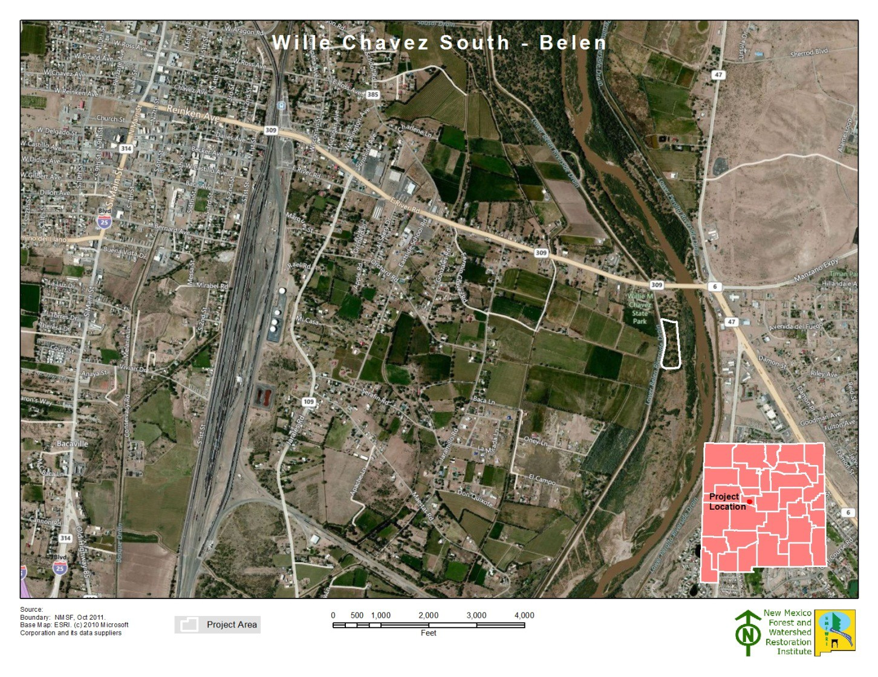

Figure 5.Willie Chavez Park South in geographic context.

Site Summary
2011 Site Observations: The project area is moderately wooded, with a light, multi-tiered understory. It had been treated in the early 2000s. Much of the area consists of grassy openings. Salt grass was noted in the area and salt was noted on the soil surface in several areas. Since monitoring was done so late in the fall, sparse forb and grasses cover may be attributed to seasonal dormancy. The plots were assessed to fall in Hink & Ohmart Structure Classes 1 and 5. Identification of forb, grasses and some shrub species was also impacted by the limited plant identification skills of the monitoring team and by the season. The project area is adjacent to a picnic area and there are several walking trails that pass through the project area.
2016 Site Observations: This project had several open areas supporting yerba mansa communities. The southern boundary was clearly marked by a solid wall of salt cedar. Resprouts of target species (salt cedar, Russian olive, Siberian elm) were observed on plots 2, 5 and 6. The plots were assessed to fall in Hink and Ohmart Structure classes 3 and 4.
2022 Site Observations: The project site was lush with understory vegetation, there were many willows. Of note were the exotic bunch grasses and kochia abundant on the plot.

Willie Chavez 2011 & 2022 - Observed plant species summary

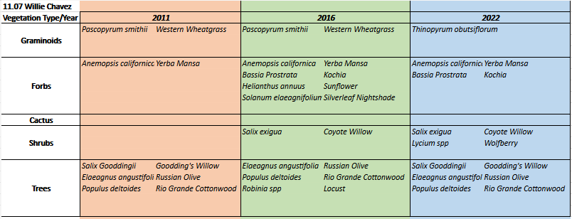

The majority of the “new” plants observed in 2016 were native species, although kochia and Siberian elm also joined the mix. The target species found in 2012, Russian olive and salt cedar, were still present in 2016, as resprouts. In both years, identification of forb, grasses and some shrub species was impacted by both the plant identification skills of the monitoring team and by the season.
Figure 6. Willie Chavez plots.

Tree Component
The tree component consists of data collected on the 1/10 acre plot Measurements of tree’s diameter at breast height (DBH), height, live crown base height, condition (live, sick or dead), and any significant mistletoe damage. We analyze tree density using Trees Per Acre (TPA) and basal density Basal Area Per Acre (BA/AC). It should be noted that no trees were recorded in plot 1.

Figure 7. Displays Trees, Seedlings and Saplings per acre for the project

Figure 8. Displays Seedlings per acre for each species

11.07 Willie Chavez |  |  | October 2022
Individual Plot Summary Table
Macro Plot Name | Total number of sample trees on plot | Growing Stock
 |  | Number of growing stock sample trees on plot |  | Trees per Acre | Basal Area per Acre
11.07_2 | 6 | 6 |  | 60 | 17.10
Total | Total number of sample trees on plot | Number of growing stock sample trees on plot |  | Average for all Plots
 |  |  |  | TPA | BA/AC
 | 6.00 | 6.00 |  | 30.00 | 8.55

Figure 9. Displays Stand Table Tree summaries for each plot

Understory and Bosque Floor Components
As described above, percent ground cover was estimated at each plot within the 1/100th acre subplot. It should be noted that average cover for 2022 monitoring could not be calculated due to missing cover data for plot 1.
 | Average Aerial Cover
Year | Tree Canopy | Seedlings <5 | Saplings 5-15' | Shrubs <5 | Shrubs-Saplings 5-15' | Graminoid | Forb
2011 | 13% | 0% | 0% | 2% | 6% | 2% | 59%
2016 | 33% | 3% | 8% | 10% | 0% | 13% | 63%
2022 | 47%

Table 1. Displays average aerial cover for 1/100-acre plot

 | Average Ground Cover
Year | Litter | Bare soil | Rock | Gravel | Water or wet soil | Plant basal area
2011 | 40% | 1% | 0% | 0% | 0% | n/a
2016 | 48% | 4% | 1% | 0% | 0% | 0%
2022

Table 2. Displays average ground cover for 1/100-acre plot

Project: Valencia SWCD Project Unit: Willie Chavez, 11.07 Plot: 11.07_1
WC_1 Aerial & Ground Cover
 | Aerial cover
Year | Tree Canopy | Seedlings <5 | Saplings 5-15' | Shrubs <5 | Shrubs-Saplings 5-15' | Graminoid | Forb
2011 | 0% | 0% | 0% | 3% | 10% | 0% | 90%
2016 | 25% | 5% | 15% | 20% | 0% | 0% | 50%
2022 | 59%

 | Ground cover
Year | Litter | Bare soil | Rock | Gravel | Water or wet soil | Plant basal area
2011 | 10% | 0% | 0% | 0% | 0% | n/a
2016 | 50% | 5% | 0% | 0% | 0% | n/a

-------------------------------------------------------------------------------------------------------------------------------------------
2011 Hink & Ohmart Type: 5
2016 Hink & Ohmart Type: 5 2016 Modified Hink & Ohmart Type: 5 or 6W
2022 Hink & Ohmart Type: 5 2022 Modified Hink & Ohmart Type: 5
-----------------------------------------------------------------------------------------------------------------------------------------
2011 Comments: None.
2016 Comments: None
2022 Comments: Dense coyote willow to north and east, with some russian olive; open to the south and west covered in yerba mansa, scattered grasses, and lycium (wolfberry).

Project: Valencia SWCD Project Unit: Willie Chavez, 11.07 Plot: 11.07_2
11.07_2 Aerial & Ground Cover
 | Aerial cover
Year | Tree Canopy | Seedlings <5 | Saplings 5-15' | Shrubs <5 | Shrubs-Saplings 5-15' | Graminoid | Forb
2011 | 25% | 0% | 0% | 0% | 1% | 4% | 28%
2016 | 0% | 0% | 0% | 0% | 0% | 25% | 75%
2022 | 35% | 0% | 1% | 0% | 5% | 35% | 50%

 | Ground cover
Year | Litter | Bare soil | Rock | Gravel | Water or wet soil | Plant basal area
2011 | 70% | 1% | 0% | 0% | 0% | n/a
2016 | 46% | 2% | 2% | 0% | 0% | 50%
2022 | 30% | 0% | 0% | 0% | 0% | 70%

-------------------------------------------------------------------------------------------------------------------------------------------
2011 Hink & Ohmart Type: 1
2016 Hink & Ohmart Type: 1 2016 Modified Hink & Ohmart Type: 1
2022 Hink & Ohmart Type: 6 2022 Modified Hink & Ohmart Type: 6S
-----------------------------------------------------------------------------------------------------------------------------------------

2011 Comments: None.
2016 Comments: Observer commented that the area was a possible playa formation.
2022 Comments: Partially open canopy under cottonwoods, with yerba mansa underneath and a black willow to the north of plot center. Grassy open area to the west and north.

Discussion
We would like to clarify that we are adapting these NMRAM metrics for our own purposes. That is, we are using them both inside and outside their intended site ranges, including on larger sites (NMRAM is designed to handle a site around 100 x 200 meters), sites further from the river (NMRAM is currently in use primarily for assessing riverine wetlands), and sites defined by exotic vegetation presence rather than hydrologic boundaries and upland vegetation indicators/apparent wetland extent. Site delineation and size is likely to be variable for a number of other reasons, including landowner participation, available funds, proposals received from contractors, etc – many of which cannot be directly correlated to site disturbance or ecological function. For this reason, we do not use the entire NMRAM assessment, or place confidence in the weighted score roll-ups that are typically part of an NMRAM report. Should one be interested, rationale for the weighting in the NMRAM score roll-up can be found in the yet-to-be-published field manual for version 2.1. For more information, contact Maryann McGraw of the NMED or NMFWRI.
While we provide a biotic site score and rating for your reference, we recommend comparisons be done with individual metrics from pre-treatment and post-treatment assessment from the same site, rather than across multiple sites. Also of note is that statistical analysis is not appropriate for NMRAM, or other low intensity, rapid field methods.
Please note that should the project area change significantly from what was originally proposed and monitored, all metrics will lose some amount of confidence on comparison as it is impractical to re-examine the original site assessment scores using new boundaries. This is an issue of concern of which GRGWA should be aware. We recommend that GRGWA attempt to minimize alterations in project boundaries once pre-treatment monitoring data has been approved for collection. Another, somewhat alternative, recommendation is that the initial monitoring regime include high-intensity modified BEMP-type plots which could be repeated in their exact initial locations, allowing collection of comparable data regardless of boundary change. We recognize that this is not always practical: boundaries change for a number of reasons and time and cost constraints can necessitate the sole use of a rapid assessment method for monitoring. We have reason to hope our outlined assessment method will still be a satisfactory indicator for site function improvement or degradation primarily because metrics in rapid assessment methods such as this are set up to have relatively low sensitivities (i.e. for a change to be reflected in the metrics, either positive or negative, disturbance on site has to be significantly altered).
From here on out, the goal of the GRGWA/ NMFWRI is that all sites will be revisited for post-treatment monitoring in 5-year intervals. It is our intention and expectation that the data collected in these intervals will reflect any significant changes in disturbance and ecological function of the site.

References
Audubon New Mexico. (2013). Water Matters: Water for New Mexico Rivers. Albuquerque, New Mexico: Utton Transboundary Resources Center.
Brown, J. K. (1974). Handbook for Inventorying Downed Woody Material, USDA Forest Service General Technical report INT-16. Handbook for Inventorying Downed Woody Material. Ogden, Utah: USDA Forest Serivce Intermountain Forest and Range Experiment Station.
Bureau of Land Management. (2006). Grazing Management Processes and Strategies for Riparian-Wetland Areas, TR 1737-20 .
Claunch-Pinto Soil and Water Conservation District on behalf of the Greater Rio Grande Watershed Aliance. (2015). Request for Proposals for Greater Rio Grande Watershed Alliance Riparian Restoration Projects. Mountainair, NM: Claunch-Pinto Soil and Water Conservation District.
Committee on Riparian Zone Functioning and Strategies for Management, et al. (2002). Riparian Areas: Functions and Strategies for Management. Washington, D.C.: National Academy Press.
Lightfoot, D. &. (2012). Greater Rio Grande Watershed Alliance Riparian Restoration Effectiveness Monitoring Plan. Albuquerque, NM: SWCA Environmental Consultants.
Lightfoot, David & Stropki, C. (2012). Field Manual for Greater Rio Grande Watershed Alliance Riparian Restoration Effectiveness Monitoring. Albuquerque, NM: SWCA Environmental Consultants.
Lizarazo, I., & Elsner, P. (2009). Fuzzy segmentation for object-based image classification. International Journal of Remote Sensing, 30.
Muldavin, E. B. (2011). New Mexico Rapid Assessment Method: Montaine Riverine Wetlands. Version 1.1. Final report to the New Mexico Environment Department, Surface Water Quality Bureau. 90 pp. and appendices.
New Mexico Department of Game and Fish Conservation Services Division. (2012). Bridge and Road Construction/Reconstruction Guidelines for Wetland and Riparian Areas.
U.S. Climate Data. (2017). Climate New Mexico. Retrieved from U.S. Climate Data: http://www.usclimatedata.com/climate/new-mexico/united-states/3201
USDA NRCS. (2016, 8 10). Web soil Survey. Retrieved from https://websoilsurvey.sc.egov.usda.gov/App/HomePage.htm
USDA NRCS n.d. (n.d.). Ecological Site Description Salty Bottomland R042XA055NM .
USDA USFS. (1996, September). Ecology, Diversity, and Sustainability of the Middle Rio Grande Basin, RM-GTR-268. (D. M. Finch, & J. A. Tainter, Eds.) Fort Collins, Colorado.

Appendix I – Photopoint Coordinates Table

Name | Latitude | Longitude
11.07_1 | 34.65024 | 106.73913
11.07_2 | 34.64873 | 106.73891

Appendix II – Modified Hink and Ohmart Categories, from NMRAM
The following is pages 39-41 in Muldavin et al.’s 2014 NMRAM for Montane Riverine Wetlands v 2.0 Manual (draft, not yet published)

Vegetation Vertical Structure Type Definitions for NMRAM

Multiple-Story Communities (Woodlands/Forests)

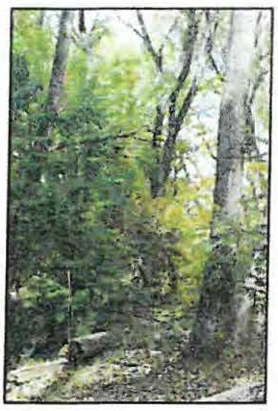Type 1- High Structure Forest with a well-developed understory.

Tall mature to intermediate-aged trees (>5 m [>15 feet]) with canopy covering >25% of the area of the community (polygon)and understory layer (0-5 m [0-15 feet]) covering >25% of the area of the community (polygon). Substantial foliage is in all height layers. (This type incorporates Hink and Ohmart structure types 1and 3.) Photograph on Gila River by Y. Chauvin,2012.

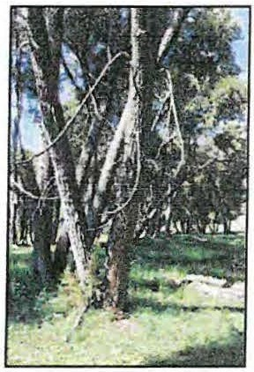Type 2 -Low Structure Forest with little or no understory.

Tall mature to intermediate-aged trees (>5 m [>15 feet]) with canopy covering >25% of the area of the community (polygon) and understory layer (1-5 m [3-15 feet]) covering <25% of the area of the community (polygon). Majority of foliage is over 5 m (15 feet) above the ground. (This type incorporates Hink and Ohmart structure types 2 and 4.) Photograph on Diamond Creek by Y. Chauvin, 2012.

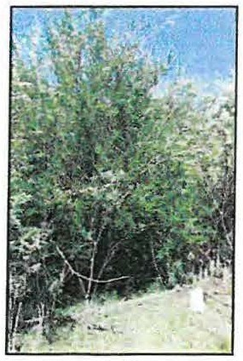Single-story Communities (Shrublands, Herbaceous and Bare Ground)

Type 5 -Tall Shrub Stands.

Young tree and shrub layer only (1.5-5 m [4.5-15 feet]) covering >25% of the area of the community (polygon). Stands dominated by tall shrubs and young trees, may include herbaceous vegetation underneath the woody vegetation. Photograph on San Francisco River by Y. Chauvin, 2012.

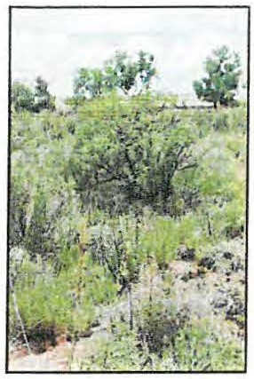Type 6S- Short Shrub Stands.

Short stature shrubs or very young shrubs and trees (up to 1.5 m [up to
4.5 feet]) covering >10% of the area of the community (polygon). Stands dominated by short woody vegetation, may include herbaceous vegetation underneath the woody vegetation. Photograph on Lower Pecos River by E. Lindahl,2008.

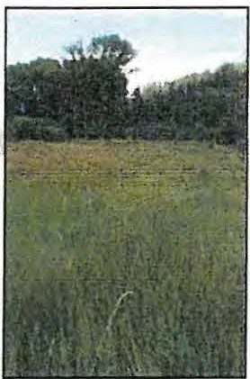Type 6W- Herbaceous Wetland.

Herbaceous wetland vegetation covering >10% of the area of the community (polygon). Stands dominated by obligate wetland herbaceous species. Woody species absent, or <10% cover. Photograph of Carex nebrascensis meadow on upper Rio Santa Barbara by Y. Chauvin, 2009.

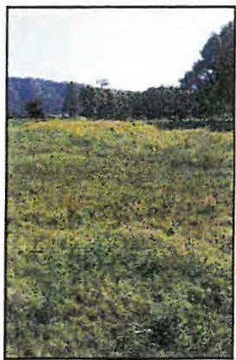Type 6H- Herbaceous.

Herbaceous vegetation covering >10% of the area of the community (polygon). Stands dominated by herbaceous vegetation of any type except obligate wetland species. Woody species absent or <10% cover. Photograph on Diamond Creek by Y. Chauvin,2012.

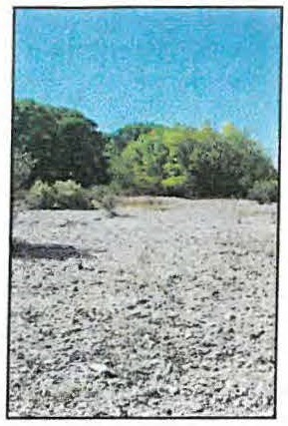Type 7-Sparse Vegetation/Bare Ground.

Bare ground, may include sparse woody or herbaceous vegetation, but total vegetation cover <10%. May be natural in origin (cobble bars) or anthropogenic in origin (graded or plowed earth) Photograph on Lower Gila River by Y. Chauvin,2012.

Appendix III – Sample Datasheets
2011 Datasheet with original Hink & Ohmart
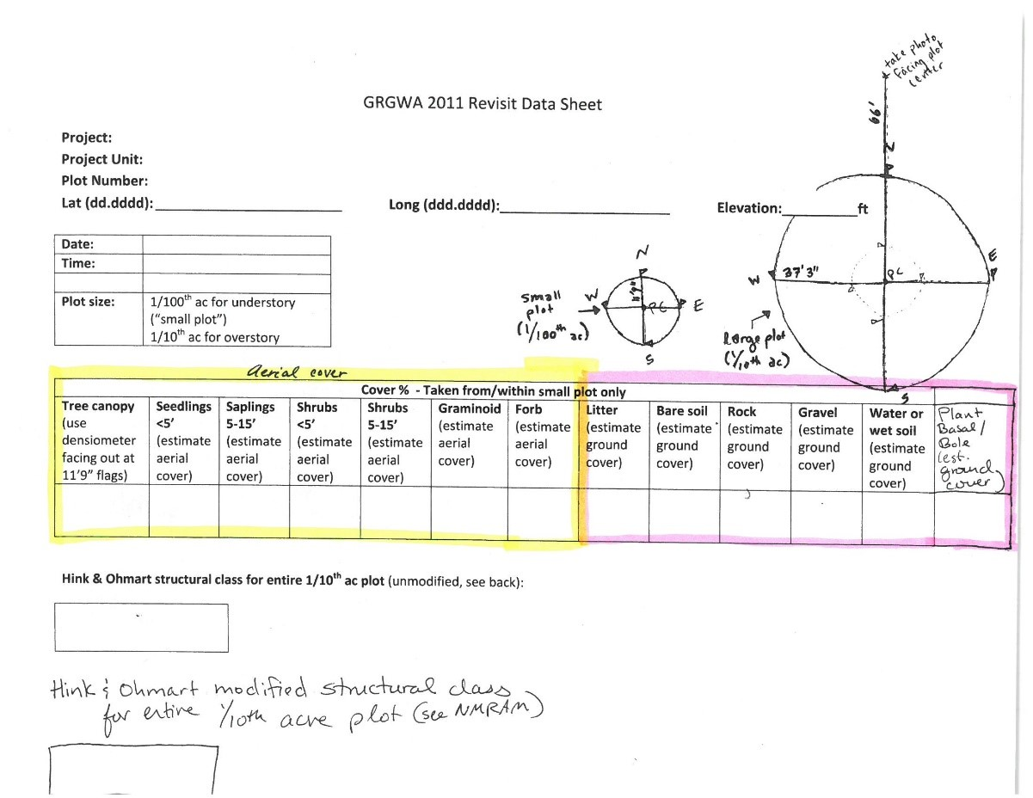

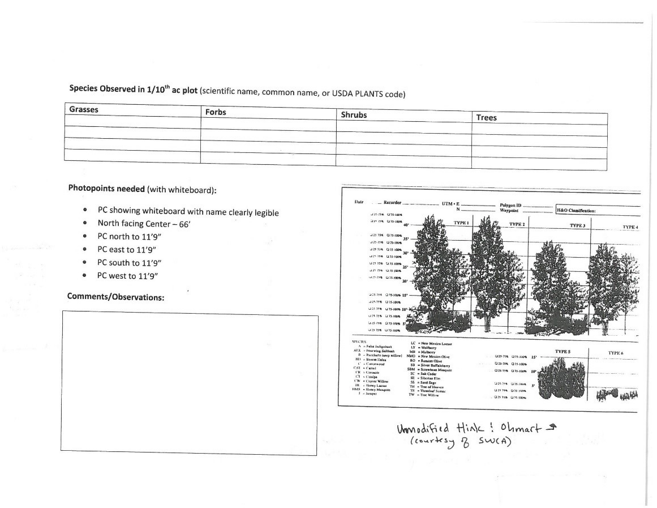

2022 Sample datasheet
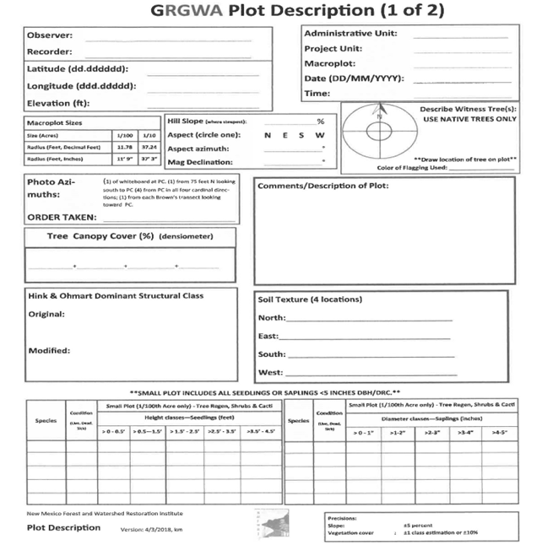

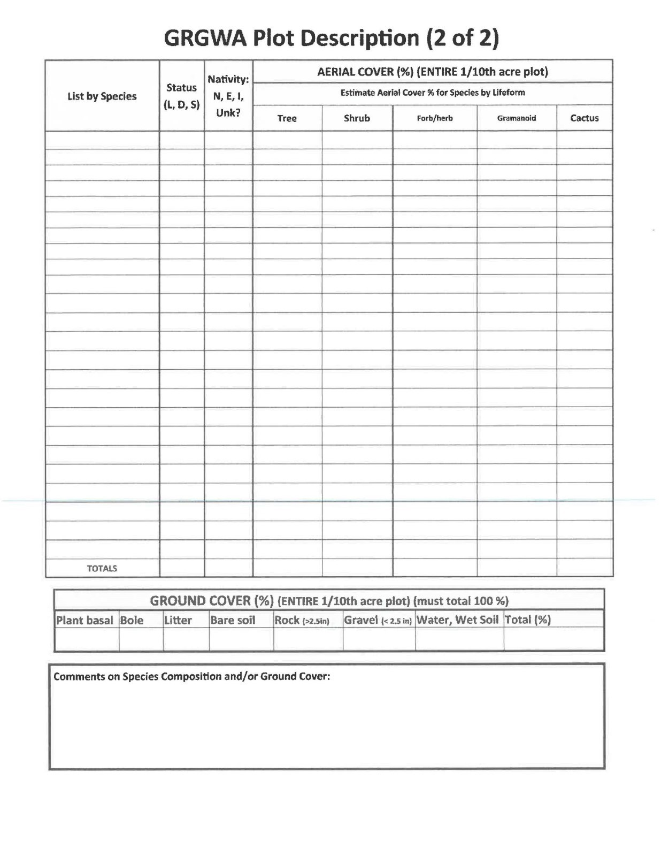
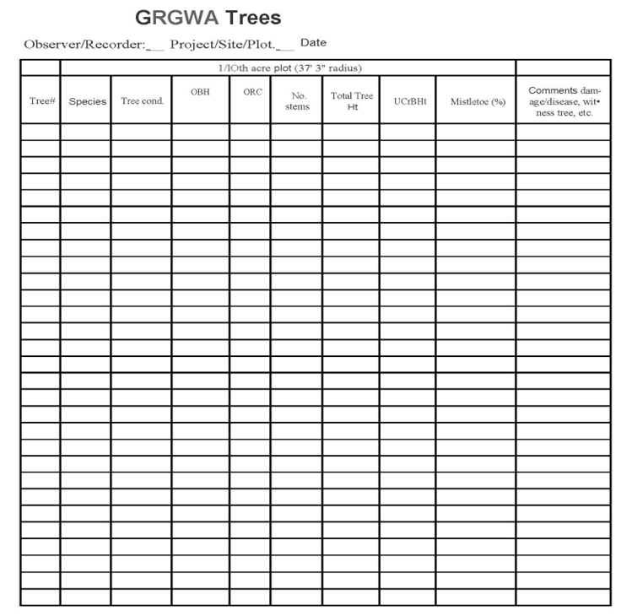

Appendix IV – Fuels Transect Data Sheet

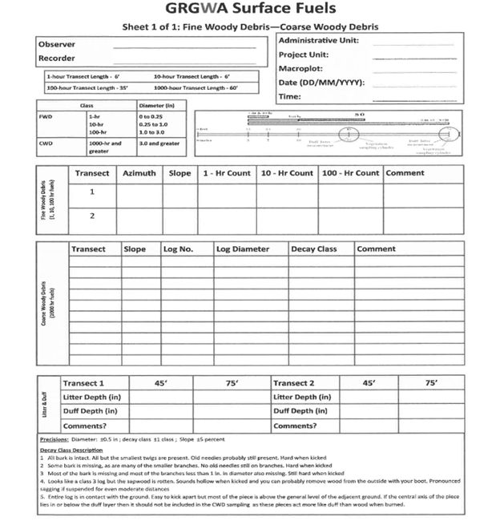

Appendix V- Photos
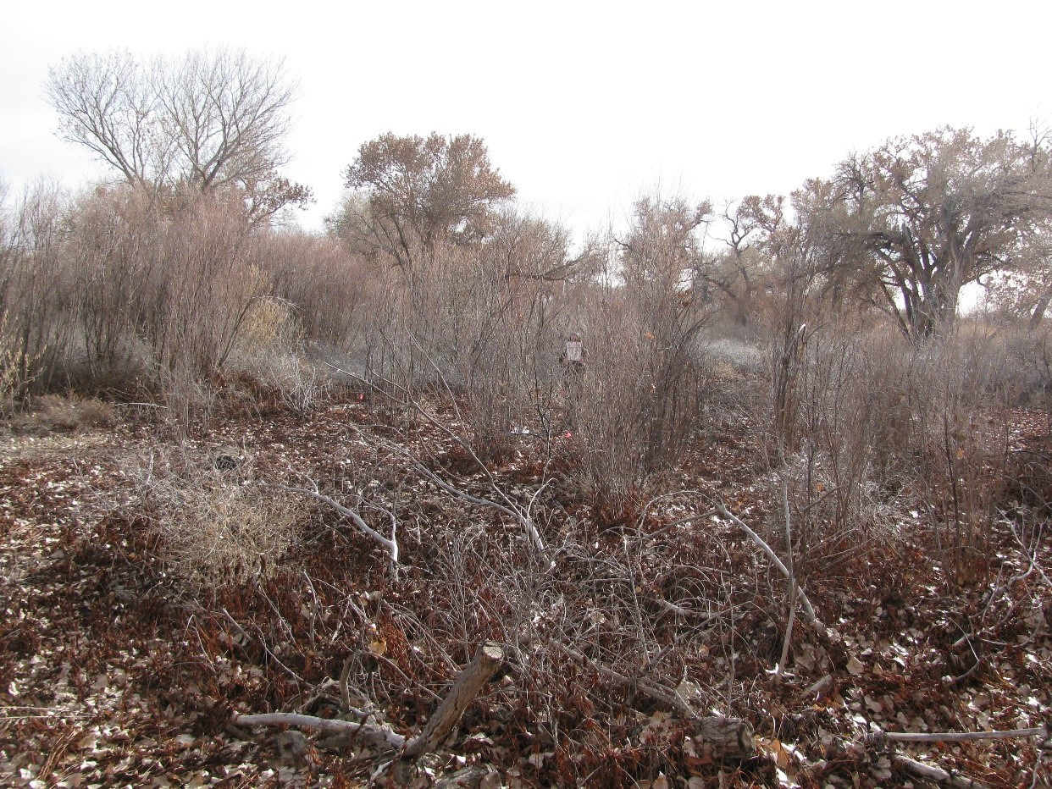11.07_1C, facing center from north at 66’ (2011)
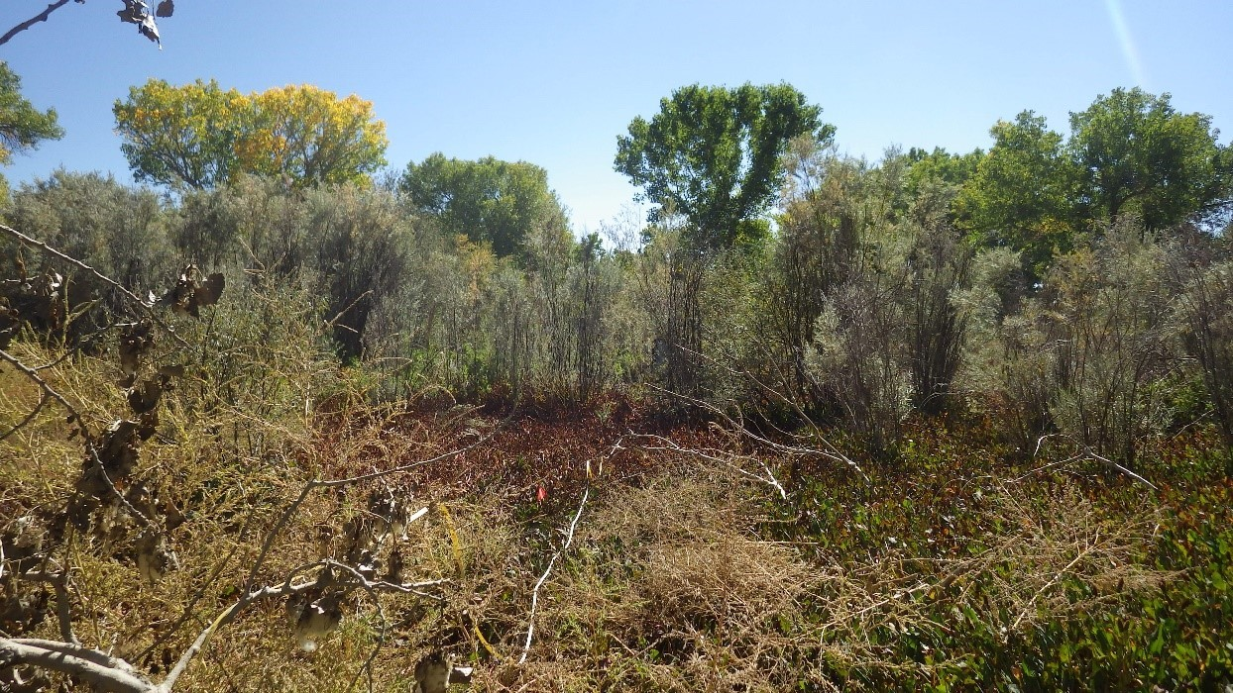11.07_1C, facing center from north at 66’ (2016)
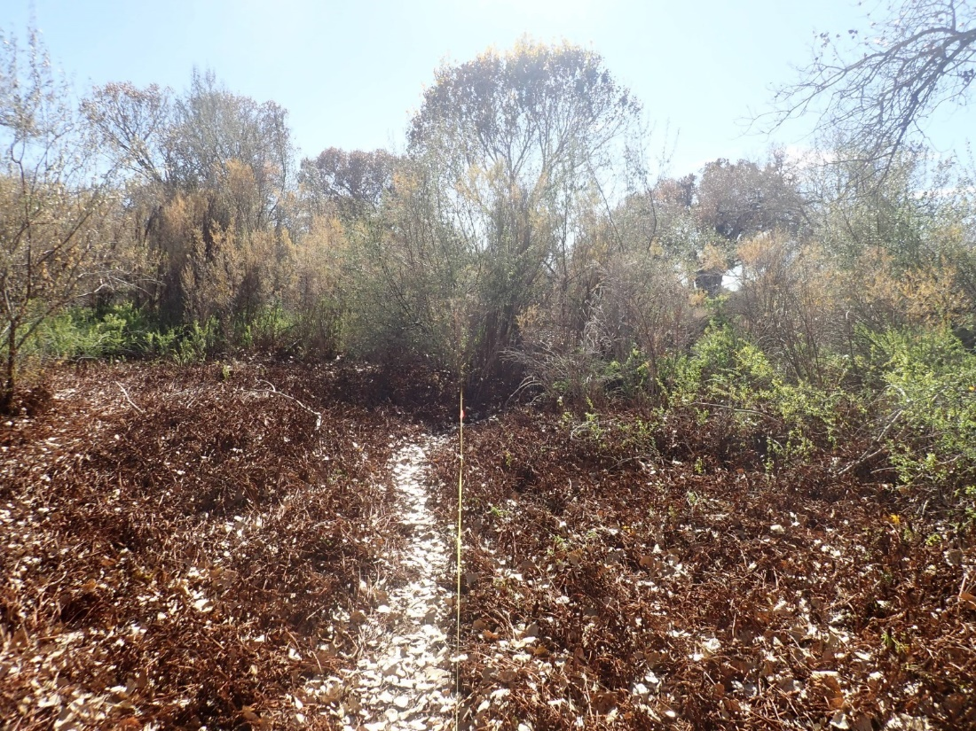11.07_1C, facing center from north at 66’ (2022)
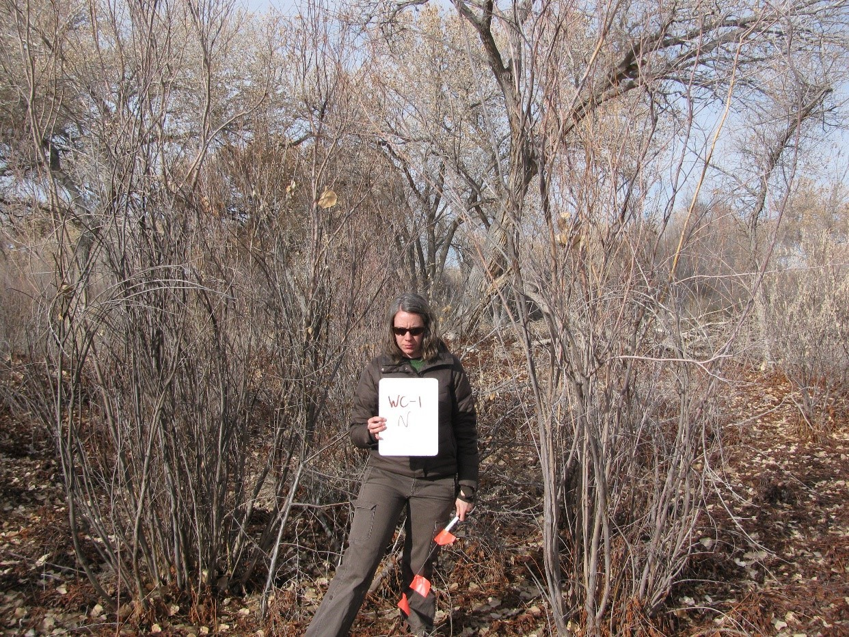11.07_1N, facing north from center at 11.8’ (2011)
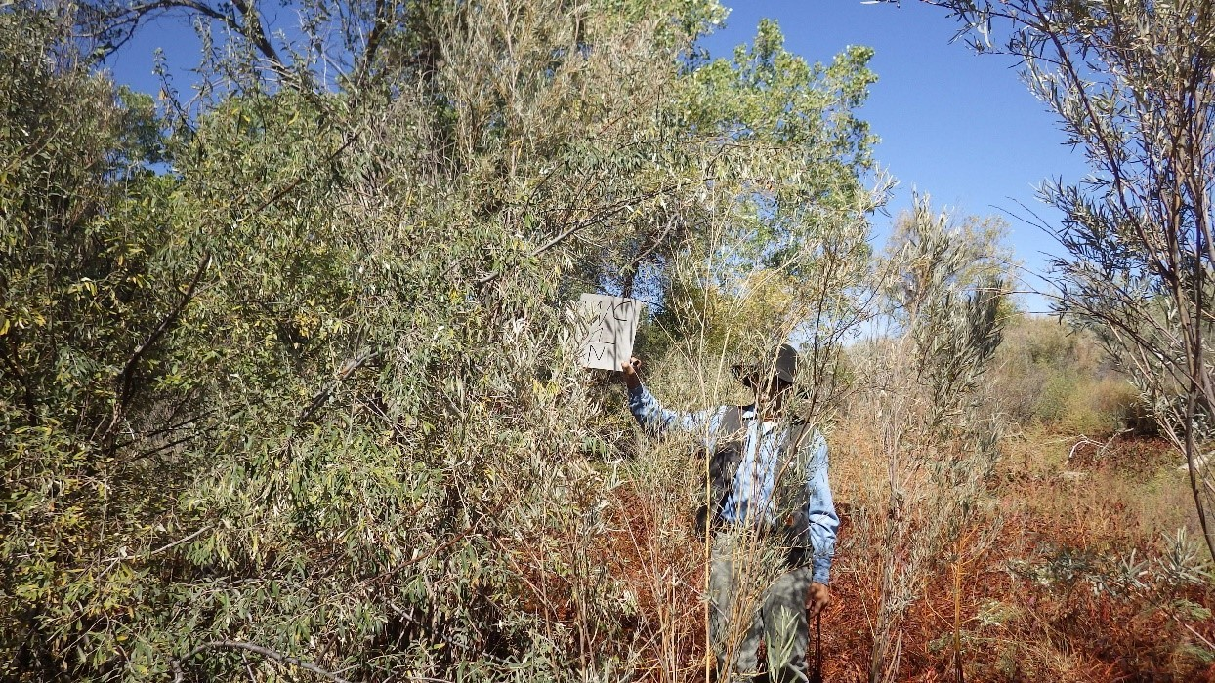11.07_1N, facing north from center at 11.8’ (2016)
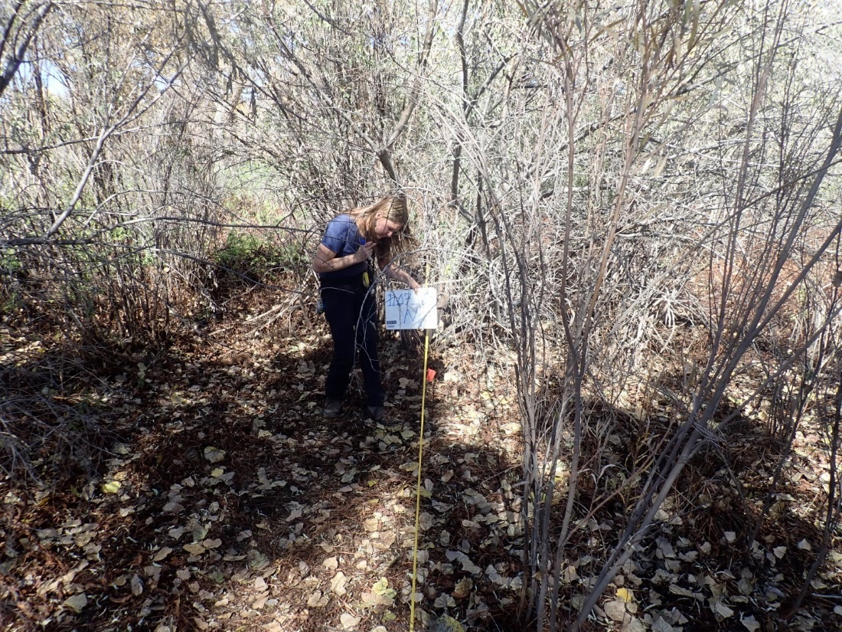11.07_1E, facing east from center at 11.8’ (2022)
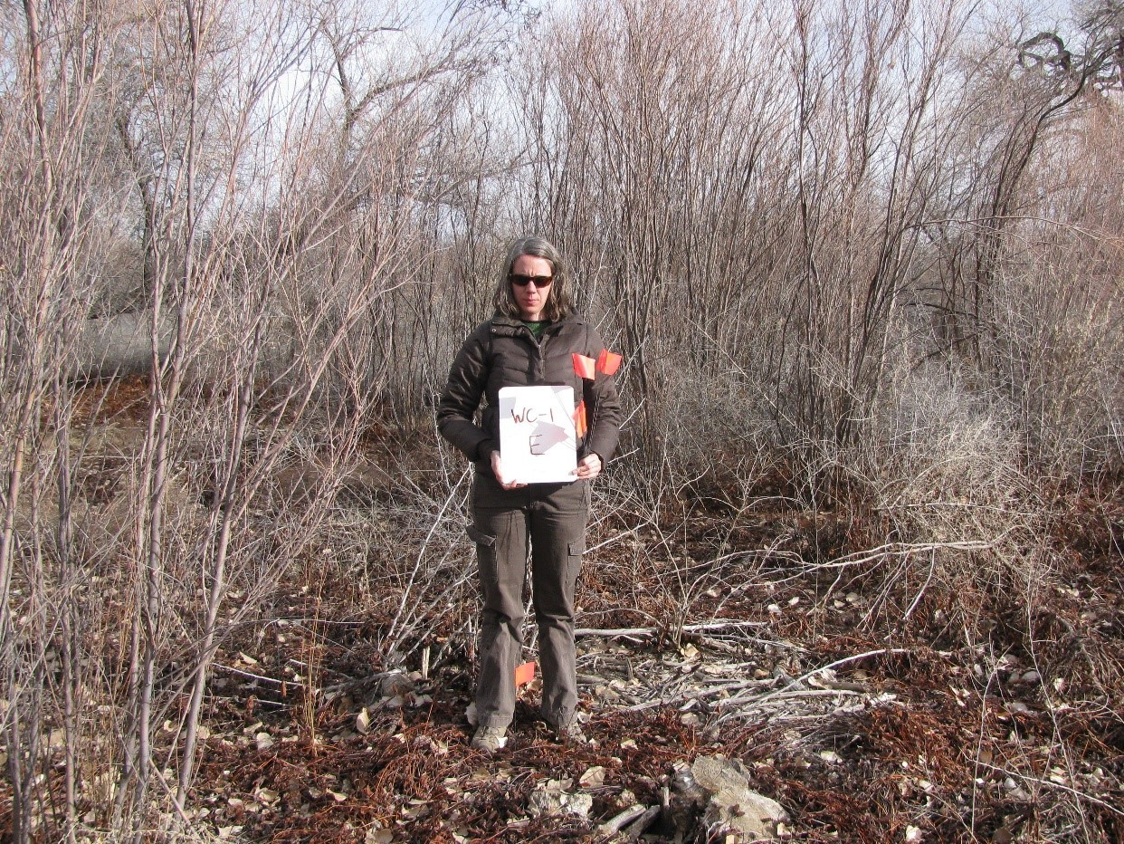11.07_1E, facing east from center at 11.8’ (2011)
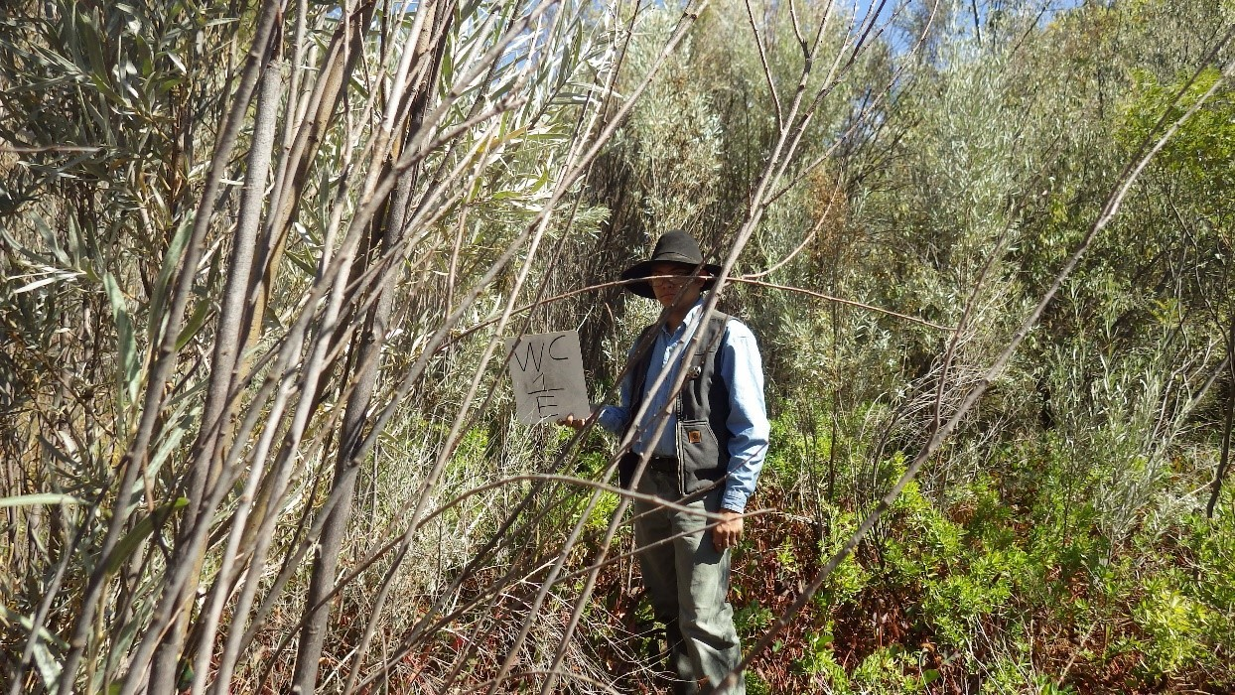11.07_1E, facing east from center at 11.8’ (2016)
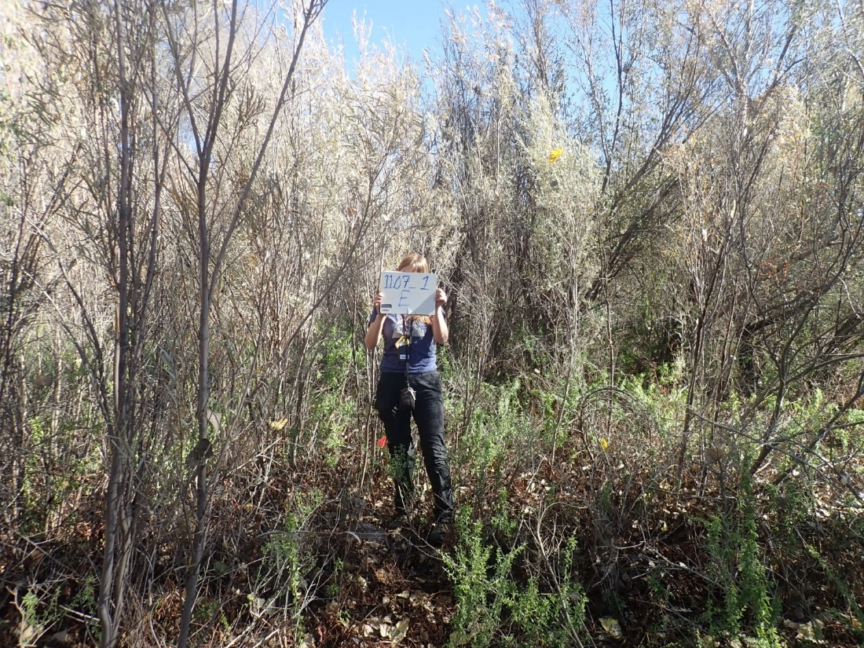11.07_1E, facing east from center at 11.8’ (2022)
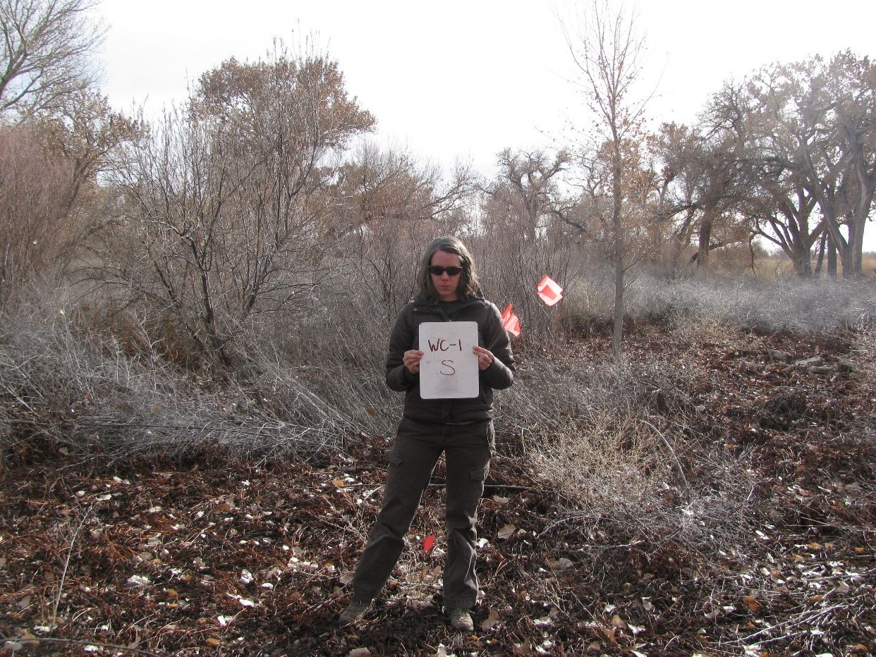11.07_1S, facing south from center from 11.8’ (2011)
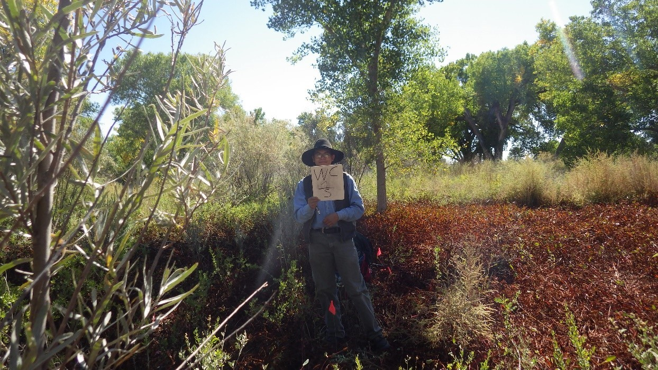11.07_1S, facing south from center at 11.8’ (2016)
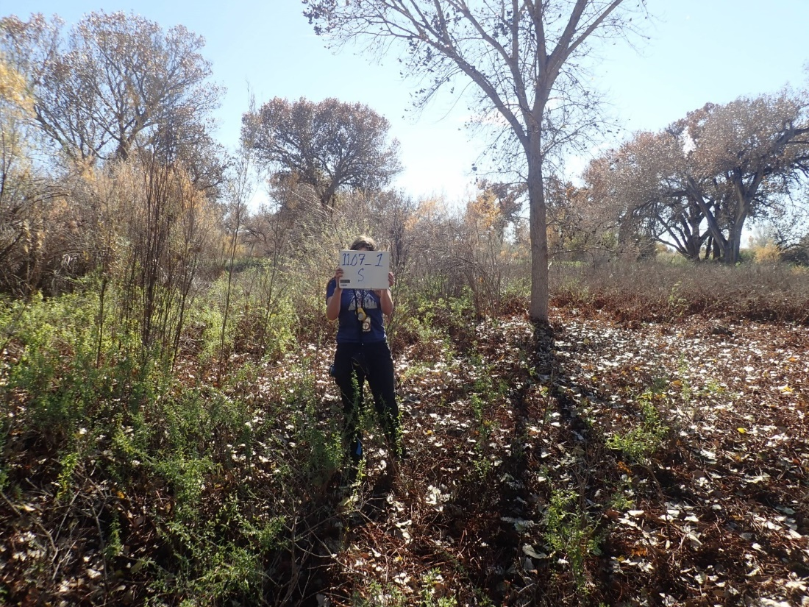11.07_1S, facing south from center at 11.8’ (2022)
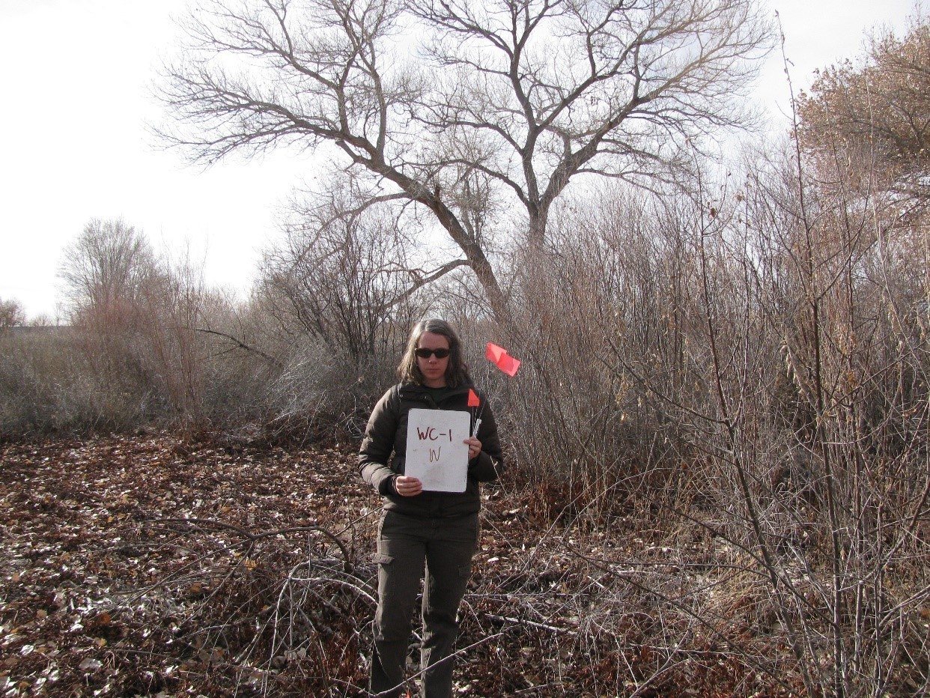11.07_1W, facing west from center at 11.8’ (2011)
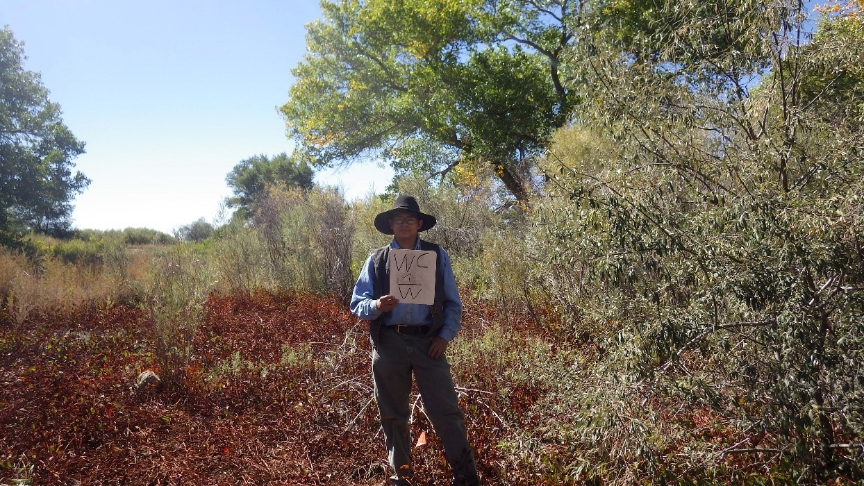11.07_1W, facing west from center at 11.8’ (2016)

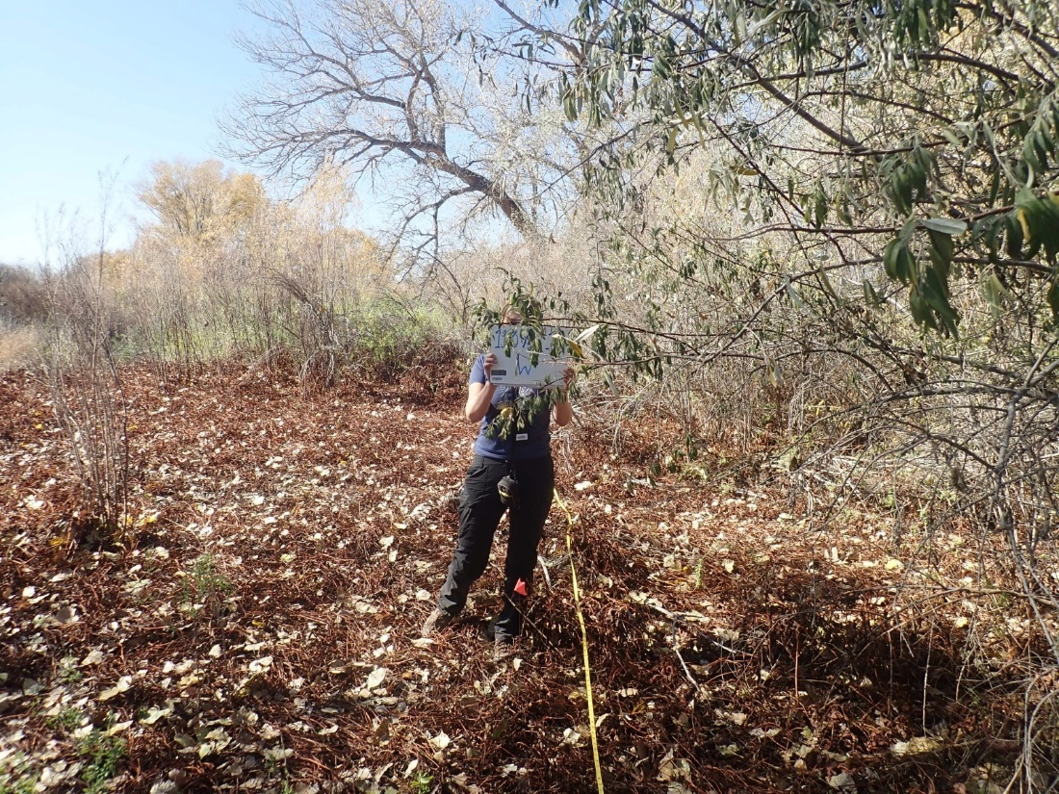
11.07_1W, facing west (2022)

from center at 11.8’ (2022)
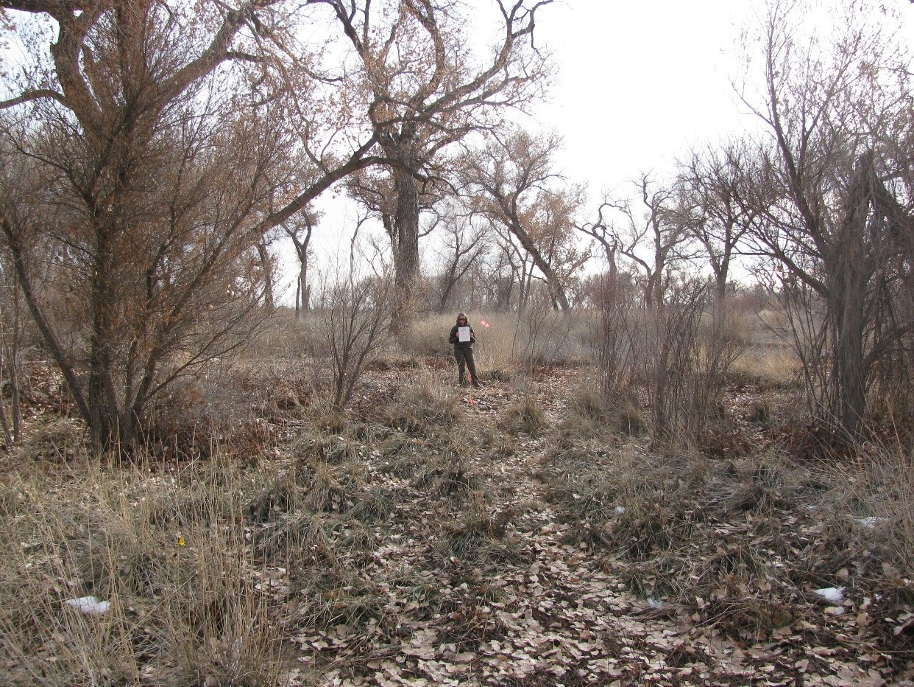11.07_2C, facing center from north at 66’ (2011)
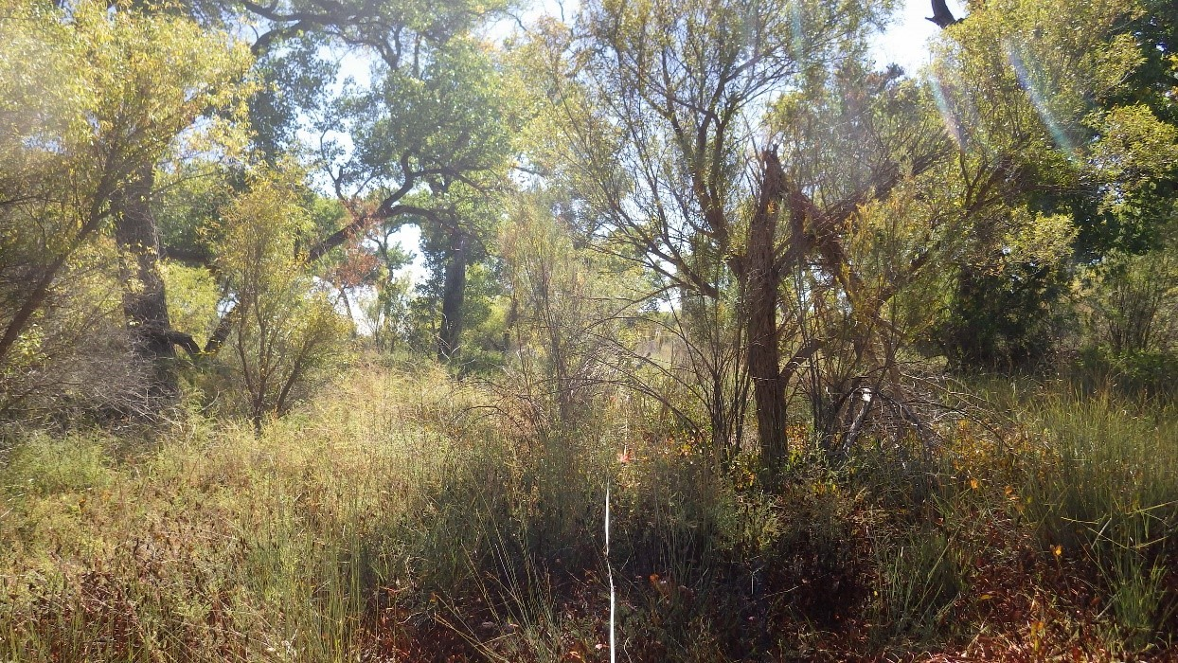11.07_2C, facing north from center at 66’ (2016)
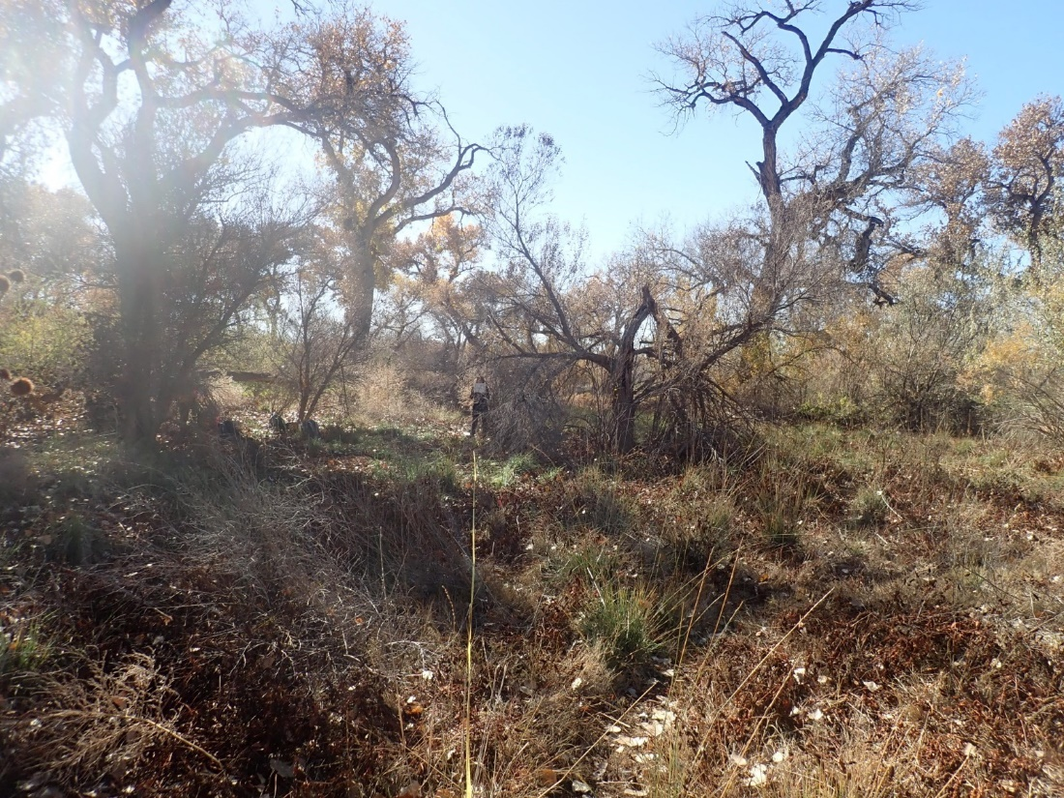11.07_2C, facing center from north at 66’ (2022)
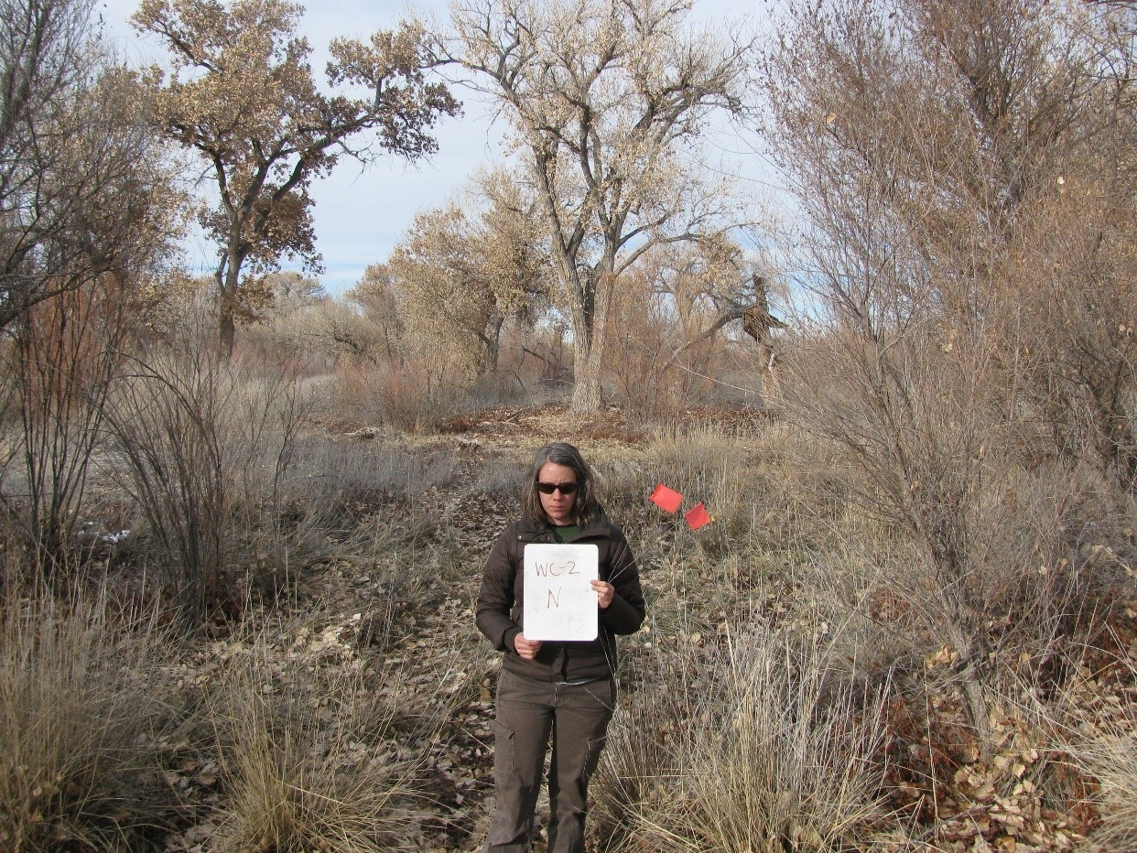11.07_2N, facing north from center at 11.8’ (2011)
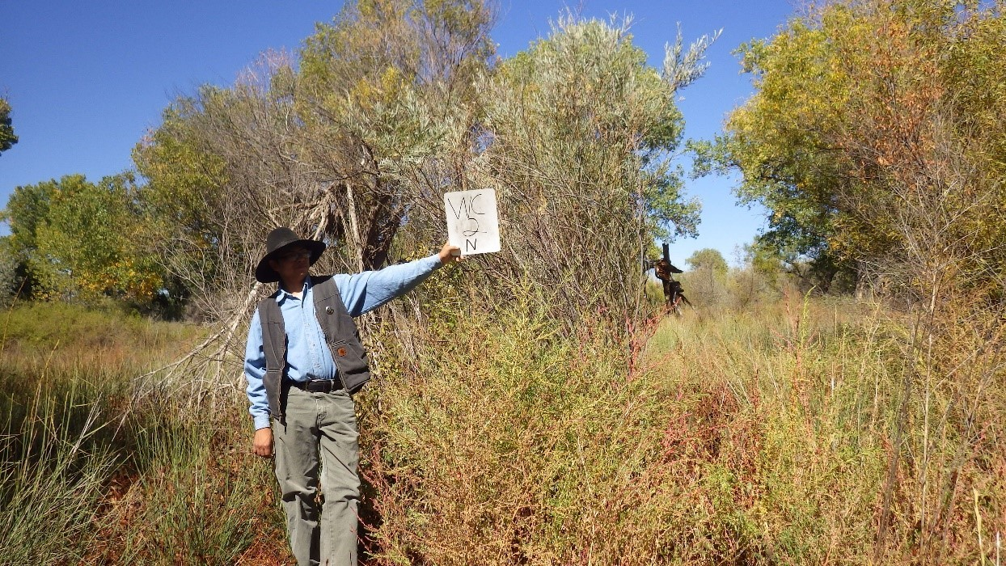11.07_2N, facing north from center at 11.8’ (2016)
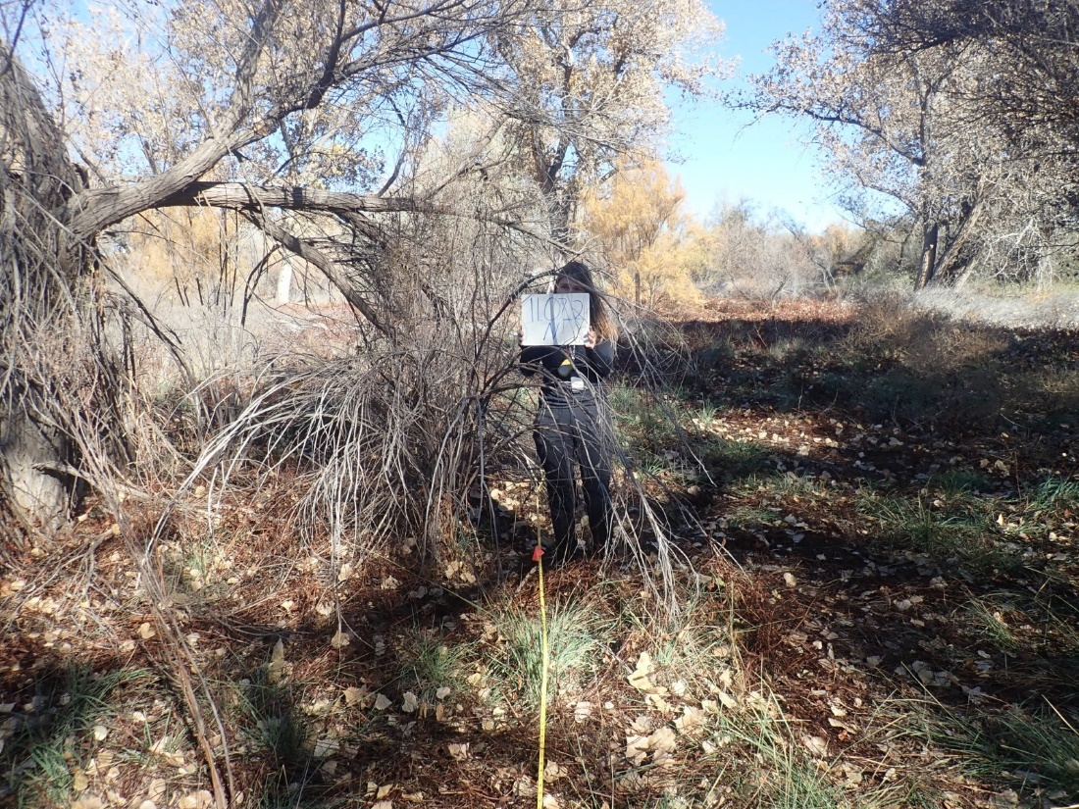11.07_2N, facing north from center at 11.8’ (2022)
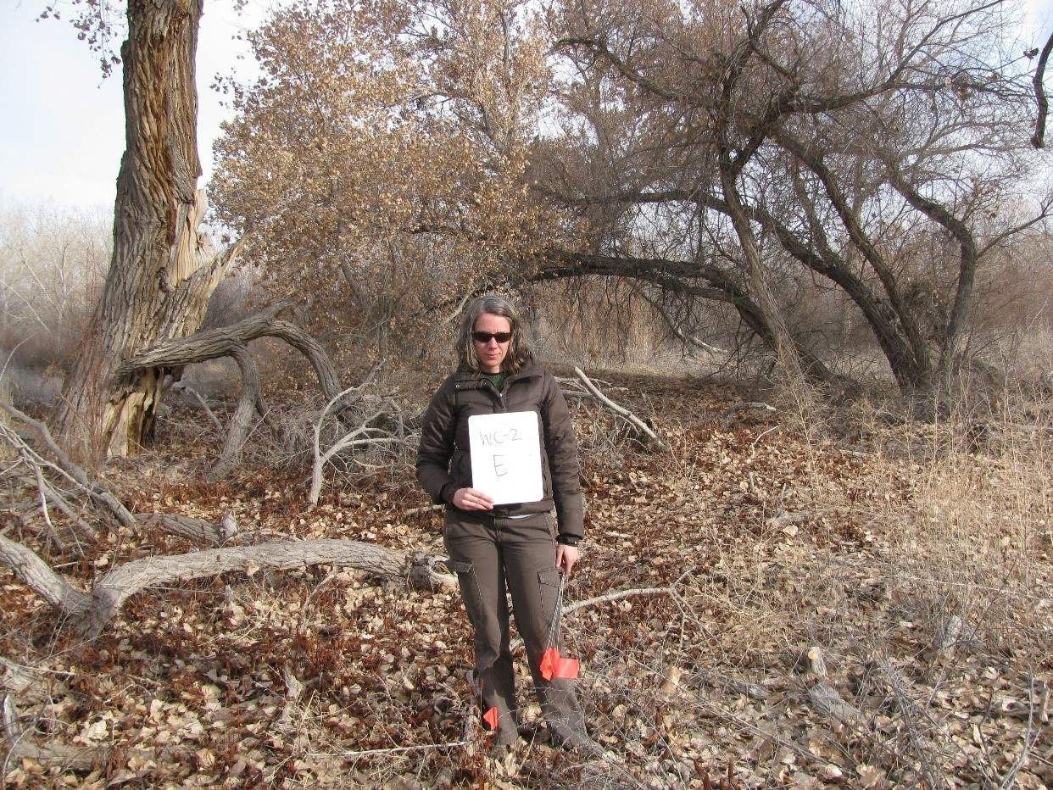11.07_2E, facing east from center at 11.8’ (2011)
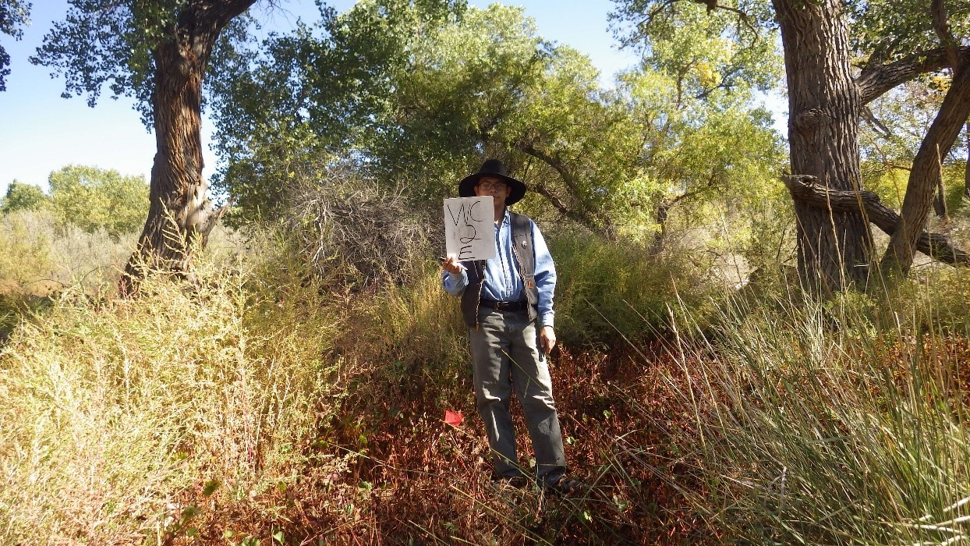11.07_2E, facing east from center at 11.8’ (2016)
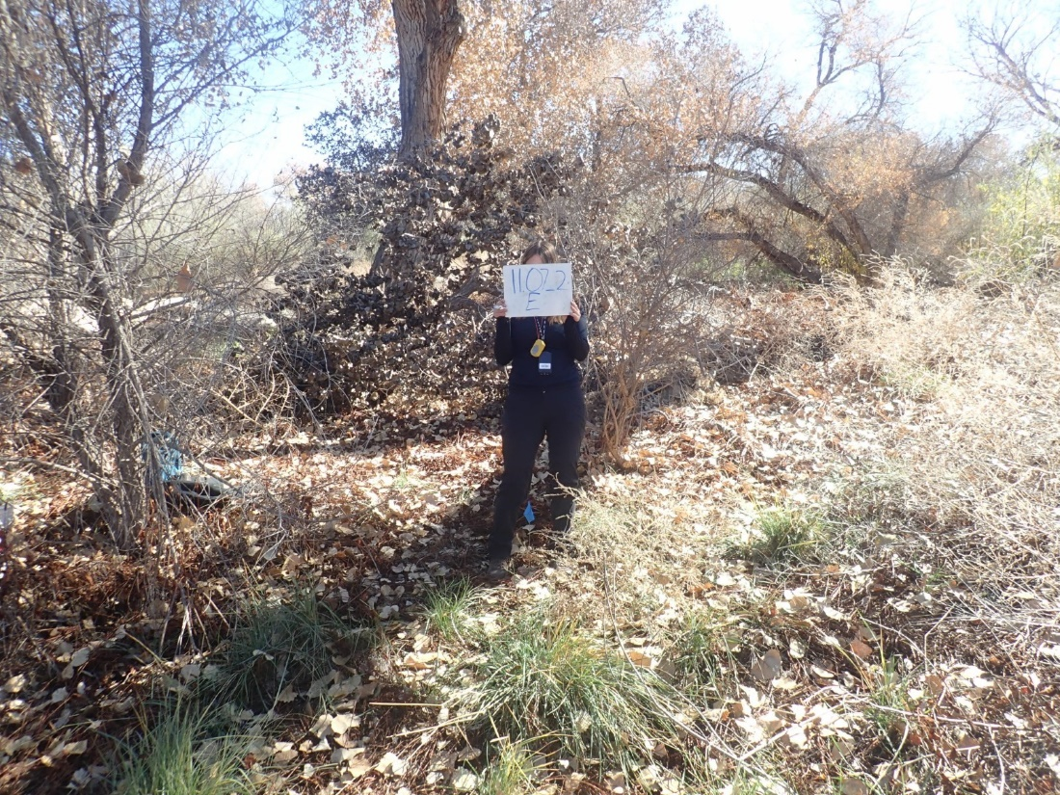11.07_2E, facing east from center at 11.8’ (2022)
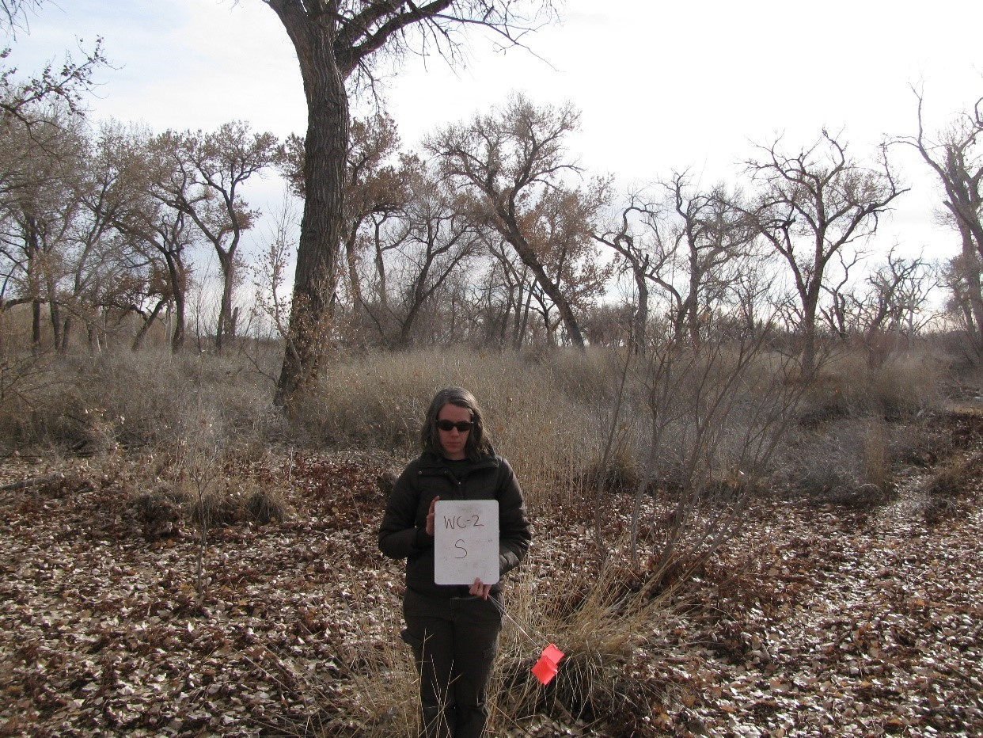11.07_2S, facing south from center at 11.8’ (2011)
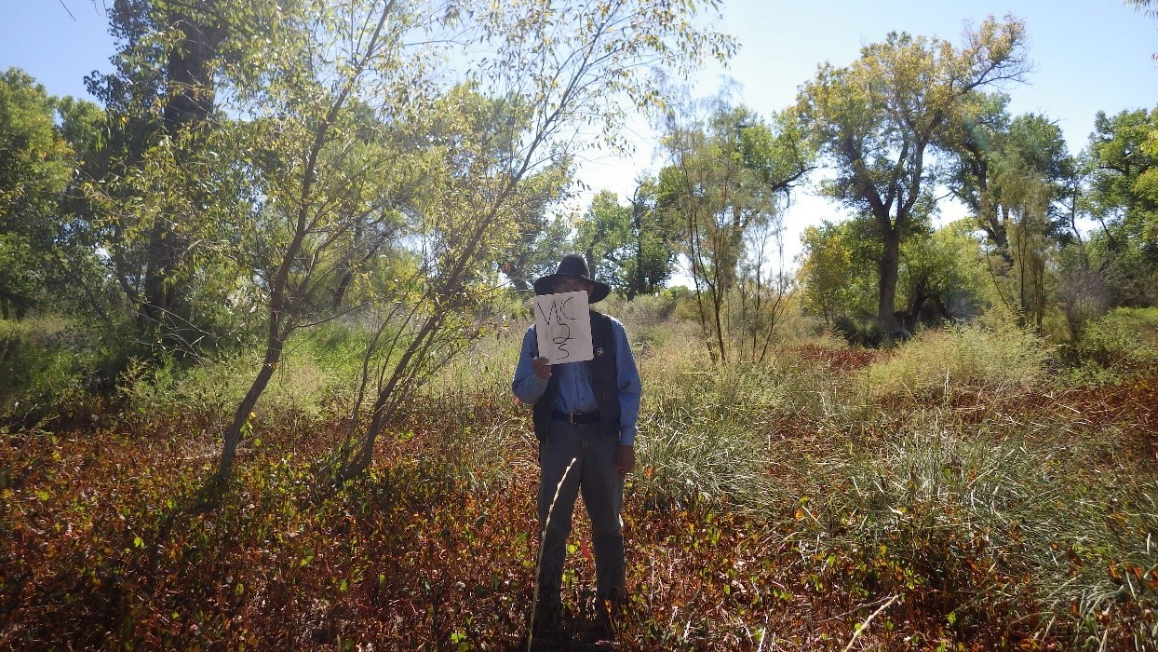11.07_2S, facing south from center at 11.8’ (2016)
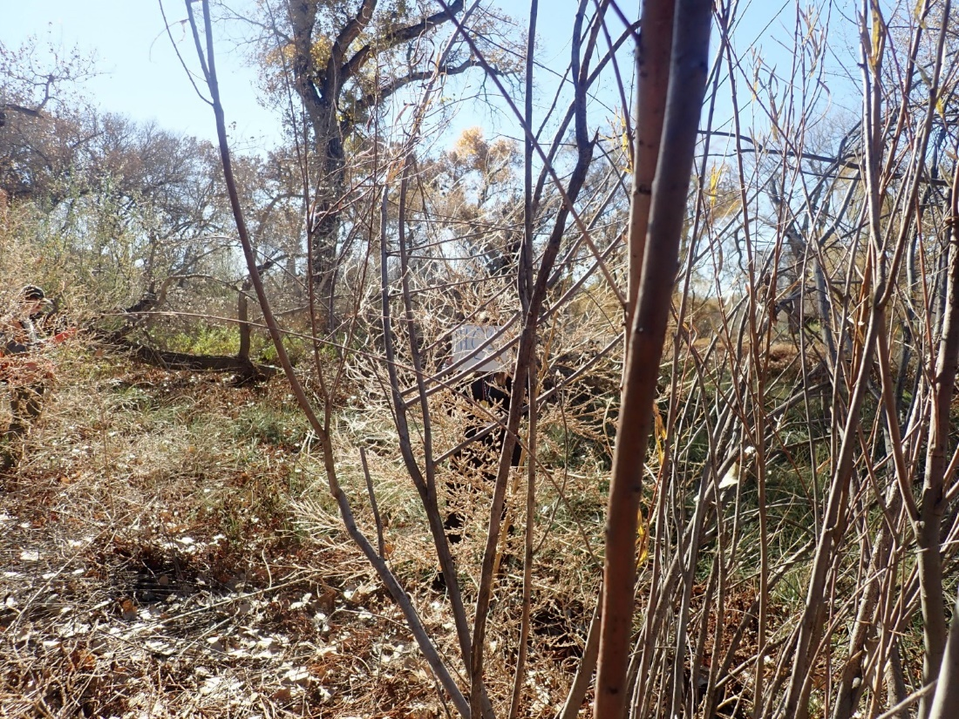11.07_2S, facing south from center at 11.8’ (2022)
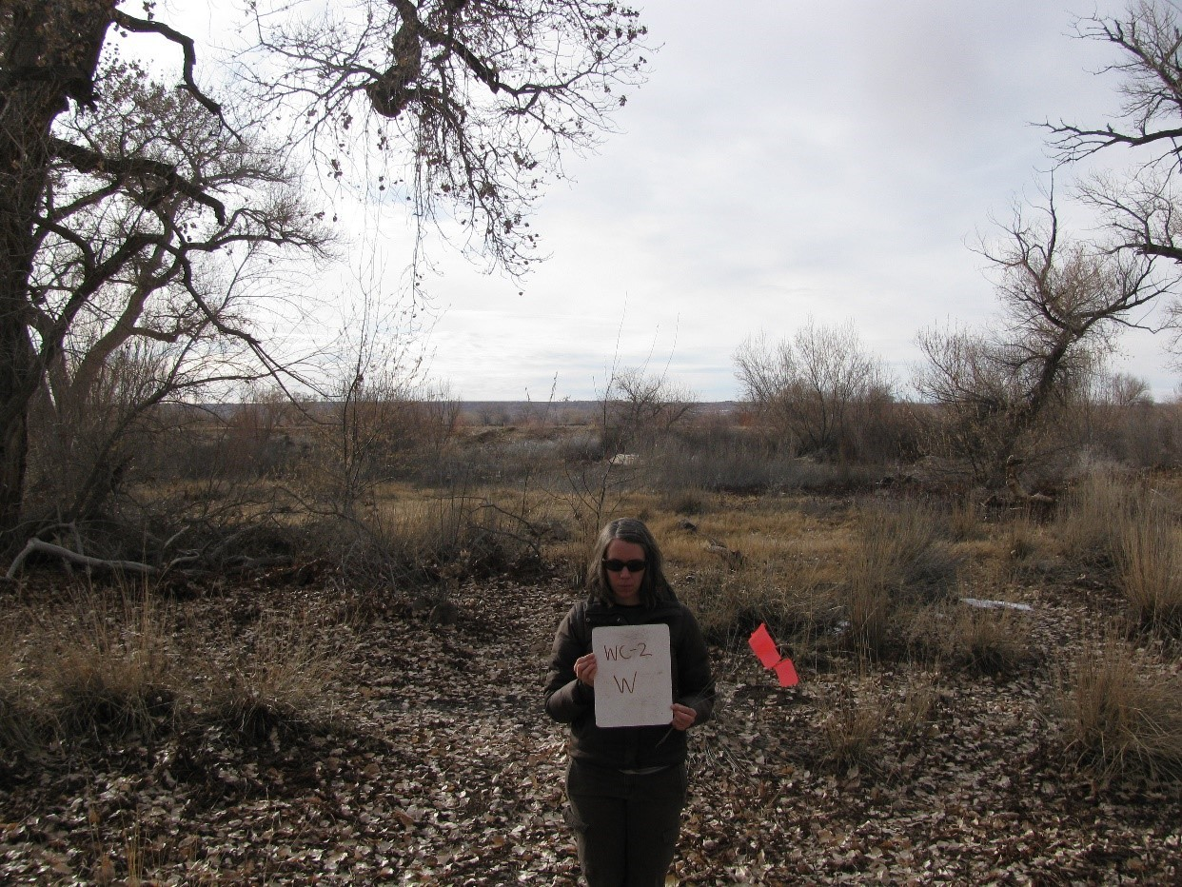11.07_2W, facing west from center at 11.8’ (2011)
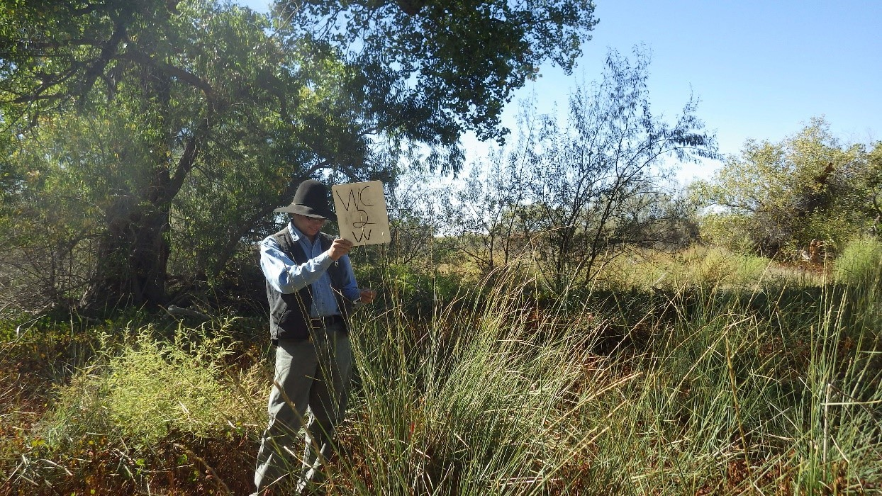11.07_2W, facing west from center at 11.8’ (2016)
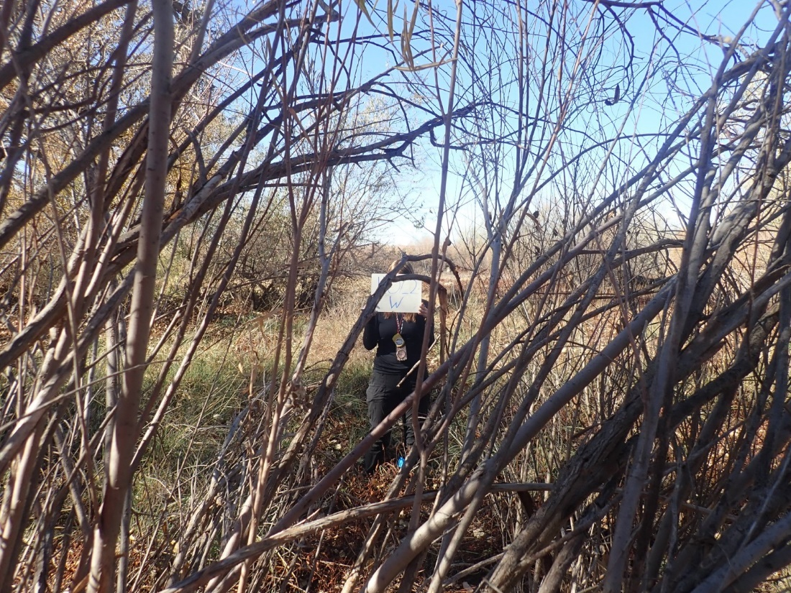11.07_2W, facing west from center at 11.8’ (2022)

